|  |  |  |  |
| --- | --- | --- | --- |
| **Acquisition Method** | PCP_BE_041422Final.dam | **Data File** | SAMPLE014.wiff |
| **Sample Name** | **NEG QC** | **Injection Volume** | 10.00 |
| **Sample Type** | Quality Control | **Injection Vial** | 10 |
| **Injection Date** | 4/30/2025 7:37:18 PM | **Dilution Factor** | 1.00 |
| **Instrument Name** | Triple Quad 5500+ | **Instrument Serial** | EX231582110 |

**Results Summary**

| **Peak Name** | **Integration Type** | **Transition** | **Retention Time** | **Rel RT** | **Peak Area** | **Area Ratio** | **Calculated Concentration (ng/mL)** | **Expected Ion Ratio** | **Calculated  Ion Ratio** | **Ratio Confirms ID** |
| --- | --- | --- | --- | --- | --- | --- | --- | --- | --- | --- |

|  |  |  |  |  |  |  |  |  |  |  |
| --- | --- | --- | --- | --- | --- | --- | --- | --- | --- | --- |
| PCP 1 | N/A | 243.8 / 159.0 | N/A | N/A* | N/A | N/A | N/A |  |  |  |

|  |  |  |  |  |  |  |  |  |  |  |
| --- | --- | --- | --- | --- | --- | --- | --- | --- | --- | --- |
| PCP 2 | N/A | 243.8 / 91.0 | N/A | N/A* | N/A | N/A |  | 59.4% | 0.0% | NO |

|  |  |  |  |  |  |  |  |  |  |  |
| --- | --- | --- | --- | --- | --- | --- | --- | --- | --- | --- |
| Benzoylecgonine 1 | N/A | 289.8 / 168.1 | N/A | N/A* | N/A | N/A | N/A |  |  |  |

|  |  |  |  |  |  |  |  |  |  |  |
| --- | --- | --- | --- | --- | --- | --- | --- | --- | --- | --- |
| Benzoylecgonine 2 | N/A | 289.8 / 104.9 | N/A | N/A* | N/A | N/A |  | 71.7% | 0.0% | NO |

**Internal Standard Data**

|  |  |  |  |  |  |  |  |  |  |
| --- | --- | --- | --- | --- | --- | --- | --- | --- | --- |
| **Internal Standard Name** | **Integration Type** | **Transition** | **Retention Time** | **Avg IS Retention Time** | **IS Peak Area** | **IS Area Within Range** | **Expected Ion Ratio** | **Calculated  Ion Ratio** | **Ratio Confirms ID** |

|  |  |  |  |  |  |  |  |  |  |
| --- | --- | --- | --- | --- | --- | --- | --- | --- | --- |
| PCP D5 1 | Baseline | 248.8 / 164.1 | 0.30* | 0.32 | 1.777e6 | ✓ |  |  |  |

|  |  |  |  |  |  |  |  |  |  |
| --- | --- | --- | --- | --- | --- | --- | --- | --- | --- |
| PCP D5 1 | Baseline | 248.8 / 164.1 | 0.30* | 0.32 | 1.777e6 |  | 100.0% | 100.0% | ✓ |

|  |  |  |  |  |  |  |  |  |  |
| --- | --- | --- | --- | --- | --- | --- | --- | --- | --- |
| Benzoylecgonine D3 1 | Baseline | 292.8 / 171.2 | 0.16* | 0.18 | 2.068e6 | ✓ |  |  |  |

|  |  |  |  |  |  |  |  |  |  |
| --- | --- | --- | --- | --- | --- | --- | --- | --- | --- |
| Benzoylecgonine D3 1 | Baseline | 292.8 / 171.2 | 0.16* | 0.18 | 2.068e6 |  | 100.0% | 100.0% | ✓ |

**Peak Review**

PCP 1 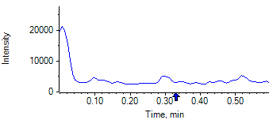

PCP 2 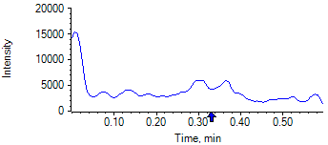

PCP D5 1 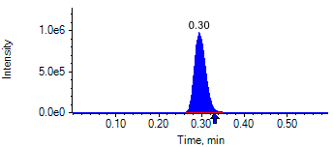

PCP D5 1 

Benzoylecgonine 1 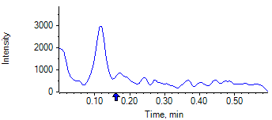

Benzoylecgonine 2 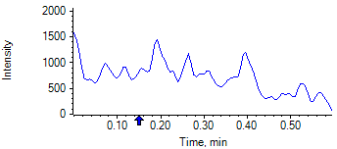

Benzoylecgonine D3 1 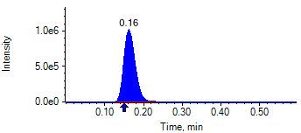

Benzoylecgonine D3 1 

|  |  |  |  |
| --- | --- | --- | --- |
| **Acquisition Method** | PCP_BE_041422Final.dam | **Data File** | SAMPLE015.wiff |
| **Sample Name** | **CPC LOW QC** | **Injection Volume** | 10.00 |
| **Sample Type** | Quality Control | **Injection Vial** | 11 |
| **Injection Date** | 4/30/2025 7:38:33 PM | **Dilution Factor** | 1.00 |
| **Instrument Name** | Triple Quad 5500+ | **Instrument Serial** | EX231582110 |

**Results Summary**

| **Peak Name** | **Integration Type** | **Transition** | **Retention Time** | **Rel RT** | **Peak Area** | **Area Ratio** | **Calculated Concentration (ng/mL)** | **Expected Ion Ratio** | **Calculated  Ion Ratio** | **Ratio Confirms ID** |
| --- | --- | --- | --- | --- | --- | --- | --- | --- | --- | --- |

|  |  |  |  |  |  |  |  |  |  |  |
| --- | --- | --- | --- | --- | --- | --- | --- | --- | --- | --- |
| PCP 1 | Baseline | 243.8 / 159.0 | 0.30 | 1.01 | 2.786e5 | 0.150 | 30.08 |  |  |  |

|  |  |  |  |  |  |  |  |  |  |  |
| --- | --- | --- | --- | --- | --- | --- | --- | --- | --- | --- |
| PCP 2 | Baseline | 243.8 / 91.0 | 0.30 | 1.01 | 1.762e5 | 0.095 |  | 59.4% | 63.2% | ✓ |

|  |  |  |  |  |  |  |  |  |  |  |
| --- | --- | --- | --- | --- | --- | --- | --- | --- | --- | --- |
| Benzoylecgonine 1 | Valley | 289.8 / 168.1 | 0.16 | 1.02 | 4.701e4 | 0.023 | 115.16 |  |  |  |

|  |  |  |  |  |  |  |  |  |  |  |
| --- | --- | --- | --- | --- | --- | --- | --- | --- | --- | --- |
| Benzoylecgonine 2 | Baseline | 289.8 / 104.9 | 0.16 | 1.02 | 3.569e4 | 0.017 |  | 71.7% | 75.9% | ✓ |

**Internal Standard Data**

|  |  |  |  |  |  |  |  |  |  |
| --- | --- | --- | --- | --- | --- | --- | --- | --- | --- |
| **Internal Standard Name** | **Integration Type** | **Transition** | **Retention Time** | **Avg IS Retention Time** | **IS Peak Area** | **IS Area Within Range** | **Expected Ion Ratio** | **Calculated  Ion Ratio** | **Ratio Confirms ID** |

|  |  |  |  |  |  |  |  |  |  |
| --- | --- | --- | --- | --- | --- | --- | --- | --- | --- |
| PCP D5 1 | Baseline | 248.8 / 164.1 | 0.29* | 0.32 | 1.862e6 | ✓ |  |  |  |

|  |  |  |  |  |  |  |  |  |  |
| --- | --- | --- | --- | --- | --- | --- | --- | --- | --- |
| PCP D5 1 | Baseline | 248.8 / 164.1 | 0.29* | 0.32 | 1.862e6 |  | 100.0% | 100.0% | ✓ |

|  |  |  |  |  |  |  |  |  |  |
| --- | --- | --- | --- | --- | --- | --- | --- | --- | --- |
| Benzoylecgonine D3 1 | Baseline | 292.8 / 171.2 | 0.16* | 0.18 | 2.057e6 | ✓ |  |  |  |

|  |  |  |  |  |  |  |  |  |  |
| --- | --- | --- | --- | --- | --- | --- | --- | --- | --- |
| Benzoylecgonine D3 1 | Baseline | 292.8 / 171.2 | 0.16* | 0.18 | 2.057e6 |  | 100.0% | 100.0% | ✓ |

**Peak Review**

PCP 1 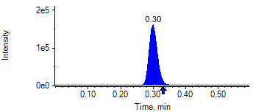

PCP 2 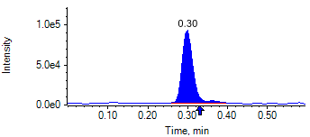

PCP D5 1 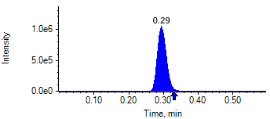

PCP D5 1 

Benzoylecgonine 1 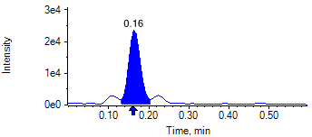

Benzoylecgonine 2 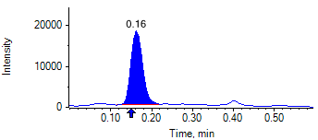

Benzoylecgonine D3 1 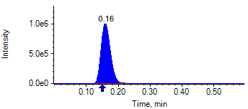

Benzoylecgonine D3 1 

|  |  |  |  |
| --- | --- | --- | --- |
| **Acquisition Method** | PCP_BE_041422Final.dam | **Data File** | SAMPLE016.wiff |
| **Sample Name** | **CPC MID QC** | **Injection Volume** | 10.00 |
| **Sample Type** | Quality Control | **Injection Vial** | 12 |
| **Injection Date** | 4/30/2025 7:39:41 PM | **Dilution Factor** | 1.00 |
| **Instrument Name** | Triple Quad 5500+ | **Instrument Serial** | EX231582110 |

**Results Summary**

| **Peak Name** | **Integration Type** | **Transition** | **Retention Time** | **Rel RT** | **Peak Area** | **Area Ratio** | **Calculated Concentration (ng/mL)** | **Expected Ion Ratio** | **Calculated  Ion Ratio** | **Ratio Confirms ID** |
| --- | --- | --- | --- | --- | --- | --- | --- | --- | --- | --- |

|  |  |  |  |  |  |  |  |  |  |  |
| --- | --- | --- | --- | --- | --- | --- | --- | --- | --- | --- |
| PCP 1 | Baseline | 243.8 / 159.0 | 0.36 | 1.01 | 1.579e7 | 8.689 | 1872.06 |  |  |  |

|  |  |  |  |  |  |  |  |  |  |  |
| --- | --- | --- | --- | --- | --- | --- | --- | --- | --- | --- |
| PCP 2 | Baseline | 243.8 / 91.0 | 0.35 | 1.01 | 9.224e6 | 5.076 |  | 59.4% | 58.4% | ✓ |

|  |  |  |  |  |  |  |  |  |  |  |
| --- | --- | --- | --- | --- | --- | --- | --- | --- | --- | --- |
| Benzoylecgonine 1 | Baseline | 289.8 / 168.1 | 0.21 | 1.02 | 2.371e6 | 1.457 | 7691.49 |  |  |  |

|  |  |  |  |  |  |  |  |  |  |  |
| --- | --- | --- | --- | --- | --- | --- | --- | --- | --- | --- |
| Benzoylecgonine 2 | Baseline | 289.8 / 104.9 | 0.21 | 1.01 | 1.699e6 | 1.045 |  | 71.7% | 71.7% | ✓ |

**Internal Standard Data**

|  |  |  |  |  |  |  |  |  |  |
| --- | --- | --- | --- | --- | --- | --- | --- | --- | --- |
| **Internal Standard Name** | **Integration Type** | **Transition** | **Retention Time** | **Avg IS Retention Time** | **IS Peak Area** | **IS Area Within Range** | **Expected Ion Ratio** | **Calculated  Ion Ratio** | **Ratio Confirms ID** |

|  |  |  |  |  |  |  |  |  |  |
| --- | --- | --- | --- | --- | --- | --- | --- | --- | --- |
| PCP D5 1 | Baseline | 248.8 / 164.1 | 0.35* | 0.32 | 1.817e6 | ✓ |  |  |  |

|  |  |  |  |  |  |  |  |  |  |
| --- | --- | --- | --- | --- | --- | --- | --- | --- | --- |
| PCP D5 1 | Baseline | 248.8 / 164.1 | 0.35* | 0.32 | 1.817e6 |  | 100.0% | 100.0% | ✓ |

|  |  |  |  |  |  |  |  |  |  |
| --- | --- | --- | --- | --- | --- | --- | --- | --- | --- |
| Benzoylecgonine D3 1 | Baseline | 292.8 / 171.2 | 0.21* | 0.18 | 1.627e6 | ✓ |  |  |  |

|  |  |  |  |  |  |  |  |  |  |
| --- | --- | --- | --- | --- | --- | --- | --- | --- | --- |
| Benzoylecgonine D3 1 | Baseline | 292.8 / 171.2 | 0.21* | 0.18 | 1.627e6 |  | 100.0% | 100.0% | ✓ |

**Peak Review**

PCP 1 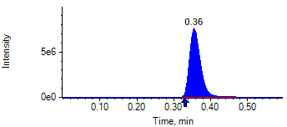

PCP 2 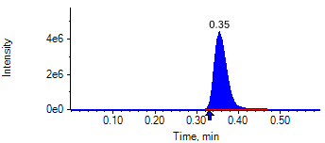

PCP D5 1 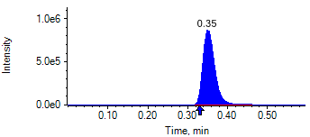

PCP D5 1 

Benzoylecgonine 1 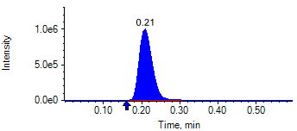

Benzoylecgonine 2 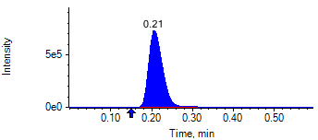

Benzoylecgonine D3 1 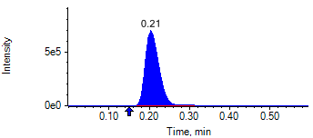

Benzoylecgonine D3 1 

|  |  |  |  |
| --- | --- | --- | --- |
| **Acquisition Method** | PCP_BE_041422Final.dam | **Data File** | SAMPLE017.wiff |
| **Sample Name** | **CPC HIGH QC** | **Injection Volume** | 10.00 |
| **Sample Type** | Quality Control | **Injection Vial** | 13 |
| **Injection Date** | 4/30/2025 7:40:53 PM | **Dilution Factor** | 1.00 |
| **Instrument Name** | Triple Quad 5500+ | **Instrument Serial** | EX231582110 |

**Results Summary**

| **Peak Name** | **Integration Type** | **Transition** | **Retention Time** | **Rel RT** | **Peak Area** | **Area Ratio** | **Calculated Concentration (ng/mL)** | **Expected Ion Ratio** | **Calculated  Ion Ratio** | **Ratio Confirms ID** |
| --- | --- | --- | --- | --- | --- | --- | --- | --- | --- | --- |

|  |  |  |  |  |  |  |  |  |  |  |
| --- | --- | --- | --- | --- | --- | --- | --- | --- | --- | --- |
| PCP 1 | Baseline | 243.8 / 159.0 | 0.32 | 1.02 | 2.728e7 | 17.950 | 4019.42 |  |  |  |

|  |  |  |  |  |  |  |  |  |  |  |
| --- | --- | --- | --- | --- | --- | --- | --- | --- | --- | --- |
| PCP 2 | Baseline | 243.8 / 91.0 | 0.32 | 1.01 | 1.569e7 | 10.320 |  | 59.4% | 57.5% | ✓ |

|  |  |  |  |  |  |  |  |  |  |  |
| --- | --- | --- | --- | --- | --- | --- | --- | --- | --- | --- |
| Benzoylecgonine 1 | Baseline | 289.8 / 168.1 | 0.18 | 1.02 | 4.396e6 | 2.905 | 15819.86 |  |  |  |

|  |  |  |  |  |  |  |  |  |  |  |
| --- | --- | --- | --- | --- | --- | --- | --- | --- | --- | --- |
| Benzoylecgonine 2 | Baseline | 289.8 / 104.9 | 0.18 | 1.02 | 3.161e6 | 2.088 |  | 71.7% | 71.9% | ✓ |

**Internal Standard Data**

|  |  |  |  |  |  |  |  |  |  |
| --- | --- | --- | --- | --- | --- | --- | --- | --- | --- |
| **Internal Standard Name** | **Integration Type** | **Transition** | **Retention Time** | **Avg IS Retention Time** | **IS Peak Area** | **IS Area Within Range** | **Expected Ion Ratio** | **Calculated  Ion Ratio** | **Ratio Confirms ID** |

|  |  |  |  |  |  |  |  |  |  |
| --- | --- | --- | --- | --- | --- | --- | --- | --- | --- |
| PCP D5 1 | Baseline | 248.8 / 164.1 | 0.32 | 0.32 | 1.520e6 | ✓ |  |  |  |

|  |  |  |  |  |  |  |  |  |  |
| --- | --- | --- | --- | --- | --- | --- | --- | --- | --- |
| PCP D5 1 | Baseline | 248.8 / 164.1 | 0.32 | 0.32 | 1.520e6 |  | 100.0% | 100.0% | ✓ |

|  |  |  |  |  |  |  |  |  |  |
| --- | --- | --- | --- | --- | --- | --- | --- | --- | --- |
| Benzoylecgonine D3 1 | Baseline | 292.8 / 171.2 | 0.18 | 0.18 | 1.513e6 | ✓ |  |  |  |

|  |  |  |  |  |  |  |  |  |  |
| --- | --- | --- | --- | --- | --- | --- | --- | --- | --- |
| Benzoylecgonine D3 1 | Baseline | 292.8 / 171.2 | 0.18 | 0.18 | 1.513e6 |  | 100.0% | 100.0% | ✓ |

**Peak Review**

PCP 1 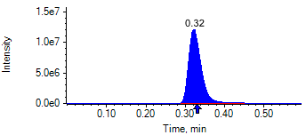

PCP 2 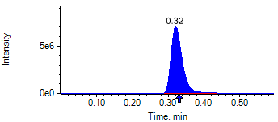

PCP D5 1 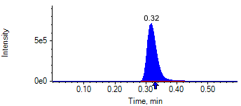

PCP D5 1 

Benzoylecgonine 1 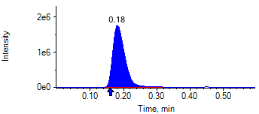

Benzoylecgonine 2 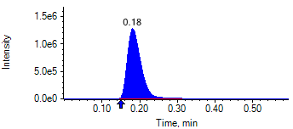

Benzoylecgonine D3 1 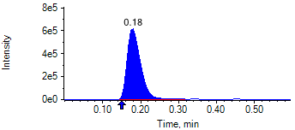

Benzoylecgonine D3 1 

|  |  |  |  |
| --- | --- | --- | --- |
| **Acquisition Method** | PCP_BE_041422Final.dam | **Data File** | SAMPLE018.wiff |
| **Sample Name** | **CPC MID QC** | **Injection Volume** | 10.00 |
| **Sample Type** | Quality Control | **Injection Vial** | 12 |
| **Injection Date** | 4/30/2025 7:42:05 PM | **Dilution Factor** | 1.00 |
| **Instrument Name** | Triple Quad 5500+ | **Instrument Serial** | EX231582110 |

**Results Summary**

| **Peak Name** | **Integration Type** | **Transition** | **Retention Time** | **Rel RT** | **Peak Area** | **Area Ratio** | **Calculated Concentration (ng/mL)** | **Expected Ion Ratio** | **Calculated  Ion Ratio** | **Ratio Confirms ID** |
| --- | --- | --- | --- | --- | --- | --- | --- | --- | --- | --- |

|  |  |  |  |  |  |  |  |  |  |  |
| --- | --- | --- | --- | --- | --- | --- | --- | --- | --- | --- |
| PCP 1 | Baseline | 243.8 / 159.0 | 0.30 | 1.02 | 1.492e7 | 8.966 | 1933.97 |  |  |  |

|  |  |  |  |  |  |  |  |  |  |  |
| --- | --- | --- | --- | --- | --- | --- | --- | --- | --- | --- |
| PCP 2 | Baseline | 243.8 / 91.0 | 0.30 | 1.01 | 8.557e6 | 5.142 |  | 59.4% | 57.4% | ✓ |

|  |  |  |  |  |  |  |  |  |  |  |
| --- | --- | --- | --- | --- | --- | --- | --- | --- | --- | --- |
| Benzoylecgonine 1 | Baseline | 289.8 / 168.1 | 0.17 | 1.02 | 2.379e6 | 1.428 | 7531.94 |  |  |  |

|  |  |  |  |  |  |  |  |  |  |  |
| --- | --- | --- | --- | --- | --- | --- | --- | --- | --- | --- |
| Benzoylecgonine 2 | Baseline | 289.8 / 104.9 | 0.17 | 1.01 | 1.755e6 | 1.054 |  | 71.7% | 73.8% | ✓ |

**Internal Standard Data**

|  |  |  |  |  |  |  |  |  |  |
| --- | --- | --- | --- | --- | --- | --- | --- | --- | --- |
| **Internal Standard Name** | **Integration Type** | **Transition** | **Retention Time** | **Avg IS Retention Time** | **IS Peak Area** | **IS Area Within Range** | **Expected Ion Ratio** | **Calculated  Ion Ratio** | **Ratio Confirms ID** |

|  |  |  |  |  |  |  |  |  |  |
| --- | --- | --- | --- | --- | --- | --- | --- | --- | --- |
| PCP D5 1 | Baseline | 248.8 / 164.1 | 0.30* | 0.32 | 1.664e6 | ✓ |  |  |  |

|  |  |  |  |  |  |  |  |  |  |
| --- | --- | --- | --- | --- | --- | --- | --- | --- | --- |
| PCP D5 1 | Baseline | 248.8 / 164.1 | 0.30* | 0.32 | 1.664e6 |  | 100.0% | 100.0% | ✓ |

|  |  |  |  |  |  |  |  |  |  |
| --- | --- | --- | --- | --- | --- | --- | --- | --- | --- |
| Benzoylecgonine D3 1 | Valley | 292.8 / 171.2 | 0.17* | 0.18 | 1.666e6 | ✓ |  |  |  |

|  |  |  |  |  |  |  |  |  |  |
| --- | --- | --- | --- | --- | --- | --- | --- | --- | --- |
| Benzoylecgonine D3 1 | Valley | 292.8 / 171.2 | 0.17* | 0.18 | 1.666e6 |  | 100.0% | 100.0% | ✓ |

**Peak Review**

PCP 1 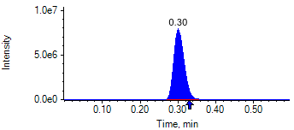

PCP 2 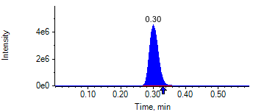

PCP D5 1 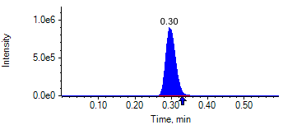

PCP D5 1 

Benzoylecgonine 1 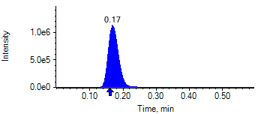

Benzoylecgonine 2 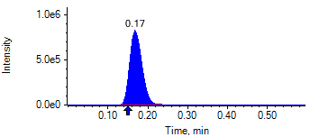

Benzoylecgonine D3 1 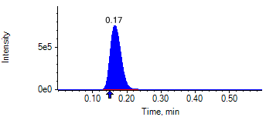

Benzoylecgonine D3 1 

|  |  |  |  |
| --- | --- | --- | --- |
| **Acquisition Method** | PCP_BE_041422Final.dam | **Data File** | SAMPLE019.wiff |
| **Sample Name** | **DL916212S05** | **Injection Volume** | 10.00 |
| **Sample Type** | Unknown | **Injection Vial** | 14 |
| **Injection Date** | 4/30/2025 7:43:14 PM | **Dilution Factor** | 1.00 |
| **Instrument Name** | Triple Quad 5500+ | **Instrument Serial** | EX231582110 |

**Results Summary**

*DL916212S05*

| **Peak Name** | **Integration Type** | **Transition** | **Retention Time** | **Rel RT** | **Peak Area** | **Area Ratio** | **Calculated Concentration (ng/mL)** | **Expected Ion Ratio** | **Calculated  Ion Ratio** | **Ratio Confirms ID** |
| --- | --- | --- | --- | --- | --- | --- | --- | --- | --- | --- |

|  |  |  |  |  |  |  |  |  |  |  |
| --- | --- | --- | --- | --- | --- | --- | --- | --- | --- | --- |
| PCP 1 | N/A | 243.8 / 159.0 | N/A | N/A* | N/A | N/A | N/A |  |  |  |

|  |  |  |  |  |  |  |  |  |  |  |
| --- | --- | --- | --- | --- | --- | --- | --- | --- | --- | --- |
| PCP 2 | N/A | 243.8 / 91.0 | N/A | N/A* | N/A | N/A |  | 59.4% | 0.0% | NO |

|  |  |  |  |  |  |  |  |  |  |  |
| --- | --- | --- | --- | --- | --- | --- | --- | --- | --- | --- |
| Benzoylecgonine 1 | N/A | 289.8 / 168.1 | N/A | N/A* | N/A | N/A | N/A |  |  |  |

|  |  |  |  |  |  |  |  |  |  |  |
| --- | --- | --- | --- | --- | --- | --- | --- | --- | --- | --- |
| Benzoylecgonine 2 | N/A | 289.8 / 104.9 | N/A | N/A* | N/A | N/A |  | 71.7% | 0.0% | NO |

**Internal Standard Data**

|  |  |  |  |  |  |  |  |  |  |
| --- | --- | --- | --- | --- | --- | --- | --- | --- | --- |
| **Internal Standard Name** | **Integration Type** | **Transition** | **Retention Time** | **Avg IS Retention Time** | **IS Peak Area** | **IS Area Within Range** | **Expected Ion Ratio** | **Calculated  Ion Ratio** | **Ratio Confirms ID** |

|  |  |  |  |  |  |  |  |  |  |
| --- | --- | --- | --- | --- | --- | --- | --- | --- | --- |
| PCP D5 1 | Baseline | 248.8 / 164.1 | 0.29* | 0.32 | 1.152e6 | ✓ |  |  |  |

|  |  |  |  |  |  |  |  |  |  |
| --- | --- | --- | --- | --- | --- | --- | --- | --- | --- |
| PCP D5 1 | Baseline | 248.8 / 164.1 | 0.29* | 0.32 | 1.152e6 |  | 100.0% | 100.0% | ✓ |

|  |  |  |  |  |  |  |  |  |  |
| --- | --- | --- | --- | --- | --- | --- | --- | --- | --- |
| Benzoylecgonine D3 1 | Baseline | 292.8 / 171.2 | 0.16* | 0.18 | 1.362e6 | ✓ |  |  |  |

|  |  |  |  |  |  |  |  |  |  |
| --- | --- | --- | --- | --- | --- | --- | --- | --- | --- |
| Benzoylecgonine D3 1 | Baseline | 292.8 / 171.2 | 0.16* | 0.18 | 1.362e6 |  | 100.0% | 100.0% | ✓ |

**Peak Review**

PCP 1 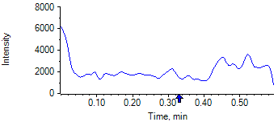

PCP 2 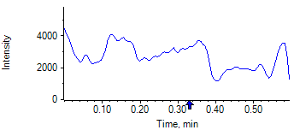

PCP D5 1 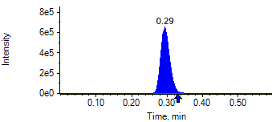

PCP D5 1 

Benzoylecgonine 1 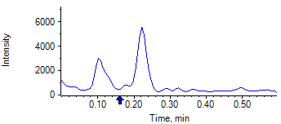

Benzoylecgonine 2 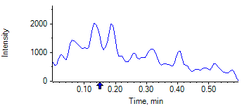

Benzoylecgonine D3 1 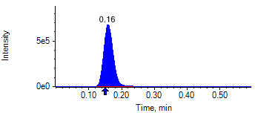

Benzoylecgonine D3 1 

|  |  |  |  |
| --- | --- | --- | --- |
| **Acquisition Method** | PCP_BE_041422Final.dam | **Data File** | SAMPLE020.wiff |
| **Sample Name** | **DL915148S05** | **Injection Volume** | 10.00 |
| **Sample Type** | Unknown | **Injection Vial** | 15 |
| **Injection Date** | 4/30/2025 7:44:29 PM | **Dilution Factor** | 1.00 |
| **Instrument Name** | Triple Quad 5500+ | **Instrument Serial** | EX231582110 |

**Results Summary**

*DL915148S05*

| **Peak Name** | **Integration Type** | **Transition** | **Retention Time** | **Rel RT** | **Peak Area** | **Area Ratio** | **Calculated Concentration (ng/mL)** | **Expected Ion Ratio** | **Calculated  Ion Ratio** | **Ratio Confirms ID** |
| --- | --- | --- | --- | --- | --- | --- | --- | --- | --- | --- |

|  |  |  |  |  |  |  |  |  |  |  |
| --- | --- | --- | --- | --- | --- | --- | --- | --- | --- | --- |
| PCP 1 | N/A | 243.8 / 159.0 | N/A | N/A* | N/A | N/A | N/A |  |  |  |

|  |  |  |  |  |  |  |  |  |  |  |
| --- | --- | --- | --- | --- | --- | --- | --- | --- | --- | --- |
| PCP 2 | N/A | 243.8 / 91.0 | N/A | N/A* | N/A | N/A |  | 59.4% | 0.0% | NO |

|  |  |  |  |  |  |  |  |  |  |  |
| --- | --- | --- | --- | --- | --- | --- | --- | --- | --- | --- |
| Benzoylecgonine 1 | N/A | 289.8 / 168.1 | N/A | N/A* | N/A | N/A | N/A |  |  |  |

|  |  |  |  |  |  |  |  |  |  |  |
| --- | --- | --- | --- | --- | --- | --- | --- | --- | --- | --- |
| Benzoylecgonine 2 | N/A | 289.8 / 104.9 | N/A | N/A* | N/A | N/A |  | 71.7% | 0.0% | NO |

**Internal Standard Data**

|  |  |  |  |  |  |  |  |  |  |
| --- | --- | --- | --- | --- | --- | --- | --- | --- | --- |
| **Internal Standard Name** | **Integration Type** | **Transition** | **Retention Time** | **Avg IS Retention Time** | **IS Peak Area** | **IS Area Within Range** | **Expected Ion Ratio** | **Calculated  Ion Ratio** | **Ratio Confirms ID** |

|  |  |  |  |  |  |  |  |  |  |
| --- | --- | --- | --- | --- | --- | --- | --- | --- | --- |
| PCP D5 1 | Baseline | 248.8 / 164.1 | 0.35* | 0.32 | 1.737e6 | ✓ |  |  |  |

|  |  |  |  |  |  |  |  |  |  |
| --- | --- | --- | --- | --- | --- | --- | --- | --- | --- |
| PCP D5 1 | Baseline | 248.8 / 164.1 | 0.35* | 0.32 | 1.737e6 |  | 100.0% | 100.0% | ✓ |

|  |  |  |  |  |  |  |  |  |  |
| --- | --- | --- | --- | --- | --- | --- | --- | --- | --- |
| Benzoylecgonine D3 1 | Baseline | 292.8 / 171.2 | 0.21* | 0.18 | 1.602e6 | ✓ |  |  |  |

|  |  |  |  |  |  |  |  |  |  |
| --- | --- | --- | --- | --- | --- | --- | --- | --- | --- |
| Benzoylecgonine D3 1 | Baseline | 292.8 / 171.2 | 0.21* | 0.18 | 1.602e6 |  | 100.0% | 100.0% | ✓ |

**Peak Review**

PCP 1 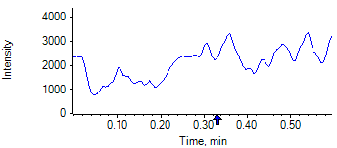

PCP 2 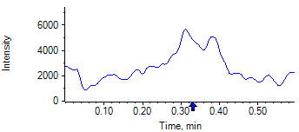

PCP D5 1 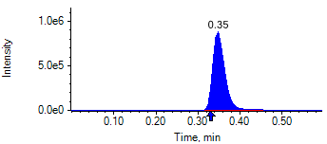

PCP D5 1 

Benzoylecgonine 1 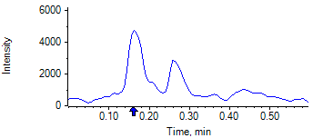

Benzoylecgonine 2 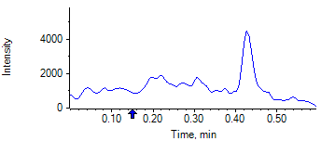

Benzoylecgonine D3 1 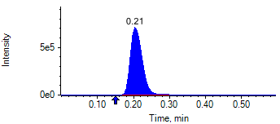

Benzoylecgonine D3 1 

|  |  |  |  |
| --- | --- | --- | --- |
| **Acquisition Method** | PCP_BE_041422Final.dam | **Data File** | SAMPLE021.wiff |
| **Sample Name** | **DL915222S05** | **Injection Volume** | 10.00 |
| **Sample Type** | Unknown | **Injection Vial** | 16 |
| **Injection Date** | 4/30/2025 7:45:37 PM | **Dilution Factor** | 1.00 |
| **Instrument Name** | Triple Quad 5500+ | **Instrument Serial** | EX231582110 |

**Results Summary**

*DL915222S05*

| **Peak Name** | **Integration Type** | **Transition** | **Retention Time** | **Rel RT** | **Peak Area** | **Area Ratio** | **Calculated Concentration (ng/mL)** | **Expected Ion Ratio** | **Calculated  Ion Ratio** | **Ratio Confirms ID** |
| --- | --- | --- | --- | --- | --- | --- | --- | --- | --- | --- |

|  |  |  |  |  |  |  |  |  |  |  |
| --- | --- | --- | --- | --- | --- | --- | --- | --- | --- | --- |
| PCP 1 | N/A | 243.8 / 159.0 | N/A | N/A* | N/A | N/A | N/A |  |  |  |

|  |  |  |  |  |  |  |  |  |  |  |
| --- | --- | --- | --- | --- | --- | --- | --- | --- | --- | --- |
| PCP 2 | N/A | 243.8 / 91.0 | N/A | N/A* | N/A | N/A |  | 59.4% | 0.0% | NO |

|  |  |  |  |  |  |  |  |  |  |  |
| --- | --- | --- | --- | --- | --- | --- | --- | --- | --- | --- |
| Benzoylecgonine 1 | N/A | 289.8 / 168.1 | N/A | N/A* | N/A | N/A | N/A |  |  |  |

|  |  |  |  |  |  |  |  |  |  |  |
| --- | --- | --- | --- | --- | --- | --- | --- | --- | --- | --- |
| Benzoylecgonine 2 | N/A | 289.8 / 104.9 | N/A | N/A* | N/A | N/A |  | 71.7% | 0.0% | NO |

**Internal Standard Data**

|  |  |  |  |  |  |  |  |  |  |
| --- | --- | --- | --- | --- | --- | --- | --- | --- | --- |
| **Internal Standard Name** | **Integration Type** | **Transition** | **Retention Time** | **Avg IS Retention Time** | **IS Peak Area** | **IS Area Within Range** | **Expected Ion Ratio** | **Calculated  Ion Ratio** | **Ratio Confirms ID** |

|  |  |  |  |  |  |  |  |  |  |
| --- | --- | --- | --- | --- | --- | --- | --- | --- | --- |
| PCP D5 1 | Baseline | 248.8 / 164.1 | 0.32 | 0.32 | 1.449e6 | ✓ |  |  |  |

|  |  |  |  |  |  |  |  |  |  |
| --- | --- | --- | --- | --- | --- | --- | --- | --- | --- |
| PCP D5 1 | Baseline | 248.8 / 164.1 | 0.32 | 0.32 | 1.449e6 |  | 100.0% | 100.0% | ✓ |

|  |  |  |  |  |  |  |  |  |  |
| --- | --- | --- | --- | --- | --- | --- | --- | --- | --- |
| Benzoylecgonine D3 1 | Baseline | 292.8 / 171.2 | 0.18 | 0.18 | 1.492e6 | ✓ |  |  |  |

|  |  |  |  |  |  |  |  |  |  |
| --- | --- | --- | --- | --- | --- | --- | --- | --- | --- |
| Benzoylecgonine D3 1 | Baseline | 292.8 / 171.2 | 0.18 | 0.18 | 1.492e6 |  | 100.0% | 100.0% | ✓ |

**Peak Review**

PCP 1 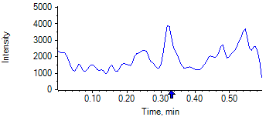

PCP 2 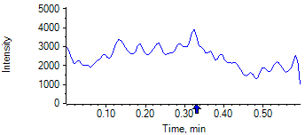

PCP D5 1 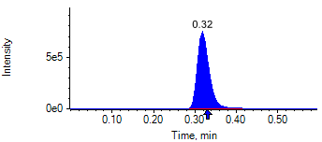

PCP D5 1 

Benzoylecgonine 1 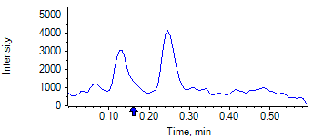

Benzoylecgonine 2 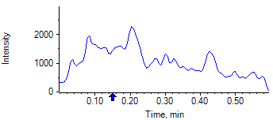

Benzoylecgonine D3 1 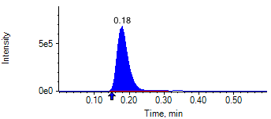

Benzoylecgonine D3 1 

|  |  |  |  |
| --- | --- | --- | --- |
| **Acquisition Method** | PCP_BE_041422Final.dam | **Data File** | SAMPLE022.wiff |
| **Sample Name** | **DL916332S05** | **Injection Volume** | 10.00 |
| **Sample Type** | Unknown | **Injection Vial** | 17 |
| **Injection Date** | 4/30/2025 7:46:47 PM | **Dilution Factor** | 1.00 |
| **Instrument Name** | Triple Quad 5500+ | **Instrument Serial** | EX231582110 |

**Results Summary**

*DL916332S05*

| **Peak Name** | **Integration Type** | **Transition** | **Retention Time** | **Rel RT** | **Peak Area** | **Area Ratio** | **Calculated Concentration (ng/mL)** | **Expected Ion Ratio** | **Calculated  Ion Ratio** | **Ratio Confirms ID** |
| --- | --- | --- | --- | --- | --- | --- | --- | --- | --- | --- |

|  |  |  |  |  |  |  |  |  |  |  |
| --- | --- | --- | --- | --- | --- | --- | --- | --- | --- | --- |
| PCP 1 | N/A | 243.8 / 159.0 | N/A | N/A* | N/A | N/A | N/A |  |  |  |

|  |  |  |  |  |  |  |  |  |  |  |
| --- | --- | --- | --- | --- | --- | --- | --- | --- | --- | --- |
| PCP 2 | N/A | 243.8 / 91.0 | N/A | N/A* | N/A | N/A |  | 59.4% | 0.0% | NO |

|  |  |  |  |  |  |  |  |  |  |  |
| --- | --- | --- | --- | --- | --- | --- | --- | --- | --- | --- |
| Benzoylecgonine 1 | N/A | 289.8 / 168.1 | N/A | N/A* | N/A | N/A | N/A |  |  |  |

|  |  |  |  |  |  |  |  |  |  |  |
| --- | --- | --- | --- | --- | --- | --- | --- | --- | --- | --- |
| Benzoylecgonine 2 | N/A | 289.8 / 104.9 | N/A | N/A* | N/A | N/A |  | 71.7% | 0.0% | NO |

**Internal Standard Data**

|  |  |  |  |  |  |  |  |  |  |
| --- | --- | --- | --- | --- | --- | --- | --- | --- | --- |
| **Internal Standard Name** | **Integration Type** | **Transition** | **Retention Time** | **Avg IS Retention Time** | **IS Peak Area** | **IS Area Within Range** | **Expected Ion Ratio** | **Calculated  Ion Ratio** | **Ratio Confirms ID** |

|  |  |  |  |  |  |  |  |  |  |
| --- | --- | --- | --- | --- | --- | --- | --- | --- | --- |
| PCP D5 1 | Baseline | 248.8 / 164.1 | 0.30* | 0.32 | 1.731e6 | ✓ |  |  |  |

|  |  |  |  |  |  |  |  |  |  |
| --- | --- | --- | --- | --- | --- | --- | --- | --- | --- |
| PCP D5 1 | Baseline | 248.8 / 164.1 | 0.30* | 0.32 | 1.731e6 |  | 100.0% | 100.0% | ✓ |

|  |  |  |  |  |  |  |  |  |  |
| --- | --- | --- | --- | --- | --- | --- | --- | --- | --- |
| Benzoylecgonine D3 1 | Baseline | 292.8 / 171.2 | 0.16* | 0.18 | 1.918e6 | ✓ |  |  |  |

|  |  |  |  |  |  |  |  |  |  |
| --- | --- | --- | --- | --- | --- | --- | --- | --- | --- |
| Benzoylecgonine D3 1 | Baseline | 292.8 / 171.2 | 0.16* | 0.18 | 1.918e6 |  | 100.0% | 100.0% | ✓ |

**Peak Review**

PCP 1 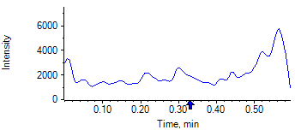

PCP 2 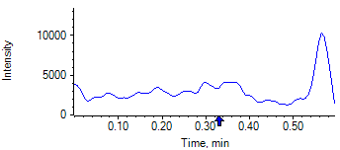

PCP D5 1 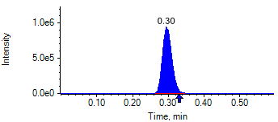

PCP D5 1 

Benzoylecgonine 1 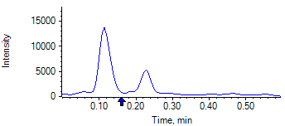

Benzoylecgonine 2 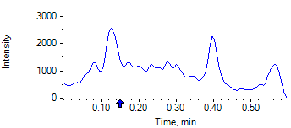

Benzoylecgonine D3 1 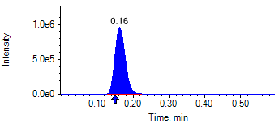

Benzoylecgonine D3 1 

|  |  |  |  |
| --- | --- | --- | --- |
| **Acquisition Method** | PCP_BE_041422Final.dam | **Data File** | SAMPLE023.wiff |
| **Sample Name** | **DL915334S05** | **Injection Volume** | 10.00 |
| **Sample Type** | Unknown | **Injection Vial** | 18 |
| **Injection Date** | 4/30/2025 7:47:58 PM | **Dilution Factor** | 1.00 |
| **Instrument Name** | Triple Quad 5500+ | **Instrument Serial** | EX231582110 |

**Results Summary**

*DL915334S05*

| **Peak Name** | **Integration Type** | **Transition** | **Retention Time** | **Rel RT** | **Peak Area** | **Area Ratio** | **Calculated Concentration (ng/mL)** | **Expected Ion Ratio** | **Calculated  Ion Ratio** | **Ratio Confirms ID** |
| --- | --- | --- | --- | --- | --- | --- | --- | --- | --- | --- |

|  |  |  |  |  |  |  |  |  |  |  |
| --- | --- | --- | --- | --- | --- | --- | --- | --- | --- | --- |
| PCP 1 | N/A | 243.8 / 159.0 | N/A | N/A* | N/A | N/A | N/A |  |  |  |

|  |  |  |  |  |  |  |  |  |  |  |
| --- | --- | --- | --- | --- | --- | --- | --- | --- | --- | --- |
| PCP 2 | N/A | 243.8 / 91.0 | N/A | N/A* | N/A | N/A |  | 59.4% | 0.0% | NO |

|  |  |  |  |  |  |  |  |  |  |  |
| --- | --- | --- | --- | --- | --- | --- | --- | --- | --- | --- |
| Benzoylecgonine 1 | N/A | 289.8 / 168.1 | N/A | N/A* | N/A | N/A | N/A |  |  |  |

|  |  |  |  |  |  |  |  |  |  |  |
| --- | --- | --- | --- | --- | --- | --- | --- | --- | --- | --- |
| Benzoylecgonine 2 | N/A | 289.8 / 104.9 | N/A | N/A* | N/A | N/A |  | 71.7% | 0.0% | NO |

**Internal Standard Data**

|  |  |  |  |  |  |  |  |  |  |
| --- | --- | --- | --- | --- | --- | --- | --- | --- | --- |
| **Internal Standard Name** | **Integration Type** | **Transition** | **Retention Time** | **Avg IS Retention Time** | **IS Peak Area** | **IS Area Within Range** | **Expected Ion Ratio** | **Calculated  Ion Ratio** | **Ratio Confirms ID** |

|  |  |  |  |  |  |  |  |  |  |
| --- | --- | --- | --- | --- | --- | --- | --- | --- | --- |
| PCP D5 1 | Baseline | 248.8 / 164.1 | 0.29* | 0.32 | 1.636e6 | ✓ |  |  |  |

|  |  |  |  |  |  |  |  |  |  |
| --- | --- | --- | --- | --- | --- | --- | --- | --- | --- |
| PCP D5 1 | Baseline | 248.8 / 164.1 | 0.29* | 0.32 | 1.636e6 |  | 100.0% | 100.0% | ✓ |

|  |  |  |  |  |  |  |  |  |  |
| --- | --- | --- | --- | --- | --- | --- | --- | --- | --- |
| Benzoylecgonine D3 1 | Baseline | 292.8 / 171.2 | 0.16* | 0.18 | 1.052e6 | ✓ |  |  |  |

|  |  |  |  |  |  |  |  |  |  |
| --- | --- | --- | --- | --- | --- | --- | --- | --- | --- |
| Benzoylecgonine D3 1 | Baseline | 292.8 / 171.2 | 0.16* | 0.18 | 1.052e6 |  | 100.0% | 100.0% | ✓ |

**Peak Review**

PCP 1 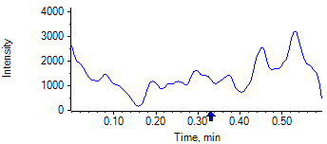

PCP 2 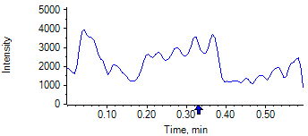

PCP D5 1 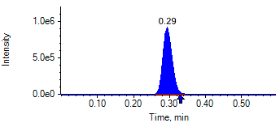

PCP D5 1 

Benzoylecgonine 1 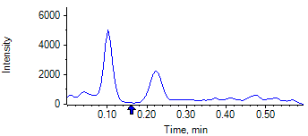

Benzoylecgonine 2 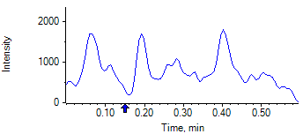

Benzoylecgonine D3 1 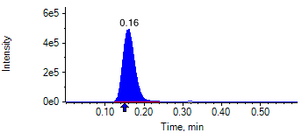

Benzoylecgonine D3 1 

|  |  |  |  |
| --- | --- | --- | --- |
| **Acquisition Method** | PCP_BE_041422Final.dam | **Data File** | SAMPLE024.wiff |
| **Sample Name** | **DL915400S05** | **Injection Volume** | 10.00 |
| **Sample Type** | Unknown | **Injection Vial** | 19 |
| **Injection Date** | 4/30/2025 7:49:10 PM | **Dilution Factor** | 1.00 |
| **Instrument Name** | Triple Quad 5500+ | **Instrument Serial** | EX231582110 |

**Results Summary**

*DL915400S05*

| **Peak Name** | **Integration Type** | **Transition** | **Retention Time** | **Rel RT** | **Peak Area** | **Area Ratio** | **Calculated Concentration (ng/mL)** | **Expected Ion Ratio** | **Calculated  Ion Ratio** | **Ratio Confirms ID** |
| --- | --- | --- | --- | --- | --- | --- | --- | --- | --- | --- |

|  |  |  |  |  |  |  |  |  |  |  |
| --- | --- | --- | --- | --- | --- | --- | --- | --- | --- | --- |
| PCP 1 | N/A | 243.8 / 159.0 | N/A | N/A* | N/A | N/A | N/A |  |  |  |

|  |  |  |  |  |  |  |  |  |  |  |
| --- | --- | --- | --- | --- | --- | --- | --- | --- | --- | --- |
| PCP 2 | N/A | 243.8 / 91.0 | N/A | N/A* | N/A | N/A |  | 59.4% | 0.0% | NO |

|  |  |  |  |  |  |  |  |  |  |  |
| --- | --- | --- | --- | --- | --- | --- | --- | --- | --- | --- |
| Benzoylecgonine 1 | N/A | 289.8 / 168.1 | N/A | N/A* | N/A | N/A | N/A |  |  |  |

|  |  |  |  |  |  |  |  |  |  |  |
| --- | --- | --- | --- | --- | --- | --- | --- | --- | --- | --- |
| Benzoylecgonine 2 | N/A | 289.8 / 104.9 | N/A | N/A* | N/A | N/A |  | 71.7% | 0.0% | NO |

**Internal Standard Data**

|  |  |  |  |  |  |  |  |  |  |
| --- | --- | --- | --- | --- | --- | --- | --- | --- | --- |
| **Internal Standard Name** | **Integration Type** | **Transition** | **Retention Time** | **Avg IS Retention Time** | **IS Peak Area** | **IS Area Within Range** | **Expected Ion Ratio** | **Calculated  Ion Ratio** | **Ratio Confirms ID** |

|  |  |  |  |  |  |  |  |  |  |
| --- | --- | --- | --- | --- | --- | --- | --- | --- | --- |
| PCP D5 1 | Baseline | 248.8 / 164.1 | 0.35* | 0.32 | 2.011e6 | ✓ |  |  |  |

|  |  |  |  |  |  |  |  |  |  |
| --- | --- | --- | --- | --- | --- | --- | --- | --- | --- |
| PCP D5 1 | Baseline | 248.8 / 164.1 | 0.35* | 0.32 | 2.011e6 |  | 100.0% | 100.0% | ✓ |

|  |  |  |  |  |  |  |  |  |  |
| --- | --- | --- | --- | --- | --- | --- | --- | --- | --- |
| Benzoylecgonine D3 1 | Baseline | 292.8 / 171.2 | 0.21* | 0.18 | 2.107e6 | ✓ |  |  |  |

|  |  |  |  |  |  |  |  |  |  |
| --- | --- | --- | --- | --- | --- | --- | --- | --- | --- |
| Benzoylecgonine D3 1 | Baseline | 292.8 / 171.2 | 0.21* | 0.18 | 2.107e6 |  | 100.0% | 100.0% | ✓ |

**Peak Review**

PCP 1 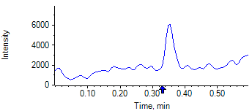

PCP 2 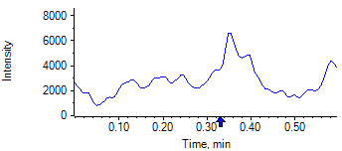

PCP D5 1 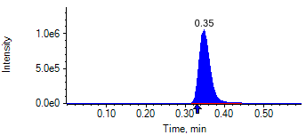

PCP D5 1 

Benzoylecgonine 1 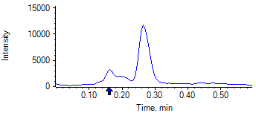

Benzoylecgonine 2 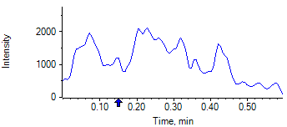

Benzoylecgonine D3 1 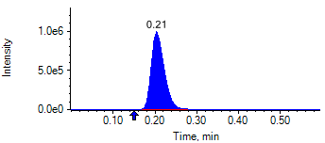

Benzoylecgonine D3 1 

|  |  |  |  |
| --- | --- | --- | --- |
| **Acquisition Method** | PCP_BE_041422Final.dam | **Data File** | SAMPLE025.wiff |
| **Sample Name** | **DL915531S05** | **Injection Volume** | 10.00 |
| **Sample Type** | Unknown | **Injection Vial** | 20 |
| **Injection Date** | 4/30/2025 7:50:23 PM | **Dilution Factor** | 1.00 |
| **Instrument Name** | Triple Quad 5500+ | **Instrument Serial** | EX231582110 |

**Results Summary**

*DL915531S05*

| **Peak Name** | **Integration Type** | **Transition** | **Retention Time** | **Rel RT** | **Peak Area** | **Area Ratio** | **Calculated Concentration (ng/mL)** | **Expected Ion Ratio** | **Calculated  Ion Ratio** | **Ratio Confirms ID** |
| --- | --- | --- | --- | --- | --- | --- | --- | --- | --- | --- |

|  |  |  |  |  |  |  |  |  |  |  |
| --- | --- | --- | --- | --- | --- | --- | --- | --- | --- | --- |
| PCP 1 | N/A | 243.8 / 159.0 | N/A | N/A* | N/A | N/A | N/A |  |  |  |

|  |  |  |  |  |  |  |  |  |  |  |
| --- | --- | --- | --- | --- | --- | --- | --- | --- | --- | --- |
| PCP 2 | N/A | 243.8 / 91.0 | N/A | N/A* | N/A | N/A |  | 59.4% | 0.0% | NO |

|  |  |  |  |  |  |  |  |  |  |  |
| --- | --- | --- | --- | --- | --- | --- | --- | --- | --- | --- |
| Benzoylecgonine 1 | N/A | 289.8 / 168.1 | N/A | N/A* | N/A | N/A | N/A |  |  |  |

|  |  |  |  |  |  |  |  |  |  |  |
| --- | --- | --- | --- | --- | --- | --- | --- | --- | --- | --- |
| Benzoylecgonine 2 | N/A | 289.8 / 104.9 | N/A | N/A* | N/A | N/A |  | 71.7% | 0.0% | NO |

**Internal Standard Data**

|  |  |  |  |  |  |  |  |  |  |
| --- | --- | --- | --- | --- | --- | --- | --- | --- | --- |
| **Internal Standard Name** | **Integration Type** | **Transition** | **Retention Time** | **Avg IS Retention Time** | **IS Peak Area** | **IS Area Within Range** | **Expected Ion Ratio** | **Calculated  Ion Ratio** | **Ratio Confirms ID** |

|  |  |  |  |  |  |  |  |  |  |
| --- | --- | --- | --- | --- | --- | --- | --- | --- | --- |
| PCP D5 1 | Baseline | 248.8 / 164.1 | 0.32 | 0.32 | 1.365e6 | ✓ |  |  |  |

|  |  |  |  |  |  |  |  |  |  |
| --- | --- | --- | --- | --- | --- | --- | --- | --- | --- |
| PCP D5 1 | Baseline | 248.8 / 164.1 | 0.32 | 0.32 | 1.365e6 |  | 100.0% | 100.0% | ✓ |

|  |  |  |  |  |  |  |  |  |  |
| --- | --- | --- | --- | --- | --- | --- | --- | --- | --- |
| Benzoylecgonine D3 1 | Baseline | 292.8 / 171.2 | 0.18 | 0.18 | 1.530e6 | ✓ |  |  |  |

|  |  |  |  |  |  |  |  |  |  |
| --- | --- | --- | --- | --- | --- | --- | --- | --- | --- |
| Benzoylecgonine D3 1 | Baseline | 292.8 / 171.2 | 0.18 | 0.18 | 1.530e6 |  | 100.0% | 100.0% | ✓ |

**Peak Review**

PCP 1 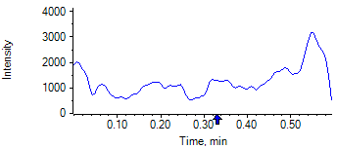

PCP 2 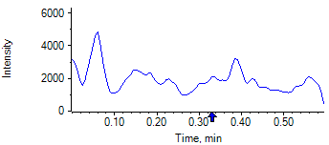

PCP D5 1 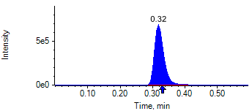

PCP D5 1 

Benzoylecgonine 1 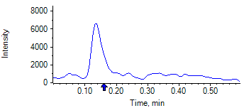

Benzoylecgonine 2 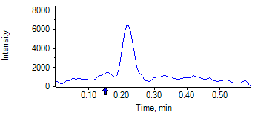

Benzoylecgonine D3 1 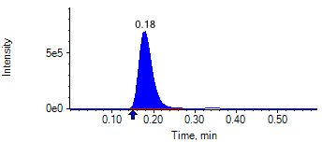

Benzoylecgonine D3 1 

|  |  |  |  |
| --- | --- | --- | --- |
| **Acquisition Method** | PCP_BE_041422Final.dam | **Data File** | SAMPLE026.wiff |
| **Sample Name** | **DL916142S05** | **Injection Volume** | 10.00 |
| **Sample Type** | Unknown | **Injection Vial** | 21 |
| **Injection Date** | 4/30/2025 7:51:33 PM | **Dilution Factor** | 1.00 |
| **Instrument Name** | Triple Quad 5500+ | **Instrument Serial** | EX231582110 |

**Results Summary**

*DL916142S05*

| **Peak Name** | **Integration Type** | **Transition** | **Retention Time** | **Rel RT** | **Peak Area** | **Area Ratio** | **Calculated Concentration (ng/mL)** | **Expected Ion Ratio** | **Calculated  Ion Ratio** | **Ratio Confirms ID** |
| --- | --- | --- | --- | --- | --- | --- | --- | --- | --- | --- |

|  |  |  |  |  |  |  |  |  |  |  |
| --- | --- | --- | --- | --- | --- | --- | --- | --- | --- | --- |
| PCP 1 | N/A | 243.8 / 159.0 | N/A | N/A* | N/A | N/A | N/A |  |  |  |

|  |  |  |  |  |  |  |  |  |  |  |
| --- | --- | --- | --- | --- | --- | --- | --- | --- | --- | --- |
| PCP 2 | N/A | 243.8 / 91.0 | N/A | N/A* | N/A | N/A |  | 59.4% | 0.0% | NO |

|  |  |  |  |  |  |  |  |  |  |  |
| --- | --- | --- | --- | --- | --- | --- | --- | --- | --- | --- |
| Benzoylecgonine 1 | N/A | 289.8 / 168.1 | N/A | N/A* | N/A | N/A | N/A |  |  |  |

|  |  |  |  |  |  |  |  |  |  |  |
| --- | --- | --- | --- | --- | --- | --- | --- | --- | --- | --- |
| Benzoylecgonine 2 | N/A | 289.8 / 104.9 | N/A | N/A* | N/A | N/A |  | 71.7% | 0.0% | NO |

**Internal Standard Data**

|  |  |  |  |  |  |  |  |  |  |
| --- | --- | --- | --- | --- | --- | --- | --- | --- | --- |
| **Internal Standard Name** | **Integration Type** | **Transition** | **Retention Time** | **Avg IS Retention Time** | **IS Peak Area** | **IS Area Within Range** | **Expected Ion Ratio** | **Calculated  Ion Ratio** | **Ratio Confirms ID** |

|  |  |  |  |  |  |  |  |  |  |
| --- | --- | --- | --- | --- | --- | --- | --- | --- | --- |
| PCP D5 1 | Baseline | 248.8 / 164.1 | 0.30* | 0.32 | 1.993e6 | ✓ |  |  |  |

|  |  |  |  |  |  |  |  |  |  |
| --- | --- | --- | --- | --- | --- | --- | --- | --- | --- |
| PCP D5 1 | Baseline | 248.8 / 164.1 | 0.30* | 0.32 | 1.993e6 |  | 100.0% | 100.0% | ✓ |

|  |  |  |  |  |  |  |  |  |  |
| --- | --- | --- | --- | --- | --- | --- | --- | --- | --- |
| Benzoylecgonine D3 1 | Baseline | 292.8 / 171.2 | 0.16* | 0.18 | 2.272e6 | ✓ |  |  |  |

|  |  |  |  |  |  |  |  |  |  |
| --- | --- | --- | --- | --- | --- | --- | --- | --- | --- |
| Benzoylecgonine D3 1 | Baseline | 292.8 / 171.2 | 0.16* | 0.18 | 2.272e6 |  | 100.0% | 100.0% | ✓ |

**Peak Review**

PCP 1 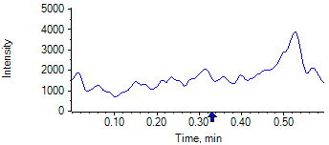

PCP 2 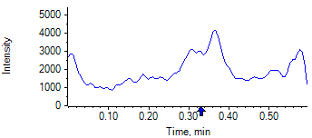

PCP D5 1 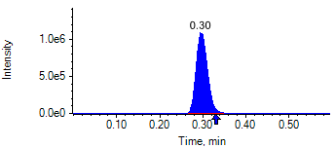

PCP D5 1 

Benzoylecgonine 1 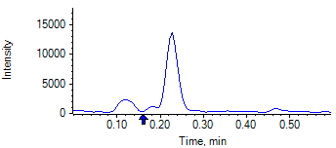

Benzoylecgonine 2 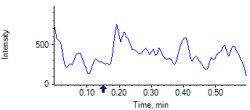

Benzoylecgonine D3 1 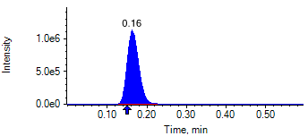

Benzoylecgonine D3 1 

|  |  |  |  |
| --- | --- | --- | --- |
| **Acquisition Method** | PCP_BE_041422Final.dam | **Data File** | SAMPLE027.wiff |
| **Sample Name** | **DL915069S05** | **Injection Volume** | 10.00 |
| **Sample Type** | Unknown | **Injection Vial** | 22 |
| **Injection Date** | 4/30/2025 7:52:44 PM | **Dilution Factor** | 1.00 |
| **Instrument Name** | Triple Quad 5500+ | **Instrument Serial** | EX231582110 |

**Results Summary**

*DL915069S05*

| **Peak Name** | **Integration Type** | **Transition** | **Retention Time** | **Rel RT** | **Peak Area** | **Area Ratio** | **Calculated Concentration (ng/mL)** | **Expected Ion Ratio** | **Calculated  Ion Ratio** | **Ratio Confirms ID** |
| --- | --- | --- | --- | --- | --- | --- | --- | --- | --- | --- |

|  |  |  |  |  |  |  |  |  |  |  |
| --- | --- | --- | --- | --- | --- | --- | --- | --- | --- | --- |
| PCP 1 | N/A | 243.8 / 159.0 | N/A | N/A* | N/A | N/A | N/A |  |  |  |

|  |  |  |  |  |  |  |  |  |  |  |
| --- | --- | --- | --- | --- | --- | --- | --- | --- | --- | --- |
| PCP 2 | N/A | 243.8 / 91.0 | N/A | N/A* | N/A | N/A |  | 59.4% | 0.0% | NO |

|  |  |  |  |  |  |  |  |  |  |  |
| --- | --- | --- | --- | --- | --- | --- | --- | --- | --- | --- |
| Benzoylecgonine 1 | N/A | 289.8 / 168.1 | N/A | N/A* | N/A | N/A | N/A |  |  |  |

|  |  |  |  |  |  |  |  |  |  |  |
| --- | --- | --- | --- | --- | --- | --- | --- | --- | --- | --- |
| Benzoylecgonine 2 | N/A | 289.8 / 104.9 | N/A | N/A* | N/A | N/A |  | 71.7% | 0.0% | NO |

**Internal Standard Data**

|  |  |  |  |  |  |  |  |  |  |
| --- | --- | --- | --- | --- | --- | --- | --- | --- | --- |
| **Internal Standard Name** | **Integration Type** | **Transition** | **Retention Time** | **Avg IS Retention Time** | **IS Peak Area** | **IS Area Within Range** | **Expected Ion Ratio** | **Calculated  Ion Ratio** | **Ratio Confirms ID** |

|  |  |  |  |  |  |  |  |  |  |
| --- | --- | --- | --- | --- | --- | --- | --- | --- | --- |
| PCP D5 1 | Baseline | 248.8 / 164.1 | 0.29* | 0.32 | 1.941e6 | ✓ |  |  |  |

|  |  |  |  |  |  |  |  |  |  |
| --- | --- | --- | --- | --- | --- | --- | --- | --- | --- |
| PCP D5 1 | Baseline | 248.8 / 164.1 | 0.29* | 0.32 | 1.941e6 |  | 100.0% | 100.0% | ✓ |

|  |  |  |  |  |  |  |  |  |  |
| --- | --- | --- | --- | --- | --- | --- | --- | --- | --- |
| Benzoylecgonine D3 1 | Baseline | 292.8 / 171.2 | 0.16* | 0.18 | 2.272e6 | ✓ |  |  |  |

|  |  |  |  |  |  |  |  |  |  |
| --- | --- | --- | --- | --- | --- | --- | --- | --- | --- |
| Benzoylecgonine D3 1 | Baseline | 292.8 / 171.2 | 0.16* | 0.18 | 2.272e6 |  | 100.0% | 100.0% | ✓ |

**Peak Review**

PCP 1 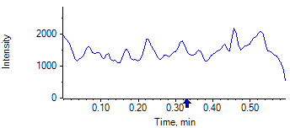

PCP 2 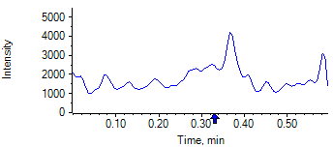

PCP D5 1 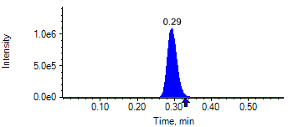

PCP D5 1 

Benzoylecgonine 1 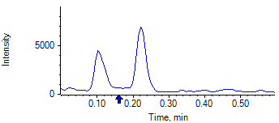

Benzoylecgonine 2 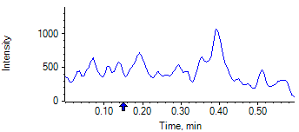

Benzoylecgonine D3 1 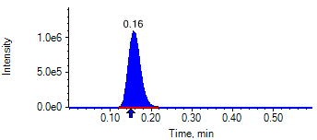

Benzoylecgonine D3 1 

|  |  |  |  |
| --- | --- | --- | --- |
| **Acquisition Method** | PCP_BE_041422Final.dam | **Data File** | SAMPLE028.wiff |
| **Sample Name** | **DL915362S05** | **Injection Volume** | 10.00 |
| **Sample Type** | Unknown | **Injection Vial** | 23 |
| **Injection Date** | 4/30/2025 7:53:56 PM | **Dilution Factor** | 1.00 |
| **Instrument Name** | Triple Quad 5500+ | **Instrument Serial** | EX231582110 |

**Results Summary**

*DL915362S05*

| **Peak Name** | **Integration Type** | **Transition** | **Retention Time** | **Rel RT** | **Peak Area** | **Area Ratio** | **Calculated Concentration (ng/mL)** | **Expected Ion Ratio** | **Calculated  Ion Ratio** | **Ratio Confirms ID** |
| --- | --- | --- | --- | --- | --- | --- | --- | --- | --- | --- |

|  |  |  |  |  |  |  |  |  |  |  |
| --- | --- | --- | --- | --- | --- | --- | --- | --- | --- | --- |
| PCP 1 | N/A | 243.8 / 159.0 | N/A | N/A* | N/A | N/A | N/A |  |  |  |

|  |  |  |  |  |  |  |  |  |  |  |
| --- | --- | --- | --- | --- | --- | --- | --- | --- | --- | --- |
| PCP 2 | N/A | 243.8 / 91.0 | N/A | N/A* | N/A | N/A |  | 59.4% | 0.0% | NO |

|  |  |  |  |  |  |  |  |  |  |  |
| --- | --- | --- | --- | --- | --- | --- | --- | --- | --- | --- |
| Benzoylecgonine 1 | N/A | 289.8 / 168.1 | N/A | N/A* | N/A | N/A | N/A |  |  |  |

|  |  |  |  |  |  |  |  |  |  |  |
| --- | --- | --- | --- | --- | --- | --- | --- | --- | --- | --- |
| Benzoylecgonine 2 | N/A | 289.8 / 104.9 | N/A | N/A* | N/A | N/A |  | 71.7% | 0.0% | NO |

**Internal Standard Data**

|  |  |  |  |  |  |  |  |  |  |
| --- | --- | --- | --- | --- | --- | --- | --- | --- | --- |
| **Internal Standard Name** | **Integration Type** | **Transition** | **Retention Time** | **Avg IS Retention Time** | **IS Peak Area** | **IS Area Within Range** | **Expected Ion Ratio** | **Calculated  Ion Ratio** | **Ratio Confirms ID** |

|  |  |  |  |  |  |  |  |  |  |
| --- | --- | --- | --- | --- | --- | --- | --- | --- | --- |
| PCP D5 1 | Baseline | 248.8 / 164.1 | 0.35* | 0.32 | 1.886e6 | ✓ |  |  |  |

|  |  |  |  |  |  |  |  |  |  |
| --- | --- | --- | --- | --- | --- | --- | --- | --- | --- |
| PCP D5 1 | Baseline | 248.8 / 164.1 | 0.35* | 0.32 | 1.886e6 |  | 100.0% | 100.0% | ✓ |

|  |  |  |  |  |  |  |  |  |  |
| --- | --- | --- | --- | --- | --- | --- | --- | --- | --- |
| Benzoylecgonine D3 1 | Baseline | 292.8 / 171.2 | 0.20* | 0.18 | 1.791e6 | ✓ |  |  |  |

|  |  |  |  |  |  |  |  |  |  |
| --- | --- | --- | --- | --- | --- | --- | --- | --- | --- |
| Benzoylecgonine D3 1 | Baseline | 292.8 / 171.2 | 0.20* | 0.18 | 1.791e6 |  | 100.0% | 100.0% | ✓ |

**Peak Review**

PCP 1 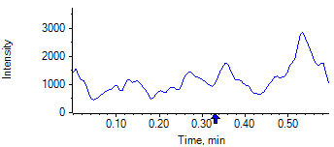

PCP 2 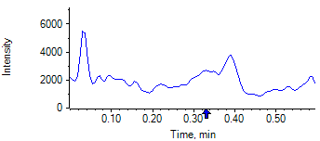

PCP D5 1 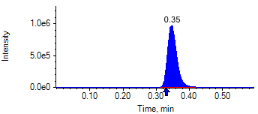

PCP D5 1 

Benzoylecgonine 1 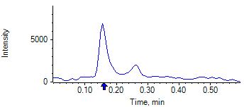

Benzoylecgonine 2 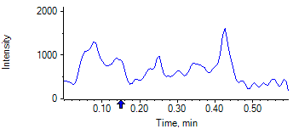

Benzoylecgonine D3 1 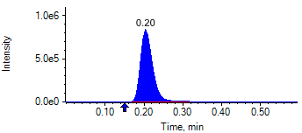

Benzoylecgonine D3 1 

|  |  |  |  |
| --- | --- | --- | --- |
| **Acquisition Method** | PCP_BE_041422Final.dam | **Data File** | SAMPLE029.wiff |
| **Sample Name** | **DL915436S05** | **Injection Volume** | 10.00 |
| **Sample Type** | Unknown | **Injection Vial** | 24 |
| **Injection Date** | 4/30/2025 7:55:08 PM | **Dilution Factor** | 1.00 |
| **Instrument Name** | Triple Quad 5500+ | **Instrument Serial** | EX231582110 |

**Results Summary**

*DL915436S05*

| **Peak Name** | **Integration Type** | **Transition** | **Retention Time** | **Rel RT** | **Peak Area** | **Area Ratio** | **Calculated Concentration (ng/mL)** | **Expected Ion Ratio** | **Calculated  Ion Ratio** | **Ratio Confirms ID** |
| --- | --- | --- | --- | --- | --- | --- | --- | --- | --- | --- |

|  |  |  |  |  |  |  |  |  |  |  |
| --- | --- | --- | --- | --- | --- | --- | --- | --- | --- | --- |
| PCP 1 | N/A | 243.8 / 159.0 | N/A | N/A* | N/A | N/A | N/A |  |  |  |

|  |  |  |  |  |  |  |  |  |  |  |
| --- | --- | --- | --- | --- | --- | --- | --- | --- | --- | --- |
| PCP 2 | N/A | 243.8 / 91.0 | N/A | N/A* | N/A | N/A |  | 59.4% | 0.0% | NO |

|  |  |  |  |  |  |  |  |  |  |  |
| --- | --- | --- | --- | --- | --- | --- | --- | --- | --- | --- |
| Benzoylecgonine 1 | N/A | 289.8 / 168.1 | N/A | N/A* | N/A | N/A | N/A |  |  |  |

|  |  |  |  |  |  |  |  |  |  |  |
| --- | --- | --- | --- | --- | --- | --- | --- | --- | --- | --- |
| Benzoylecgonine 2 | N/A | 289.8 / 104.9 | N/A | N/A* | N/A | N/A |  | 71.7% | 0.0% | NO |

**Internal Standard Data**

|  |  |  |  |  |  |  |  |  |  |
| --- | --- | --- | --- | --- | --- | --- | --- | --- | --- |
| **Internal Standard Name** | **Integration Type** | **Transition** | **Retention Time** | **Avg IS Retention Time** | **IS Peak Area** | **IS Area Within Range** | **Expected Ion Ratio** | **Calculated  Ion Ratio** | **Ratio Confirms ID** |

|  |  |  |  |  |  |  |  |  |  |
| --- | --- | --- | --- | --- | --- | --- | --- | --- | --- |
| PCP D5 1 | Baseline | 248.8 / 164.1 | 0.32 | 0.32 | 2.037e6 | ✓ |  |  |  |

|  |  |  |  |  |  |  |  |  |  |
| --- | --- | --- | --- | --- | --- | --- | --- | --- | --- |
| PCP D5 1 | Baseline | 248.8 / 164.1 | 0.32 | 0.32 | 2.037e6 |  | 100.0% | 100.0% | ✓ |

|  |  |  |  |  |  |  |  |  |  |
| --- | --- | --- | --- | --- | --- | --- | --- | --- | --- |
| Benzoylecgonine D3 1 | Baseline | 292.8 / 171.2 | 0.18 | 0.18 | 1.785e6 | ✓ |  |  |  |

|  |  |  |  |  |  |  |  |  |  |
| --- | --- | --- | --- | --- | --- | --- | --- | --- | --- |
| Benzoylecgonine D3 1 | Baseline | 292.8 / 171.2 | 0.18 | 0.18 | 1.785e6 |  | 100.0% | 100.0% | ✓ |

**Peak Review**

PCP 1 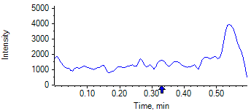

PCP 2 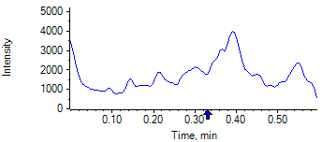

PCP D5 1 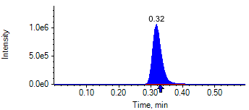

PCP D5 1 

Benzoylecgonine 1 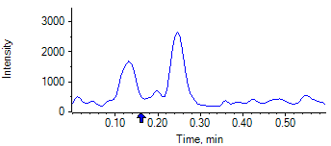

Benzoylecgonine 2 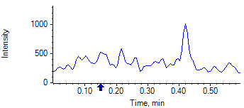

Benzoylecgonine D3 1 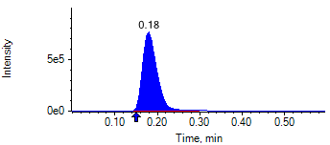

Benzoylecgonine D3 1 

|  |  |  |  |
| --- | --- | --- | --- |
| **Acquisition Method** | PCP_BE_041422Final.dam | **Data File** | SAMPLE030.wiff |
| **Sample Name** | **DL915292S05** | **Injection Volume** | 10.00 |
| **Sample Type** | Unknown | **Injection Vial** | 25 |
| **Injection Date** | 4/30/2025 7:56:17 PM | **Dilution Factor** | 1.00 |
| **Instrument Name** | Triple Quad 5500+ | **Instrument Serial** | EX231582110 |

**Results Summary**

*DL915292S05*

| **Peak Name** | **Integration Type** | **Transition** | **Retention Time** | **Rel RT** | **Peak Area** | **Area Ratio** | **Calculated Concentration (ng/mL)** | **Expected Ion Ratio** | **Calculated  Ion Ratio** | **Ratio Confirms ID** |
| --- | --- | --- | --- | --- | --- | --- | --- | --- | --- | --- |

|  |  |  |  |  |  |  |  |  |  |  |
| --- | --- | --- | --- | --- | --- | --- | --- | --- | --- | --- |
| PCP 1 | N/A | 243.8 / 159.0 | N/A | N/A* | N/A | N/A | N/A |  |  |  |

|  |  |  |  |  |  |  |  |  |  |  |
| --- | --- | --- | --- | --- | --- | --- | --- | --- | --- | --- |
| PCP 2 | N/A | 243.8 / 91.0 | N/A | N/A* | N/A | N/A |  | 59.4% | 0.0% | NO |

|  |  |  |  |  |  |  |  |  |  |  |
| --- | --- | --- | --- | --- | --- | --- | --- | --- | --- | --- |
| Benzoylecgonine 1 | N/A | 289.8 / 168.1 | N/A | N/A* | N/A | N/A | N/A |  |  |  |

|  |  |  |  |  |  |  |  |  |  |  |
| --- | --- | --- | --- | --- | --- | --- | --- | --- | --- | --- |
| Benzoylecgonine 2 | N/A | 289.8 / 104.9 | N/A | N/A* | N/A | N/A |  | 71.7% | 0.0% | NO |

**Internal Standard Data**

|  |  |  |  |  |  |  |  |  |  |
| --- | --- | --- | --- | --- | --- | --- | --- | --- | --- |
| **Internal Standard Name** | **Integration Type** | **Transition** | **Retention Time** | **Avg IS Retention Time** | **IS Peak Area** | **IS Area Within Range** | **Expected Ion Ratio** | **Calculated  Ion Ratio** | **Ratio Confirms ID** |

|  |  |  |  |  |  |  |  |  |  |
| --- | --- | --- | --- | --- | --- | --- | --- | --- | --- |
| PCP D5 1 | Baseline | 248.8 / 164.1 | 0.30* | 0.32 | 1.715e6 | ✓ |  |  |  |

|  |  |  |  |  |  |  |  |  |  |
| --- | --- | --- | --- | --- | --- | --- | --- | --- | --- |
| PCP D5 1 | Baseline | 248.8 / 164.1 | 0.30* | 0.32 | 1.715e6 |  | 100.0% | 100.0% | ✓ |

|  |  |  |  |  |  |  |  |  |  |
| --- | --- | --- | --- | --- | --- | --- | --- | --- | --- |
| Benzoylecgonine D3 1 | Baseline | 292.8 / 171.2 | 0.16* | 0.18 | 1.398e6 | ✓ |  |  |  |

|  |  |  |  |  |  |  |  |  |  |
| --- | --- | --- | --- | --- | --- | --- | --- | --- | --- |
| Benzoylecgonine D3 1 | Baseline | 292.8 / 171.2 | 0.16* | 0.18 | 1.398e6 |  | 100.0% | 100.0% | ✓ |

**Peak Review**

PCP 1 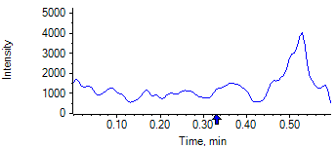

PCP 2 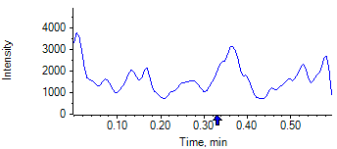

PCP D5 1 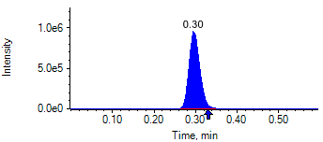

PCP D5 1 

Benzoylecgonine 1 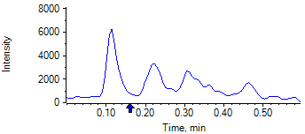

Benzoylecgonine 2 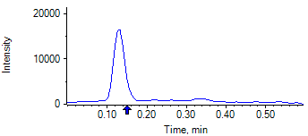

Benzoylecgonine D3 1 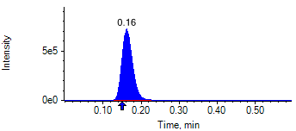

Benzoylecgonine D3 1 

|  |  |  |  |
| --- | --- | --- | --- |
| **Acquisition Method** | PCP_BE_041422Final.dam | **Data File** | SAMPLE031.wiff |
| **Sample Name** | **DL915266S05** | **Injection Volume** | 10.00 |
| **Sample Type** | Unknown | **Injection Vial** | 26 |
| **Injection Date** | 4/30/2025 7:57:29 PM | **Dilution Factor** | 1.00 |
| **Instrument Name** | Triple Quad 5500+ | **Instrument Serial** | EX231582110 |

**Results Summary**

*DL915266S05*

| **Peak Name** | **Integration Type** | **Transition** | **Retention Time** | **Rel RT** | **Peak Area** | **Area Ratio** | **Calculated Concentration (ng/mL)** | **Expected Ion Ratio** | **Calculated  Ion Ratio** | **Ratio Confirms ID** |
| --- | --- | --- | --- | --- | --- | --- | --- | --- | --- | --- |

|  |  |  |  |  |  |  |  |  |  |  |
| --- | --- | --- | --- | --- | --- | --- | --- | --- | --- | --- |
| PCP 1 | N/A | 243.8 / 159.0 | N/A | N/A* | N/A | N/A | N/A |  |  |  |

|  |  |  |  |  |  |  |  |  |  |  |
| --- | --- | --- | --- | --- | --- | --- | --- | --- | --- | --- |
| PCP 2 | N/A | 243.8 / 91.0 | N/A | N/A* | N/A | N/A |  | 59.4% | 0.0% | NO |

|  |  |  |  |  |  |  |  |  |  |  |
| --- | --- | --- | --- | --- | --- | --- | --- | --- | --- | --- |
| Benzoylecgonine 1 | N/A | 289.8 / 168.1 | N/A | N/A* | N/A | N/A | N/A |  |  |  |

|  |  |  |  |  |  |  |  |  |  |  |
| --- | --- | --- | --- | --- | --- | --- | --- | --- | --- | --- |
| Benzoylecgonine 2 | N/A | 289.8 / 104.9 | N/A | N/A* | N/A | N/A |  | 71.7% | 0.0% | NO |

**Internal Standard Data**

|  |  |  |  |  |  |  |  |  |  |
| --- | --- | --- | --- | --- | --- | --- | --- | --- | --- |
| **Internal Standard Name** | **Integration Type** | **Transition** | **Retention Time** | **Avg IS Retention Time** | **IS Peak Area** | **IS Area Within Range** | **Expected Ion Ratio** | **Calculated  Ion Ratio** | **Ratio Confirms ID** |

|  |  |  |  |  |  |  |  |  |  |
| --- | --- | --- | --- | --- | --- | --- | --- | --- | --- |
| PCP D5 1 | Baseline | 248.8 / 164.1 | 0.29* | 0.32 | 1.596e6 | ✓ |  |  |  |

|  |  |  |  |  |  |  |  |  |  |
| --- | --- | --- | --- | --- | --- | --- | --- | --- | --- |
| PCP D5 1 | Baseline | 248.8 / 164.1 | 0.29* | 0.32 | 1.596e6 |  | 100.0% | 100.0% | ✓ |

|  |  |  |  |  |  |  |  |  |  |
| --- | --- | --- | --- | --- | --- | --- | --- | --- | --- |
| Benzoylecgonine D3 1 | Baseline | 292.8 / 171.2 | 0.16* | 0.18 | 1.139e6 | ✓ |  |  |  |

|  |  |  |  |  |  |  |  |  |  |
| --- | --- | --- | --- | --- | --- | --- | --- | --- | --- |
| Benzoylecgonine D3 1 | Baseline | 292.8 / 171.2 | 0.16* | 0.18 | 1.139e6 |  | 100.0% | 100.0% | ✓ |

**Peak Review**

PCP 1 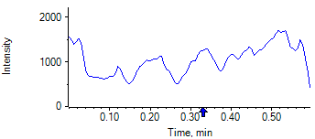

PCP 2 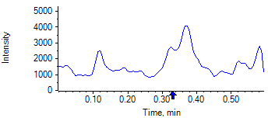

PCP D5 1 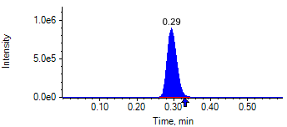

PCP D5 1 

Benzoylecgonine 1 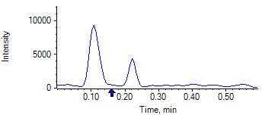

Benzoylecgonine 2 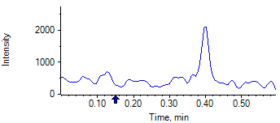

Benzoylecgonine D3 1 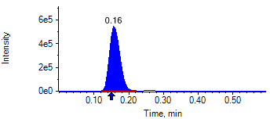

Benzoylecgonine D3 1 

|  |  |  |  |
| --- | --- | --- | --- |
| **Acquisition Method** | PCP_BE_041422Final.dam | **Data File** | SAMPLE032.wiff |
| **Sample Name** | **DL915466S05** | **Injection Volume** | 10.00 |
| **Sample Type** | Unknown | **Injection Vial** | 27 |
| **Injection Date** | 4/30/2025 7:58:40 PM | **Dilution Factor** | 1.00 |
| **Instrument Name** | Triple Quad 5500+ | **Instrument Serial** | EX231582110 |

**Results Summary**

*DL915466S05*

| **Peak Name** | **Integration Type** | **Transition** | **Retention Time** | **Rel RT** | **Peak Area** | **Area Ratio** | **Calculated Concentration (ng/mL)** | **Expected Ion Ratio** | **Calculated  Ion Ratio** | **Ratio Confirms ID** |
| --- | --- | --- | --- | --- | --- | --- | --- | --- | --- | --- |

|  |  |  |  |  |  |  |  |  |  |  |
| --- | --- | --- | --- | --- | --- | --- | --- | --- | --- | --- |
| PCP 1 | N/A | 243.8 / 159.0 | N/A | N/A* | N/A | N/A | N/A |  |  |  |

|  |  |  |  |  |  |  |  |  |  |  |
| --- | --- | --- | --- | --- | --- | --- | --- | --- | --- | --- |
| PCP 2 | N/A | 243.8 / 91.0 | N/A | N/A* | N/A | N/A |  | 59.4% | 0.0% | NO |

|  |  |  |  |  |  |  |  |  |  |  |
| --- | --- | --- | --- | --- | --- | --- | --- | --- | --- | --- |
| Benzoylecgonine 1 | N/A | 289.8 / 168.1 | N/A | N/A* | N/A | N/A | N/A |  |  |  |

|  |  |  |  |  |  |  |  |  |  |  |
| --- | --- | --- | --- | --- | --- | --- | --- | --- | --- | --- |
| Benzoylecgonine 2 | N/A | 289.8 / 104.9 | N/A | N/A* | N/A | N/A |  | 71.7% | 0.0% | NO |

**Internal Standard Data**

|  |  |  |  |  |  |  |  |  |  |
| --- | --- | --- | --- | --- | --- | --- | --- | --- | --- |
| **Internal Standard Name** | **Integration Type** | **Transition** | **Retention Time** | **Avg IS Retention Time** | **IS Peak Area** | **IS Area Within Range** | **Expected Ion Ratio** | **Calculated  Ion Ratio** | **Ratio Confirms ID** |

|  |  |  |  |  |  |  |  |  |  |
| --- | --- | --- | --- | --- | --- | --- | --- | --- | --- |
| PCP D5 1 | Baseline | 248.8 / 164.1 | 0.35* | 0.32 | 1.891e6 | ✓ |  |  |  |

|  |  |  |  |  |  |  |  |  |  |
| --- | --- | --- | --- | --- | --- | --- | --- | --- | --- |
| PCP D5 1 | Baseline | 248.8 / 164.1 | 0.35* | 0.32 | 1.891e6 |  | 100.0% | 100.0% | ✓ |

|  |  |  |  |  |  |  |  |  |  |
| --- | --- | --- | --- | --- | --- | --- | --- | --- | --- |
| Benzoylecgonine D3 1 | Baseline | 292.8 / 171.2 | 0.20* | 0.18 | 2.168e6 | ✓ |  |  |  |

|  |  |  |  |  |  |  |  |  |  |
| --- | --- | --- | --- | --- | --- | --- | --- | --- | --- |
| Benzoylecgonine D3 1 | Baseline | 292.8 / 171.2 | 0.20* | 0.18 | 2.168e6 |  | 100.0% | 100.0% | ✓ |

**Peak Review**

PCP 1 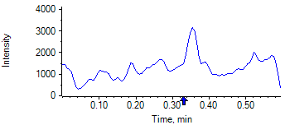

PCP 2 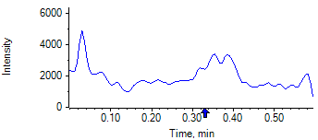

PCP D5 1 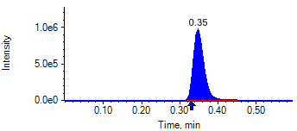

PCP D5 1 

Benzoylecgonine 1 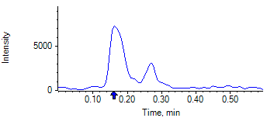

Benzoylecgonine 2 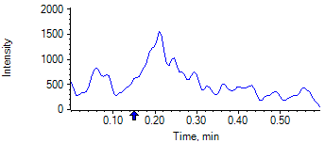

Benzoylecgonine D3 1 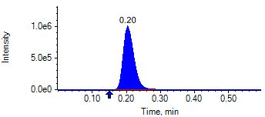

Benzoylecgonine D3 1 

|  |  |  |  |
| --- | --- | --- | --- |
| **Acquisition Method** | PCP_BE_041422Final.dam | **Data File** | SAMPLE033.wiff |
| **Sample Name** | **DL916054S05** | **Injection Volume** | 10.00 |
| **Sample Type** | Unknown | **Injection Vial** | 28 |
| **Injection Date** | 4/30/2025 7:59:50 PM | **Dilution Factor** | 1.00 |
| **Instrument Name** | Triple Quad 5500+ | **Instrument Serial** | EX231582110 |

**Results Summary**

*DL916054S05*

| **Peak Name** | **Integration Type** | **Transition** | **Retention Time** | **Rel RT** | **Peak Area** | **Area Ratio** | **Calculated Concentration (ng/mL)** | **Expected Ion Ratio** | **Calculated  Ion Ratio** | **Ratio Confirms ID** |
| --- | --- | --- | --- | --- | --- | --- | --- | --- | --- | --- |

|  |  |  |  |  |  |  |  |  |  |  |
| --- | --- | --- | --- | --- | --- | --- | --- | --- | --- | --- |
| PCP 1 | N/A | 243.8 / 159.0 | N/A | N/A* | N/A | N/A | N/A |  |  |  |

|  |  |  |  |  |  |  |  |  |  |  |
| --- | --- | --- | --- | --- | --- | --- | --- | --- | --- | --- |
| PCP 2 | N/A | 243.8 / 91.0 | N/A | N/A* | N/A | N/A |  | 59.4% | 0.0% | NO |

|  |  |  |  |  |  |  |  |  |  |  |
| --- | --- | --- | --- | --- | --- | --- | --- | --- | --- | --- |
| Benzoylecgonine 1 | N/A | 289.8 / 168.1 | N/A | N/A* | N/A | N/A | N/A |  |  |  |

|  |  |  |  |  |  |  |  |  |  |  |
| --- | --- | --- | --- | --- | --- | --- | --- | --- | --- | --- |
| Benzoylecgonine 2 | N/A | 289.8 / 104.9 | N/A | N/A* | N/A | N/A |  | 71.7% | 0.0% | NO |

**Internal Standard Data**

|  |  |  |  |  |  |  |  |  |  |
| --- | --- | --- | --- | --- | --- | --- | --- | --- | --- |
| **Internal Standard Name** | **Integration Type** | **Transition** | **Retention Time** | **Avg IS Retention Time** | **IS Peak Area** | **IS Area Within Range** | **Expected Ion Ratio** | **Calculated  Ion Ratio** | **Ratio Confirms ID** |

|  |  |  |  |  |  |  |  |  |  |
| --- | --- | --- | --- | --- | --- | --- | --- | --- | --- |
| PCP D5 1 | Baseline | 248.8 / 164.1 | 0.32 | 0.32 | 1.895e6 | ✓ |  |  |  |

|  |  |  |  |  |  |  |  |  |  |
| --- | --- | --- | --- | --- | --- | --- | --- | --- | --- |
| PCP D5 1 | Baseline | 248.8 / 164.1 | 0.32 | 0.32 | 1.895e6 |  | 100.0% | 100.0% | ✓ |

|  |  |  |  |  |  |  |  |  |  |
| --- | --- | --- | --- | --- | --- | --- | --- | --- | --- |
| Benzoylecgonine D3 1 | Baseline | 292.8 / 171.2 | 0.18 | 0.18 | 1.953e6 | ✓ |  |  |  |

|  |  |  |  |  |  |  |  |  |  |
| --- | --- | --- | --- | --- | --- | --- | --- | --- | --- |
| Benzoylecgonine D3 1 | Baseline | 292.8 / 171.2 | 0.18 | 0.18 | 1.953e6 |  | 100.0% | 100.0% | ✓ |

**Peak Review**

PCP 1 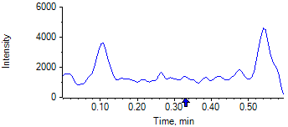

PCP 2 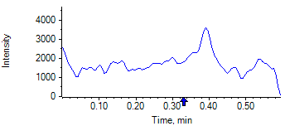

PCP D5 1 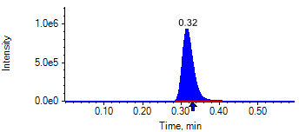

PCP D5 1 

Benzoylecgonine 1 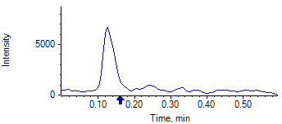

Benzoylecgonine 2 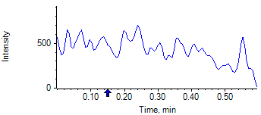

Benzoylecgonine D3 1 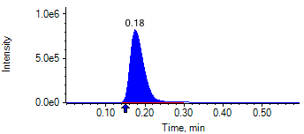

Benzoylecgonine D3 1 

|  |  |  |  |
| --- | --- | --- | --- |
| **Acquisition Method** | PCP_BE_041422Final.dam | **Data File** | SAMPLE034.wiff |
| **Sample Name** | **DL915117S05** | **Injection Volume** | 10.00 |
| **Sample Type** | Unknown | **Injection Vial** | 29 |
| **Injection Date** | 4/30/2025 8:01:01 PM | **Dilution Factor** | 1.00 |
| **Instrument Name** | Triple Quad 5500+ | **Instrument Serial** | EX231582110 |

**Results Summary**

*DL915117S05*

| **Peak Name** | **Integration Type** | **Transition** | **Retention Time** | **Rel RT** | **Peak Area** | **Area Ratio** | **Calculated Concentration (ng/mL)** | **Expected Ion Ratio** | **Calculated  Ion Ratio** | **Ratio Confirms ID** |
| --- | --- | --- | --- | --- | --- | --- | --- | --- | --- | --- |

|  |  |  |  |  |  |  |  |  |  |  |
| --- | --- | --- | --- | --- | --- | --- | --- | --- | --- | --- |
| PCP 1 | N/A | 243.8 / 159.0 | N/A | N/A* | N/A | N/A | N/A |  |  |  |

|  |  |  |  |  |  |  |  |  |  |  |
| --- | --- | --- | --- | --- | --- | --- | --- | --- | --- | --- |
| PCP 2 | N/A | 243.8 / 91.0 | N/A | N/A* | N/A | N/A |  | 59.4% | 0.0% | NO |

|  |  |  |  |  |  |  |  |  |  |  |
| --- | --- | --- | --- | --- | --- | --- | --- | --- | --- | --- |
| Benzoylecgonine 1 | N/A | 289.8 / 168.1 | N/A | N/A* | N/A | N/A | N/A |  |  |  |

|  |  |  |  |  |  |  |  |  |  |  |
| --- | --- | --- | --- | --- | --- | --- | --- | --- | --- | --- |
| Benzoylecgonine 2 | N/A | 289.8 / 104.9 | N/A | N/A* | N/A | N/A |  | 71.7% | 0.0% | NO |

**Internal Standard Data**

|  |  |  |  |  |  |  |  |  |  |
| --- | --- | --- | --- | --- | --- | --- | --- | --- | --- |
| **Internal Standard Name** | **Integration Type** | **Transition** | **Retention Time** | **Avg IS Retention Time** | **IS Peak Area** | **IS Area Within Range** | **Expected Ion Ratio** | **Calculated  Ion Ratio** | **Ratio Confirms ID** |

|  |  |  |  |  |  |  |  |  |  |
| --- | --- | --- | --- | --- | --- | --- | --- | --- | --- |
| PCP D5 1 | Baseline | 248.8 / 164.1 | 0.30* | 0.32 | 1.820e6 | ✓ |  |  |  |

|  |  |  |  |  |  |  |  |  |  |
| --- | --- | --- | --- | --- | --- | --- | --- | --- | --- |
| PCP D5 1 | Baseline | 248.8 / 164.1 | 0.30* | 0.32 | 1.820e6 |  | 100.0% | 100.0% | ✓ |

|  |  |  |  |  |  |  |  |  |  |
| --- | --- | --- | --- | --- | --- | --- | --- | --- | --- |
| Benzoylecgonine D3 1 | Valley | 292.8 / 171.2 | 0.16* | 0.18 | 1.476e6 | ✓ |  |  |  |

|  |  |  |  |  |  |  |  |  |  |
| --- | --- | --- | --- | --- | --- | --- | --- | --- | --- |
| Benzoylecgonine D3 1 | Valley | 292.8 / 171.2 | 0.16* | 0.18 | 1.476e6 |  | 100.0% | 100.0% | ✓ |

**Peak Review**

PCP 1 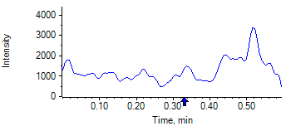

PCP 2 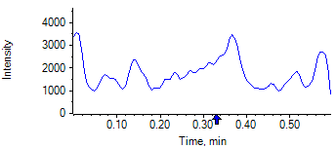

PCP D5 1 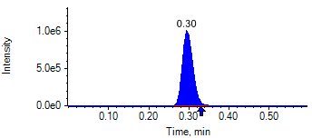

PCP D5 1 

Benzoylecgonine 1 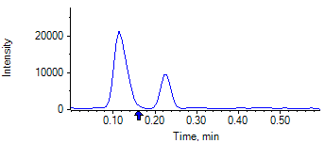

Benzoylecgonine 2 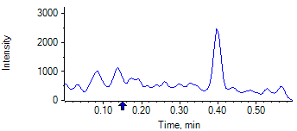

Benzoylecgonine D3 1 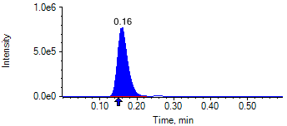

Benzoylecgonine D3 1 

|  |  |  |  |
| --- | --- | --- | --- |
| **Acquisition Method** | PCP_BE_041422Final.dam | **Data File** | SAMPLE035.wiff |
| **Sample Name** | **DL915559S05** | **Injection Volume** | 10.00 |
| **Sample Type** | Unknown | **Injection Vial** | 30 |
| **Injection Date** | 4/30/2025 8:02:13 PM | **Dilution Factor** | 1.00 |
| **Instrument Name** | Triple Quad 5500+ | **Instrument Serial** | EX231582110 |

**Results Summary**

*DL915559S05*

| **Peak Name** | **Integration Type** | **Transition** | **Retention Time** | **Rel RT** | **Peak Area** | **Area Ratio** | **Calculated Concentration (ng/mL)** | **Expected Ion Ratio** | **Calculated  Ion Ratio** | **Ratio Confirms ID** |
| --- | --- | --- | --- | --- | --- | --- | --- | --- | --- | --- |

|  |  |  |  |  |  |  |  |  |  |  |
| --- | --- | --- | --- | --- | --- | --- | --- | --- | --- | --- |
| PCP 1 | N/A | 243.8 / 159.0 | N/A | N/A* | N/A | N/A | N/A |  |  |  |

|  |  |  |  |  |  |  |  |  |  |  |
| --- | --- | --- | --- | --- | --- | --- | --- | --- | --- | --- |
| PCP 2 | N/A | 243.8 / 91.0 | N/A | N/A* | N/A | N/A |  | 59.4% | 0.0% | NO |

|  |  |  |  |  |  |  |  |  |  |  |
| --- | --- | --- | --- | --- | --- | --- | --- | --- | --- | --- |
| Benzoylecgonine 1 | N/A | 289.8 / 168.1 | N/A | N/A* | N/A | N/A | N/A |  |  |  |

|  |  |  |  |  |  |  |  |  |  |  |
| --- | --- | --- | --- | --- | --- | --- | --- | --- | --- | --- |
| Benzoylecgonine 2 | N/A | 289.8 / 104.9 | N/A | N/A* | N/A | N/A |  | 71.7% | 0.0% | NO |

**Internal Standard Data**

|  |  |  |  |  |  |  |  |  |  |
| --- | --- | --- | --- | --- | --- | --- | --- | --- | --- |
| **Internal Standard Name** | **Integration Type** | **Transition** | **Retention Time** | **Avg IS Retention Time** | **IS Peak Area** | **IS Area Within Range** | **Expected Ion Ratio** | **Calculated  Ion Ratio** | **Ratio Confirms ID** |

|  |  |  |  |  |  |  |  |  |  |
| --- | --- | --- | --- | --- | --- | --- | --- | --- | --- |
| PCP D5 1 | Baseline | 248.8 / 164.1 | 0.29* | 0.32 | 1.673e6 | ✓ |  |  |  |

|  |  |  |  |  |  |  |  |  |  |
| --- | --- | --- | --- | --- | --- | --- | --- | --- | --- |
| PCP D5 1 | Baseline | 248.8 / 164.1 | 0.29* | 0.32 | 1.673e6 |  | 100.0% | 100.0% | ✓ |

|  |  |  |  |  |  |  |  |  |  |
| --- | --- | --- | --- | --- | --- | --- | --- | --- | --- |
| Benzoylecgonine D3 1 | Baseline | 292.8 / 171.2 | 0.16* | 0.18 | 1.584e6 | ✓ |  |  |  |

|  |  |  |  |  |  |  |  |  |  |
| --- | --- | --- | --- | --- | --- | --- | --- | --- | --- |
| Benzoylecgonine D3 1 | Baseline | 292.8 / 171.2 | 0.16* | 0.18 | 1.584e6 |  | 100.0% | 100.0% | ✓ |

**Peak Review**

PCP 1 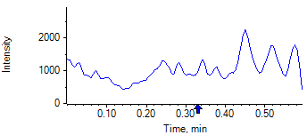

PCP 2 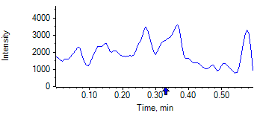

PCP D5 1 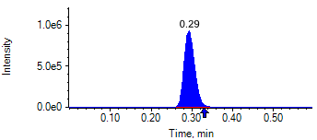

PCP D5 1 

Benzoylecgonine 1 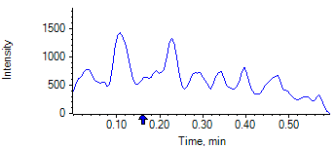

Benzoylecgonine 2 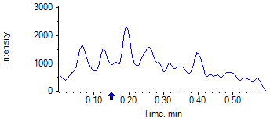

Benzoylecgonine D3 1 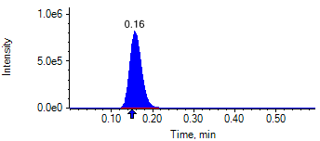

Benzoylecgonine D3 1 

|  |  |  |  |
| --- | --- | --- | --- |
| **Acquisition Method** | PCP_BE_041422Final.dam | **Data File** | SAMPLE036.wiff |
| **Sample Name** | **DL918888S05** | **Injection Volume** | 10.00 |
| **Sample Type** | Unknown | **Injection Vial** | 31 |
| **Injection Date** | 4/30/2025 8:03:28 PM | **Dilution Factor** | 1.00 |
| **Instrument Name** | Triple Quad 5500+ | **Instrument Serial** | EX231582110 |

**Results Summary**

*DL918888S05*

| **Peak Name** | **Integration Type** | **Transition** | **Retention Time** | **Rel RT** | **Peak Area** | **Area Ratio** | **Calculated Concentration (ng/mL)** | **Expected Ion Ratio** | **Calculated  Ion Ratio** | **Ratio Confirms ID** |
| --- | --- | --- | --- | --- | --- | --- | --- | --- | --- | --- |

|  |  |  |  |  |  |  |  |  |  |  |
| --- | --- | --- | --- | --- | --- | --- | --- | --- | --- | --- |
| PCP 1 | N/A | 243.8 / 159.0 | N/A | N/A* | N/A | N/A | N/A |  |  |  |

|  |  |  |  |  |  |  |  |  |  |  |
| --- | --- | --- | --- | --- | --- | --- | --- | --- | --- | --- |
| PCP 2 | N/A | 243.8 / 91.0 | N/A | N/A* | N/A | N/A |  | 59.4% | 0.0% | NO |

|  |  |  |  |  |  |  |  |  |  |  |
| --- | --- | --- | --- | --- | --- | --- | --- | --- | --- | --- |
| Benzoylecgonine 1 | N/A | 289.8 / 168.1 | N/A | N/A* | N/A | N/A | N/A |  |  |  |

|  |  |  |  |  |  |  |  |  |  |  |
| --- | --- | --- | --- | --- | --- | --- | --- | --- | --- | --- |
| Benzoylecgonine 2 | N/A | 289.8 / 104.9 | N/A | N/A* | N/A | N/A |  | 71.7% | 0.0% | NO |

**Internal Standard Data**

|  |  |  |  |  |  |  |  |  |  |
| --- | --- | --- | --- | --- | --- | --- | --- | --- | --- |
| **Internal Standard Name** | **Integration Type** | **Transition** | **Retention Time** | **Avg IS Retention Time** | **IS Peak Area** | **IS Area Within Range** | **Expected Ion Ratio** | **Calculated  Ion Ratio** | **Ratio Confirms ID** |

|  |  |  |  |  |  |  |  |  |  |
| --- | --- | --- | --- | --- | --- | --- | --- | --- | --- |
| PCP D5 1 | Baseline | 248.8 / 164.1 | 0.35* | 0.32 | 2.020e6 | ✓ |  |  |  |

|  |  |  |  |  |  |  |  |  |  |
| --- | --- | --- | --- | --- | --- | --- | --- | --- | --- |
| PCP D5 1 | Baseline | 248.8 / 164.1 | 0.35* | 0.32 | 2.020e6 |  | 100.0% | 100.0% | ✓ |

|  |  |  |  |  |  |  |  |  |  |
| --- | --- | --- | --- | --- | --- | --- | --- | --- | --- |
| Benzoylecgonine D3 1 | Baseline | 292.8 / 171.2 | 0.20* | 0.18 | 2.374e6 | ✓ |  |  |  |

|  |  |  |  |  |  |  |  |  |  |
| --- | --- | --- | --- | --- | --- | --- | --- | --- | --- |
| Benzoylecgonine D3 1 | Baseline | 292.8 / 171.2 | 0.20* | 0.18 | 2.374e6 |  | 100.0% | 100.0% | ✓ |

**Peak Review**

PCP 1 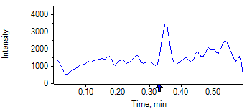

PCP 2 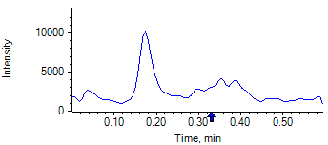

PCP D5 1 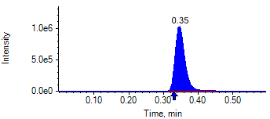

PCP D5 1 

Benzoylecgonine 1 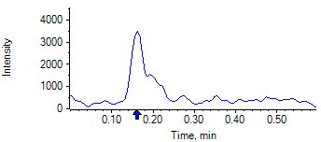

Benzoylecgonine 2 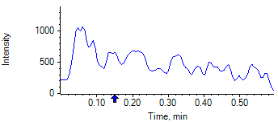

Benzoylecgonine D3 1 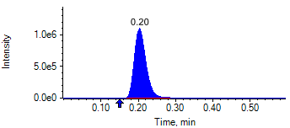

Benzoylecgonine D3 1 

|  |  |  |  |
| --- | --- | --- | --- |
| **Acquisition Method** | PCP_BE_041422Final.dam | **Data File** | SAMPLE037.wiff |
| **Sample Name** | **DL919116S05** | **Injection Volume** | 10.00 |
| **Sample Type** | Unknown | **Injection Vial** | 32 |
| **Injection Date** | 4/30/2025 8:04:36 PM | **Dilution Factor** | 1.00 |
| **Instrument Name** | Triple Quad 5500+ | **Instrument Serial** | EX231582110 |

**Results Summary**

*DL919116S05*

| **Peak Name** | **Integration Type** | **Transition** | **Retention Time** | **Rel RT** | **Peak Area** | **Area Ratio** | **Calculated Concentration (ng/mL)** | **Expected Ion Ratio** | **Calculated  Ion Ratio** | **Ratio Confirms ID** |
| --- | --- | --- | --- | --- | --- | --- | --- | --- | --- | --- |

|  |  |  |  |  |  |  |  |  |  |  |
| --- | --- | --- | --- | --- | --- | --- | --- | --- | --- | --- |
| PCP 1 | N/A | 243.8 / 159.0 | N/A | N/A* | N/A | N/A | N/A |  |  |  |

|  |  |  |  |  |  |  |  |  |  |  |
| --- | --- | --- | --- | --- | --- | --- | --- | --- | --- | --- |
| PCP 2 | N/A | 243.8 / 91.0 | N/A | N/A* | N/A | N/A |  | 59.4% | 0.0% | NO |

|  |  |  |  |  |  |  |  |  |  |  |
| --- | --- | --- | --- | --- | --- | --- | --- | --- | --- | --- |
| Benzoylecgonine 1 | N/A | 289.8 / 168.1 | N/A | N/A* | N/A | N/A | N/A |  |  |  |

|  |  |  |  |  |  |  |  |  |  |  |
| --- | --- | --- | --- | --- | --- | --- | --- | --- | --- | --- |
| Benzoylecgonine 2 | N/A | 289.8 / 104.9 | N/A | N/A* | N/A | N/A |  | 71.7% | 0.0% | NO |

**Internal Standard Data**

|  |  |  |  |  |  |  |  |  |  |
| --- | --- | --- | --- | --- | --- | --- | --- | --- | --- |
| **Internal Standard Name** | **Integration Type** | **Transition** | **Retention Time** | **Avg IS Retention Time** | **IS Peak Area** | **IS Area Within Range** | **Expected Ion Ratio** | **Calculated  Ion Ratio** | **Ratio Confirms ID** |

|  |  |  |  |  |  |  |  |  |  |
| --- | --- | --- | --- | --- | --- | --- | --- | --- | --- |
| PCP D5 1 | Baseline | 248.8 / 164.1 | 0.32 | 0.32 | 1.950e6 | ✓ |  |  |  |

|  |  |  |  |  |  |  |  |  |  |
| --- | --- | --- | --- | --- | --- | --- | --- | --- | --- |
| PCP D5 1 | Baseline | 248.8 / 164.1 | 0.32 | 0.32 | 1.950e6 |  | 100.0% | 100.0% | ✓ |

|  |  |  |  |  |  |  |  |  |  |
| --- | --- | --- | --- | --- | --- | --- | --- | --- | --- |
| Benzoylecgonine D3 1 | Baseline | 292.8 / 171.2 | 0.18 | 0.18 | 2.326e6 | ✓ |  |  |  |

|  |  |  |  |  |  |  |  |  |  |
| --- | --- | --- | --- | --- | --- | --- | --- | --- | --- |
| Benzoylecgonine D3 1 | Baseline | 292.8 / 171.2 | 0.18 | 0.18 | 2.326e6 |  | 100.0% | 100.0% | ✓ |

**Peak Review**

PCP 1 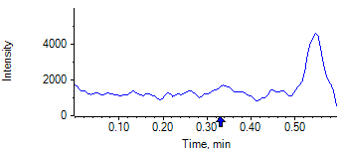

PCP 2 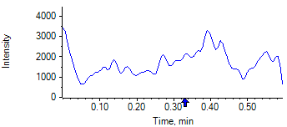

PCP D5 1 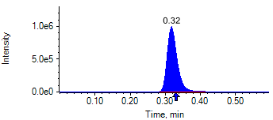

PCP D5 1 

Benzoylecgonine 1 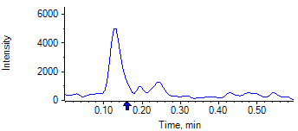

Benzoylecgonine 2 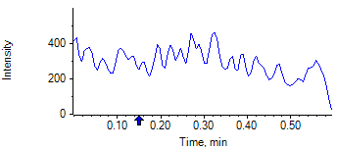

Benzoylecgonine D3 1 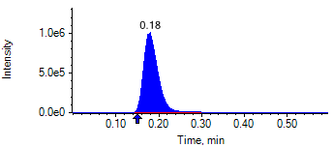

Benzoylecgonine D3 1 

|  |  |  |  |
| --- | --- | --- | --- |
| **Acquisition Method** | PCP_BE_041422Final.dam | **Data File** | SAMPLE038.wiff |
| **Sample Name** | **DL918941S05** | **Injection Volume** | 10.00 |
| **Sample Type** | Unknown | **Injection Vial** | 33 |
| **Injection Date** | 4/30/2025 8:05:46 PM | **Dilution Factor** | 1.00 |
| **Instrument Name** | Triple Quad 5500+ | **Instrument Serial** | EX231582110 |

**Results Summary**

*DL918941S05*

| **Peak Name** | **Integration Type** | **Transition** | **Retention Time** | **Rel RT** | **Peak Area** | **Area Ratio** | **Calculated Concentration (ng/mL)** | **Expected Ion Ratio** | **Calculated  Ion Ratio** | **Ratio Confirms ID** |
| --- | --- | --- | --- | --- | --- | --- | --- | --- | --- | --- |

|  |  |  |  |  |  |  |  |  |  |  |
| --- | --- | --- | --- | --- | --- | --- | --- | --- | --- | --- |
| PCP 1 | N/A | 243.8 / 159.0 | N/A | N/A* | N/A | N/A | N/A |  |  |  |

|  |  |  |  |  |  |  |  |  |  |  |
| --- | --- | --- | --- | --- | --- | --- | --- | --- | --- | --- |
| PCP 2 | N/A | 243.8 / 91.0 | N/A | N/A* | N/A | N/A |  | 59.4% | 0.0% | NO |

|  |  |  |  |  |  |  |  |  |  |  |
| --- | --- | --- | --- | --- | --- | --- | --- | --- | --- | --- |
| Benzoylecgonine 1 | N/A | 289.8 / 168.1 | N/A | N/A* | N/A | N/A | N/A |  |  |  |

|  |  |  |  |  |  |  |  |  |  |  |
| --- | --- | --- | --- | --- | --- | --- | --- | --- | --- | --- |
| Benzoylecgonine 2 | N/A | 289.8 / 104.9 | N/A | N/A* | N/A | N/A |  | 71.7% | 0.0% | NO |

**Internal Standard Data**

|  |  |  |  |  |  |  |  |  |  |
| --- | --- | --- | --- | --- | --- | --- | --- | --- | --- |
| **Internal Standard Name** | **Integration Type** | **Transition** | **Retention Time** | **Avg IS Retention Time** | **IS Peak Area** | **IS Area Within Range** | **Expected Ion Ratio** | **Calculated  Ion Ratio** | **Ratio Confirms ID** |

|  |  |  |  |  |  |  |  |  |  |
| --- | --- | --- | --- | --- | --- | --- | --- | --- | --- |
| PCP D5 1 | Baseline | 248.8 / 164.1 | 0.30* | 0.32 | 1.927e6 | ✓ |  |  |  |

|  |  |  |  |  |  |  |  |  |  |
| --- | --- | --- | --- | --- | --- | --- | --- | --- | --- |
| PCP D5 1 | Baseline | 248.8 / 164.1 | 0.30* | 0.32 | 1.927e6 |  | 100.0% | 100.0% | ✓ |

|  |  |  |  |  |  |  |  |  |  |
| --- | --- | --- | --- | --- | --- | --- | --- | --- | --- |
| Benzoylecgonine D3 1 | Baseline | 292.8 / 171.2 | 0.16* | 0.18 | 2.332e6 | ✓ |  |  |  |

|  |  |  |  |  |  |  |  |  |  |
| --- | --- | --- | --- | --- | --- | --- | --- | --- | --- |
| Benzoylecgonine D3 1 | Baseline | 292.8 / 171.2 | 0.16* | 0.18 | 2.332e6 |  | 100.0% | 100.0% | ✓ |

**Peak Review**

PCP 1 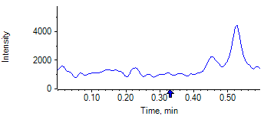

PCP 2 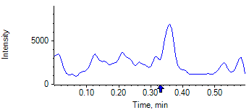

PCP D5 1 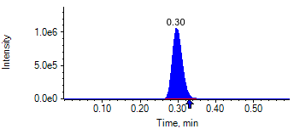

PCP D5 1 

Benzoylecgonine 1 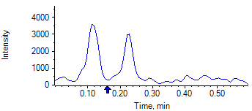

Benzoylecgonine 2 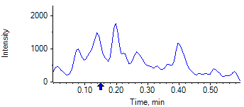

Benzoylecgonine D3 1 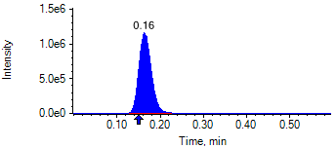

Benzoylecgonine D3 1 

|  |  |  |  |
| --- | --- | --- | --- |
| **Acquisition Method** | PCP_BE_041422Final.dam | **Data File** | SAMPLE039.wiff |
| **Sample Name** | **DL919087S05** | **Injection Volume** | 10.00 |
| **Sample Type** | Unknown | **Injection Vial** | 34 |
| **Injection Date** | 4/30/2025 8:06:55 PM | **Dilution Factor** | 1.00 |
| **Instrument Name** | Triple Quad 5500+ | **Instrument Serial** | EX231582110 |

**Results Summary**

*DL919087S05*

| **Peak Name** | **Integration Type** | **Transition** | **Retention Time** | **Rel RT** | **Peak Area** | **Area Ratio** | **Calculated Concentration (ng/mL)** | **Expected Ion Ratio** | **Calculated  Ion Ratio** | **Ratio Confirms ID** |
| --- | --- | --- | --- | --- | --- | --- | --- | --- | --- | --- |

|  |  |  |  |  |  |  |  |  |  |  |
| --- | --- | --- | --- | --- | --- | --- | --- | --- | --- | --- |
| PCP 1 | N/A | 243.8 / 159.0 | N/A | N/A* | N/A | N/A | N/A |  |  |  |

|  |  |  |  |  |  |  |  |  |  |  |
| --- | --- | --- | --- | --- | --- | --- | --- | --- | --- | --- |
| PCP 2 | N/A | 243.8 / 91.0 | N/A | N/A* | N/A | N/A |  | 59.4% | 0.0% | NO |

|  |  |  |  |  |  |  |  |  |  |  |
| --- | --- | --- | --- | --- | --- | --- | --- | --- | --- | --- |
| Benzoylecgonine 1 | N/A | 289.8 / 168.1 | N/A | N/A* | N/A | N/A | N/A |  |  |  |

|  |  |  |  |  |  |  |  |  |  |  |
| --- | --- | --- | --- | --- | --- | --- | --- | --- | --- | --- |
| Benzoylecgonine 2 | N/A | 289.8 / 104.9 | N/A | N/A* | N/A | N/A |  | 71.7% | 0.0% | NO |

**Internal Standard Data**

|  |  |  |  |  |  |  |  |  |  |
| --- | --- | --- | --- | --- | --- | --- | --- | --- | --- |
| **Internal Standard Name** | **Integration Type** | **Transition** | **Retention Time** | **Avg IS Retention Time** | **IS Peak Area** | **IS Area Within Range** | **Expected Ion Ratio** | **Calculated  Ion Ratio** | **Ratio Confirms ID** |

|  |  |  |  |  |  |  |  |  |  |
| --- | --- | --- | --- | --- | --- | --- | --- | --- | --- |
| PCP D5 1 | Baseline | 248.8 / 164.1 | 0.29* | 0.32 | 1.973e6 | ✓ |  |  |  |

|  |  |  |  |  |  |  |  |  |  |
| --- | --- | --- | --- | --- | --- | --- | --- | --- | --- |
| PCP D5 1 | Baseline | 248.8 / 164.1 | 0.29* | 0.32 | 1.973e6 |  | 100.0% | 100.0% | ✓ |

|  |  |  |  |  |  |  |  |  |  |
| --- | --- | --- | --- | --- | --- | --- | --- | --- | --- |
| Benzoylecgonine D3 1 | Baseline | 292.8 / 171.2 | 0.16* | 0.18 | 2.281e6 | ✓ |  |  |  |

|  |  |  |  |  |  |  |  |  |  |
| --- | --- | --- | --- | --- | --- | --- | --- | --- | --- |
| Benzoylecgonine D3 1 | Baseline | 292.8 / 171.2 | 0.16* | 0.18 | 2.281e6 |  | 100.0% | 100.0% | ✓ |

**Peak Review**

PCP 1 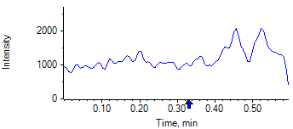

PCP 2 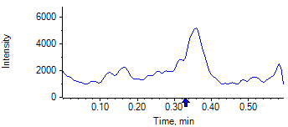

PCP D5 1 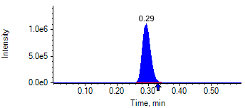

PCP D5 1 

Benzoylecgonine 1 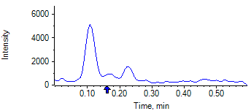

Benzoylecgonine 2 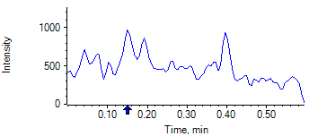

Benzoylecgonine D3 1 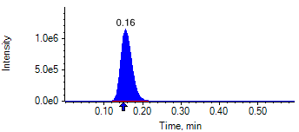

Benzoylecgonine D3 1 

|  |  |  |  |
| --- | --- | --- | --- |
| **Acquisition Method** | PCP_BE_041422Final.dam | **Data File** | SAMPLE040.wiff |
| **Sample Name** | **DL918980S05** | **Injection Volume** | 10.00 |
| **Sample Type** | Unknown | **Injection Vial** | 35 |
| **Injection Date** | 4/30/2025 8:08:08 PM | **Dilution Factor** | 1.00 |
| **Instrument Name** | Triple Quad 5500+ | **Instrument Serial** | EX231582110 |

**Results Summary**

*DL918980S05*

| **Peak Name** | **Integration Type** | **Transition** | **Retention Time** | **Rel RT** | **Peak Area** | **Area Ratio** | **Calculated Concentration (ng/mL)** | **Expected Ion Ratio** | **Calculated  Ion Ratio** | **Ratio Confirms ID** |
| --- | --- | --- | --- | --- | --- | --- | --- | --- | --- | --- |

|  |  |  |  |  |  |  |  |  |  |  |
| --- | --- | --- | --- | --- | --- | --- | --- | --- | --- | --- |
| PCP 1 | N/A | 243.8 / 159.0 | N/A | N/A* | N/A | N/A | N/A |  |  |  |

|  |  |  |  |  |  |  |  |  |  |  |
| --- | --- | --- | --- | --- | --- | --- | --- | --- | --- | --- |
| PCP 2 | N/A | 243.8 / 91.0 | N/A | N/A* | N/A | N/A |  | 59.4% | 0.0% | NO |

|  |  |  |  |  |  |  |  |  |  |  |
| --- | --- | --- | --- | --- | --- | --- | --- | --- | --- | --- |
| Benzoylecgonine 1 | N/A | 289.8 / 168.1 | N/A | N/A* | N/A | N/A | N/A |  |  |  |

|  |  |  |  |  |  |  |  |  |  |  |
| --- | --- | --- | --- | --- | --- | --- | --- | --- | --- | --- |
| Benzoylecgonine 2 | N/A | 289.8 / 104.9 | N/A | N/A* | N/A | N/A |  | 71.7% | 0.0% | NO |

**Internal Standard Data**

|  |  |  |  |  |  |  |  |  |  |
| --- | --- | --- | --- | --- | --- | --- | --- | --- | --- |
| **Internal Standard Name** | **Integration Type** | **Transition** | **Retention Time** | **Avg IS Retention Time** | **IS Peak Area** | **IS Area Within Range** | **Expected Ion Ratio** | **Calculated  Ion Ratio** | **Ratio Confirms ID** |

|  |  |  |  |  |  |  |  |  |  |
| --- | --- | --- | --- | --- | --- | --- | --- | --- | --- |
| PCP D5 1 | Baseline | 248.8 / 164.1 | 0.35* | 0.32 | 1.887e6 | ✓ |  |  |  |

|  |  |  |  |  |  |  |  |  |  |
| --- | --- | --- | --- | --- | --- | --- | --- | --- | --- |
| PCP D5 1 | Baseline | 248.8 / 164.1 | 0.35* | 0.32 | 1.887e6 |  | 100.0% | 100.0% | ✓ |

|  |  |  |  |  |  |  |  |  |  |
| --- | --- | --- | --- | --- | --- | --- | --- | --- | --- |
| Benzoylecgonine D3 1 | Baseline | 292.8 / 171.2 | 0.20* | 0.18 | 1.980e6 | ✓ |  |  |  |

|  |  |  |  |  |  |  |  |  |  |
| --- | --- | --- | --- | --- | --- | --- | --- | --- | --- |
| Benzoylecgonine D3 1 | Baseline | 292.8 / 171.2 | 0.20* | 0.18 | 1.980e6 |  | 100.0% | 100.0% | ✓ |

**Peak Review**

PCP 1 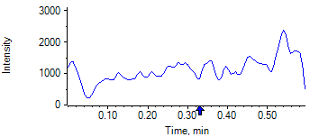

PCP 2 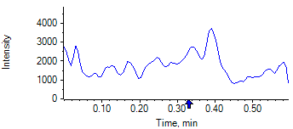

PCP D5 1 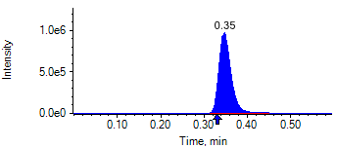

PCP D5 1 

Benzoylecgonine 1 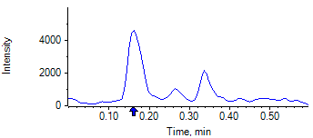

Benzoylecgonine 2 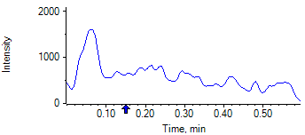

Benzoylecgonine D3 1 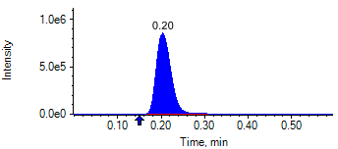

Benzoylecgonine D3 1 

|  |  |  |  |
| --- | --- | --- | --- |
| **Acquisition Method** | PCP_BE_041422Final.dam | **Data File** | SAMPLE041.wiff |
| **Sample Name** | **DL919146S05** | **Injection Volume** | 10.00 |
| **Sample Type** | Unknown | **Injection Vial** | 36 |
| **Injection Date** | 4/30/2025 8:09:18 PM | **Dilution Factor** | 1.00 |
| **Instrument Name** | Triple Quad 5500+ | **Instrument Serial** | EX231582110 |

**Results Summary**

*DL919146S05*

| **Peak Name** | **Integration Type** | **Transition** | **Retention Time** | **Rel RT** | **Peak Area** | **Area Ratio** | **Calculated Concentration (ng/mL)** | **Expected Ion Ratio** | **Calculated  Ion Ratio** | **Ratio Confirms ID** |
| --- | --- | --- | --- | --- | --- | --- | --- | --- | --- | --- |

|  |  |  |  |  |  |  |  |  |  |  |
| --- | --- | --- | --- | --- | --- | --- | --- | --- | --- | --- |
| PCP 1 | N/A | 243.8 / 159.0 | N/A | N/A* | N/A | N/A | N/A |  |  |  |

|  |  |  |  |  |  |  |  |  |  |  |
| --- | --- | --- | --- | --- | --- | --- | --- | --- | --- | --- |
| PCP 2 | N/A | 243.8 / 91.0 | N/A | N/A* | N/A | N/A |  | 59.4% | 0.0% | NO |

|  |  |  |  |  |  |  |  |  |  |  |
| --- | --- | --- | --- | --- | --- | --- | --- | --- | --- | --- |
| Benzoylecgonine 1 | N/A | 289.8 / 168.1 | N/A | N/A* | N/A | N/A | N/A |  |  |  |

|  |  |  |  |  |  |  |  |  |  |  |
| --- | --- | --- | --- | --- | --- | --- | --- | --- | --- | --- |
| Benzoylecgonine 2 | N/A | 289.8 / 104.9 | N/A | N/A* | N/A | N/A |  | 71.7% | 0.0% | NO |

**Internal Standard Data**

|  |  |  |  |  |  |  |  |  |  |
| --- | --- | --- | --- | --- | --- | --- | --- | --- | --- |
| **Internal Standard Name** | **Integration Type** | **Transition** | **Retention Time** | **Avg IS Retention Time** | **IS Peak Area** | **IS Area Within Range** | **Expected Ion Ratio** | **Calculated  Ion Ratio** | **Ratio Confirms ID** |

|  |  |  |  |  |  |  |  |  |  |
| --- | --- | --- | --- | --- | --- | --- | --- | --- | --- |
| PCP D5 1 | Baseline | 248.8 / 164.1 | 0.32 | 0.32 | 1.706e6 | ✓ |  |  |  |

|  |  |  |  |  |  |  |  |  |  |
| --- | --- | --- | --- | --- | --- | --- | --- | --- | --- |
| PCP D5 1 | Baseline | 248.8 / 164.1 | 0.32 | 0.32 | 1.706e6 |  | 100.0% | 100.0% | ✓ |

|  |  |  |  |  |  |  |  |  |  |
| --- | --- | --- | --- | --- | --- | --- | --- | --- | --- |
| Benzoylecgonine D3 1 | Baseline | 292.8 / 171.2 | 0.18 | 0.18 | 1.654e6 | ✓ |  |  |  |

|  |  |  |  |  |  |  |  |  |  |
| --- | --- | --- | --- | --- | --- | --- | --- | --- | --- |
| Benzoylecgonine D3 1 | Baseline | 292.8 / 171.2 | 0.18 | 0.18 | 1.654e6 |  | 100.0% | 100.0% | ✓ |

**Peak Review**

PCP 1 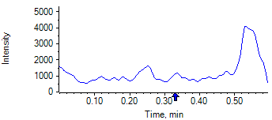

PCP 2 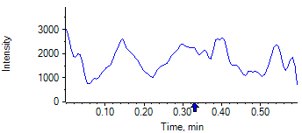

PCP D5 1 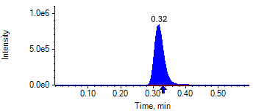

PCP D5 1 

Benzoylecgonine 1 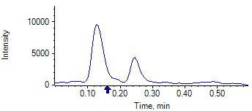

Benzoylecgonine 2 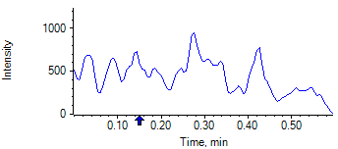

Benzoylecgonine D3 1 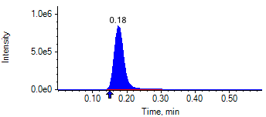

Benzoylecgonine D3 1 

|  |  |  |  |
| --- | --- | --- | --- |
| **Acquisition Method** | PCP_BE_041422Final.dam | **Data File** | SAMPLE042.wiff |
| **Sample Name** | **DL919177S05** | **Injection Volume** | 10.00 |
| **Sample Type** | Unknown | **Injection Vial** | 37 |
| **Injection Date** | 4/30/2025 8:10:30 PM | **Dilution Factor** | 1.00 |
| **Instrument Name** | Triple Quad 5500+ | **Instrument Serial** | EX231582110 |

**Results Summary**

*DL919177S05*

| **Peak Name** | **Integration Type** | **Transition** | **Retention Time** | **Rel RT** | **Peak Area** | **Area Ratio** | **Calculated Concentration (ng/mL)** | **Expected Ion Ratio** | **Calculated  Ion Ratio** | **Ratio Confirms ID** |
| --- | --- | --- | --- | --- | --- | --- | --- | --- | --- | --- |

|  |  |  |  |  |  |  |  |  |  |  |
| --- | --- | --- | --- | --- | --- | --- | --- | --- | --- | --- |
| PCP 1 | N/A | 243.8 / 159.0 | N/A | N/A* | N/A | N/A | N/A |  |  |  |

|  |  |  |  |  |  |  |  |  |  |  |
| --- | --- | --- | --- | --- | --- | --- | --- | --- | --- | --- |
| PCP 2 | N/A | 243.8 / 91.0 | N/A | N/A* | N/A | N/A |  | 59.4% | 0.0% | NO |

|  |  |  |  |  |  |  |  |  |  |  |
| --- | --- | --- | --- | --- | --- | --- | --- | --- | --- | --- |
| Benzoylecgonine 1 | N/A | 289.8 / 168.1 | N/A | N/A* | N/A | N/A | N/A |  |  |  |

|  |  |  |  |  |  |  |  |  |  |  |
| --- | --- | --- | --- | --- | --- | --- | --- | --- | --- | --- |
| Benzoylecgonine 2 | N/A | 289.8 / 104.9 | N/A | N/A* | N/A | N/A |  | 71.7% | 0.0% | NO |

**Internal Standard Data**

|  |  |  |  |  |  |  |  |  |  |
| --- | --- | --- | --- | --- | --- | --- | --- | --- | --- |
| **Internal Standard Name** | **Integration Type** | **Transition** | **Retention Time** | **Avg IS Retention Time** | **IS Peak Area** | **IS Area Within Range** | **Expected Ion Ratio** | **Calculated  Ion Ratio** | **Ratio Confirms ID** |

|  |  |  |  |  |  |  |  |  |  |
| --- | --- | --- | --- | --- | --- | --- | --- | --- | --- |
| PCP D5 1 | Baseline | 248.8 / 164.1 | 0.30* | 0.32 | 1.739e6 | ✓ |  |  |  |

|  |  |  |  |  |  |  |  |  |  |
| --- | --- | --- | --- | --- | --- | --- | --- | --- | --- |
| PCP D5 1 | Baseline | 248.8 / 164.1 | 0.30* | 0.32 | 1.739e6 |  | 100.0% | 100.0% | ✓ |

|  |  |  |  |  |  |  |  |  |  |
| --- | --- | --- | --- | --- | --- | --- | --- | --- | --- |
| Benzoylecgonine D3 1 | Baseline | 292.8 / 171.2 | 0.16* | 0.18 | 1.918e6 | ✓ |  |  |  |

|  |  |  |  |  |  |  |  |  |  |
| --- | --- | --- | --- | --- | --- | --- | --- | --- | --- |
| Benzoylecgonine D3 1 | Baseline | 292.8 / 171.2 | 0.16* | 0.18 | 1.918e6 |  | 100.0% | 100.0% | ✓ |

**Peak Review**

PCP 1 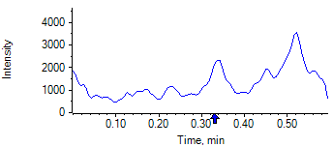

PCP 2 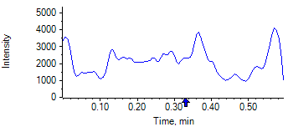

PCP D5 1 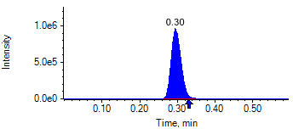

PCP D5 1 

Benzoylecgonine 1 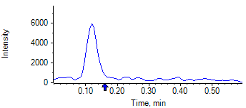

Benzoylecgonine 2 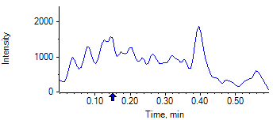

Benzoylecgonine D3 1 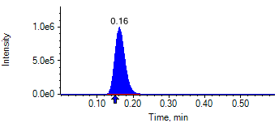

Benzoylecgonine D3 1 

|  |  |  |  |
| --- | --- | --- | --- |
| **Acquisition Method** | PCP_BE_041422Final.dam | **Data File** | SAMPLE043.wiff |
| **Sample Name** | **DL919062S05** | **Injection Volume** | 10.00 |
| **Sample Type** | Unknown | **Injection Vial** | 38 |
| **Injection Date** | 4/30/2025 8:11:39 PM | **Dilution Factor** | 1.00 |
| **Instrument Name** | Triple Quad 5500+ | **Instrument Serial** | EX231582110 |

**Results Summary**

*DL919062S05*

| **Peak Name** | **Integration Type** | **Transition** | **Retention Time** | **Rel RT** | **Peak Area** | **Area Ratio** | **Calculated Concentration (ng/mL)** | **Expected Ion Ratio** | **Calculated  Ion Ratio** | **Ratio Confirms ID** |
| --- | --- | --- | --- | --- | --- | --- | --- | --- | --- | --- |

|  |  |  |  |  |  |  |  |  |  |  |
| --- | --- | --- | --- | --- | --- | --- | --- | --- | --- | --- |
| PCP 1 | N/A | 243.8 / 159.0 | N/A | N/A* | N/A | N/A | N/A |  |  |  |

|  |  |  |  |  |  |  |  |  |  |  |
| --- | --- | --- | --- | --- | --- | --- | --- | --- | --- | --- |
| PCP 2 | N/A | 243.8 / 91.0 | N/A | N/A* | N/A | N/A |  | 59.4% | 0.0% | NO |

|  |  |  |  |  |  |  |  |  |  |  |
| --- | --- | --- | --- | --- | --- | --- | --- | --- | --- | --- |
| Benzoylecgonine 1 | N/A | 289.8 / 168.1 | N/A | N/A* | N/A | N/A | N/A |  |  |  |

|  |  |  |  |  |  |  |  |  |  |  |
| --- | --- | --- | --- | --- | --- | --- | --- | --- | --- | --- |
| Benzoylecgonine 2 | N/A | 289.8 / 104.9 | N/A | N/A* | N/A | N/A |  | 71.7% | 0.0% | NO |

**Internal Standard Data**

|  |  |  |  |  |  |  |  |  |  |
| --- | --- | --- | --- | --- | --- | --- | --- | --- | --- |
| **Internal Standard Name** | **Integration Type** | **Transition** | **Retention Time** | **Avg IS Retention Time** | **IS Peak Area** | **IS Area Within Range** | **Expected Ion Ratio** | **Calculated  Ion Ratio** | **Ratio Confirms ID** |

|  |  |  |  |  |  |  |  |  |  |
| --- | --- | --- | --- | --- | --- | --- | --- | --- | --- |
| PCP D5 1 | Baseline | 248.8 / 164.1 | 0.29* | 0.32 | 1.958e6 | ✓ |  |  |  |

|  |  |  |  |  |  |  |  |  |  |
| --- | --- | --- | --- | --- | --- | --- | --- | --- | --- |
| PCP D5 1 | Baseline | 248.8 / 164.1 | 0.29* | 0.32 | 1.958e6 |  | 100.0% | 100.0% | ✓ |

|  |  |  |  |  |  |  |  |  |  |
| --- | --- | --- | --- | --- | --- | --- | --- | --- | --- |
| Benzoylecgonine D3 1 | Baseline | 292.8 / 171.2 | 0.16* | 0.18 | 2.334e6 | ✓ |  |  |  |

|  |  |  |  |  |  |  |  |  |  |
| --- | --- | --- | --- | --- | --- | --- | --- | --- | --- |
| Benzoylecgonine D3 1 | Baseline | 292.8 / 171.2 | 0.16* | 0.18 | 2.334e6 |  | 100.0% | 100.0% | ✓ |

**Peak Review**

PCP 1 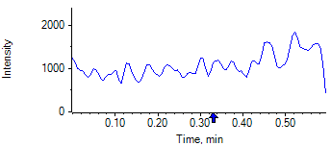

PCP 2 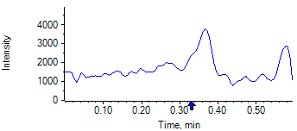

PCP D5 1 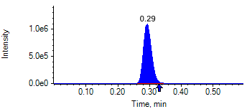

PCP D5 1 

Benzoylecgonine 1 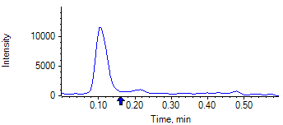

Benzoylecgonine 2 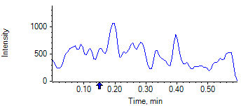

Benzoylecgonine D3 1 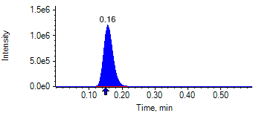

Benzoylecgonine D3 1 

|  |  |  |  |
| --- | --- | --- | --- |
| **Acquisition Method** | PCP_BE_041422Final.dam | **Data File** | SAMPLE044.wiff |
| **Sample Name** | **DL916828S05** | **Injection Volume** | 10.00 |
| **Sample Type** | Unknown | **Injection Vial** | 39 |
| **Injection Date** | 4/30/2025 8:12:51 PM | **Dilution Factor** | 1.00 |
| **Instrument Name** | Triple Quad 5500+ | **Instrument Serial** | EX231582110 |

**Results Summary**

*DL916828S05*

| **Peak Name** | **Integration Type** | **Transition** | **Retention Time** | **Rel RT** | **Peak Area** | **Area Ratio** | **Calculated Concentration (ng/mL)** | **Expected Ion Ratio** | **Calculated  Ion Ratio** | **Ratio Confirms ID** |
| --- | --- | --- | --- | --- | --- | --- | --- | --- | --- | --- |

|  |  |  |  |  |  |  |  |  |  |  |
| --- | --- | --- | --- | --- | --- | --- | --- | --- | --- | --- |
| PCP 1 | N/A | 243.8 / 159.0 | N/A | N/A* | N/A | N/A | N/A |  |  |  |

|  |  |  |  |  |  |  |  |  |  |  |
| --- | --- | --- | --- | --- | --- | --- | --- | --- | --- | --- |
| PCP 2 | N/A | 243.8 / 91.0 | N/A | N/A* | N/A | N/A |  | 59.4% | 0.0% | NO |

|  |  |  |  |  |  |  |  |  |  |  |
| --- | --- | --- | --- | --- | --- | --- | --- | --- | --- | --- |
| Benzoylecgonine 1 | N/A | 289.8 / 168.1 | N/A | N/A* | N/A | N/A | N/A |  |  |  |

|  |  |  |  |  |  |  |  |  |  |  |
| --- | --- | --- | --- | --- | --- | --- | --- | --- | --- | --- |
| Benzoylecgonine 2 | N/A | 289.8 / 104.9 | N/A | N/A* | N/A | N/A |  | 71.7% | 0.0% | NO |

**Internal Standard Data**

|  |  |  |  |  |  |  |  |  |  |
| --- | --- | --- | --- | --- | --- | --- | --- | --- | --- |
| **Internal Standard Name** | **Integration Type** | **Transition** | **Retention Time** | **Avg IS Retention Time** | **IS Peak Area** | **IS Area Within Range** | **Expected Ion Ratio** | **Calculated  Ion Ratio** | **Ratio Confirms ID** |

|  |  |  |  |  |  |  |  |  |  |
| --- | --- | --- | --- | --- | --- | --- | --- | --- | --- |
| PCP D5 1 | Baseline | 248.8 / 164.1 | 0.35* | 0.32 | 1.765e6 | ✓ |  |  |  |

|  |  |  |  |  |  |  |  |  |  |
| --- | --- | --- | --- | --- | --- | --- | --- | --- | --- |
| PCP D5 1 | Baseline | 248.8 / 164.1 | 0.35* | 0.32 | 1.765e6 |  | 100.0% | 100.0% | ✓ |

|  |  |  |  |  |  |  |  |  |  |
| --- | --- | --- | --- | --- | --- | --- | --- | --- | --- |
| Benzoylecgonine D3 1 | Baseline | 292.8 / 171.2 | 0.20* | 0.18 | 1.704e6 | ✓ |  |  |  |

|  |  |  |  |  |  |  |  |  |  |
| --- | --- | --- | --- | --- | --- | --- | --- | --- | --- |
| Benzoylecgonine D3 1 | Baseline | 292.8 / 171.2 | 0.20* | 0.18 | 1.704e6 |  | 100.0% | 100.0% | ✓ |

**Peak Review**

PCP 1 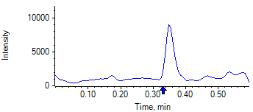

PCP 2 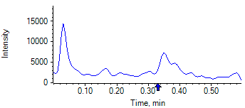

PCP D5 1 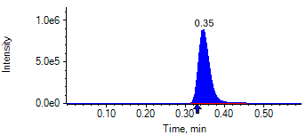

PCP D5 1 

Benzoylecgonine 1 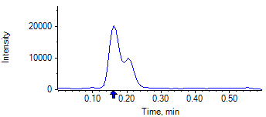

Benzoylecgonine 2 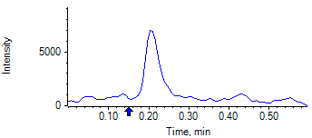

Benzoylecgonine D3 1 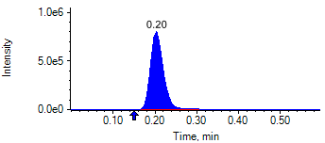

Benzoylecgonine D3 1 

|  |  |  |  |
| --- | --- | --- | --- |
| **Acquisition Method** | PCP_BE_041422Final.dam | **Data File** | SAMPLE045.wiff |
| **Sample Name** | **DL920583S05** | **Injection Volume** | 10.00 |
| **Sample Type** | Unknown | **Injection Vial** | 40 |
| **Injection Date** | 4/30/2025 8:14:04 PM | **Dilution Factor** | 1.00 |
| **Instrument Name** | Triple Quad 5500+ | **Instrument Serial** | EX231582110 |

**Results Summary**

*DL920583S05*

| **Peak Name** | **Integration Type** | **Transition** | **Retention Time** | **Rel RT** | **Peak Area** | **Area Ratio** | **Calculated Concentration (ng/mL)** | **Expected Ion Ratio** | **Calculated  Ion Ratio** | **Ratio Confirms ID** |
| --- | --- | --- | --- | --- | --- | --- | --- | --- | --- | --- |

|  |  |  |  |  |  |  |  |  |  |  |
| --- | --- | --- | --- | --- | --- | --- | --- | --- | --- | --- |
| PCP 1 | N/A | 243.8 / 159.0 | N/A | N/A* | N/A | N/A | N/A |  |  |  |

|  |  |  |  |  |  |  |  |  |  |  |
| --- | --- | --- | --- | --- | --- | --- | --- | --- | --- | --- |
| PCP 2 | N/A | 243.8 / 91.0 | N/A | N/A* | N/A | N/A |  | 59.4% | 0.0% | NO |

|  |  |  |  |  |  |  |  |  |  |  |
| --- | --- | --- | --- | --- | --- | --- | --- | --- | --- | --- |
| Benzoylecgonine 1 | N/A | 289.8 / 168.1 | N/A | N/A* | N/A | N/A | N/A |  |  |  |

|  |  |  |  |  |  |  |  |  |  |  |
| --- | --- | --- | --- | --- | --- | --- | --- | --- | --- | --- |
| Benzoylecgonine 2 | N/A | 289.8 / 104.9 | N/A | N/A* | N/A | N/A |  | 71.7% | 0.0% | NO |

**Internal Standard Data**

|  |  |  |  |  |  |  |  |  |  |
| --- | --- | --- | --- | --- | --- | --- | --- | --- | --- |
| **Internal Standard Name** | **Integration Type** | **Transition** | **Retention Time** | **Avg IS Retention Time** | **IS Peak Area** | **IS Area Within Range** | **Expected Ion Ratio** | **Calculated  Ion Ratio** | **Ratio Confirms ID** |

|  |  |  |  |  |  |  |  |  |  |
| --- | --- | --- | --- | --- | --- | --- | --- | --- | --- |
| PCP D5 1 | Baseline | 248.8 / 164.1 | 0.32 | 0.32 | 1.765e6 | ✓ |  |  |  |

|  |  |  |  |  |  |  |  |  |  |
| --- | --- | --- | --- | --- | --- | --- | --- | --- | --- |
| PCP D5 1 | Baseline | 248.8 / 164.1 | 0.32 | 0.32 | 1.765e6 |  | 100.0% | 100.0% | ✓ |

|  |  |  |  |  |  |  |  |  |  |
| --- | --- | --- | --- | --- | --- | --- | --- | --- | --- |
| Benzoylecgonine D3 1 | Baseline | 292.8 / 171.2 | 0.18 | 0.18 | 1.183e6 | ✓ |  |  |  |

|  |  |  |  |  |  |  |  |  |  |
| --- | --- | --- | --- | --- | --- | --- | --- | --- | --- |
| Benzoylecgonine D3 1 | Baseline | 292.8 / 171.2 | 0.18 | 0.18 | 1.183e6 |  | 100.0% | 100.0% | ✓ |

**Peak Review**

PCP 1 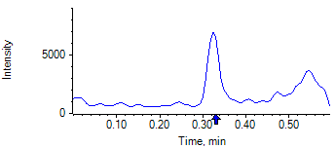

PCP 2 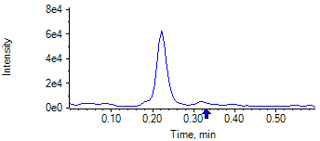

PCP D5 1 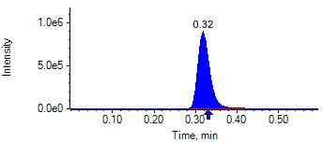

PCP D5 1 

Benzoylecgonine 1 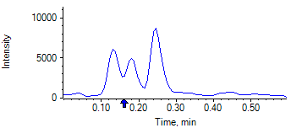

Benzoylecgonine 2 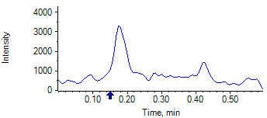

Benzoylecgonine D3 1 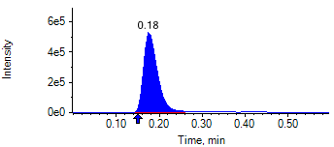

Benzoylecgonine D3 1 

|  |  |  |  |
| --- | --- | --- | --- |
| **Acquisition Method** | PCP_BE_041422Final.dam | **Data File** | SAMPLE046.wiff |
| **Sample Name** | **DL916890S05** | **Injection Volume** | 10.00 |
| **Sample Type** | Unknown | **Injection Vial** | 41 |
| **Injection Date** | 4/30/2025 8:15:14 PM | **Dilution Factor** | 1.00 |
| **Instrument Name** | Triple Quad 5500+ | **Instrument Serial** | EX231582110 |

**Results Summary**

*DL916890S05*

| **Peak Name** | **Integration Type** | **Transition** | **Retention Time** | **Rel RT** | **Peak Area** | **Area Ratio** | **Calculated Concentration (ng/mL)** | **Expected Ion Ratio** | **Calculated  Ion Ratio** | **Ratio Confirms ID** |
| --- | --- | --- | --- | --- | --- | --- | --- | --- | --- | --- |

|  |  |  |  |  |  |  |  |  |  |  |
| --- | --- | --- | --- | --- | --- | --- | --- | --- | --- | --- |
| PCP 1 | N/A | 243.8 / 159.0 | N/A | N/A* | N/A | N/A | N/A |  |  |  |

|  |  |  |  |  |  |  |  |  |  |  |
| --- | --- | --- | --- | --- | --- | --- | --- | --- | --- | --- |
| PCP 2 | N/A | 243.8 / 91.0 | N/A | N/A* | N/A | N/A |  | 59.4% | 0.0% | NO |

|  |  |  |  |  |  |  |  |  |  |  |
| --- | --- | --- | --- | --- | --- | --- | --- | --- | --- | --- |
| Benzoylecgonine 1 | N/A | 289.8 / 168.1 | N/A | N/A* | N/A | N/A | N/A |  |  |  |

|  |  |  |  |  |  |  |  |  |  |  |
| --- | --- | --- | --- | --- | --- | --- | --- | --- | --- | --- |
| Benzoylecgonine 2 | N/A | 289.8 / 104.9 | N/A | N/A* | N/A | N/A |  | 71.7% | 0.0% | NO |

**Internal Standard Data**

|  |  |  |  |  |  |  |  |  |  |
| --- | --- | --- | --- | --- | --- | --- | --- | --- | --- |
| **Internal Standard Name** | **Integration Type** | **Transition** | **Retention Time** | **Avg IS Retention Time** | **IS Peak Area** | **IS Area Within Range** | **Expected Ion Ratio** | **Calculated  Ion Ratio** | **Ratio Confirms ID** |

|  |  |  |  |  |  |  |  |  |  |
| --- | --- | --- | --- | --- | --- | --- | --- | --- | --- |
| PCP D5 1 | Baseline | 248.8 / 164.1 | 0.30* | 0.32 | 1.514e6 | ✓ |  |  |  |

|  |  |  |  |  |  |  |  |  |  |
| --- | --- | --- | --- | --- | --- | --- | --- | --- | --- |
| PCP D5 1 | Baseline | 248.8 / 164.1 | 0.30* | 0.32 | 1.514e6 |  | 100.0% | 100.0% | ✓ |

|  |  |  |  |  |  |  |  |  |  |
| --- | --- | --- | --- | --- | --- | --- | --- | --- | --- |
| Benzoylecgonine D3 1 | Valley | 292.8 / 171.2 | 0.16* | 0.18 | 1.744e6 | ✓ |  |  |  |

|  |  |  |  |  |  |  |  |  |  |
| --- | --- | --- | --- | --- | --- | --- | --- | --- | --- |
| Benzoylecgonine D3 1 | Valley | 292.8 / 171.2 | 0.16* | 0.18 | 1.744e6 |  | 100.0% | 100.0% | ✓ |

**Peak Review**

PCP 1 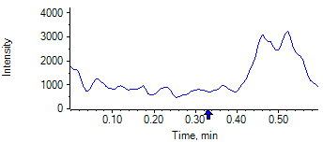

PCP 2 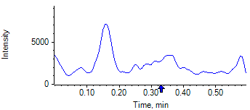

PCP D5 1 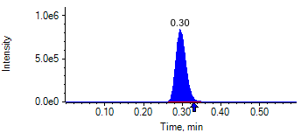

PCP D5 1 

Benzoylecgonine 1 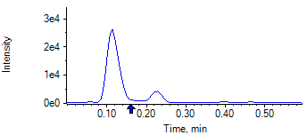

Benzoylecgonine 2 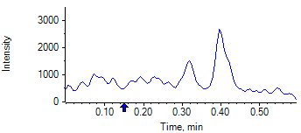

Benzoylecgonine D3 1 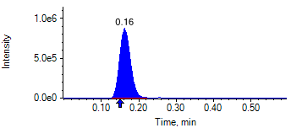

Benzoylecgonine D3 1 

|  |  |  |  |
| --- | --- | --- | --- |
| **Acquisition Method** | PCP_BE_041422Final.dam | **Data File** | SAMPLE047.wiff |
| **Sample Name** | **DL916590S05** | **Injection Volume** | 10.00 |
| **Sample Type** | Unknown | **Injection Vial** | 42 |
| **Injection Date** | 4/30/2025 8:16:24 PM | **Dilution Factor** | 1.00 |
| **Instrument Name** | Triple Quad 5500+ | **Instrument Serial** | EX231582110 |

**Results Summary**

*DL916590S05*

| **Peak Name** | **Integration Type** | **Transition** | **Retention Time** | **Rel RT** | **Peak Area** | **Area Ratio** | **Calculated Concentration (ng/mL)** | **Expected Ion Ratio** | **Calculated  Ion Ratio** | **Ratio Confirms ID** |
| --- | --- | --- | --- | --- | --- | --- | --- | --- | --- | --- |

|  |  |  |  |  |  |  |  |  |  |  |
| --- | --- | --- | --- | --- | --- | --- | --- | --- | --- | --- |
| PCP 1 | N/A | 243.8 / 159.0 | N/A | N/A* | N/A | N/A | N/A |  |  |  |

|  |  |  |  |  |  |  |  |  |  |  |
| --- | --- | --- | --- | --- | --- | --- | --- | --- | --- | --- |
| PCP 2 | N/A | 243.8 / 91.0 | N/A | N/A* | N/A | N/A |  | 59.4% | 0.0% | NO |

|  |  |  |  |  |  |  |  |  |  |  |
| --- | --- | --- | --- | --- | --- | --- | --- | --- | --- | --- |
| Benzoylecgonine 1 | N/A | 289.8 / 168.1 | N/A | N/A* | N/A | N/A | N/A |  |  |  |

|  |  |  |  |  |  |  |  |  |  |  |
| --- | --- | --- | --- | --- | --- | --- | --- | --- | --- | --- |
| Benzoylecgonine 2 | N/A | 289.8 / 104.9 | N/A | N/A* | N/A | N/A |  | 71.7% | 0.0% | NO |

**Internal Standard Data**

|  |  |  |  |  |  |  |  |  |  |
| --- | --- | --- | --- | --- | --- | --- | --- | --- | --- |
| **Internal Standard Name** | **Integration Type** | **Transition** | **Retention Time** | **Avg IS Retention Time** | **IS Peak Area** | **IS Area Within Range** | **Expected Ion Ratio** | **Calculated  Ion Ratio** | **Ratio Confirms ID** |

|  |  |  |  |  |  |  |  |  |  |
| --- | --- | --- | --- | --- | --- | --- | --- | --- | --- |
| PCP D5 1 | Baseline | 248.8 / 164.1 | 0.31* | 0.32 | 1.589e6 | ✓ |  |  |  |

|  |  |  |  |  |  |  |  |  |  |
| --- | --- | --- | --- | --- | --- | --- | --- | --- | --- |
| PCP D5 1 | Baseline | 248.8 / 164.1 | 0.31* | 0.32 | 1.589e6 |  | 100.0% | 100.0% | ✓ |

|  |  |  |  |  |  |  |  |  |  |
| --- | --- | --- | --- | --- | --- | --- | --- | --- | --- |
| Benzoylecgonine D3 1 | Baseline | 292.8 / 171.2 | 0.17* | 0.18 | 1.788e6 | ✓ |  |  |  |

|  |  |  |  |  |  |  |  |  |  |
| --- | --- | --- | --- | --- | --- | --- | --- | --- | --- |
| Benzoylecgonine D3 1 | Baseline | 292.8 / 171.2 | 0.17* | 0.18 | 1.788e6 |  | 100.0% | 100.0% | ✓ |

**Peak Review**

PCP 1 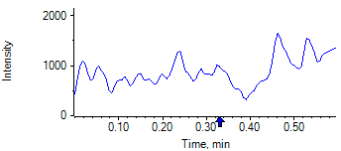

PCP 2 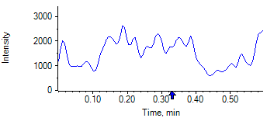

PCP D5 1 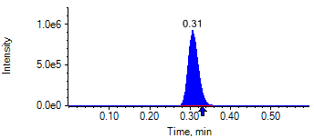

PCP D5 1 

Benzoylecgonine 1 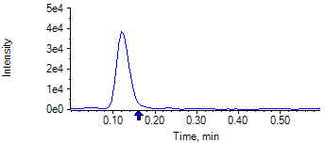

Benzoylecgonine 2 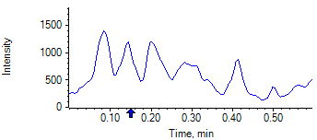

Benzoylecgonine D3 1 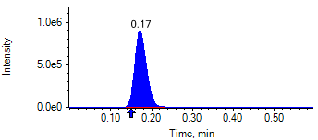

Benzoylecgonine D3 1 

|  |  |  |  |
| --- | --- | --- | --- |
| **Acquisition Method** | PCP_BE_041422Final.dam | **Data File** | SAMPLE048.wiff |
| **Sample Name** | **DL916798S05** | **Injection Volume** | 10.00 |
| **Sample Type** | Unknown | **Injection Vial** | 43 |
| **Injection Date** | 4/30/2025 8:17:35 PM | **Dilution Factor** | 1.00 |
| **Instrument Name** | Triple Quad 5500+ | **Instrument Serial** | EX231582110 |

**Results Summary**

*DL916798S05*

| **Peak Name** | **Integration Type** | **Transition** | **Retention Time** | **Rel RT** | **Peak Area** | **Area Ratio** | **Calculated Concentration (ng/mL)** | **Expected Ion Ratio** | **Calculated  Ion Ratio** | **Ratio Confirms ID** |
| --- | --- | --- | --- | --- | --- | --- | --- | --- | --- | --- |

|  |  |  |  |  |  |  |  |  |  |  |
| --- | --- | --- | --- | --- | --- | --- | --- | --- | --- | --- |
| PCP 1 | N/A | 243.8 / 159.0 | N/A | N/A* | N/A | N/A | N/A |  |  |  |

|  |  |  |  |  |  |  |  |  |  |  |
| --- | --- | --- | --- | --- | --- | --- | --- | --- | --- | --- |
| PCP 2 | N/A | 243.8 / 91.0 | N/A | N/A* | N/A | N/A |  | 59.4% | 0.0% | NO |

|  |  |  |  |  |  |  |  |  |  |  |
| --- | --- | --- | --- | --- | --- | --- | --- | --- | --- | --- |
| Benzoylecgonine 1 | N/A | 289.8 / 168.1 | N/A | N/A* | N/A | N/A | N/A |  |  |  |

|  |  |  |  |  |  |  |  |  |  |  |
| --- | --- | --- | --- | --- | --- | --- | --- | --- | --- | --- |
| Benzoylecgonine 2 | N/A | 289.8 / 104.9 | N/A | N/A* | N/A | N/A |  | 71.7% | 0.0% | NO |

**Internal Standard Data**

|  |  |  |  |  |  |  |  |  |  |
| --- | --- | --- | --- | --- | --- | --- | --- | --- | --- |
| **Internal Standard Name** | **Integration Type** | **Transition** | **Retention Time** | **Avg IS Retention Time** | **IS Peak Area** | **IS Area Within Range** | **Expected Ion Ratio** | **Calculated  Ion Ratio** | **Ratio Confirms ID** |

|  |  |  |  |  |  |  |  |  |  |
| --- | --- | --- | --- | --- | --- | --- | --- | --- | --- |
| PCP D5 1 | Baseline | 248.8 / 164.1 | 0.35* | 0.32 | 1.919e6 | ✓ |  |  |  |

|  |  |  |  |  |  |  |  |  |  |
| --- | --- | --- | --- | --- | --- | --- | --- | --- | --- |
| PCP D5 1 | Baseline | 248.8 / 164.1 | 0.35* | 0.32 | 1.919e6 |  | 100.0% | 100.0% | ✓ |

|  |  |  |  |  |  |  |  |  |  |
| --- | --- | --- | --- | --- | --- | --- | --- | --- | --- |
| Benzoylecgonine D3 1 | Baseline | 292.8 / 171.2 | 0.20* | 0.18 | 2.200e6 | ✓ |  |  |  |

|  |  |  |  |  |  |  |  |  |  |
| --- | --- | --- | --- | --- | --- | --- | --- | --- | --- |
| Benzoylecgonine D3 1 | Baseline | 292.8 / 171.2 | 0.20* | 0.18 | 2.200e6 |  | 100.0% | 100.0% | ✓ |

**Peak Review**

PCP 1 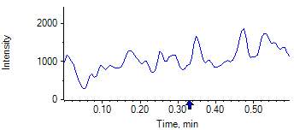

PCP 2 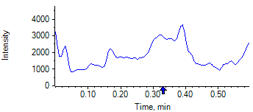

PCP D5 1 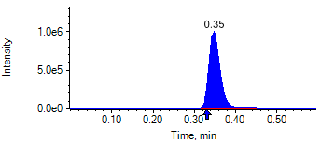

PCP D5 1 

Benzoylecgonine 1 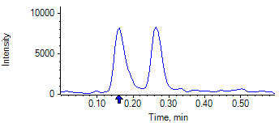

Benzoylecgonine 2 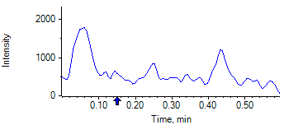

Benzoylecgonine D3 1 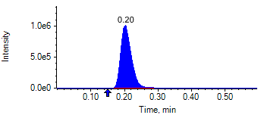

Benzoylecgonine D3 1 

|  |  |  |  |
| --- | --- | --- | --- |
| **Acquisition Method** | PCP_BE_041422Final.dam | **Data File** | SAMPLE049.wiff |
| **Sample Name** | **DL916927S05** | **Injection Volume** | 10.00 |
| **Sample Type** | Unknown | **Injection Vial** | 44 |
| **Injection Date** | 4/30/2025 8:18:47 PM | **Dilution Factor** | 1.00 |
| **Instrument Name** | Triple Quad 5500+ | **Instrument Serial** | EX231582110 |

**Results Summary**

*DL916927S05*

| **Peak Name** | **Integration Type** | **Transition** | **Retention Time** | **Rel RT** | **Peak Area** | **Area Ratio** | **Calculated Concentration (ng/mL)** | **Expected Ion Ratio** | **Calculated  Ion Ratio** | **Ratio Confirms ID** |
| --- | --- | --- | --- | --- | --- | --- | --- | --- | --- | --- |

|  |  |  |  |  |  |  |  |  |  |  |
| --- | --- | --- | --- | --- | --- | --- | --- | --- | --- | --- |
| PCP 1 | N/A | 243.8 / 159.0 | N/A | N/A* | N/A | N/A | N/A |  |  |  |

|  |  |  |  |  |  |  |  |  |  |  |
| --- | --- | --- | --- | --- | --- | --- | --- | --- | --- | --- |
| PCP 2 | N/A | 243.8 / 91.0 | N/A | N/A* | N/A | N/A |  | 59.4% | 0.0% | NO |

|  |  |  |  |  |  |  |  |  |  |  |
| --- | --- | --- | --- | --- | --- | --- | --- | --- | --- | --- |
| Benzoylecgonine 1 | N/A | 289.8 / 168.1 | N/A | N/A* | N/A | N/A | N/A |  |  |  |

|  |  |  |  |  |  |  |  |  |  |  |
| --- | --- | --- | --- | --- | --- | --- | --- | --- | --- | --- |
| Benzoylecgonine 2 | N/A | 289.8 / 104.9 | N/A | N/A* | N/A | N/A |  | 71.7% | 0.0% | NO |

**Internal Standard Data**

|  |  |  |  |  |  |  |  |  |  |
| --- | --- | --- | --- | --- | --- | --- | --- | --- | --- |
| **Internal Standard Name** | **Integration Type** | **Transition** | **Retention Time** | **Avg IS Retention Time** | **IS Peak Area** | **IS Area Within Range** | **Expected Ion Ratio** | **Calculated  Ion Ratio** | **Ratio Confirms ID** |

|  |  |  |  |  |  |  |  |  |  |
| --- | --- | --- | --- | --- | --- | --- | --- | --- | --- |
| PCP D5 1 | Baseline | 248.8 / 164.1 | 0.32 | 0.32 | 1.493e6 | ✓ |  |  |  |

|  |  |  |  |  |  |  |  |  |  |
| --- | --- | --- | --- | --- | --- | --- | --- | --- | --- |
| PCP D5 1 | Baseline | 248.8 / 164.1 | 0.32 | 0.32 | 1.493e6 |  | 100.0% | 100.0% | ✓ |

|  |  |  |  |  |  |  |  |  |  |
| --- | --- | --- | --- | --- | --- | --- | --- | --- | --- |
| Benzoylecgonine D3 1 | Baseline | 292.8 / 171.2 | 0.18 | 0.18 | 1.572e6 | ✓ |  |  |  |

|  |  |  |  |  |  |  |  |  |  |
| --- | --- | --- | --- | --- | --- | --- | --- | --- | --- |
| Benzoylecgonine D3 1 | Baseline | 292.8 / 171.2 | 0.18 | 0.18 | 1.572e6 |  | 100.0% | 100.0% | ✓ |

**Peak Review**

PCP 1 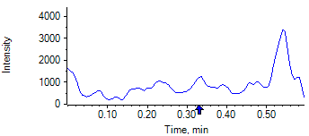

PCP 2 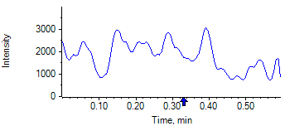

PCP D5 1 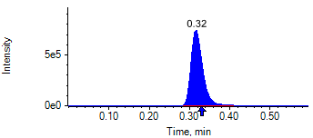

PCP D5 1 

Benzoylecgonine 1 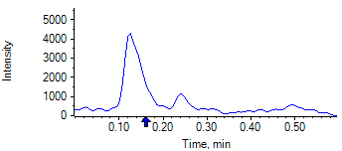

Benzoylecgonine 2 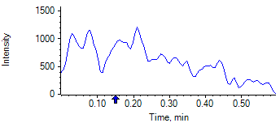

Benzoylecgonine D3 1 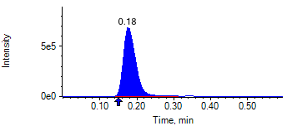

Benzoylecgonine D3 1 

|  |  |  |  |
| --- | --- | --- | --- |
| **Acquisition Method** | PCP_BE_041422Final.dam | **Data File** | SAMPLE050.wiff |
| **Sample Name** | **DL923774S05** | **Injection Volume** | 10.00 |
| **Sample Type** | Unknown | **Injection Vial** | 45 |
| **Injection Date** | 4/30/2025 8:19:55 PM | **Dilution Factor** | 1.00 |
| **Instrument Name** | Triple Quad 5500+ | **Instrument Serial** | EX231582110 |

**Results Summary**

*DL923774S05*

| **Peak Name** | **Integration Type** | **Transition** | **Retention Time** | **Rel RT** | **Peak Area** | **Area Ratio** | **Calculated Concentration (ng/mL)** | **Expected Ion Ratio** | **Calculated  Ion Ratio** | **Ratio Confirms ID** |
| --- | --- | --- | --- | --- | --- | --- | --- | --- | --- | --- |

|  |  |  |  |  |  |  |  |  |  |  |
| --- | --- | --- | --- | --- | --- | --- | --- | --- | --- | --- |
| PCP 1 | N/A | 243.8 / 159.0 | N/A | N/A* | N/A | N/A | N/A |  |  |  |

|  |  |  |  |  |  |  |  |  |  |  |
| --- | --- | --- | --- | --- | --- | --- | --- | --- | --- | --- |
| PCP 2 | N/A | 243.8 / 91.0 | N/A | N/A* | N/A | N/A |  | 59.4% | 0.0% | NO |

|  |  |  |  |  |  |  |  |  |  |  |
| --- | --- | --- | --- | --- | --- | --- | --- | --- | --- | --- |
| Benzoylecgonine 1 | N/A | 289.8 / 168.1 | N/A | N/A* | N/A | N/A | N/A |  |  |  |

|  |  |  |  |  |  |  |  |  |  |  |
| --- | --- | --- | --- | --- | --- | --- | --- | --- | --- | --- |
| Benzoylecgonine 2 | N/A | 289.8 / 104.9 | N/A | N/A* | N/A | N/A |  | 71.7% | 0.0% | NO |

**Internal Standard Data**

|  |  |  |  |  |  |  |  |  |  |
| --- | --- | --- | --- | --- | --- | --- | --- | --- | --- |
| **Internal Standard Name** | **Integration Type** | **Transition** | **Retention Time** | **Avg IS Retention Time** | **IS Peak Area** | **IS Area Within Range** | **Expected Ion Ratio** | **Calculated  Ion Ratio** | **Ratio Confirms ID** |

|  |  |  |  |  |  |  |  |  |  |
| --- | --- | --- | --- | --- | --- | --- | --- | --- | --- |
| PCP D5 1 | Baseline | 248.8 / 164.1 | 0.30* | 0.32 | 1.429e6 | ✓ |  |  |  |

|  |  |  |  |  |  |  |  |  |  |
| --- | --- | --- | --- | --- | --- | --- | --- | --- | --- |
| PCP D5 1 | Baseline | 248.8 / 164.1 | 0.30* | 0.32 | 1.429e6 |  | 100.0% | 100.0% | ✓ |

|  |  |  |  |  |  |  |  |  |  |
| --- | --- | --- | --- | --- | --- | --- | --- | --- | --- |
| Benzoylecgonine D3 1 | Baseline | 292.8 / 171.2 | 0.16* | 0.18 | 1.457e6 | ✓ |  |  |  |

|  |  |  |  |  |  |  |  |  |  |
| --- | --- | --- | --- | --- | --- | --- | --- | --- | --- |
| Benzoylecgonine D3 1 | Baseline | 292.8 / 171.2 | 0.16* | 0.18 | 1.457e6 |  | 100.0% | 100.0% | ✓ |

**Peak Review**

PCP 1 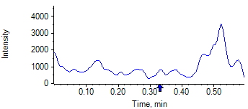

PCP 2 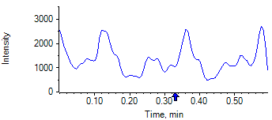

PCP D5 1 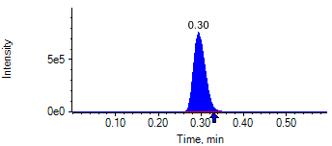

PCP D5 1 

Benzoylecgonine 1 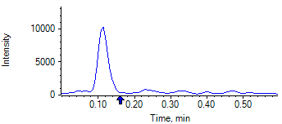

Benzoylecgonine 2 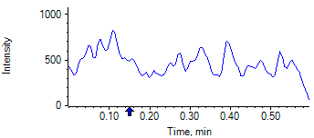

Benzoylecgonine D3 1 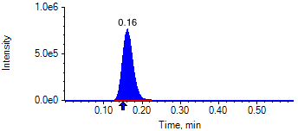

Benzoylecgonine D3 1 

|  |  |  |  |
| --- | --- | --- | --- |
| **Acquisition Method** | PCP_BE_041422Final.dam | **Data File** | SAMPLE051.wiff |
| **Sample Name** | **DL914108S02** | **Injection Volume** | 10.00 |
| **Sample Type** | Unknown | **Injection Vial** | 46 |
| **Injection Date** | 4/30/2025 8:21:08 PM | **Dilution Factor** | 1.00 |
| **Instrument Name** | Triple Quad 5500+ | **Instrument Serial** | EX231582110 |

**Results Summary**

*DL914108S02*

| **Peak Name** | **Integration Type** | **Transition** | **Retention Time** | **Rel RT** | **Peak Area** | **Area Ratio** | **Calculated Concentration (ng/mL)** | **Expected Ion Ratio** | **Calculated  Ion Ratio** | **Ratio Confirms ID** |
| --- | --- | --- | --- | --- | --- | --- | --- | --- | --- | --- |

|  |  |  |  |  |  |  |  |  |  |  |
| --- | --- | --- | --- | --- | --- | --- | --- | --- | --- | --- |
| PCP 1 | N/A | 243.8 / 159.0 | N/A | N/A* | N/A | N/A | N/A |  |  |  |

|  |  |  |  |  |  |  |  |  |  |  |
| --- | --- | --- | --- | --- | --- | --- | --- | --- | --- | --- |
| PCP 2 | N/A | 243.8 / 91.0 | N/A | N/A* | N/A | N/A |  | 59.4% | 0.0% | NO |

|  |  |  |  |  |  |  |  |  |  |  |
| --- | --- | --- | --- | --- | --- | --- | --- | --- | --- | --- |
| Benzoylecgonine 1 | N/A | 289.8 / 168.1 | N/A | N/A* | N/A | N/A | N/A |  |  |  |

|  |  |  |  |  |  |  |  |  |  |  |
| --- | --- | --- | --- | --- | --- | --- | --- | --- | --- | --- |
| Benzoylecgonine 2 | N/A | 289.8 / 104.9 | N/A | N/A* | N/A | N/A |  | 71.7% | 0.0% | NO |

**Internal Standard Data**

|  |  |  |  |  |  |  |  |  |  |
| --- | --- | --- | --- | --- | --- | --- | --- | --- | --- |
| **Internal Standard Name** | **Integration Type** | **Transition** | **Retention Time** | **Avg IS Retention Time** | **IS Peak Area** | **IS Area Within Range** | **Expected Ion Ratio** | **Calculated  Ion Ratio** | **Ratio Confirms ID** |

|  |  |  |  |  |  |  |  |  |  |
| --- | --- | --- | --- | --- | --- | --- | --- | --- | --- |
| PCP D5 1 | Baseline | 248.8 / 164.1 | 0.29* | 0.32 | 1.876e6 | ✓ |  |  |  |

|  |  |  |  |  |  |  |  |  |  |
| --- | --- | --- | --- | --- | --- | --- | --- | --- | --- |
| PCP D5 1 | Baseline | 248.8 / 164.1 | 0.29* | 0.32 | 1.876e6 |  | 100.0% | 100.0% | ✓ |

|  |  |  |  |  |  |  |  |  |  |
| --- | --- | --- | --- | --- | --- | --- | --- | --- | --- |
| Benzoylecgonine D3 1 | Baseline | 292.8 / 171.2 | 0.16* | 0.18 | 2.170e6 | ✓ |  |  |  |

|  |  |  |  |  |  |  |  |  |  |
| --- | --- | --- | --- | --- | --- | --- | --- | --- | --- |
| Benzoylecgonine D3 1 | Baseline | 292.8 / 171.2 | 0.16* | 0.18 | 2.170e6 |  | 100.0% | 100.0% | ✓ |

**Peak Review**

PCP 1 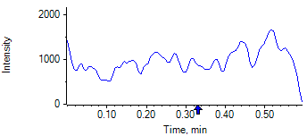

PCP 2 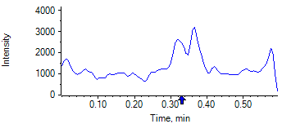

PCP D5 1 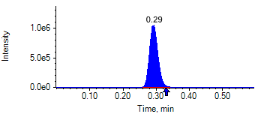

PCP D5 1 

Benzoylecgonine 1 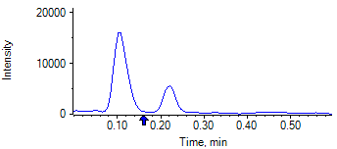

Benzoylecgonine 2 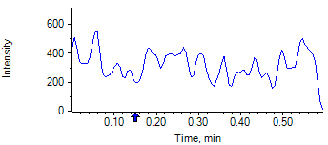

Benzoylecgonine D3 1 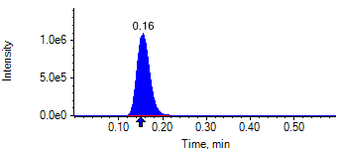

Benzoylecgonine D3 1 

|  |  |  |  |
| --- | --- | --- | --- |
| **Acquisition Method** | PCP_BE_041422Final.dam | **Data File** | SAMPLE052.wiff |
| **Sample Name** | **DL915698S03** | **Injection Volume** | 10.00 |
| **Sample Type** | Unknown | **Injection Vial** | 47 |
| **Injection Date** | 4/30/2025 8:22:18 PM | **Dilution Factor** | 1.00 |
| **Instrument Name** | Triple Quad 5500+ | **Instrument Serial** | EX231582110 |

**Results Summary**

*DL915698S03*

| **Peak Name** | **Integration Type** | **Transition** | **Retention Time** | **Rel RT** | **Peak Area** | **Area Ratio** | **Calculated Concentration (ng/mL)** | **Expected Ion Ratio** | **Calculated  Ion Ratio** | **Ratio Confirms ID** |
| --- | --- | --- | --- | --- | --- | --- | --- | --- | --- | --- |

|  |  |  |  |  |  |  |  |  |  |  |
| --- | --- | --- | --- | --- | --- | --- | --- | --- | --- | --- |
| PCP 1 | N/A | 243.8 / 159.0 | N/A | N/A* | N/A | N/A | N/A |  |  |  |

|  |  |  |  |  |  |  |  |  |  |  |
| --- | --- | --- | --- | --- | --- | --- | --- | --- | --- | --- |
| PCP 2 | N/A | 243.8 / 91.0 | N/A | N/A* | N/A | N/A |  | 59.4% | 0.0% | NO |

|  |  |  |  |  |  |  |  |  |  |  |
| --- | --- | --- | --- | --- | --- | --- | --- | --- | --- | --- |
| Benzoylecgonine 1 | N/A | 289.8 / 168.1 | N/A | N/A* | N/A | N/A | N/A |  |  |  |

|  |  |  |  |  |  |  |  |  |  |  |
| --- | --- | --- | --- | --- | --- | --- | --- | --- | --- | --- |
| Benzoylecgonine 2 | N/A | 289.8 / 104.9 | N/A | N/A* | N/A | N/A |  | 71.7% | 0.0% | NO |

**Internal Standard Data**

|  |  |  |  |  |  |  |  |  |  |
| --- | --- | --- | --- | --- | --- | --- | --- | --- | --- |
| **Internal Standard Name** | **Integration Type** | **Transition** | **Retention Time** | **Avg IS Retention Time** | **IS Peak Area** | **IS Area Within Range** | **Expected Ion Ratio** | **Calculated  Ion Ratio** | **Ratio Confirms ID** |

|  |  |  |  |  |  |  |  |  |  |
| --- | --- | --- | --- | --- | --- | --- | --- | --- | --- |
| PCP D5 1 | Baseline | 248.8 / 164.1 | 0.35* | 0.32 | 1.645e6 | ✓ |  |  |  |

|  |  |  |  |  |  |  |  |  |  |
| --- | --- | --- | --- | --- | --- | --- | --- | --- | --- |
| PCP D5 1 | Baseline | 248.8 / 164.1 | 0.35* | 0.32 | 1.645e6 |  | 100.0% | 100.0% | ✓ |

|  |  |  |  |  |  |  |  |  |  |
| --- | --- | --- | --- | --- | --- | --- | --- | --- | --- |
| Benzoylecgonine D3 1 | Valley | 292.8 / 171.2 | 0.21* | 0.18 | 1.526e6 | ✓ |  |  |  |

|  |  |  |  |  |  |  |  |  |  |
| --- | --- | --- | --- | --- | --- | --- | --- | --- | --- |
| Benzoylecgonine D3 1 | Valley | 292.8 / 171.2 | 0.21* | 0.18 | 1.526e6 |  | 100.0% | 100.0% | ✓ |

**Peak Review**

PCP 1 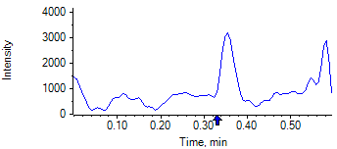

PCP 2 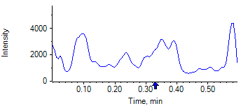

PCP D5 1 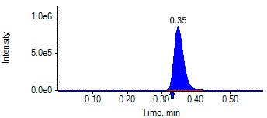

PCP D5 1 

Benzoylecgonine 1 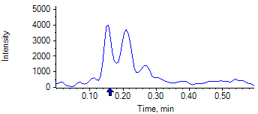

Benzoylecgonine 2 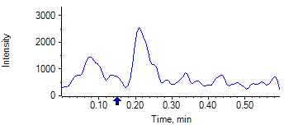

Benzoylecgonine D3 1 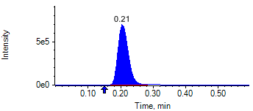

Benzoylecgonine D3 1 

|  |  |  |  |
| --- | --- | --- | --- |
| **Acquisition Method** | PCP_BE_041422Final.dam | **Data File** | SAMPLE053.wiff |
| **Sample Name** | **DL908644S01** | **Injection Volume** | 10.00 |
| **Sample Type** | Unknown | **Injection Vial** | 48 |
| **Injection Date** | 4/30/2025 8:23:29 PM | **Dilution Factor** | 1.00 |
| **Instrument Name** | Triple Quad 5500+ | **Instrument Serial** | EX231582110 |

**Results Summary**

*DL908644S01*

| **Peak Name** | **Integration Type** | **Transition** | **Retention Time** | **Rel RT** | **Peak Area** | **Area Ratio** | **Calculated Concentration (ng/mL)** | **Expected Ion Ratio** | **Calculated  Ion Ratio** | **Ratio Confirms ID** |
| --- | --- | --- | --- | --- | --- | --- | --- | --- | --- | --- |

|  |  |  |  |  |  |  |  |  |  |  |
| --- | --- | --- | --- | --- | --- | --- | --- | --- | --- | --- |
| PCP 1 | N/A | 243.8 / 159.0 | N/A | N/A* | N/A | N/A | N/A |  |  |  |

|  |  |  |  |  |  |  |  |  |  |  |
| --- | --- | --- | --- | --- | --- | --- | --- | --- | --- | --- |
| PCP 2 | N/A | 243.8 / 91.0 | N/A | N/A* | N/A | N/A |  | 59.4% | 0.0% | NO |

|  |  |  |  |  |  |  |  |  |  |  |
| --- | --- | --- | --- | --- | --- | --- | --- | --- | --- | --- |
| Benzoylecgonine 1 | Baseline | 289.8 / 168.1 | 0.18 | 1.03 | 1.421e7 | 16.790 | no root |  |  |  |

|  |  |  |  |  |  |  |  |  |  |  |
| --- | --- | --- | --- | --- | --- | --- | --- | --- | --- | --- |
| Benzoylecgonine 2 | Baseline | 289.8 / 104.9 | 0.18 | 1.02 | 1.018e7 | 12.030 |  | 71.7% | 71.6% | ✓ |

**Internal Standard Data**

|  |  |  |  |  |  |  |  |  |  |
| --- | --- | --- | --- | --- | --- | --- | --- | --- | --- |
| **Internal Standard Name** | **Integration Type** | **Transition** | **Retention Time** | **Avg IS Retention Time** | **IS Peak Area** | **IS Area Within Range** | **Expected Ion Ratio** | **Calculated  Ion Ratio** | **Ratio Confirms ID** |

|  |  |  |  |  |  |  |  |  |  |
| --- | --- | --- | --- | --- | --- | --- | --- | --- | --- |
| PCP D5 1 | Baseline | 248.8 / 164.1 | 0.32 | 0.32 | 1.643e6 | ✓ |  |  |  |

|  |  |  |  |  |  |  |  |  |  |
| --- | --- | --- | --- | --- | --- | --- | --- | --- | --- |
| PCP D5 1 | Baseline | 248.8 / 164.1 | 0.32 | 0.32 | 1.643e6 |  | 100.0% | 100.0% | ✓ |

|  |  |  |  |  |  |  |  |  |  |
| --- | --- | --- | --- | --- | --- | --- | --- | --- | --- |
| Benzoylecgonine D3 1 | Baseline | 292.8 / 171.2 | 0.18 | 0.18 | 8.463e5 | ✓ |  |  |  |

|  |  |  |  |  |  |  |  |  |  |
| --- | --- | --- | --- | --- | --- | --- | --- | --- | --- |
| Benzoylecgonine D3 1 | Baseline | 292.8 / 171.2 | 0.18 | 0.18 | 8.463e5 |  | 100.0% | 100.0% | ✓ |

**Peak Review**

PCP 1 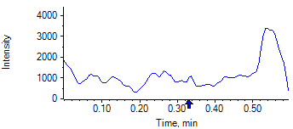

PCP 2 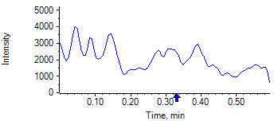

PCP D5 1 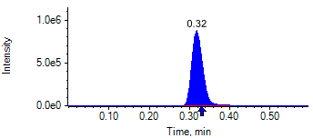

PCP D5 1 

Benzoylecgonine 1 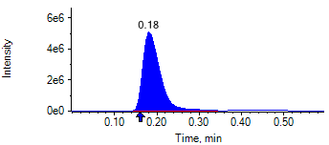

Benzoylecgonine 2 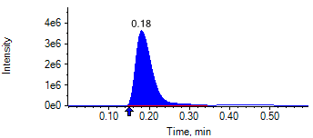

Benzoylecgonine D3 1 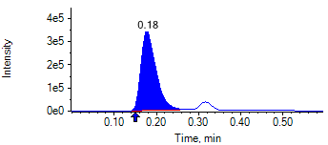

Benzoylecgonine D3 1 

|  |  |  |  |
| --- | --- | --- | --- |
| **Acquisition Method** | PCP_BE_041422Final.dam | **Data File** | SAMPLE054.wiff |
| **Sample Name** | **DL910522S01** | **Injection Volume** | 10.00 |
| **Sample Type** | Unknown | **Injection Vial** | 49 |
| **Injection Date** | 4/30/2025 8:24:40 PM | **Dilution Factor** | 1.00 |
| **Instrument Name** | Triple Quad 5500+ | **Instrument Serial** | EX231582110 |

**Results Summary**

*DL910522S01*

| **Peak Name** | **Integration Type** | **Transition** | **Retention Time** | **Rel RT** | **Peak Area** | **Area Ratio** | **Calculated Concentration (ng/mL)** | **Expected Ion Ratio** | **Calculated  Ion Ratio** | **Ratio Confirms ID** |
| --- | --- | --- | --- | --- | --- | --- | --- | --- | --- | --- |

|  |  |  |  |  |  |  |  |  |  |  |
| --- | --- | --- | --- | --- | --- | --- | --- | --- | --- | --- |
| PCP 1 | N/A | 243.8 / 159.0 | N/A | N/A* | N/A | N/A | N/A |  |  |  |

|  |  |  |  |  |  |  |  |  |  |  |
| --- | --- | --- | --- | --- | --- | --- | --- | --- | --- | --- |
| PCP 2 | N/A | 243.8 / 91.0 | N/A | N/A* | N/A | N/A |  | 59.4% | 0.0% | NO |

|  |  |  |  |  |  |  |  |  |  |  |
| --- | --- | --- | --- | --- | --- | --- | --- | --- | --- | --- |
| Benzoylecgonine 1 | Valley | 289.8 / 168.1 | 0.17 | 1.02 | 1.840e5 | 0.168 | 862.82 |  |  |  |

|  |  |  |  |  |  |  |  |  |  |  |
| --- | --- | --- | --- | --- | --- | --- | --- | --- | --- | --- |
| Benzoylecgonine 2 | Baseline | 289.8 / 104.9 | 0.17 | 1.02 | 1.304e5 | 0.119 |  | 71.7% | 70.9% | ✓ |

**Internal Standard Data**

|  |  |  |  |  |  |  |  |  |  |
| --- | --- | --- | --- | --- | --- | --- | --- | --- | --- |
| **Internal Standard Name** | **Integration Type** | **Transition** | **Retention Time** | **Avg IS Retention Time** | **IS Peak Area** | **IS Area Within Range** | **Expected Ion Ratio** | **Calculated  Ion Ratio** | **Ratio Confirms ID** |

|  |  |  |  |  |  |  |  |  |  |
| --- | --- | --- | --- | --- | --- | --- | --- | --- | --- |
| PCP D5 1 | Baseline | 248.8 / 164.1 | 0.30* | 0.32 | 1.747e6 | ✓ |  |  |  |

|  |  |  |  |  |  |  |  |  |  |
| --- | --- | --- | --- | --- | --- | --- | --- | --- | --- |
| PCP D5 1 | Baseline | 248.8 / 164.1 | 0.30* | 0.32 | 1.747e6 |  | 100.0% | 100.0% | ✓ |

|  |  |  |  |  |  |  |  |  |  |
| --- | --- | --- | --- | --- | --- | --- | --- | --- | --- |
| Benzoylecgonine D3 1 | Baseline | 292.8 / 171.2 | 0.16* | 0.18 | 1.095e6 | ✓ |  |  |  |

|  |  |  |  |  |  |  |  |  |  |
| --- | --- | --- | --- | --- | --- | --- | --- | --- | --- |
| Benzoylecgonine D3 1 | Baseline | 292.8 / 171.2 | 0.16* | 0.18 | 1.095e6 |  | 100.0% | 100.0% | ✓ |

**Peak Review**

PCP 1 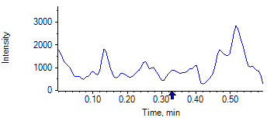

PCP 2 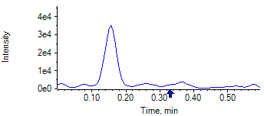

PCP D5 1 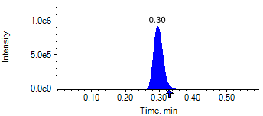

PCP D5 1 

Benzoylecgonine 1 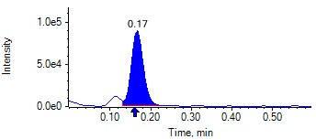

Benzoylecgonine 2 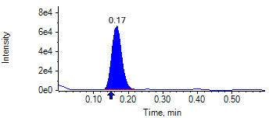

Benzoylecgonine D3 1 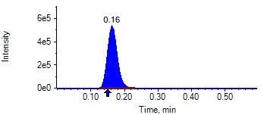

Benzoylecgonine D3 1 

|  |  |  |  |
| --- | --- | --- | --- |
| **Acquisition Method** | PCP_BE_041422Final.dam | **Data File** | SAMPLE055.wiff |
| **Sample Name** | **DL910545S01** | **Injection Volume** | 10.00 |
| **Sample Type** | Unknown | **Injection Vial** | 50 |
| **Injection Date** | 4/30/2025 8:25:50 PM | **Dilution Factor** | 1.00 |
| **Instrument Name** | Triple Quad 5500+ | **Instrument Serial** | EX231582110 |

**Results Summary**

*DL910545S01*

| **Peak Name** | **Integration Type** | **Transition** | **Retention Time** | **Rel RT** | **Peak Area** | **Area Ratio** | **Calculated Concentration (ng/mL)** | **Expected Ion Ratio** | **Calculated  Ion Ratio** | **Ratio Confirms ID** |
| --- | --- | --- | --- | --- | --- | --- | --- | --- | --- | --- |

|  |  |  |  |  |  |  |  |  |  |  |
| --- | --- | --- | --- | --- | --- | --- | --- | --- | --- | --- |
| PCP 1 | N/A | 243.8 / 159.0 | N/A | N/A* | N/A | N/A | N/A |  |  |  |

|  |  |  |  |  |  |  |  |  |  |  |
| --- | --- | --- | --- | --- | --- | --- | --- | --- | --- | --- |
| PCP 2 | N/A | 243.8 / 91.0 | N/A | N/A* | N/A | N/A |  | 59.4% | 0.0% | NO |

|  |  |  |  |  |  |  |  |  |  |  |
| --- | --- | --- | --- | --- | --- | --- | --- | --- | --- | --- |
| Benzoylecgonine 1 | Baseline | 289.8 / 168.1 | 0.16 | 1.03 | 1.761e6 | 1.564 | 8270.70 |  |  |  |

|  |  |  |  |  |  |  |  |  |  |  |
| --- | --- | --- | --- | --- | --- | --- | --- | --- | --- | --- |
| Benzoylecgonine 2 | Baseline | 289.8 / 104.9 | 0.16 | 1.02 | 1.274e6 | 1.131 |  | 71.7% | 72.3% | ✓ |

**Internal Standard Data**

|  |  |  |  |  |  |  |  |  |  |
| --- | --- | --- | --- | --- | --- | --- | --- | --- | --- |
| **Internal Standard Name** | **Integration Type** | **Transition** | **Retention Time** | **Avg IS Retention Time** | **IS Peak Area** | **IS Area Within Range** | **Expected Ion Ratio** | **Calculated  Ion Ratio** | **Ratio Confirms ID** |

|  |  |  |  |  |  |  |  |  |  |
| --- | --- | --- | --- | --- | --- | --- | --- | --- | --- |
| PCP D5 1 | Baseline | 248.8 / 164.1 | 0.29* | 0.32 | 1.786e6 | ✓ |  |  |  |

|  |  |  |  |  |  |  |  |  |  |
| --- | --- | --- | --- | --- | --- | --- | --- | --- | --- |
| PCP D5 1 | Baseline | 248.8 / 164.1 | 0.29* | 0.32 | 1.786e6 |  | 100.0% | 100.0% | ✓ |

|  |  |  |  |  |  |  |  |  |  |
| --- | --- | --- | --- | --- | --- | --- | --- | --- | --- |
| Benzoylecgonine D3 1 | Baseline | 292.8 / 171.2 | 0.16* | 0.18 | 1.126e6 | ✓ |  |  |  |

|  |  |  |  |  |  |  |  |  |  |
| --- | --- | --- | --- | --- | --- | --- | --- | --- | --- |
| Benzoylecgonine D3 1 | Baseline | 292.8 / 171.2 | 0.16* | 0.18 | 1.126e6 |  | 100.0% | 100.0% | ✓ |

**Peak Review**

PCP 1 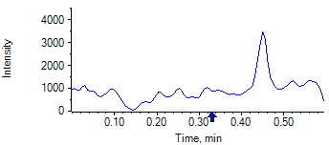

PCP 2 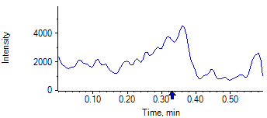

PCP D5 1 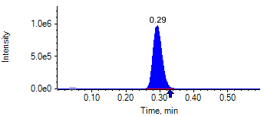

PCP D5 1 

Benzoylecgonine 1 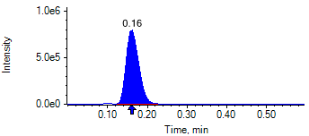

Benzoylecgonine 2 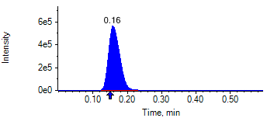

Benzoylecgonine D3 1 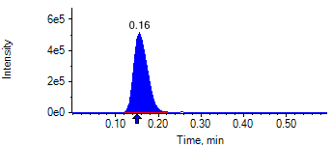

Benzoylecgonine D3 1 

|  |  |  |  |
| --- | --- | --- | --- |
| **Acquisition Method** | PCP_BE_041422Final.dam | **Data File** | SAMPLE056.wiff |
| **Sample Name** | **DL913440S02** | **Injection Volume** | 10.00 |
| **Sample Type** | Unknown | **Injection Vial** | 51 |
| **Injection Date** | 4/30/2025 8:27:04 PM | **Dilution Factor** | 1.00 |
| **Instrument Name** | Triple Quad 5500+ | **Instrument Serial** | EX231582110 |

**Results Summary**

*DL913440S02*

| **Peak Name** | **Integration Type** | **Transition** | **Retention Time** | **Rel RT** | **Peak Area** | **Area Ratio** | **Calculated Concentration (ng/mL)** | **Expected Ion Ratio** | **Calculated  Ion Ratio** | **Ratio Confirms ID** |
| --- | --- | --- | --- | --- | --- | --- | --- | --- | --- | --- |

|  |  |  |  |  |  |  |  |  |  |  |
| --- | --- | --- | --- | --- | --- | --- | --- | --- | --- | --- |
| PCP 1 | N/A | 243.8 / 159.0 | N/A | N/A* | N/A | N/A | N/A |  |  |  |

|  |  |  |  |  |  |  |  |  |  |  |
| --- | --- | --- | --- | --- | --- | --- | --- | --- | --- | --- |
| PCP 2 | N/A | 243.8 / 91.0 | N/A | N/A* | N/A | N/A |  | 59.4% | 0.0% | NO |

|  |  |  |  |  |  |  |  |  |  |  |
| --- | --- | --- | --- | --- | --- | --- | --- | --- | --- | --- |
| Benzoylecgonine 1 | N/A | 289.8 / 168.1 | N/A | N/A* | N/A | N/A | N/A |  |  |  |

|  |  |  |  |  |  |  |  |  |  |  |
| --- | --- | --- | --- | --- | --- | --- | --- | --- | --- | --- |
| Benzoylecgonine 2 | N/A | 289.8 / 104.9 | N/A | N/A* | N/A | N/A |  | 71.7% | 0.0% | NO |

**Internal Standard Data**

|  |  |  |  |  |  |  |  |  |  |
| --- | --- | --- | --- | --- | --- | --- | --- | --- | --- |
| **Internal Standard Name** | **Integration Type** | **Transition** | **Retention Time** | **Avg IS Retention Time** | **IS Peak Area** | **IS Area Within Range** | **Expected Ion Ratio** | **Calculated  Ion Ratio** | **Ratio Confirms ID** |

|  |  |  |  |  |  |  |  |  |  |
| --- | --- | --- | --- | --- | --- | --- | --- | --- | --- |
| PCP D5 1 | Baseline | 248.8 / 164.1 | 0.35* | 0.32 | 1.946e6 | ✓ |  |  |  |

|  |  |  |  |  |  |  |  |  |  |
| --- | --- | --- | --- | --- | --- | --- | --- | --- | --- |
| PCP D5 1 | Baseline | 248.8 / 164.1 | 0.35* | 0.32 | 1.946e6 |  | 100.0% | 100.0% | ✓ |

|  |  |  |  |  |  |  |  |  |  |
| --- | --- | --- | --- | --- | --- | --- | --- | --- | --- |
| Benzoylecgonine D3 1 | Baseline | 292.8 / 171.2 | 0.20* | 0.18 | 1.854e6 | ✓ |  |  |  |

|  |  |  |  |  |  |  |  |  |  |
| --- | --- | --- | --- | --- | --- | --- | --- | --- | --- |
| Benzoylecgonine D3 1 | Baseline | 292.8 / 171.2 | 0.20* | 0.18 | 1.854e6 |  | 100.0% | 100.0% | ✓ |

**Peak Review**

PCP 1 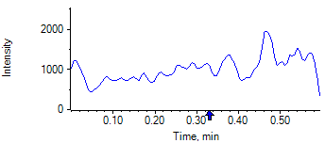

PCP 2 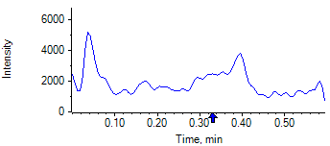

PCP D5 1 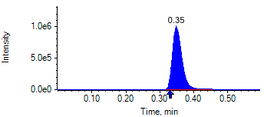

PCP D5 1 

Benzoylecgonine 1 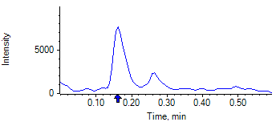

Benzoylecgonine 2 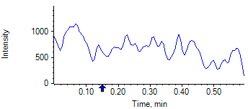

Benzoylecgonine D3 1 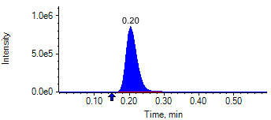

Benzoylecgonine D3 1 

|  |  |  |  |
| --- | --- | --- | --- |
| **Acquisition Method** | PCP_BE_041422Final.dam | **Data File** | SAMPLE057.wiff |
| **Sample Name** | **DL913504S04** | **Injection Volume** | 10.00 |
| **Sample Type** | Unknown | **Injection Vial** | 52 |
| **Injection Date** | 4/30/2025 8:28:13 PM | **Dilution Factor** | 1.00 |
| **Instrument Name** | Triple Quad 5500+ | **Instrument Serial** | EX231582110 |

**Results Summary**

*DL913504S04*

| **Peak Name** | **Integration Type** | **Transition** | **Retention Time** | **Rel RT** | **Peak Area** | **Area Ratio** | **Calculated Concentration (ng/mL)** | **Expected Ion Ratio** | **Calculated  Ion Ratio** | **Ratio Confirms ID** |
| --- | --- | --- | --- | --- | --- | --- | --- | --- | --- | --- |

|  |  |  |  |  |  |  |  |  |  |  |
| --- | --- | --- | --- | --- | --- | --- | --- | --- | --- | --- |
| PCP 1 | N/A | 243.8 / 159.0 | N/A | N/A* | N/A | N/A | N/A |  |  |  |

|  |  |  |  |  |  |  |  |  |  |  |
| --- | --- | --- | --- | --- | --- | --- | --- | --- | --- | --- |
| PCP 2 | N/A | 243.8 / 91.0 | N/A | N/A* | N/A | N/A |  | 59.4% | 0.0% | NO |

|  |  |  |  |  |  |  |  |  |  |  |
| --- | --- | --- | --- | --- | --- | --- | --- | --- | --- | --- |
| Benzoylecgonine 1 | N/A | 289.8 / 168.1 | N/A | N/A* | N/A | N/A | N/A |  |  |  |

|  |  |  |  |  |  |  |  |  |  |  |
| --- | --- | --- | --- | --- | --- | --- | --- | --- | --- | --- |
| Benzoylecgonine 2 | N/A | 289.8 / 104.9 | N/A | N/A* | N/A | N/A |  | 71.7% | 0.0% | NO |

**Internal Standard Data**

|  |  |  |  |  |  |  |  |  |  |
| --- | --- | --- | --- | --- | --- | --- | --- | --- | --- |
| **Internal Standard Name** | **Integration Type** | **Transition** | **Retention Time** | **Avg IS Retention Time** | **IS Peak Area** | **IS Area Within Range** | **Expected Ion Ratio** | **Calculated  Ion Ratio** | **Ratio Confirms ID** |

|  |  |  |  |  |  |  |  |  |  |
| --- | --- | --- | --- | --- | --- | --- | --- | --- | --- |
| PCP D5 1 | Baseline | 248.8 / 164.1 | 0.32 | 0.32 | 1.816e6 | ✓ |  |  |  |

|  |  |  |  |  |  |  |  |  |  |
| --- | --- | --- | --- | --- | --- | --- | --- | --- | --- |
| PCP D5 1 | Baseline | 248.8 / 164.1 | 0.32 | 0.32 | 1.816e6 |  | 100.0% | 100.0% | ✓ |

|  |  |  |  |  |  |  |  |  |  |
| --- | --- | --- | --- | --- | --- | --- | --- | --- | --- |
| Benzoylecgonine D3 1 | Baseline | 292.8 / 171.2 | 0.18 | 0.18 | 1.872e6 | ✓ |  |  |  |

|  |  |  |  |  |  |  |  |  |  |
| --- | --- | --- | --- | --- | --- | --- | --- | --- | --- |
| Benzoylecgonine D3 1 | Baseline | 292.8 / 171.2 | 0.18 | 0.18 | 1.872e6 |  | 100.0% | 100.0% | ✓ |

**Peak Review**

PCP 1 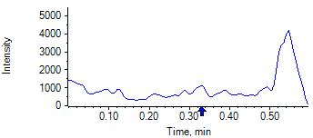

PCP 2 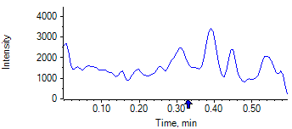

PCP D5 1 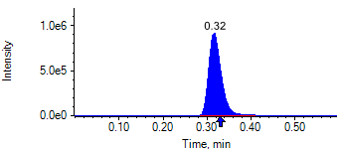

PCP D5 1 

Benzoylecgonine 1 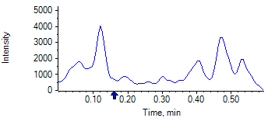

Benzoylecgonine 2 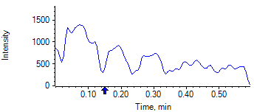

Benzoylecgonine D3 1 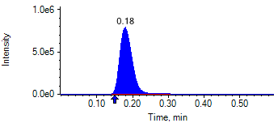

Benzoylecgonine D3 1 

|  |  |  |  |
| --- | --- | --- | --- |
| **Acquisition Method** | PCP_BE_041422Final.dam | **Data File** | SAMPLE058.wiff |
| **Sample Name** | **CPC MID3** | **Injection Volume** | 10.00 |
| **Sample Type** | Quality Control | **Injection Vial** | 53 |
| **Injection Date** | 4/30/2025 8:29:25 PM | **Dilution Factor** | 1.00 |
| **Instrument Name** | Triple Quad 5500+ | **Instrument Serial** | EX231582110 |

**Results Summary**

| **Peak Name** | **Integration Type** | **Transition** | **Retention Time** | **Rel RT** | **Peak Area** | **Area Ratio** | **Calculated Concentration (ng/mL)** | **Expected Ion Ratio** | **Calculated  Ion Ratio** | **Ratio Confirms ID** |
| --- | --- | --- | --- | --- | --- | --- | --- | --- | --- | --- |

|  |  |  |  |  |  |  |  |  |  |  |
| --- | --- | --- | --- | --- | --- | --- | --- | --- | --- | --- |
| PCP 1 | Baseline | 243.8 / 159.0 | 0.30 | 1.02 | 1.474e7 | 8.708 | 1876.26 |  |  |  |

|  |  |  |  |  |  |  |  |  |  |  |
| --- | --- | --- | --- | --- | --- | --- | --- | --- | --- | --- |
| PCP 2 | Baseline | 243.8 / 91.0 | 0.30 | 1.01 | 8.630e6 | 5.100 |  | 59.4% | 58.6% | ✓ |

|  |  |  |  |  |  |  |  |  |  |  |
| --- | --- | --- | --- | --- | --- | --- | --- | --- | --- | --- |
| Benzoylecgonine 1 | Baseline | 289.8 / 168.1 | 0.16 | 1.03 | 2.407e6 | 1.456 | 7684.73 |  |  |  |

|  |  |  |  |  |  |  |  |  |  |  |
| --- | --- | --- | --- | --- | --- | --- | --- | --- | --- | --- |
| Benzoylecgonine 2 | Baseline | 289.8 / 104.9 | 0.16 | 1.02 | 1.707e6 | 1.033 |  | 71.7% | 70.9% | ✓ |

**Internal Standard Data**

|  |  |  |  |  |  |  |  |  |  |
| --- | --- | --- | --- | --- | --- | --- | --- | --- | --- |
| **Internal Standard Name** | **Integration Type** | **Transition** | **Retention Time** | **Avg IS Retention Time** | **IS Peak Area** | **IS Area Within Range** | **Expected Ion Ratio** | **Calculated  Ion Ratio** | **Ratio Confirms ID** |

|  |  |  |  |  |  |  |  |  |  |
| --- | --- | --- | --- | --- | --- | --- | --- | --- | --- |
| PCP D5 1 | Baseline | 248.8 / 164.1 | 0.29* | 0.32 | 1.692e6 | ✓ |  |  |  |

|  |  |  |  |  |  |  |  |  |  |
| --- | --- | --- | --- | --- | --- | --- | --- | --- | --- |
| PCP D5 1 | Baseline | 248.8 / 164.1 | 0.29* | 0.32 | 1.692e6 |  | 100.0% | 100.0% | ✓ |

|  |  |  |  |  |  |  |  |  |  |
| --- | --- | --- | --- | --- | --- | --- | --- | --- | --- |
| Benzoylecgonine D3 1 | Baseline | 292.8 / 171.2 | 0.16* | 0.18 | 1.653e6 | ✓ |  |  |  |

|  |  |  |  |  |  |  |  |  |  |
| --- | --- | --- | --- | --- | --- | --- | --- | --- | --- |
| Benzoylecgonine D3 1 | Baseline | 292.8 / 171.2 | 0.16* | 0.18 | 1.653e6 |  | 100.0% | 100.0% | ✓ |

**Peak Review**

PCP 1 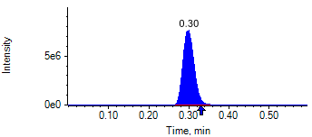

PCP 2 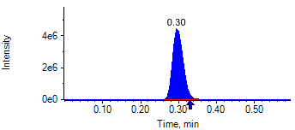

PCP D5 1 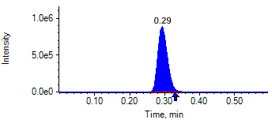

PCP D5 1 

Benzoylecgonine 1 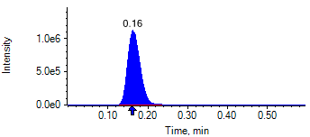

Benzoylecgonine 2 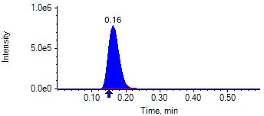

Benzoylecgonine D3 1 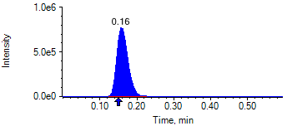

Benzoylecgonine D3 1 

|  |  |  |  |
| --- | --- | --- | --- |
| **Acquisition Method** | PCP_BE_041422Final.dam | **Data File** | SAMPLE059.wiff |
| **Sample Name** | **DL913344S03** | **Injection Volume** | 10.00 |
| **Sample Type** | Unknown | **Injection Vial** | 54 |
| **Injection Date** | 4/30/2025 8:30:35 PM | **Dilution Factor** | 1.00 |
| **Instrument Name** | Triple Quad 5500+ | **Instrument Serial** | EX231582110 |

**Results Summary**

*DL913344S03*

| **Peak Name** | **Integration Type** | **Transition** | **Retention Time** | **Rel RT** | **Peak Area** | **Area Ratio** | **Calculated Concentration (ng/mL)** | **Expected Ion Ratio** | **Calculated  Ion Ratio** | **Ratio Confirms ID** |
| --- | --- | --- | --- | --- | --- | --- | --- | --- | --- | --- |

|  |  |  |  |  |  |  |  |  |  |  |
| --- | --- | --- | --- | --- | --- | --- | --- | --- | --- | --- |
| PCP 1 | N/A | 243.8 / 159.0 | N/A | N/A* | N/A | N/A | N/A |  |  |  |

|  |  |  |  |  |  |  |  |  |  |  |
| --- | --- | --- | --- | --- | --- | --- | --- | --- | --- | --- |
| PCP 2 | N/A | 243.8 / 91.0 | N/A | N/A* | N/A | N/A |  | 59.4% | 0.0% | NO |

|  |  |  |  |  |  |  |  |  |  |  |
| --- | --- | --- | --- | --- | --- | --- | --- | --- | --- | --- |
| Benzoylecgonine 1 | N/A | 289.8 / 168.1 | N/A | N/A* | N/A | N/A | N/A |  |  |  |

|  |  |  |  |  |  |  |  |  |  |  |
| --- | --- | --- | --- | --- | --- | --- | --- | --- | --- | --- |
| Benzoylecgonine 2 | N/A | 289.8 / 104.9 | N/A | N/A* | N/A | N/A |  | 71.7% | 0.0% | NO |

**Internal Standard Data**

|  |  |  |  |  |  |  |  |  |  |
| --- | --- | --- | --- | --- | --- | --- | --- | --- | --- |
| **Internal Standard Name** | **Integration Type** | **Transition** | **Retention Time** | **Avg IS Retention Time** | **IS Peak Area** | **IS Area Within Range** | **Expected Ion Ratio** | **Calculated  Ion Ratio** | **Ratio Confirms ID** |

|  |  |  |  |  |  |  |  |  |  |
| --- | --- | --- | --- | --- | --- | --- | --- | --- | --- |
| PCP D5 1 | Baseline | 248.8 / 164.1 | 0.29* | 0.32 | 1.869e6 | ✓ |  |  |  |

|  |  |  |  |  |  |  |  |  |  |
| --- | --- | --- | --- | --- | --- | --- | --- | --- | --- |
| PCP D5 1 | Baseline | 248.8 / 164.1 | 0.29* | 0.32 | 1.869e6 |  | 100.0% | 100.0% | ✓ |

|  |  |  |  |  |  |  |  |  |  |
| --- | --- | --- | --- | --- | --- | --- | --- | --- | --- |
| Benzoylecgonine D3 1 | Baseline | 292.8 / 171.2 | 0.16* | 0.18 | 2.101e6 | ✓ |  |  |  |

|  |  |  |  |  |  |  |  |  |  |
| --- | --- | --- | --- | --- | --- | --- | --- | --- | --- |
| Benzoylecgonine D3 1 | Baseline | 292.8 / 171.2 | 0.16* | 0.18 | 2.101e6 |  | 100.0% | 100.0% | ✓ |

**Peak Review**

PCP 1 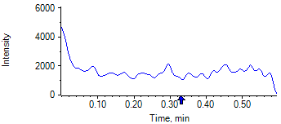

PCP 2 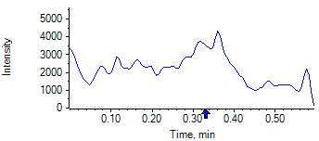

PCP D5 1 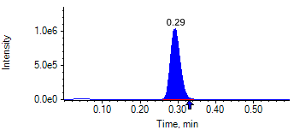

PCP D5 1 

Benzoylecgonine 1 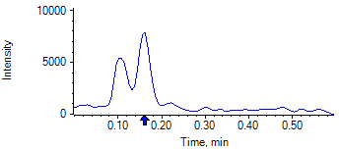

Benzoylecgonine 2 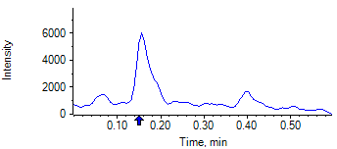

Benzoylecgonine D3 1 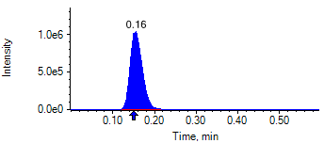

Benzoylecgonine D3 1 

|  |  |  |  |
| --- | --- | --- | --- |
| **Acquisition Method** | PCP_BE_041422Final.dam | **Data File** | SAMPLE060.wiff |
| **Sample Name** | **DL913276S04** | **Injection Volume** | 10.00 |
| **Sample Type** | Unknown | **Injection Vial** | 55 |
| **Injection Date** | 4/30/2025 8:31:46 PM | **Dilution Factor** | 1.00 |
| **Instrument Name** | Triple Quad 5500+ | **Instrument Serial** | EX231582110 |

**Results Summary**

*DL913276S04*

| **Peak Name** | **Integration Type** | **Transition** | **Retention Time** | **Rel RT** | **Peak Area** | **Area Ratio** | **Calculated Concentration (ng/mL)** | **Expected Ion Ratio** | **Calculated  Ion Ratio** | **Ratio Confirms ID** |
| --- | --- | --- | --- | --- | --- | --- | --- | --- | --- | --- |

|  |  |  |  |  |  |  |  |  |  |  |
| --- | --- | --- | --- | --- | --- | --- | --- | --- | --- | --- |
| PCP 1 | N/A | 243.8 / 159.0 | N/A | N/A* | N/A | N/A | N/A |  |  |  |

|  |  |  |  |  |  |  |  |  |  |  |
| --- | --- | --- | --- | --- | --- | --- | --- | --- | --- | --- |
| PCP 2 | N/A | 243.8 / 91.0 | N/A | N/A* | N/A | N/A |  | 59.4% | 0.0% | NO |

|  |  |  |  |  |  |  |  |  |  |  |
| --- | --- | --- | --- | --- | --- | --- | --- | --- | --- | --- |
| Benzoylecgonine 1 | N/A | 289.8 / 168.1 | N/A | N/A* | N/A | N/A | N/A |  |  |  |

|  |  |  |  |  |  |  |  |  |  |  |
| --- | --- | --- | --- | --- | --- | --- | --- | --- | --- | --- |
| Benzoylecgonine 2 | N/A | 289.8 / 104.9 | N/A | N/A* | N/A | N/A |  | 71.7% | 0.0% | NO |

**Internal Standard Data**

|  |  |  |  |  |  |  |  |  |  |
| --- | --- | --- | --- | --- | --- | --- | --- | --- | --- |
| **Internal Standard Name** | **Integration Type** | **Transition** | **Retention Time** | **Avg IS Retention Time** | **IS Peak Area** | **IS Area Within Range** | **Expected Ion Ratio** | **Calculated  Ion Ratio** | **Ratio Confirms ID** |

|  |  |  |  |  |  |  |  |  |  |
| --- | --- | --- | --- | --- | --- | --- | --- | --- | --- |
| PCP D5 1 | Baseline | 248.8 / 164.1 | 0.35* | 0.32 | 1.779e6 | ✓ |  |  |  |

|  |  |  |  |  |  |  |  |  |  |
| --- | --- | --- | --- | --- | --- | --- | --- | --- | --- |
| PCP D5 1 | Baseline | 248.8 / 164.1 | 0.35* | 0.32 | 1.779e6 |  | 100.0% | 100.0% | ✓ |

|  |  |  |  |  |  |  |  |  |  |
| --- | --- | --- | --- | --- | --- | --- | --- | --- | --- |
| Benzoylecgonine D3 1 | Baseline | 292.8 / 171.2 | 0.20* | 0.18 | 1.828e6 | ✓ |  |  |  |

|  |  |  |  |  |  |  |  |  |  |
| --- | --- | --- | --- | --- | --- | --- | --- | --- | --- |
| Benzoylecgonine D3 1 | Baseline | 292.8 / 171.2 | 0.20* | 0.18 | 1.828e6 |  | 100.0% | 100.0% | ✓ |

**Peak Review**

PCP 1 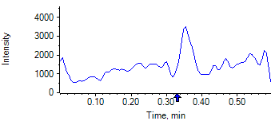

PCP 2 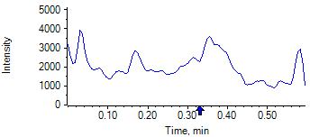

PCP D5 1 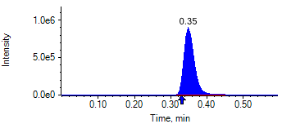

PCP D5 1 

Benzoylecgonine 1 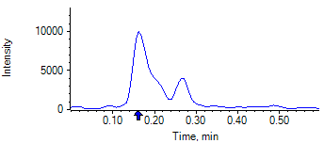

Benzoylecgonine 2 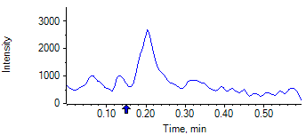

Benzoylecgonine D3 1 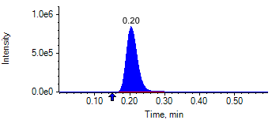

Benzoylecgonine D3 1 

|  |  |  |  |
| --- | --- | --- | --- |
| **Acquisition Method** | PCP_BE_041422Final.dam | **Data File** | SAMPLE061.wiff |
| **Sample Name** | **DL913356S02** | **Injection Volume** | 10.00 |
| **Sample Type** | Unknown | **Injection Vial** | 56 |
| **Injection Date** | 4/30/2025 8:32:55 PM | **Dilution Factor** | 1.00 |
| **Instrument Name** | Triple Quad 5500+ | **Instrument Serial** | EX231582110 |

**Results Summary**

*DL913356S02*

| **Peak Name** | **Integration Type** | **Transition** | **Retention Time** | **Rel RT** | **Peak Area** | **Area Ratio** | **Calculated Concentration (ng/mL)** | **Expected Ion Ratio** | **Calculated  Ion Ratio** | **Ratio Confirms ID** |
| --- | --- | --- | --- | --- | --- | --- | --- | --- | --- | --- |

|  |  |  |  |  |  |  |  |  |  |  |
| --- | --- | --- | --- | --- | --- | --- | --- | --- | --- | --- |
| PCP 1 | N/A | 243.8 / 159.0 | N/A | N/A* | N/A | N/A | N/A |  |  |  |

|  |  |  |  |  |  |  |  |  |  |  |
| --- | --- | --- | --- | --- | --- | --- | --- | --- | --- | --- |
| PCP 2 | N/A | 243.8 / 91.0 | N/A | N/A* | N/A | N/A |  | 59.4% | 0.0% | NO |

|  |  |  |  |  |  |  |  |  |  |  |
| --- | --- | --- | --- | --- | --- | --- | --- | --- | --- | --- |
| Benzoylecgonine 1 | N/A | 289.8 / 168.1 | N/A | N/A* | N/A | N/A | N/A |  |  |  |

|  |  |  |  |  |  |  |  |  |  |  |
| --- | --- | --- | --- | --- | --- | --- | --- | --- | --- | --- |
| Benzoylecgonine 2 | N/A | 289.8 / 104.9 | N/A | N/A* | N/A | N/A |  | 71.7% | 0.0% | NO |

**Internal Standard Data**

|  |  |  |  |  |  |  |  |  |  |
| --- | --- | --- | --- | --- | --- | --- | --- | --- | --- |
| **Internal Standard Name** | **Integration Type** | **Transition** | **Retention Time** | **Avg IS Retention Time** | **IS Peak Area** | **IS Area Within Range** | **Expected Ion Ratio** | **Calculated  Ion Ratio** | **Ratio Confirms ID** |

|  |  |  |  |  |  |  |  |  |  |
| --- | --- | --- | --- | --- | --- | --- | --- | --- | --- |
| PCP D5 1 | Baseline | 248.8 / 164.1 | 0.32 | 0.32 | 1.730e6 | ✓ |  |  |  |

|  |  |  |  |  |  |  |  |  |  |
| --- | --- | --- | --- | --- | --- | --- | --- | --- | --- |
| PCP D5 1 | Baseline | 248.8 / 164.1 | 0.32 | 0.32 | 1.730e6 |  | 100.0% | 100.0% | ✓ |

|  |  |  |  |  |  |  |  |  |  |
| --- | --- | --- | --- | --- | --- | --- | --- | --- | --- |
| Benzoylecgonine D3 1 | Baseline | 292.8 / 171.2 | 0.18 | 0.18 | 1.756e6 | ✓ |  |  |  |

|  |  |  |  |  |  |  |  |  |  |
| --- | --- | --- | --- | --- | --- | --- | --- | --- | --- |
| Benzoylecgonine D3 1 | Baseline | 292.8 / 171.2 | 0.18 | 0.18 | 1.756e6 |  | 100.0% | 100.0% | ✓ |

**Peak Review**

PCP 1 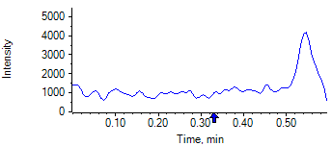

PCP 2 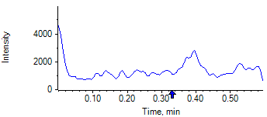

PCP D5 1 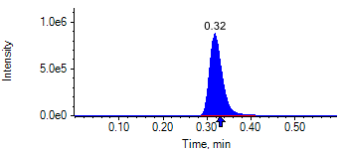

PCP D5 1 

Benzoylecgonine 1 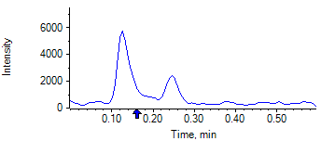

Benzoylecgonine 2 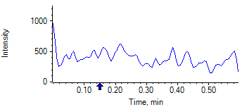

Benzoylecgonine D3 1 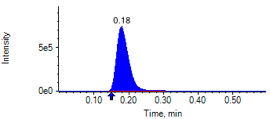

Benzoylecgonine D3 1 

|  |  |  |  |
| --- | --- | --- | --- |
| **Acquisition Method** | PCP_BE_041422Final.dam | **Data File** | SAMPLE062.wiff |
| **Sample Name** | **DL913337S05** | **Injection Volume** | 10.00 |
| **Sample Type** | Unknown | **Injection Vial** | 57 |
| **Injection Date** | 4/30/2025 8:34:07 PM | **Dilution Factor** | 1.00 |
| **Instrument Name** | Triple Quad 5500+ | **Instrument Serial** | EX231582110 |

**Results Summary**

*DL913337S05*

| **Peak Name** | **Integration Type** | **Transition** | **Retention Time** | **Rel RT** | **Peak Area** | **Area Ratio** | **Calculated Concentration (ng/mL)** | **Expected Ion Ratio** | **Calculated  Ion Ratio** | **Ratio Confirms ID** |
| --- | --- | --- | --- | --- | --- | --- | --- | --- | --- | --- |

|  |  |  |  |  |  |  |  |  |  |  |
| --- | --- | --- | --- | --- | --- | --- | --- | --- | --- | --- |
| PCP 1 | N/A | 243.8 / 159.0 | N/A | N/A* | N/A | N/A | N/A |  |  |  |

|  |  |  |  |  |  |  |  |  |  |  |
| --- | --- | --- | --- | --- | --- | --- | --- | --- | --- | --- |
| PCP 2 | N/A | 243.8 / 91.0 | N/A | N/A* | N/A | N/A |  | 59.4% | 0.0% | NO |

|  |  |  |  |  |  |  |  |  |  |  |
| --- | --- | --- | --- | --- | --- | --- | --- | --- | --- | --- |
| Benzoylecgonine 1 | N/A | 289.8 / 168.1 | N/A | N/A* | N/A | N/A | N/A |  |  |  |

|  |  |  |  |  |  |  |  |  |  |  |
| --- | --- | --- | --- | --- | --- | --- | --- | --- | --- | --- |
| Benzoylecgonine 2 | N/A | 289.8 / 104.9 | N/A | N/A* | N/A | N/A |  | 71.7% | 0.0% | NO |

**Internal Standard Data**

|  |  |  |  |  |  |  |  |  |  |
| --- | --- | --- | --- | --- | --- | --- | --- | --- | --- |
| **Internal Standard Name** | **Integration Type** | **Transition** | **Retention Time** | **Avg IS Retention Time** | **IS Peak Area** | **IS Area Within Range** | **Expected Ion Ratio** | **Calculated  Ion Ratio** | **Ratio Confirms ID** |

|  |  |  |  |  |  |  |  |  |  |
| --- | --- | --- | --- | --- | --- | --- | --- | --- | --- |
| PCP D5 1 | Baseline | 248.8 / 164.1 | 0.30* | 0.32 | 1.978e6 | ✓ |  |  |  |

|  |  |  |  |  |  |  |  |  |  |
| --- | --- | --- | --- | --- | --- | --- | --- | --- | --- |
| PCP D5 1 | Baseline | 248.8 / 164.1 | 0.30* | 0.32 | 1.978e6 |  | 100.0% | 100.0% | ✓ |

|  |  |  |  |  |  |  |  |  |  |
| --- | --- | --- | --- | --- | --- | --- | --- | --- | --- |
| Benzoylecgonine D3 1 | Baseline | 292.8 / 171.2 | 0.16* | 0.18 | 2.257e6 | ✓ |  |  |  |

|  |  |  |  |  |  |  |  |  |  |
| --- | --- | --- | --- | --- | --- | --- | --- | --- | --- |
| Benzoylecgonine D3 1 | Baseline | 292.8 / 171.2 | 0.16* | 0.18 | 2.257e6 |  | 100.0% | 100.0% | ✓ |

**Peak Review**

PCP 1 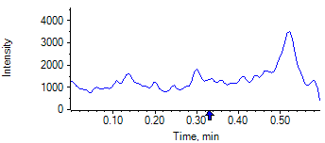

PCP 2 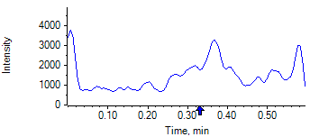

PCP D5 1 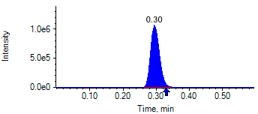

PCP D5 1 

Benzoylecgonine 1 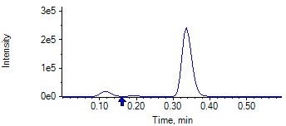

Benzoylecgonine 2 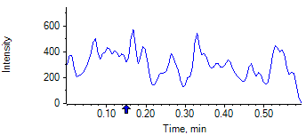

Benzoylecgonine D3 1 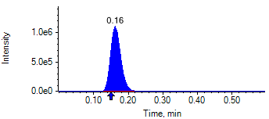

Benzoylecgonine D3 1 

|  |  |  |  |
| --- | --- | --- | --- |
| **Acquisition Method** | PCP_BE_041422Final.dam | **Data File** | SAMPLE063.wiff |
| **Sample Name** | **DL914280S02** | **Injection Volume** | 10.00 |
| **Sample Type** | Unknown | **Injection Vial** | 58 |
| **Injection Date** | 4/30/2025 8:35:15 PM | **Dilution Factor** | 1.00 |
| **Instrument Name** | Triple Quad 5500+ | **Instrument Serial** | EX231582110 |

**Results Summary**

*DL914280S02*

| **Peak Name** | **Integration Type** | **Transition** | **Retention Time** | **Rel RT** | **Peak Area** | **Area Ratio** | **Calculated Concentration (ng/mL)** | **Expected Ion Ratio** | **Calculated  Ion Ratio** | **Ratio Confirms ID** |
| --- | --- | --- | --- | --- | --- | --- | --- | --- | --- | --- |

|  |  |  |  |  |  |  |  |  |  |  |
| --- | --- | --- | --- | --- | --- | --- | --- | --- | --- | --- |
| PCP 1 | N/A | 243.8 / 159.0 | N/A | N/A* | N/A | N/A | N/A |  |  |  |

|  |  |  |  |  |  |  |  |  |  |  |
| --- | --- | --- | --- | --- | --- | --- | --- | --- | --- | --- |
| PCP 2 | N/A | 243.8 / 91.0 | N/A | N/A* | N/A | N/A |  | 59.4% | 0.0% | NO |

|  |  |  |  |  |  |  |  |  |  |  |
| --- | --- | --- | --- | --- | --- | --- | --- | --- | --- | --- |
| Benzoylecgonine 1 | N/A | 289.8 / 168.1 | N/A | N/A* | N/A | N/A | N/A |  |  |  |

|  |  |  |  |  |  |  |  |  |  |  |
| --- | --- | --- | --- | --- | --- | --- | --- | --- | --- | --- |
| Benzoylecgonine 2 | N/A | 289.8 / 104.9 | N/A | N/A* | N/A | N/A |  | 71.7% | 0.0% | NO |

**Internal Standard Data**

|  |  |  |  |  |  |  |  |  |  |
| --- | --- | --- | --- | --- | --- | --- | --- | --- | --- |
| **Internal Standard Name** | **Integration Type** | **Transition** | **Retention Time** | **Avg IS Retention Time** | **IS Peak Area** | **IS Area Within Range** | **Expected Ion Ratio** | **Calculated  Ion Ratio** | **Ratio Confirms ID** |

|  |  |  |  |  |  |  |  |  |  |
| --- | --- | --- | --- | --- | --- | --- | --- | --- | --- |
| PCP D5 1 | Baseline | 248.8 / 164.1 | 0.29* | 0.32 | 1.871e6 | ✓ |  |  |  |

|  |  |  |  |  |  |  |  |  |  |
| --- | --- | --- | --- | --- | --- | --- | --- | --- | --- |
| PCP D5 1 | Baseline | 248.8 / 164.1 | 0.29* | 0.32 | 1.871e6 |  | 100.0% | 100.0% | ✓ |

|  |  |  |  |  |  |  |  |  |  |
| --- | --- | --- | --- | --- | --- | --- | --- | --- | --- |
| Benzoylecgonine D3 1 | Baseline | 292.8 / 171.2 | 0.16* | 0.18 | 2.290e6 | ✓ |  |  |  |

|  |  |  |  |  |  |  |  |  |  |
| --- | --- | --- | --- | --- | --- | --- | --- | --- | --- |
| Benzoylecgonine D3 1 | Baseline | 292.8 / 171.2 | 0.16* | 0.18 | 2.290e6 |  | 100.0% | 100.0% | ✓ |

**Peak Review**

PCP 1 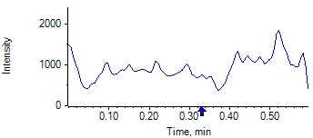

PCP 2 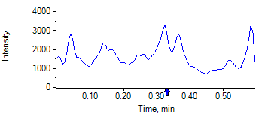

PCP D5 1 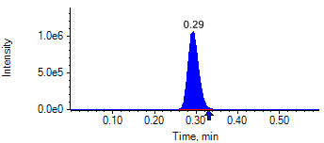

PCP D5 1 

Benzoylecgonine 1 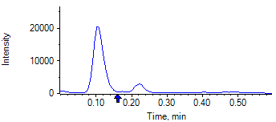

Benzoylecgonine 2 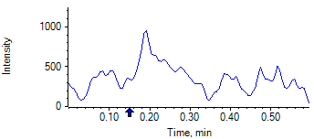

Benzoylecgonine D3 1 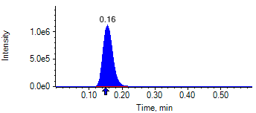

Benzoylecgonine D3 1 

|  |  |  |  |
| --- | --- | --- | --- |
| **Acquisition Method** | PCP_BE_041422Final.dam | **Data File** | SAMPLE064.wiff |
| **Sample Name** | **DL913882S04** | **Injection Volume** | 10.00 |
| **Sample Type** | Unknown | **Injection Vial** | 59 |
| **Injection Date** | 4/30/2025 8:36:28 PM | **Dilution Factor** | 1.00 |
| **Instrument Name** | Triple Quad 5500+ | **Instrument Serial** | EX231582110 |

**Results Summary**

*DL913882S04*

| **Peak Name** | **Integration Type** | **Transition** | **Retention Time** | **Rel RT** | **Peak Area** | **Area Ratio** | **Calculated Concentration (ng/mL)** | **Expected Ion Ratio** | **Calculated  Ion Ratio** | **Ratio Confirms ID** |
| --- | --- | --- | --- | --- | --- | --- | --- | --- | --- | --- |

|  |  |  |  |  |  |  |  |  |  |  |
| --- | --- | --- | --- | --- | --- | --- | --- | --- | --- | --- |
| PCP 1 | N/A | 243.8 / 159.0 | N/A | N/A* | N/A | N/A | N/A |  |  |  |

|  |  |  |  |  |  |  |  |  |  |  |
| --- | --- | --- | --- | --- | --- | --- | --- | --- | --- | --- |
| PCP 2 | N/A | 243.8 / 91.0 | N/A | N/A* | N/A | N/A |  | 59.4% | 0.0% | NO |

|  |  |  |  |  |  |  |  |  |  |  |
| --- | --- | --- | --- | --- | --- | --- | --- | --- | --- | --- |
| Benzoylecgonine 1 | N/A | 289.8 / 168.1 | N/A | N/A* | N/A | N/A | N/A |  |  |  |

|  |  |  |  |  |  |  |  |  |  |  |
| --- | --- | --- | --- | --- | --- | --- | --- | --- | --- | --- |
| Benzoylecgonine 2 | N/A | 289.8 / 104.9 | N/A | N/A* | N/A | N/A |  | 71.7% | 0.0% | NO |

**Internal Standard Data**

|  |  |  |  |  |  |  |  |  |  |
| --- | --- | --- | --- | --- | --- | --- | --- | --- | --- |
| **Internal Standard Name** | **Integration Type** | **Transition** | **Retention Time** | **Avg IS Retention Time** | **IS Peak Area** | **IS Area Within Range** | **Expected Ion Ratio** | **Calculated  Ion Ratio** | **Ratio Confirms ID** |

|  |  |  |  |  |  |  |  |  |  |
| --- | --- | --- | --- | --- | --- | --- | --- | --- | --- |
| PCP D5 1 | Baseline | 248.8 / 164.1 | 0.35* | 0.32 | 2.033e6 | ✓ |  |  |  |

|  |  |  |  |  |  |  |  |  |  |
| --- | --- | --- | --- | --- | --- | --- | --- | --- | --- |
| PCP D5 1 | Baseline | 248.8 / 164.1 | 0.35* | 0.32 | 2.033e6 |  | 100.0% | 100.0% | ✓ |

|  |  |  |  |  |  |  |  |  |  |
| --- | --- | --- | --- | --- | --- | --- | --- | --- | --- |
| Benzoylecgonine D3 1 | Baseline | 292.8 / 171.2 | 0.20* | 0.18 | 2.338e6 | ✓ |  |  |  |

|  |  |  |  |  |  |  |  |  |  |
| --- | --- | --- | --- | --- | --- | --- | --- | --- | --- |
| Benzoylecgonine D3 1 | Baseline | 292.8 / 171.2 | 0.20* | 0.18 | 2.338e6 |  | 100.0% | 100.0% | ✓ |

**Peak Review**

PCP 1 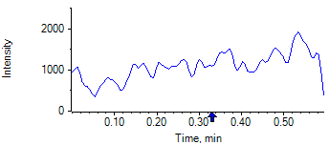

PCP 2 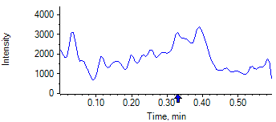

PCP D5 1 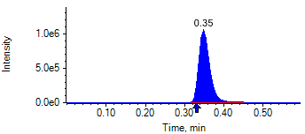

PCP D5 1 

Benzoylecgonine 1 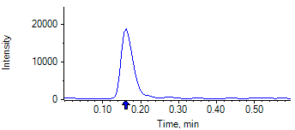

Benzoylecgonine 2 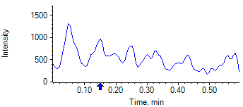

Benzoylecgonine D3 1 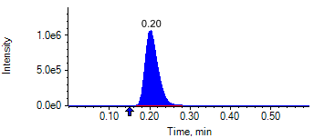

Benzoylecgonine D3 1 

|  |  |  |  |
| --- | --- | --- | --- |
| **Acquisition Method** | PCP_BE_041422Final.dam | **Data File** | SAMPLE065.wiff |
| **Sample Name** | **DL913360S03** | **Injection Volume** | 10.00 |
| **Sample Type** | Unknown | **Injection Vial** | 60 |
| **Injection Date** | 4/30/2025 8:37:38 PM | **Dilution Factor** | 1.00 |
| **Instrument Name** | Triple Quad 5500+ | **Instrument Serial** | EX231582110 |

**Results Summary**

*DL913360S03*

| **Peak Name** | **Integration Type** | **Transition** | **Retention Time** | **Rel RT** | **Peak Area** | **Area Ratio** | **Calculated Concentration (ng/mL)** | **Expected Ion Ratio** | **Calculated  Ion Ratio** | **Ratio Confirms ID** |
| --- | --- | --- | --- | --- | --- | --- | --- | --- | --- | --- |

|  |  |  |  |  |  |  |  |  |  |  |
| --- | --- | --- | --- | --- | --- | --- | --- | --- | --- | --- |
| PCP 1 | N/A | 243.8 / 159.0 | N/A | N/A* | N/A | N/A | N/A |  |  |  |

|  |  |  |  |  |  |  |  |  |  |  |
| --- | --- | --- | --- | --- | --- | --- | --- | --- | --- | --- |
| PCP 2 | N/A | 243.8 / 91.0 | N/A | N/A* | N/A | N/A |  | 59.4% | 0.0% | NO |

|  |  |  |  |  |  |  |  |  |  |  |
| --- | --- | --- | --- | --- | --- | --- | --- | --- | --- | --- |
| Benzoylecgonine 1 | N/A | 289.8 / 168.1 | N/A | N/A* | N/A | N/A | N/A |  |  |  |

|  |  |  |  |  |  |  |  |  |  |  |
| --- | --- | --- | --- | --- | --- | --- | --- | --- | --- | --- |
| Benzoylecgonine 2 | N/A | 289.8 / 104.9 | N/A | N/A* | N/A | N/A |  | 71.7% | 0.0% | NO |

**Internal Standard Data**

|  |  |  |  |  |  |  |  |  |  |
| --- | --- | --- | --- | --- | --- | --- | --- | --- | --- |
| **Internal Standard Name** | **Integration Type** | **Transition** | **Retention Time** | **Avg IS Retention Time** | **IS Peak Area** | **IS Area Within Range** | **Expected Ion Ratio** | **Calculated  Ion Ratio** | **Ratio Confirms ID** |

|  |  |  |  |  |  |  |  |  |  |
| --- | --- | --- | --- | --- | --- | --- | --- | --- | --- |
| PCP D5 1 | Baseline | 248.8 / 164.1 | 0.32 | 0.32 | 1.534e6 | ✓ |  |  |  |

|  |  |  |  |  |  |  |  |  |  |
| --- | --- | --- | --- | --- | --- | --- | --- | --- | --- |
| PCP D5 1 | Baseline | 248.8 / 164.1 | 0.32 | 0.32 | 1.534e6 |  | 100.0% | 100.0% | ✓ |

|  |  |  |  |  |  |  |  |  |  |
| --- | --- | --- | --- | --- | --- | --- | --- | --- | --- |
| Benzoylecgonine D3 1 | Baseline | 292.8 / 171.2 | 0.18 | 0.18 | 1.346e6 | ✓ |  |  |  |

|  |  |  |  |  |  |  |  |  |  |
| --- | --- | --- | --- | --- | --- | --- | --- | --- | --- |
| Benzoylecgonine D3 1 | Baseline | 292.8 / 171.2 | 0.18 | 0.18 | 1.346e6 |  | 100.0% | 100.0% | ✓ |

**Peak Review**

PCP 1 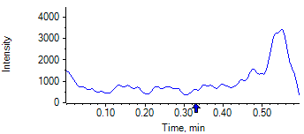

PCP 2 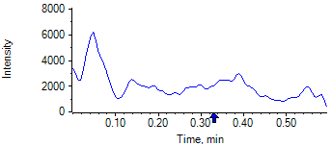

PCP D5 1 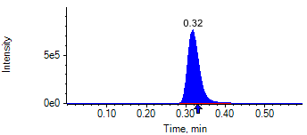

PCP D5 1 

Benzoylecgonine 1 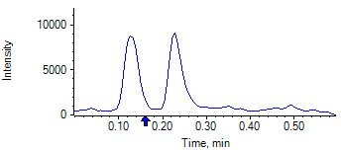

Benzoylecgonine 2 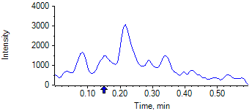

Benzoylecgonine D3 1 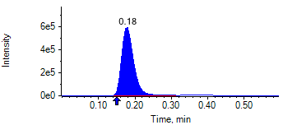

Benzoylecgonine D3 1 

|  |  |  |  |
| --- | --- | --- | --- |
| **Acquisition Method** | PCP_BE_041422Final.dam | **Data File** | SAMPLE066.wiff |
| **Sample Name** | **DL914346S03** | **Injection Volume** | 10.00 |
| **Sample Type** | Unknown | **Injection Vial** | 61 |
| **Injection Date** | 4/30/2025 8:38:49 PM | **Dilution Factor** | 1.00 |
| **Instrument Name** | Triple Quad 5500+ | **Instrument Serial** | EX231582110 |

**Results Summary**

*DL914346S03*

| **Peak Name** | **Integration Type** | **Transition** | **Retention Time** | **Rel RT** | **Peak Area** | **Area Ratio** | **Calculated Concentration (ng/mL)** | **Expected Ion Ratio** | **Calculated  Ion Ratio** | **Ratio Confirms ID** |
| --- | --- | --- | --- | --- | --- | --- | --- | --- | --- | --- |

|  |  |  |  |  |  |  |  |  |  |  |
| --- | --- | --- | --- | --- | --- | --- | --- | --- | --- | --- |
| PCP 1 | N/A | 243.8 / 159.0 | N/A | N/A* | N/A | N/A | N/A |  |  |  |

|  |  |  |  |  |  |  |  |  |  |  |
| --- | --- | --- | --- | --- | --- | --- | --- | --- | --- | --- |
| PCP 2 | N/A | 243.8 / 91.0 | N/A | N/A* | N/A | N/A |  | 59.4% | 0.0% | NO |

|  |  |  |  |  |  |  |  |  |  |  |
| --- | --- | --- | --- | --- | --- | --- | --- | --- | --- | --- |
| Benzoylecgonine 1 | N/A | 289.8 / 168.1 | N/A | N/A* | N/A | N/A | N/A |  |  |  |

|  |  |  |  |  |  |  |  |  |  |  |
| --- | --- | --- | --- | --- | --- | --- | --- | --- | --- | --- |
| Benzoylecgonine 2 | N/A | 289.8 / 104.9 | N/A | N/A* | N/A | N/A |  | 71.7% | 0.0% | NO |

**Internal Standard Data**

|  |  |  |  |  |  |  |  |  |  |
| --- | --- | --- | --- | --- | --- | --- | --- | --- | --- |
| **Internal Standard Name** | **Integration Type** | **Transition** | **Retention Time** | **Avg IS Retention Time** | **IS Peak Area** | **IS Area Within Range** | **Expected Ion Ratio** | **Calculated  Ion Ratio** | **Ratio Confirms ID** |

|  |  |  |  |  |  |  |  |  |  |
| --- | --- | --- | --- | --- | --- | --- | --- | --- | --- |
| PCP D5 1 | Baseline | 248.8 / 164.1 | 0.30* | 0.32 | 1.630e6 | ✓ |  |  |  |

|  |  |  |  |  |  |  |  |  |  |
| --- | --- | --- | --- | --- | --- | --- | --- | --- | --- |
| PCP D5 1 | Baseline | 248.8 / 164.1 | 0.30* | 0.32 | 1.630e6 |  | 100.0% | 100.0% | ✓ |

|  |  |  |  |  |  |  |  |  |  |
| --- | --- | --- | --- | --- | --- | --- | --- | --- | --- |
| Benzoylecgonine D3 1 | Valley | 292.8 / 171.2 | 0.16* | 0.18 | 1.822e6 | ✓ |  |  |  |

|  |  |  |  |  |  |  |  |  |  |
| --- | --- | --- | --- | --- | --- | --- | --- | --- | --- |
| Benzoylecgonine D3 1 | Valley | 292.8 / 171.2 | 0.16* | 0.18 | 1.822e6 |  | 100.0% | 100.0% | ✓ |

**Peak Review**

PCP 1 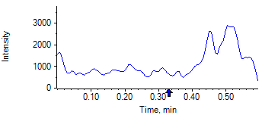

PCP 2 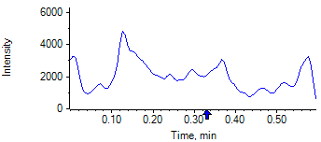

PCP D5 1 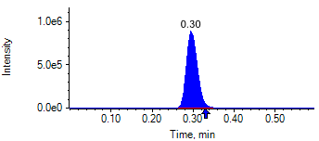

PCP D5 1 

Benzoylecgonine 1 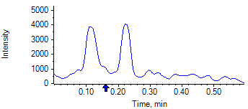

Benzoylecgonine 2 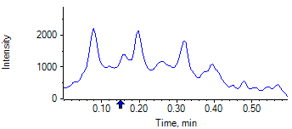

Benzoylecgonine D3 1 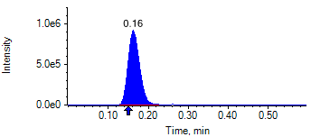

Benzoylecgonine D3 1 

|  |  |  |  |
| --- | --- | --- | --- |
| **Acquisition Method** | PCP_BE_041422Final.dam | **Data File** | SAMPLE067.wiff |
| **Sample Name** | **DL914192S02** | **Injection Volume** | 10.00 |
| **Sample Type** | Unknown | **Injection Vial** | 62 |
| **Injection Date** | 4/30/2025 8:39:59 PM | **Dilution Factor** | 1.00 |
| **Instrument Name** | Triple Quad 5500+ | **Instrument Serial** | EX231582110 |

**Results Summary**

*DL914192S02*

| **Peak Name** | **Integration Type** | **Transition** | **Retention Time** | **Rel RT** | **Peak Area** | **Area Ratio** | **Calculated Concentration (ng/mL)** | **Expected Ion Ratio** | **Calculated  Ion Ratio** | **Ratio Confirms ID** |
| --- | --- | --- | --- | --- | --- | --- | --- | --- | --- | --- |

|  |  |  |  |  |  |  |  |  |  |  |
| --- | --- | --- | --- | --- | --- | --- | --- | --- | --- | --- |
| PCP 1 | N/A | 243.8 / 159.0 | N/A | N/A* | N/A | N/A | N/A |  |  |  |

|  |  |  |  |  |  |  |  |  |  |  |
| --- | --- | --- | --- | --- | --- | --- | --- | --- | --- | --- |
| PCP 2 | N/A | 243.8 / 91.0 | N/A | N/A* | N/A | N/A |  | 59.4% | 0.0% | NO |

|  |  |  |  |  |  |  |  |  |  |  |
| --- | --- | --- | --- | --- | --- | --- | --- | --- | --- | --- |
| Benzoylecgonine 1 | N/A | 289.8 / 168.1 | N/A | N/A* | N/A | N/A | N/A |  |  |  |

|  |  |  |  |  |  |  |  |  |  |  |
| --- | --- | --- | --- | --- | --- | --- | --- | --- | --- | --- |
| Benzoylecgonine 2 | N/A | 289.8 / 104.9 | N/A | N/A* | N/A | N/A |  | 71.7% | 0.0% | NO |

**Internal Standard Data**

|  |  |  |  |  |  |  |  |  |  |
| --- | --- | --- | --- | --- | --- | --- | --- | --- | --- |
| **Internal Standard Name** | **Integration Type** | **Transition** | **Retention Time** | **Avg IS Retention Time** | **IS Peak Area** | **IS Area Within Range** | **Expected Ion Ratio** | **Calculated  Ion Ratio** | **Ratio Confirms ID** |

|  |  |  |  |  |  |  |  |  |  |
| --- | --- | --- | --- | --- | --- | --- | --- | --- | --- |
| PCP D5 1 | Baseline | 248.8 / 164.1 | 0.29* | 0.32 | 1.774e6 | ✓ |  |  |  |

|  |  |  |  |  |  |  |  |  |  |
| --- | --- | --- | --- | --- | --- | --- | --- | --- | --- |
| PCP D5 1 | Baseline | 248.8 / 164.1 | 0.29* | 0.32 | 1.774e6 |  | 100.0% | 100.0% | ✓ |

|  |  |  |  |  |  |  |  |  |  |
| --- | --- | --- | --- | --- | --- | --- | --- | --- | --- |
| Benzoylecgonine D3 1 | Valley | 292.8 / 171.2 | 0.15* | 0.18 | 2.147e6 | ✓ |  |  |  |

|  |  |  |  |  |  |  |  |  |  |
| --- | --- | --- | --- | --- | --- | --- | --- | --- | --- |
| Benzoylecgonine D3 1 | Valley | 292.8 / 171.2 | 0.15* | 0.18 | 2.147e6 |  | 100.0% | 100.0% | ✓ |

**Peak Review**

PCP 1 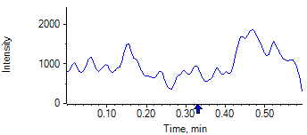

PCP 2 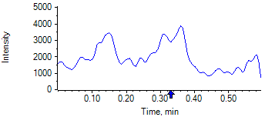

PCP D5 1 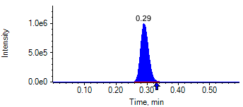

PCP D5 1 

Benzoylecgonine 1 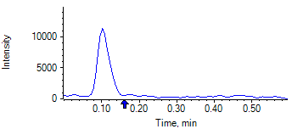

Benzoylecgonine 2 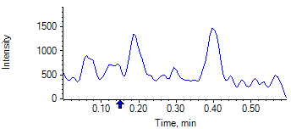

Benzoylecgonine D3 1 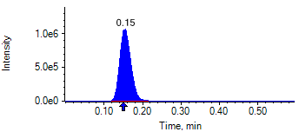

Benzoylecgonine D3 1 

|  |  |  |  |
| --- | --- | --- | --- |
| **Acquisition Method** | PCP_BE_041422Final.dam | **Data File** | SAMPLE068.wiff |
| **Sample Name** | **DL913522S05** | **Injection Volume** | 10.00 |
| **Sample Type** | Unknown | **Injection Vial** | 63 |
| **Injection Date** | 4/30/2025 8:41:12 PM | **Dilution Factor** | 1.00 |
| **Instrument Name** | Triple Quad 5500+ | **Instrument Serial** | EX231582110 |

**Results Summary**

*DL913522S05*

| **Peak Name** | **Integration Type** | **Transition** | **Retention Time** | **Rel RT** | **Peak Area** | **Area Ratio** | **Calculated Concentration (ng/mL)** | **Expected Ion Ratio** | **Calculated  Ion Ratio** | **Ratio Confirms ID** |
| --- | --- | --- | --- | --- | --- | --- | --- | --- | --- | --- |

|  |  |  |  |  |  |  |  |  |  |  |
| --- | --- | --- | --- | --- | --- | --- | --- | --- | --- | --- |
| PCP 1 | N/A | 243.8 / 159.0 | N/A | N/A* | N/A | N/A | N/A |  |  |  |

|  |  |  |  |  |  |  |  |  |  |  |
| --- | --- | --- | --- | --- | --- | --- | --- | --- | --- | --- |
| PCP 2 | N/A | 243.8 / 91.0 | N/A | N/A* | N/A | N/A |  | 59.4% | 0.0% | NO |

|  |  |  |  |  |  |  |  |  |  |  |
| --- | --- | --- | --- | --- | --- | --- | --- | --- | --- | --- |
| Benzoylecgonine 1 | N/A | 289.8 / 168.1 | N/A | N/A* | N/A | N/A | N/A |  |  |  |

|  |  |  |  |  |  |  |  |  |  |  |
| --- | --- | --- | --- | --- | --- | --- | --- | --- | --- | --- |
| Benzoylecgonine 2 | N/A | 289.8 / 104.9 | N/A | N/A* | N/A | N/A |  | 71.7% | 0.0% | NO |

**Internal Standard Data**

|  |  |  |  |  |  |  |  |  |  |
| --- | --- | --- | --- | --- | --- | --- | --- | --- | --- |
| **Internal Standard Name** | **Integration Type** | **Transition** | **Retention Time** | **Avg IS Retention Time** | **IS Peak Area** | **IS Area Within Range** | **Expected Ion Ratio** | **Calculated  Ion Ratio** | **Ratio Confirms ID** |

|  |  |  |  |  |  |  |  |  |  |
| --- | --- | --- | --- | --- | --- | --- | --- | --- | --- |
| PCP D5 1 | Baseline | 248.8 / 164.1 | 0.35* | 0.32 | 1.787e6 | ✓ |  |  |  |

|  |  |  |  |  |  |  |  |  |  |
| --- | --- | --- | --- | --- | --- | --- | --- | --- | --- |
| PCP D5 1 | Baseline | 248.8 / 164.1 | 0.35* | 0.32 | 1.787e6 |  | 100.0% | 100.0% | ✓ |

|  |  |  |  |  |  |  |  |  |  |
| --- | --- | --- | --- | --- | --- | --- | --- | --- | --- |
| Benzoylecgonine D3 1 | Baseline | 292.8 / 171.2 | 0.20* | 0.18 | 1.783e6 | ✓ |  |  |  |

|  |  |  |  |  |  |  |  |  |  |
| --- | --- | --- | --- | --- | --- | --- | --- | --- | --- |
| Benzoylecgonine D3 1 | Baseline | 292.8 / 171.2 | 0.20* | 0.18 | 1.783e6 |  | 100.0% | 100.0% | ✓ |

**Peak Review**

PCP 1 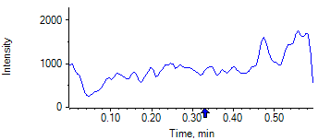

PCP 2 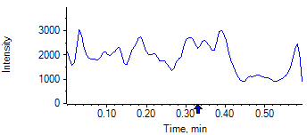

PCP D5 1 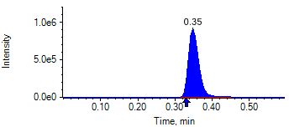

PCP D5 1 

Benzoylecgonine 1 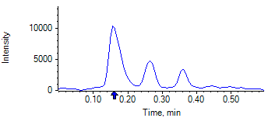

Benzoylecgonine 2 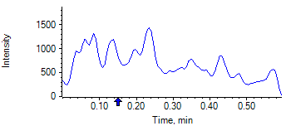

Benzoylecgonine D3 1 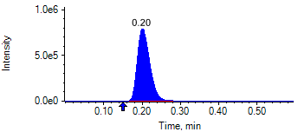

Benzoylecgonine D3 1 

|  |  |  |  |
| --- | --- | --- | --- |
| **Acquisition Method** | PCP_BE_041422Final.dam | **Data File** | SAMPLE069.wiff |
| **Sample Name** | **DZ768880P01** | **Injection Volume** | 10.00 |
| **Sample Type** | Unknown | **Injection Vial** | 64 |
| **Injection Date** | 4/30/2025 8:42:22 PM | **Dilution Factor** | 1.00 |
| **Instrument Name** | Triple Quad 5500+ | **Instrument Serial** | EX231582110 |

**Results Summary**

*DZ768880P01*

| **Peak Name** | **Integration Type** | **Transition** | **Retention Time** | **Rel RT** | **Peak Area** | **Area Ratio** | **Calculated Concentration (ng/mL)** | **Expected Ion Ratio** | **Calculated  Ion Ratio** | **Ratio Confirms ID** |
| --- | --- | --- | --- | --- | --- | --- | --- | --- | --- | --- |

|  |  |  |  |  |  |  |  |  |  |  |
| --- | --- | --- | --- | --- | --- | --- | --- | --- | --- | --- |
| PCP 1 | N/A | 243.8 / 159.0 | N/A | N/A* | N/A | N/A | N/A |  |  |  |

|  |  |  |  |  |  |  |  |  |  |  |
| --- | --- | --- | --- | --- | --- | --- | --- | --- | --- | --- |
| PCP 2 | N/A | 243.8 / 91.0 | N/A | N/A* | N/A | N/A |  | 59.4% | 0.0% | NO |

|  |  |  |  |  |  |  |  |  |  |  |
| --- | --- | --- | --- | --- | --- | --- | --- | --- | --- | --- |
| Benzoylecgonine 1 | Baseline | 289.8 / 168.1 | 0.18 | 1.03 | 1.481e7 | 14.230 | no root |  |  |  |

|  |  |  |  |  |  |  |  |  |  |  |
| --- | --- | --- | --- | --- | --- | --- | --- | --- | --- | --- |
| Benzoylecgonine 2 | Baseline | 289.8 / 104.9 | 0.18 | 1.02 | 1.060e7 | 10.180 |  | 71.7% | 71.6% | ✓ |

**Internal Standard Data**

|  |  |  |  |  |  |  |  |  |  |
| --- | --- | --- | --- | --- | --- | --- | --- | --- | --- |
| **Internal Standard Name** | **Integration Type** | **Transition** | **Retention Time** | **Avg IS Retention Time** | **IS Peak Area** | **IS Area Within Range** | **Expected Ion Ratio** | **Calculated  Ion Ratio** | **Ratio Confirms ID** |

|  |  |  |  |  |  |  |  |  |  |
| --- | --- | --- | --- | --- | --- | --- | --- | --- | --- |
| PCP D5 1 | Baseline | 248.8 / 164.1 | 0.32 | 0.32 | 1.829e6 | ✓ |  |  |  |

|  |  |  |  |  |  |  |  |  |  |
| --- | --- | --- | --- | --- | --- | --- | --- | --- | --- |
| PCP D5 1 | Baseline | 248.8 / 164.1 | 0.32 | 0.32 | 1.829e6 |  | 100.0% | 100.0% | ✓ |

|  |  |  |  |  |  |  |  |  |  |
| --- | --- | --- | --- | --- | --- | --- | --- | --- | --- |
| Benzoylecgonine D3 1 | Baseline | 292.8 / 171.2 | 0.18 | 0.18 | 1.041e6 | ✓ |  |  |  |

|  |  |  |  |  |  |  |  |  |  |
| --- | --- | --- | --- | --- | --- | --- | --- | --- | --- |
| Benzoylecgonine D3 1 | Baseline | 292.8 / 171.2 | 0.18 | 0.18 | 1.041e6 |  | 100.0% | 100.0% | ✓ |

**Peak Review**

PCP 1 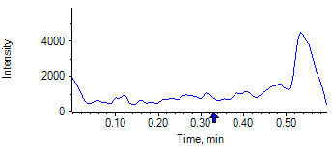

PCP 2 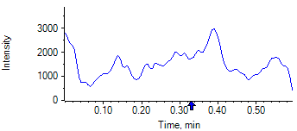

PCP D5 1 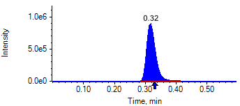

PCP D5 1 

Benzoylecgonine 1 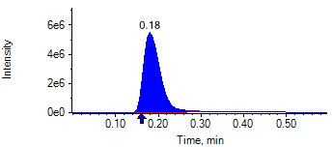

Benzoylecgonine 2 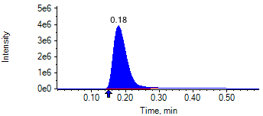

Benzoylecgonine D3 1 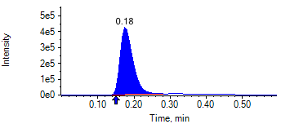

Benzoylecgonine D3 1 

|  |  |  |  |
| --- | --- | --- | --- |
| **Acquisition Method** | PCP_BE_041422Final.dam | **Data File** | SAMPLE070.wiff |
| **Sample Name** | **DL911845S01** | **Injection Volume** | 10.00 |
| **Sample Type** | Unknown | **Injection Vial** | 65 |
| **Injection Date** | 4/30/2025 8:43:32 PM | **Dilution Factor** | 1.00 |
| **Instrument Name** | Triple Quad 5500+ | **Instrument Serial** | EX231582110 |

**Results Summary**

*DL911845S01*

| **Peak Name** | **Integration Type** | **Transition** | **Retention Time** | **Rel RT** | **Peak Area** | **Area Ratio** | **Calculated Concentration (ng/mL)** | **Expected Ion Ratio** | **Calculated  Ion Ratio** | **Ratio Confirms ID** |
| --- | --- | --- | --- | --- | --- | --- | --- | --- | --- | --- |

|  |  |  |  |  |  |  |  |  |  |  |
| --- | --- | --- | --- | --- | --- | --- | --- | --- | --- | --- |
| PCP 1 | N/A | 243.8 / 159.0 | N/A | N/A* | N/A | N/A | N/A |  |  |  |

|  |  |  |  |  |  |  |  |  |  |  |
| --- | --- | --- | --- | --- | --- | --- | --- | --- | --- | --- |
| PCP 2 | N/A | 243.8 / 91.0 | N/A | N/A* | N/A | N/A |  | 59.4% | 0.0% | NO |

|  |  |  |  |  |  |  |  |  |  |  |
| --- | --- | --- | --- | --- | --- | --- | --- | --- | --- | --- |
| Benzoylecgonine 1 | N/A | 289.8 / 168.1 | N/A | N/A* | N/A | N/A | N/A |  |  |  |

|  |  |  |  |  |  |  |  |  |  |  |
| --- | --- | --- | --- | --- | --- | --- | --- | --- | --- | --- |
| Benzoylecgonine 2 | N/A | 289.8 / 104.9 | N/A | N/A* | N/A | N/A |  | 71.7% | 0.0% | NO |

**Internal Standard Data**

|  |  |  |  |  |  |  |  |  |  |
| --- | --- | --- | --- | --- | --- | --- | --- | --- | --- |
| **Internal Standard Name** | **Integration Type** | **Transition** | **Retention Time** | **Avg IS Retention Time** | **IS Peak Area** | **IS Area Within Range** | **Expected Ion Ratio** | **Calculated  Ion Ratio** | **Ratio Confirms ID** |

|  |  |  |  |  |  |  |  |  |  |
| --- | --- | --- | --- | --- | --- | --- | --- | --- | --- |
| PCP D5 1 | Baseline | 248.8 / 164.1 | 0.31* | 0.32 | 1.534e6 | ✓ |  |  |  |

|  |  |  |  |  |  |  |  |  |  |
| --- | --- | --- | --- | --- | --- | --- | --- | --- | --- |
| PCP D5 1 | Baseline | 248.8 / 164.1 | 0.31* | 0.32 | 1.534e6 |  | 100.0% | 100.0% | ✓ |

|  |  |  |  |  |  |  |  |  |  |
| --- | --- | --- | --- | --- | --- | --- | --- | --- | --- |
| Benzoylecgonine D3 1 | Valley | 292.8 / 171.2 | 0.18 | 0.18 | 1.646e6 | ✓ |  |  |  |

|  |  |  |  |  |  |  |  |  |  |
| --- | --- | --- | --- | --- | --- | --- | --- | --- | --- |
| Benzoylecgonine D3 1 | Valley | 292.8 / 171.2 | 0.18 | 0.18 | 1.646e6 |  | 100.0% | 100.0% | ✓ |

**Peak Review**

PCP 1 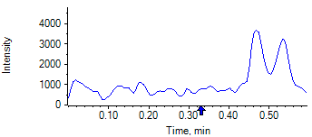

PCP 2 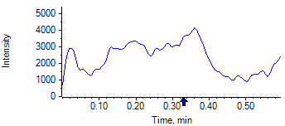

PCP D5 1 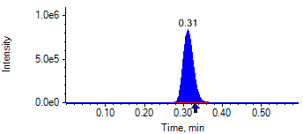

PCP D5 1 

Benzoylecgonine 1 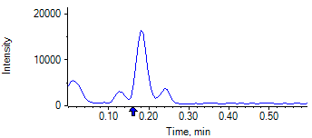

Benzoylecgonine 2 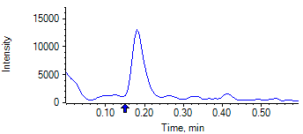

Benzoylecgonine D3 1 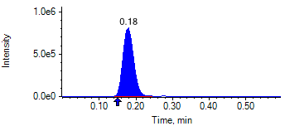

Benzoylecgonine D3 1 

|  |  |  |  |
| --- | --- | --- | --- |
| **Acquisition Method** | PCP_BE_041422Final.dam | **Data File** | SAMPLE071.wiff |
| **Sample Name** | **DK758059K06** | **Injection Volume** | 10.00 |
| **Sample Type** | Unknown | **Injection Vial** | 66 |
| **Injection Date** | 4/30/2025 8:44:43 PM | **Dilution Factor** | 1.00 |
| **Instrument Name** | Triple Quad 5500+ | **Instrument Serial** | EX231582110 |

**Results Summary**

*DK758059K06*

| **Peak Name** | **Integration Type** | **Transition** | **Retention Time** | **Rel RT** | **Peak Area** | **Area Ratio** | **Calculated Concentration (ng/mL)** | **Expected Ion Ratio** | **Calculated  Ion Ratio** | **Ratio Confirms ID** |
| --- | --- | --- | --- | --- | --- | --- | --- | --- | --- | --- |

|  |  |  |  |  |  |  |  |  |  |  |
| --- | --- | --- | --- | --- | --- | --- | --- | --- | --- | --- |
| PCP 1 | N/A | 243.8 / 159.0 | N/A | N/A* | N/A | N/A | N/A |  |  |  |

|  |  |  |  |  |  |  |  |  |  |  |
| --- | --- | --- | --- | --- | --- | --- | --- | --- | --- | --- |
| PCP 2 | N/A | 243.8 / 91.0 | N/A | N/A* | N/A | N/A |  | 59.4% | 0.0% | NO |

|  |  |  |  |  |  |  |  |  |  |  |
| --- | --- | --- | --- | --- | --- | --- | --- | --- | --- | --- |
| Benzoylecgonine 1 | N/A | 289.8 / 168.1 | N/A | N/A* | N/A | N/A | N/A |  |  |  |

|  |  |  |  |  |  |  |  |  |  |  |
| --- | --- | --- | --- | --- | --- | --- | --- | --- | --- | --- |
| Benzoylecgonine 2 | N/A | 289.8 / 104.9 | N/A | N/A* | N/A | N/A |  | 71.7% | 0.0% | NO |

**Internal Standard Data**

|  |  |  |  |  |  |  |  |  |  |
| --- | --- | --- | --- | --- | --- | --- | --- | --- | --- |
| **Internal Standard Name** | **Integration Type** | **Transition** | **Retention Time** | **Avg IS Retention Time** | **IS Peak Area** | **IS Area Within Range** | **Expected Ion Ratio** | **Calculated  Ion Ratio** | **Ratio Confirms ID** |

|  |  |  |  |  |  |  |  |  |  |
| --- | --- | --- | --- | --- | --- | --- | --- | --- | --- |
| PCP D5 1 | Baseline | 248.8 / 164.1 | 0.29* | 0.32 | 1.976e6 | ✓ |  |  |  |

|  |  |  |  |  |  |  |  |  |  |
| --- | --- | --- | --- | --- | --- | --- | --- | --- | --- |
| PCP D5 1 | Baseline | 248.8 / 164.1 | 0.29* | 0.32 | 1.976e6 |  | 100.0% | 100.0% | ✓ |

|  |  |  |  |  |  |  |  |  |  |
| --- | --- | --- | --- | --- | --- | --- | --- | --- | --- |
| Benzoylecgonine D3 1 | Baseline | 292.8 / 171.2 | 0.15* | 0.18 | 2.606e6 | ✓ |  |  |  |

|  |  |  |  |  |  |  |  |  |  |
| --- | --- | --- | --- | --- | --- | --- | --- | --- | --- |
| Benzoylecgonine D3 1 | Baseline | 292.8 / 171.2 | 0.15* | 0.18 | 2.606e6 |  | 100.0% | 100.0% | ✓ |

**Peak Review**

PCP 1 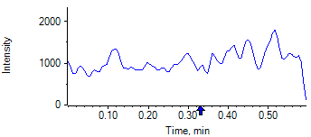

PCP 2 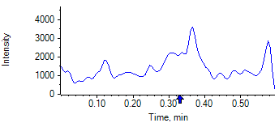

PCP D5 1 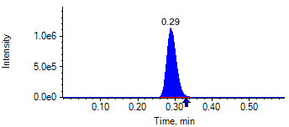

PCP D5 1 

Benzoylecgonine 1 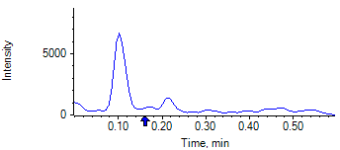

Benzoylecgonine 2 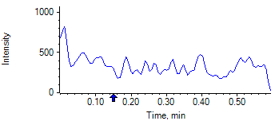

Benzoylecgonine D3 1 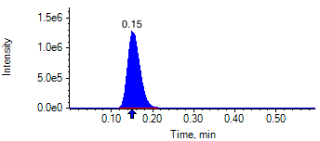

Benzoylecgonine D3 1 

|  |  |  |  |
| --- | --- | --- | --- |
| **Acquisition Method** | PCP_BE_041422Final.dam | **Data File** | SAMPLE072.wiff |
| **Sample Name** | **DK757688K06** | **Injection Volume** | 10.00 |
| **Sample Type** | Unknown | **Injection Vial** | 67 |
| **Injection Date** | 4/30/2025 8:45:54 PM | **Dilution Factor** | 1.00 |
| **Instrument Name** | Triple Quad 5500+ | **Instrument Serial** | EX231582110 |

**Results Summary**

*DK757688K06*

| **Peak Name** | **Integration Type** | **Transition** | **Retention Time** | **Rel RT** | **Peak Area** | **Area Ratio** | **Calculated Concentration (ng/mL)** | **Expected Ion Ratio** | **Calculated  Ion Ratio** | **Ratio Confirms ID** |
| --- | --- | --- | --- | --- | --- | --- | --- | --- | --- | --- |

|  |  |  |  |  |  |  |  |  |  |  |
| --- | --- | --- | --- | --- | --- | --- | --- | --- | --- | --- |
| PCP 1 | N/A | 243.8 / 159.0 | N/A | N/A* | N/A | N/A | N/A |  |  |  |

|  |  |  |  |  |  |  |  |  |  |  |
| --- | --- | --- | --- | --- | --- | --- | --- | --- | --- | --- |
| PCP 2 | N/A | 243.8 / 91.0 | N/A | N/A* | N/A | N/A |  | 59.4% | 0.0% | NO |

|  |  |  |  |  |  |  |  |  |  |  |
| --- | --- | --- | --- | --- | --- | --- | --- | --- | --- | --- |
| Benzoylecgonine 1 | N/A | 289.8 / 168.1 | N/A | N/A* | N/A | N/A | N/A |  |  |  |

|  |  |  |  |  |  |  |  |  |  |  |
| --- | --- | --- | --- | --- | --- | --- | --- | --- | --- | --- |
| Benzoylecgonine 2 | N/A | 289.8 / 104.9 | N/A | N/A* | N/A | N/A |  | 71.7% | 0.0% | NO |

**Internal Standard Data**

|  |  |  |  |  |  |  |  |  |  |
| --- | --- | --- | --- | --- | --- | --- | --- | --- | --- |
| **Internal Standard Name** | **Integration Type** | **Transition** | **Retention Time** | **Avg IS Retention Time** | **IS Peak Area** | **IS Area Within Range** | **Expected Ion Ratio** | **Calculated  Ion Ratio** | **Ratio Confirms ID** |

|  |  |  |  |  |  |  |  |  |  |
| --- | --- | --- | --- | --- | --- | --- | --- | --- | --- |
| PCP D5 1 | Baseline | 248.8 / 164.1 | 0.35* | 0.32 | 1.584e6 | ✓ |  |  |  |

|  |  |  |  |  |  |  |  |  |  |
| --- | --- | --- | --- | --- | --- | --- | --- | --- | --- |
| PCP D5 1 | Baseline | 248.8 / 164.1 | 0.35* | 0.32 | 1.584e6 |  | 100.0% | 100.0% | ✓ |

|  |  |  |  |  |  |  |  |  |  |
| --- | --- | --- | --- | --- | --- | --- | --- | --- | --- |
| Benzoylecgonine D3 1 | Baseline | 292.8 / 171.2 | 0.20* | 0.18 | 1.848e6 | ✓ |  |  |  |

|  |  |  |  |  |  |  |  |  |  |
| --- | --- | --- | --- | --- | --- | --- | --- | --- | --- |
| Benzoylecgonine D3 1 | Baseline | 292.8 / 171.2 | 0.20* | 0.18 | 1.848e6 |  | 100.0% | 100.0% | ✓ |

**Peak Review**

PCP 1 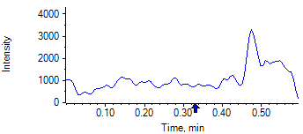

PCP 2 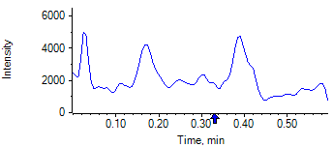

PCP D5 1 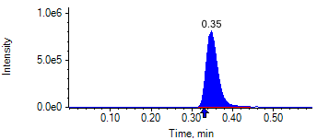

PCP D5 1 

Benzoylecgonine 1 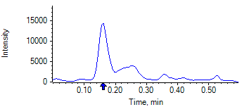

Benzoylecgonine 2 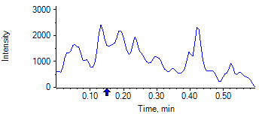

Benzoylecgonine D3 1 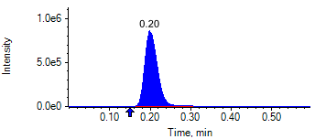

Benzoylecgonine D3 1 

|  |  |  |  |
| --- | --- | --- | --- |
| **Acquisition Method** | PCP_BE_041422Final.dam | **Data File** | SAMPLE073.wiff |
| **Sample Name** | **DK758060K06** | **Injection Volume** | 10.00 |
| **Sample Type** | Unknown | **Injection Vial** | 68 |
| **Injection Date** | 4/30/2025 8:47:06 PM | **Dilution Factor** | 1.00 |
| **Instrument Name** | Triple Quad 5500+ | **Instrument Serial** | EX231582110 |

**Results Summary**

*DK758060K06*

| **Peak Name** | **Integration Type** | **Transition** | **Retention Time** | **Rel RT** | **Peak Area** | **Area Ratio** | **Calculated Concentration (ng/mL)** | **Expected Ion Ratio** | **Calculated  Ion Ratio** | **Ratio Confirms ID** |
| --- | --- | --- | --- | --- | --- | --- | --- | --- | --- | --- |

|  |  |  |  |  |  |  |  |  |  |  |
| --- | --- | --- | --- | --- | --- | --- | --- | --- | --- | --- |
| PCP 1 | N/A | 243.8 / 159.0 | N/A | N/A* | N/A | N/A | N/A |  |  |  |

|  |  |  |  |  |  |  |  |  |  |  |
| --- | --- | --- | --- | --- | --- | --- | --- | --- | --- | --- |
| PCP 2 | N/A | 243.8 / 91.0 | N/A | N/A* | N/A | N/A |  | 59.4% | 0.0% | NO |

|  |  |  |  |  |  |  |  |  |  |  |
| --- | --- | --- | --- | --- | --- | --- | --- | --- | --- | --- |
| Benzoylecgonine 1 | N/A | 289.8 / 168.1 | N/A | N/A* | N/A | N/A | N/A |  |  |  |

|  |  |  |  |  |  |  |  |  |  |  |
| --- | --- | --- | --- | --- | --- | --- | --- | --- | --- | --- |
| Benzoylecgonine 2 | N/A | 289.8 / 104.9 | N/A | N/A* | N/A | N/A |  | 71.7% | 0.0% | NO |

**Internal Standard Data**

|  |  |  |  |  |  |  |  |  |  |
| --- | --- | --- | --- | --- | --- | --- | --- | --- | --- |
| **Internal Standard Name** | **Integration Type** | **Transition** | **Retention Time** | **Avg IS Retention Time** | **IS Peak Area** | **IS Area Within Range** | **Expected Ion Ratio** | **Calculated  Ion Ratio** | **Ratio Confirms ID** |

|  |  |  |  |  |  |  |  |  |  |
| --- | --- | --- | --- | --- | --- | --- | --- | --- | --- |
| PCP D5 1 | Baseline | 248.8 / 164.1 | 0.33* | 0.32 | 1.723e6 | ✓ |  |  |  |

|  |  |  |  |  |  |  |  |  |  |
| --- | --- | --- | --- | --- | --- | --- | --- | --- | --- |
| PCP D5 1 | Baseline | 248.8 / 164.1 | 0.33* | 0.32 | 1.723e6 |  | 100.0% | 100.0% | ✓ |

|  |  |  |  |  |  |  |  |  |  |
| --- | --- | --- | --- | --- | --- | --- | --- | --- | --- |
| Benzoylecgonine D3 1 | Baseline | 292.8 / 171.2 | 0.19* | 0.18 | 1.993e6 | ✓ |  |  |  |

|  |  |  |  |  |  |  |  |  |  |
| --- | --- | --- | --- | --- | --- | --- | --- | --- | --- |
| Benzoylecgonine D3 1 | Baseline | 292.8 / 171.2 | 0.19* | 0.18 | 1.993e6 |  | 100.0% | 100.0% | ✓ |

**Peak Review**

PCP 1 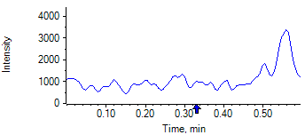

PCP 2 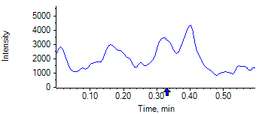

PCP D5 1 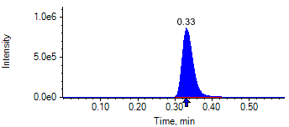

PCP D5 1 

Benzoylecgonine 1 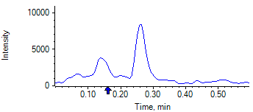

Benzoylecgonine 2 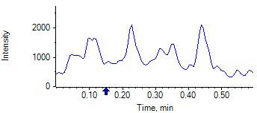

Benzoylecgonine D3 1 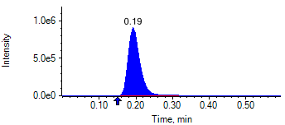

Benzoylecgonine D3 1 

|  |  |  |  |
| --- | --- | --- | --- |
| **Acquisition Method** | PCP_BE_041422Final.dam | **Data File** | SAMPLE074.wiff |
| **Sample Name** | **HL389688F02** | **Injection Volume** | 10.00 |
| **Sample Type** | Unknown | **Injection Vial** | 69 |
| **Injection Date** | 4/30/2025 8:48:16 PM | **Dilution Factor** | 1.00 |
| **Instrument Name** | Triple Quad 5500+ | **Instrument Serial** | EX231582110 |

**Results Summary**

*HL389688F02*

| **Peak Name** | **Integration Type** | **Transition** | **Retention Time** | **Rel RT** | **Peak Area** | **Area Ratio** | **Calculated Concentration (ng/mL)** | **Expected Ion Ratio** | **Calculated  Ion Ratio** | **Ratio Confirms ID** |
| --- | --- | --- | --- | --- | --- | --- | --- | --- | --- | --- |

|  |  |  |  |  |  |  |  |  |  |  |
| --- | --- | --- | --- | --- | --- | --- | --- | --- | --- | --- |
| PCP 1 | N/A | 243.8 / 159.0 | N/A | N/A* | N/A | N/A | N/A |  |  |  |

|  |  |  |  |  |  |  |  |  |  |  |
| --- | --- | --- | --- | --- | --- | --- | --- | --- | --- | --- |
| PCP 2 | N/A | 243.8 / 91.0 | N/A | N/A* | N/A | N/A |  | 59.4% | 0.0% | NO |

|  |  |  |  |  |  |  |  |  |  |  |
| --- | --- | --- | --- | --- | --- | --- | --- | --- | --- | --- |
| Benzoylecgonine 1 | N/A | 289.8 / 168.1 | N/A | N/A* | N/A | N/A | N/A |  |  |  |

|  |  |  |  |  |  |  |  |  |  |  |
| --- | --- | --- | --- | --- | --- | --- | --- | --- | --- | --- |
| Benzoylecgonine 2 | N/A | 289.8 / 104.9 | N/A | N/A* | N/A | N/A |  | 71.7% | 0.0% | NO |

**Internal Standard Data**

|  |  |  |  |  |  |  |  |  |  |
| --- | --- | --- | --- | --- | --- | --- | --- | --- | --- |
| **Internal Standard Name** | **Integration Type** | **Transition** | **Retention Time** | **Avg IS Retention Time** | **IS Peak Area** | **IS Area Within Range** | **Expected Ion Ratio** | **Calculated  Ion Ratio** | **Ratio Confirms ID** |

|  |  |  |  |  |  |  |  |  |  |
| --- | --- | --- | --- | --- | --- | --- | --- | --- | --- |
| PCP D5 1 | Baseline | 248.8 / 164.1 | 0.31 | 0.32 | 1.652e6 | ✓ |  |  |  |

|  |  |  |  |  |  |  |  |  |  |
| --- | --- | --- | --- | --- | --- | --- | --- | --- | --- |
| PCP D5 1 | Baseline | 248.8 / 164.1 | 0.31 | 0.32 | 1.652e6 |  | 100.0% | 100.0% | ✓ |

|  |  |  |  |  |  |  |  |  |  |
| --- | --- | --- | --- | --- | --- | --- | --- | --- | --- |
| Benzoylecgonine D3 1 | Baseline | 292.8 / 171.2 | 0.18 | 0.18 | 2.137e6 | ✓ |  |  |  |

|  |  |  |  |  |  |  |  |  |  |
| --- | --- | --- | --- | --- | --- | --- | --- | --- | --- |
| Benzoylecgonine D3 1 | Baseline | 292.8 / 171.2 | 0.18 | 0.18 | 2.137e6 |  | 100.0% | 100.0% | ✓ |

**Peak Review**

PCP 1 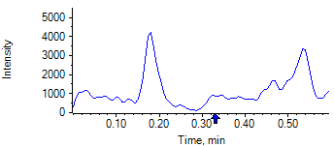

PCP 2 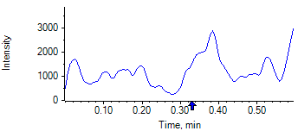

PCP D5 1 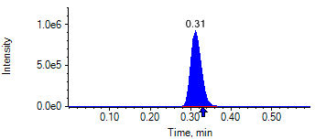

PCP D5 1 

Benzoylecgonine 1 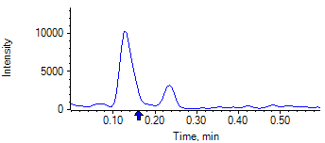

Benzoylecgonine 2 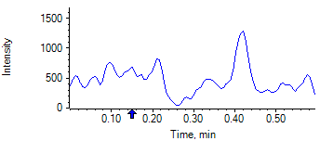

Benzoylecgonine D3 1 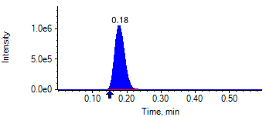

Benzoylecgonine D3 1 

|  |  |  |  |
| --- | --- | --- | --- |
| **Acquisition Method** | PCP_BE_041422Final.dam | **Data File** | SAMPLE075.wiff |
| **Sample Name** | **DL913282S03** | **Injection Volume** | 10.00 |
| **Sample Type** | Unknown | **Injection Vial** | 70 |
| **Injection Date** | 4/30/2025 8:49:25 PM | **Dilution Factor** | 1.00 |
| **Instrument Name** | Triple Quad 5500+ | **Instrument Serial** | EX231582110 |

**Results Summary**

*DL913282S03*

| **Peak Name** | **Integration Type** | **Transition** | **Retention Time** | **Rel RT** | **Peak Area** | **Area Ratio** | **Calculated Concentration (ng/mL)** | **Expected Ion Ratio** | **Calculated  Ion Ratio** | **Ratio Confirms ID** |
| --- | --- | --- | --- | --- | --- | --- | --- | --- | --- | --- |

|  |  |  |  |  |  |  |  |  |  |  |
| --- | --- | --- | --- | --- | --- | --- | --- | --- | --- | --- |
| PCP 1 | N/A | 243.8 / 159.0 | N/A | N/A* | N/A | N/A | N/A |  |  |  |

|  |  |  |  |  |  |  |  |  |  |  |
| --- | --- | --- | --- | --- | --- | --- | --- | --- | --- | --- |
| PCP 2 | N/A | 243.8 / 91.0 | N/A | N/A* | N/A | N/A |  | 59.4% | 0.0% | NO |

|  |  |  |  |  |  |  |  |  |  |  |
| --- | --- | --- | --- | --- | --- | --- | --- | --- | --- | --- |
| Benzoylecgonine 1 | N/A | 289.8 / 168.1 | N/A | N/A* | N/A | N/A | N/A |  |  |  |

|  |  |  |  |  |  |  |  |  |  |  |
| --- | --- | --- | --- | --- | --- | --- | --- | --- | --- | --- |
| Benzoylecgonine 2 | N/A | 289.8 / 104.9 | N/A | N/A* | N/A | N/A |  | 71.7% | 0.0% | NO |

**Internal Standard Data**

|  |  |  |  |  |  |  |  |  |  |
| --- | --- | --- | --- | --- | --- | --- | --- | --- | --- |
| **Internal Standard Name** | **Integration Type** | **Transition** | **Retention Time** | **Avg IS Retention Time** | **IS Peak Area** | **IS Area Within Range** | **Expected Ion Ratio** | **Calculated  Ion Ratio** | **Ratio Confirms ID** |

|  |  |  |  |  |  |  |  |  |  |
| --- | --- | --- | --- | --- | --- | --- | --- | --- | --- |
| PCP D5 1 | Baseline | 248.8 / 164.1 | 0.31* | 0.32 | 1.088e6 | ✓ |  |  |  |

|  |  |  |  |  |  |  |  |  |  |
| --- | --- | --- | --- | --- | --- | --- | --- | --- | --- |
| PCP D5 1 | Baseline | 248.8 / 164.1 | 0.31* | 0.32 | 1.088e6 |  | 100.0% | 100.0% | ✓ |

|  |  |  |  |  |  |  |  |  |  |
| --- | --- | --- | --- | --- | --- | --- | --- | --- | --- |
| Benzoylecgonine D3 1 | Baseline | 292.8 / 171.2 | 0.17* | 0.18 | 1.326e6 | ✓ |  |  |  |

|  |  |  |  |  |  |  |  |  |  |
| --- | --- | --- | --- | --- | --- | --- | --- | --- | --- |
| Benzoylecgonine D3 1 | Baseline | 292.8 / 171.2 | 0.17* | 0.18 | 1.326e6 |  | 100.0% | 100.0% | ✓ |

**Peak Review**

PCP 1 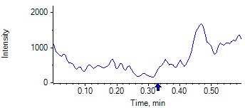

PCP 2 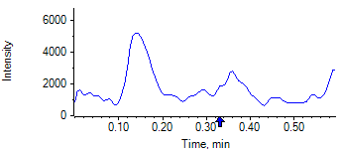

PCP D5 1 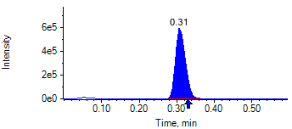

PCP D5 1 

Benzoylecgonine 1 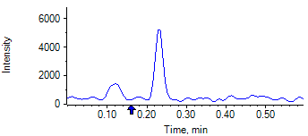

Benzoylecgonine 2 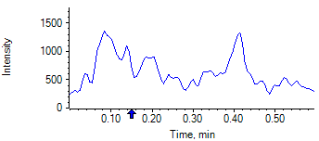

Benzoylecgonine D3 1 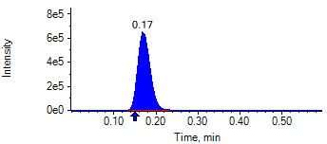

Benzoylecgonine D3 1 

|  |  |  |  |
| --- | --- | --- | --- |
| **Acquisition Method** | PCP_BE_041422Final.dam | **Data File** | SAMPLE076.wiff |
| **Sample Name** | **DL913291S03** | **Injection Volume** | 10.00 |
| **Sample Type** | Unknown | **Injection Vial** | 71 |
| **Injection Date** | 4/30/2025 8:50:35 PM | **Dilution Factor** | 1.00 |
| **Instrument Name** | Triple Quad 5500+ | **Instrument Serial** | EX231582110 |

**Results Summary**

*DL913291S03*

| **Peak Name** | **Integration Type** | **Transition** | **Retention Time** | **Rel RT** | **Peak Area** | **Area Ratio** | **Calculated Concentration (ng/mL)** | **Expected Ion Ratio** | **Calculated  Ion Ratio** | **Ratio Confirms ID** |
| --- | --- | --- | --- | --- | --- | --- | --- | --- | --- | --- |

|  |  |  |  |  |  |  |  |  |  |  |
| --- | --- | --- | --- | --- | --- | --- | --- | --- | --- | --- |
| PCP 1 | N/A | 243.8 / 159.0 | N/A | N/A* | N/A | N/A | N/A |  |  |  |

|  |  |  |  |  |  |  |  |  |  |  |
| --- | --- | --- | --- | --- | --- | --- | --- | --- | --- | --- |
| PCP 2 | N/A | 243.8 / 91.0 | N/A | N/A* | N/A | N/A |  | 59.4% | 0.0% | NO |

|  |  |  |  |  |  |  |  |  |  |  |
| --- | --- | --- | --- | --- | --- | --- | --- | --- | --- | --- |
| Benzoylecgonine 1 | N/A | 289.8 / 168.1 | N/A | N/A* | N/A | N/A | N/A |  |  |  |

|  |  |  |  |  |  |  |  |  |  |  |
| --- | --- | --- | --- | --- | --- | --- | --- | --- | --- | --- |
| Benzoylecgonine 2 | N/A | 289.8 / 104.9 | N/A | N/A* | N/A | N/A |  | 71.7% | 0.0% | NO |

**Internal Standard Data**

|  |  |  |  |  |  |  |  |  |  |
| --- | --- | --- | --- | --- | --- | --- | --- | --- | --- |
| **Internal Standard Name** | **Integration Type** | **Transition** | **Retention Time** | **Avg IS Retention Time** | **IS Peak Area** | **IS Area Within Range** | **Expected Ion Ratio** | **Calculated  Ion Ratio** | **Ratio Confirms ID** |

|  |  |  |  |  |  |  |  |  |  |
| --- | --- | --- | --- | --- | --- | --- | --- | --- | --- |
| PCP D5 1 | Baseline | 248.8 / 164.1 | 0.35* | 0.32 | 1.731e6 | ✓ |  |  |  |

|  |  |  |  |  |  |  |  |  |  |
| --- | --- | --- | --- | --- | --- | --- | --- | --- | --- |
| PCP D5 1 | Baseline | 248.8 / 164.1 | 0.35* | 0.32 | 1.731e6 |  | 100.0% | 100.0% | ✓ |

|  |  |  |  |  |  |  |  |  |  |
| --- | --- | --- | --- | --- | --- | --- | --- | --- | --- |
| Benzoylecgonine D3 1 | Baseline | 292.8 / 171.2 | 0.20* | 0.18 | 2.010e6 | ✓ |  |  |  |

|  |  |  |  |  |  |  |  |  |  |
| --- | --- | --- | --- | --- | --- | --- | --- | --- | --- |
| Benzoylecgonine D3 1 | Baseline | 292.8 / 171.2 | 0.20* | 0.18 | 2.010e6 |  | 100.0% | 100.0% | ✓ |

**Peak Review**

PCP 1 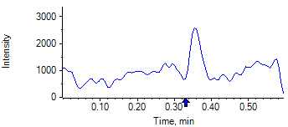

PCP 2 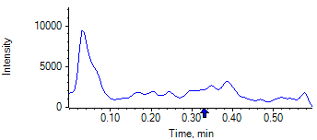

PCP D5 1 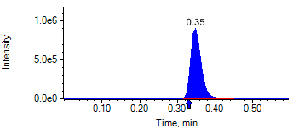

PCP D5 1 

Benzoylecgonine 1 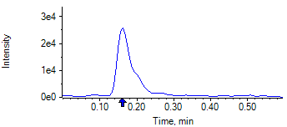

Benzoylecgonine 2 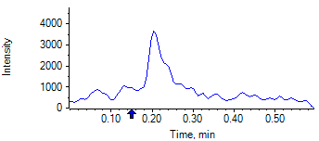

Benzoylecgonine D3 1 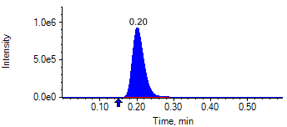

Benzoylecgonine D3 1 

|  |  |  |  |
| --- | --- | --- | --- |
| **Acquisition Method** | PCP_BE_041422Final.dam | **Data File** | SAMPLE077.wiff |
| **Sample Name** | **DL914210S03** | **Injection Volume** | 10.00 |
| **Sample Type** | Unknown | **Injection Vial** | 72 |
| **Injection Date** | 4/30/2025 8:51:47 PM | **Dilution Factor** | 1.00 |
| **Instrument Name** | Triple Quad 5500+ | **Instrument Serial** | EX231582110 |

**Results Summary**

*DL914210S03*

| **Peak Name** | **Integration Type** | **Transition** | **Retention Time** | **Rel RT** | **Peak Area** | **Area Ratio** | **Calculated Concentration (ng/mL)** | **Expected Ion Ratio** | **Calculated  Ion Ratio** | **Ratio Confirms ID** |
| --- | --- | --- | --- | --- | --- | --- | --- | --- | --- | --- |

|  |  |  |  |  |  |  |  |  |  |  |
| --- | --- | --- | --- | --- | --- | --- | --- | --- | --- | --- |
| PCP 1 | N/A | 243.8 / 159.0 | N/A | N/A* | N/A | N/A | N/A |  |  |  |

|  |  |  |  |  |  |  |  |  |  |  |
| --- | --- | --- | --- | --- | --- | --- | --- | --- | --- | --- |
| PCP 2 | N/A | 243.8 / 91.0 | N/A | N/A* | N/A | N/A |  | 59.4% | 0.0% | NO |

|  |  |  |  |  |  |  |  |  |  |  |
| --- | --- | --- | --- | --- | --- | --- | --- | --- | --- | --- |
| Benzoylecgonine 1 | N/A | 289.8 / 168.1 | N/A | N/A* | N/A | N/A | N/A |  |  |  |

|  |  |  |  |  |  |  |  |  |  |  |
| --- | --- | --- | --- | --- | --- | --- | --- | --- | --- | --- |
| Benzoylecgonine 2 | N/A | 289.8 / 104.9 | N/A | N/A* | N/A | N/A |  | 71.7% | 0.0% | NO |

**Internal Standard Data**

|  |  |  |  |  |  |  |  |  |  |
| --- | --- | --- | --- | --- | --- | --- | --- | --- | --- |
| **Internal Standard Name** | **Integration Type** | **Transition** | **Retention Time** | **Avg IS Retention Time** | **IS Peak Area** | **IS Area Within Range** | **Expected Ion Ratio** | **Calculated  Ion Ratio** | **Ratio Confirms ID** |

|  |  |  |  |  |  |  |  |  |  |
| --- | --- | --- | --- | --- | --- | --- | --- | --- | --- |
| PCP D5 1 | Baseline | 248.8 / 164.1 | 0.33* | 0.32 | 1.870e6 | ✓ |  |  |  |

|  |  |  |  |  |  |  |  |  |  |
| --- | --- | --- | --- | --- | --- | --- | --- | --- | --- |
| PCP D5 1 | Baseline | 248.8 / 164.1 | 0.33* | 0.32 | 1.870e6 |  | 100.0% | 100.0% | ✓ |

|  |  |  |  |  |  |  |  |  |  |
| --- | --- | --- | --- | --- | --- | --- | --- | --- | --- |
| Benzoylecgonine D3 1 | Baseline | 292.8 / 171.2 | 0.19* | 0.18 | 2.114e6 | ✓ |  |  |  |

|  |  |  |  |  |  |  |  |  |  |
| --- | --- | --- | --- | --- | --- | --- | --- | --- | --- |
| Benzoylecgonine D3 1 | Baseline | 292.8 / 171.2 | 0.19* | 0.18 | 2.114e6 |  | 100.0% | 100.0% | ✓ |

**Peak Review**

PCP 1 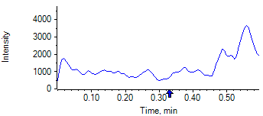

PCP 2 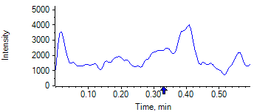

PCP D5 1 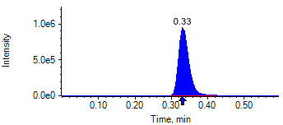

PCP D5 1 

Benzoylecgonine 1 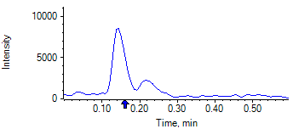

Benzoylecgonine 2 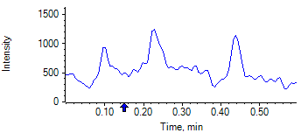

Benzoylecgonine D3 1 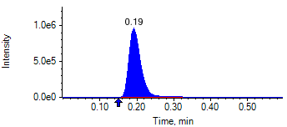

Benzoylecgonine D3 1 

|  |  |  |  |
| --- | --- | --- | --- |
| **Acquisition Method** | PCP_BE_041422Final.dam | **Data File** | SAMPLE078.wiff |
| **Sample Name** | **DL891599S03** | **Injection Volume** | 10.00 |
| **Sample Type** | Unknown | **Injection Vial** | 73 |
| **Injection Date** | 4/30/2025 8:52:56 PM | **Dilution Factor** | 1.00 |
| **Instrument Name** | Triple Quad 5500+ | **Instrument Serial** | EX231582110 |

**Results Summary**

*DL891599S03*

| **Peak Name** | **Integration Type** | **Transition** | **Retention Time** | **Rel RT** | **Peak Area** | **Area Ratio** | **Calculated Concentration (ng/mL)** | **Expected Ion Ratio** | **Calculated  Ion Ratio** | **Ratio Confirms ID** |
| --- | --- | --- | --- | --- | --- | --- | --- | --- | --- | --- |

|  |  |  |  |  |  |  |  |  |  |  |
| --- | --- | --- | --- | --- | --- | --- | --- | --- | --- | --- |
| PCP 1 | N/A | 243.8 / 159.0 | N/A | N/A* | N/A | N/A | N/A |  |  |  |

|  |  |  |  |  |  |  |  |  |  |  |
| --- | --- | --- | --- | --- | --- | --- | --- | --- | --- | --- |
| PCP 2 | N/A | 243.8 / 91.0 | N/A | N/A* | N/A | N/A |  | 59.4% | 0.0% | NO |

|  |  |  |  |  |  |  |  |  |  |  |
| --- | --- | --- | --- | --- | --- | --- | --- | --- | --- | --- |
| Benzoylecgonine 1 | N/A | 289.8 / 168.1 | N/A | N/A* | N/A | N/A | N/A |  |  |  |

|  |  |  |  |  |  |  |  |  |  |  |
| --- | --- | --- | --- | --- | --- | --- | --- | --- | --- | --- |
| Benzoylecgonine 2 | N/A | 289.8 / 104.9 | N/A | N/A* | N/A | N/A |  | 71.7% | 0.0% | NO |

**Internal Standard Data**

|  |  |  |  |  |  |  |  |  |  |
| --- | --- | --- | --- | --- | --- | --- | --- | --- | --- |
| **Internal Standard Name** | **Integration Type** | **Transition** | **Retention Time** | **Avg IS Retention Time** | **IS Peak Area** | **IS Area Within Range** | **Expected Ion Ratio** | **Calculated  Ion Ratio** | **Ratio Confirms ID** |

|  |  |  |  |  |  |  |  |  |  |
| --- | --- | --- | --- | --- | --- | --- | --- | --- | --- |
| PCP D5 1 | Baseline | 248.8 / 164.1 | 0.29* | 0.32 | 1.492e6 | ✓ |  |  |  |

|  |  |  |  |  |  |  |  |  |  |
| --- | --- | --- | --- | --- | --- | --- | --- | --- | --- |
| PCP D5 1 | Baseline | 248.8 / 164.1 | 0.29* | 0.32 | 1.492e6 |  | 100.0% | 100.0% | ✓ |

|  |  |  |  |  |  |  |  |  |  |
| --- | --- | --- | --- | --- | --- | --- | --- | --- | --- |
| Benzoylecgonine D3 1 | Baseline | 292.8 / 171.2 | 0.16* | 0.18 | 1.698e6 | ✓ |  |  |  |

|  |  |  |  |  |  |  |  |  |  |
| --- | --- | --- | --- | --- | --- | --- | --- | --- | --- |
| Benzoylecgonine D3 1 | Baseline | 292.8 / 171.2 | 0.16* | 0.18 | 1.698e6 |  | 100.0% | 100.0% | ✓ |

**Peak Review**

PCP 1 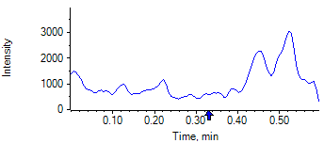

PCP 2 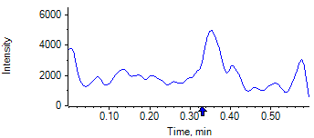

PCP D5 1 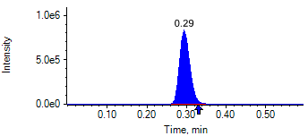

PCP D5 1 

Benzoylecgonine 1 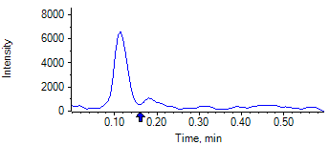

Benzoylecgonine 2 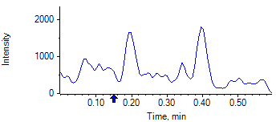

Benzoylecgonine D3 1 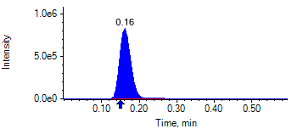

Benzoylecgonine D3 1 

|  |  |  |  |
| --- | --- | --- | --- |
| **Acquisition Method** | PCP_BE_041422Final.dam | **Data File** | SAMPLE079.wiff |
| **Sample Name** | **CPC PC** | **Injection Volume** | 10.00 |
| **Sample Type** | Quality Control | **Injection Vial** | 74 |
| **Injection Date** | 4/30/2025 8:54:08 PM | **Dilution Factor** | 1.00 |
| **Instrument Name** | Triple Quad 5500+ | **Instrument Serial** | EX231582110 |

**Results Summary**

| **Peak Name** | **Integration Type** | **Transition** | **Retention Time** | **Rel RT** | **Peak Area** | **Area Ratio** | **Calculated Concentration (ng/mL)** | **Expected Ion Ratio** | **Calculated  Ion Ratio** | **Ratio Confirms ID** |
| --- | --- | --- | --- | --- | --- | --- | --- | --- | --- | --- |

|  |  |  |  |  |  |  |  |  |  |  |
| --- | --- | --- | --- | --- | --- | --- | --- | --- | --- | --- |
| PCP 1 | Baseline | 243.8 / 159.0 | 0.30 | 1.02 | 1.526e7 | 9.300 | 2008.48 |  |  |  |

|  |  |  |  |  |  |  |  |  |  |  |
| --- | --- | --- | --- | --- | --- | --- | --- | --- | --- | --- |
| PCP 2 | Baseline | 243.8 / 91.0 | 0.30 | 1.02 | 8.694e6 | 5.297 |  | 59.4% | 57.0% | ✓ |

|  |  |  |  |  |  |  |  |  |  |  |
| --- | --- | --- | --- | --- | --- | --- | --- | --- | --- | --- |
| Benzoylecgonine 1 | Baseline | 289.8 / 168.1 | 0.16 | 1.02 | 2.469e6 | 1.449 | 7644.97 |  |  |  |

|  |  |  |  |  |  |  |  |  |  |  |
| --- | --- | --- | --- | --- | --- | --- | --- | --- | --- | --- |
| Benzoylecgonine 2 | Baseline | 289.8 / 104.9 | 0.16 | 1.02 | 1.839e6 | 1.079 |  | 71.7% | 74.5% | ✓ |

**Internal Standard Data**

|  |  |  |  |  |  |  |  |  |  |
| --- | --- | --- | --- | --- | --- | --- | --- | --- | --- |
| **Internal Standard Name** | **Integration Type** | **Transition** | **Retention Time** | **Avg IS Retention Time** | **IS Peak Area** | **IS Area Within Range** | **Expected Ion Ratio** | **Calculated  Ion Ratio** | **Ratio Confirms ID** |

|  |  |  |  |  |  |  |  |  |  |
| --- | --- | --- | --- | --- | --- | --- | --- | --- | --- |
| PCP D5 1 | Baseline | 248.8 / 164.1 | 0.29* | 0.32 | 1.641e6 | ✓ |  |  |  |

|  |  |  |  |  |  |  |  |  |  |
| --- | --- | --- | --- | --- | --- | --- | --- | --- | --- |
| PCP D5 1 | Baseline | 248.8 / 164.1 | 0.29* | 0.32 | 1.641e6 |  | 100.0% | 100.0% | ✓ |

|  |  |  |  |  |  |  |  |  |  |
| --- | --- | --- | --- | --- | --- | --- | --- | --- | --- |
| Benzoylecgonine D3 1 | Baseline | 292.8 / 171.2 | 0.15* | 0.18 | 1.704e6 | ✓ |  |  |  |

|  |  |  |  |  |  |  |  |  |  |
| --- | --- | --- | --- | --- | --- | --- | --- | --- | --- |
| Benzoylecgonine D3 1 | Baseline | 292.8 / 171.2 | 0.15* | 0.18 | 1.704e6 |  | 100.0% | 100.0% | ✓ |

**Peak Review**

PCP 1 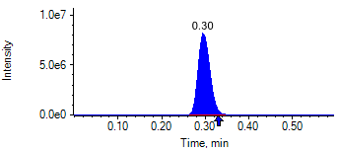

PCP 2 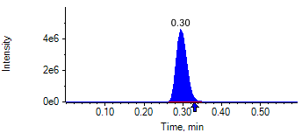

PCP D5 1 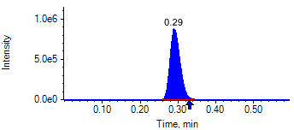

PCP D5 1 

Benzoylecgonine 1 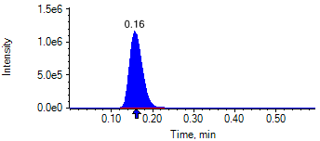

Benzoylecgonine 2 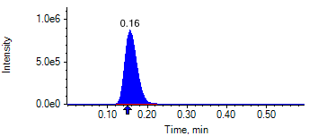

Benzoylecgonine D3 1 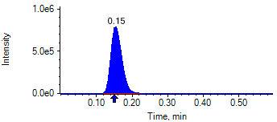

Benzoylecgonine D3 1 

|  |  |  |  |
| --- | --- | --- | --- |
| **Acquisition Method** | PCP_BE_041422Final.dam | **Data File** | SAMPLE080.wiff |
| **Sample Name** | **DL913313S03** | **Injection Volume** | 10.00 |
| **Sample Type** | Unknown | **Injection Vial** | 75 |
| **Injection Date** | 4/30/2025 8:55:21 PM | **Dilution Factor** | 1.00 |
| **Instrument Name** | Triple Quad 5500+ | **Instrument Serial** | EX231582110 |

**Results Summary**

*DL913313S03*

| **Peak Name** | **Integration Type** | **Transition** | **Retention Time** | **Rel RT** | **Peak Area** | **Area Ratio** | **Calculated Concentration (ng/mL)** | **Expected Ion Ratio** | **Calculated  Ion Ratio** | **Ratio Confirms ID** |
| --- | --- | --- | --- | --- | --- | --- | --- | --- | --- | --- |

|  |  |  |  |  |  |  |  |  |  |  |
| --- | --- | --- | --- | --- | --- | --- | --- | --- | --- | --- |
| PCP 1 | N/A | 243.8 / 159.0 | N/A | N/A* | N/A | N/A | N/A |  |  |  |

|  |  |  |  |  |  |  |  |  |  |  |
| --- | --- | --- | --- | --- | --- | --- | --- | --- | --- | --- |
| PCP 2 | N/A | 243.8 / 91.0 | N/A | N/A* | N/A | N/A |  | 59.4% | 0.0% | NO |

|  |  |  |  |  |  |  |  |  |  |  |
| --- | --- | --- | --- | --- | --- | --- | --- | --- | --- | --- |
| Benzoylecgonine 1 | N/A | 289.8 / 168.1 | N/A | N/A* | N/A | N/A | N/A |  |  |  |

|  |  |  |  |  |  |  |  |  |  |  |
| --- | --- | --- | --- | --- | --- | --- | --- | --- | --- | --- |
| Benzoylecgonine 2 | N/A | 289.8 / 104.9 | N/A | N/A* | N/A | N/A |  | 71.7% | 0.0% | NO |

**Internal Standard Data**

|  |  |  |  |  |  |  |  |  |  |
| --- | --- | --- | --- | --- | --- | --- | --- | --- | --- |
| **Internal Standard Name** | **Integration Type** | **Transition** | **Retention Time** | **Avg IS Retention Time** | **IS Peak Area** | **IS Area Within Range** | **Expected Ion Ratio** | **Calculated  Ion Ratio** | **Ratio Confirms ID** |

|  |  |  |  |  |  |  |  |  |  |
| --- | --- | --- | --- | --- | --- | --- | --- | --- | --- |
| PCP D5 1 | Baseline | 248.8 / 164.1 | 0.35* | 0.32 | 1.075e6 | ✓ |  |  |  |

|  |  |  |  |  |  |  |  |  |  |
| --- | --- | --- | --- | --- | --- | --- | --- | --- | --- |
| PCP D5 1 | Baseline | 248.8 / 164.1 | 0.35* | 0.32 | 1.075e6 |  | 100.0% | 100.0% | ✓ |

|  |  |  |  |  |  |  |  |  |  |
| --- | --- | --- | --- | --- | --- | --- | --- | --- | --- |
| Benzoylecgonine D3 1 | Valley | 292.8 / 171.2 | 0.20* | 0.18 | 1.001e6 | ✓ |  |  |  |

|  |  |  |  |  |  |  |  |  |  |
| --- | --- | --- | --- | --- | --- | --- | --- | --- | --- |
| Benzoylecgonine D3 1 | Valley | 292.8 / 171.2 | 0.20* | 0.18 | 1.001e6 |  | 100.0% | 100.0% | ✓ |

**Peak Review**

PCP 1 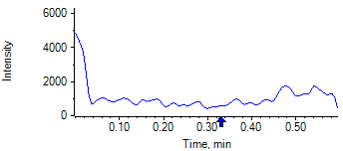

PCP 2 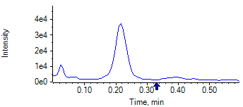

PCP D5 1 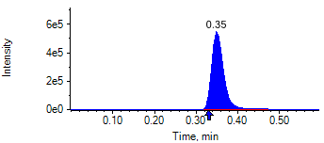

PCP D5 1 

Benzoylecgonine 1 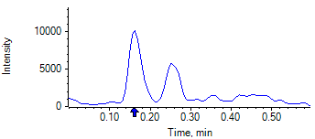

Benzoylecgonine 2 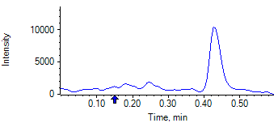

Benzoylecgonine D3 1 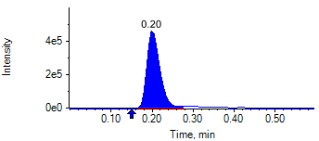

Benzoylecgonine D3 1 

|  |  |  |  |
| --- | --- | --- | --- |
| **Acquisition Method** | PCP_BE_041422Final.dam | **Data File** | SAMPLE081.wiff |
| **Sample Name** | **DL913325S03** | **Injection Volume** | 10.00 |
| **Sample Type** | Unknown | **Injection Vial** | 76 |
| **Injection Date** | 4/30/2025 8:56:33 PM | **Dilution Factor** | 1.00 |
| **Instrument Name** | Triple Quad 5500+ | **Instrument Serial** | EX231582110 |

**Results Summary**

*DL913325S03*

| **Peak Name** | **Integration Type** | **Transition** | **Retention Time** | **Rel RT** | **Peak Area** | **Area Ratio** | **Calculated Concentration (ng/mL)** | **Expected Ion Ratio** | **Calculated  Ion Ratio** | **Ratio Confirms ID** |
| --- | --- | --- | --- | --- | --- | --- | --- | --- | --- | --- |

|  |  |  |  |  |  |  |  |  |  |  |
| --- | --- | --- | --- | --- | --- | --- | --- | --- | --- | --- |
| PCP 1 | N/A | 243.8 / 159.0 | N/A | N/A* | N/A | N/A | N/A |  |  |  |

|  |  |  |  |  |  |  |  |  |  |  |
| --- | --- | --- | --- | --- | --- | --- | --- | --- | --- | --- |
| PCP 2 | N/A | 243.8 / 91.0 | N/A | N/A* | N/A | N/A |  | 59.4% | 0.0% | NO |

|  |  |  |  |  |  |  |  |  |  |  |
| --- | --- | --- | --- | --- | --- | --- | --- | --- | --- | --- |
| Benzoylecgonine 1 | N/A | 289.8 / 168.1 | N/A | N/A* | N/A | N/A | N/A |  |  |  |

|  |  |  |  |  |  |  |  |  |  |  |
| --- | --- | --- | --- | --- | --- | --- | --- | --- | --- | --- |
| Benzoylecgonine 2 | N/A | 289.8 / 104.9 | N/A | N/A* | N/A | N/A |  | 71.7% | 0.0% | NO |

**Internal Standard Data**

|  |  |  |  |  |  |  |  |  |  |
| --- | --- | --- | --- | --- | --- | --- | --- | --- | --- |
| **Internal Standard Name** | **Integration Type** | **Transition** | **Retention Time** | **Avg IS Retention Time** | **IS Peak Area** | **IS Area Within Range** | **Expected Ion Ratio** | **Calculated  Ion Ratio** | **Ratio Confirms ID** |

|  |  |  |  |  |  |  |  |  |  |
| --- | --- | --- | --- | --- | --- | --- | --- | --- | --- |
| PCP D5 1 | Baseline | 248.8 / 164.1 | 0.32 | 0.32 | 1.512e6 | ✓ |  |  |  |

|  |  |  |  |  |  |  |  |  |  |
| --- | --- | --- | --- | --- | --- | --- | --- | --- | --- |
| PCP D5 1 | Baseline | 248.8 / 164.1 | 0.32 | 0.32 | 1.512e6 |  | 100.0% | 100.0% | ✓ |

|  |  |  |  |  |  |  |  |  |  |
| --- | --- | --- | --- | --- | --- | --- | --- | --- | --- |
| Benzoylecgonine D3 1 | Baseline | 292.8 / 171.2 | 0.18 | 0.18 | 1.731e6 | ✓ |  |  |  |

|  |  |  |  |  |  |  |  |  |  |
| --- | --- | --- | --- | --- | --- | --- | --- | --- | --- |
| Benzoylecgonine D3 1 | Baseline | 292.8 / 171.2 | 0.18 | 0.18 | 1.731e6 |  | 100.0% | 100.0% | ✓ |

**Peak Review**

PCP 1 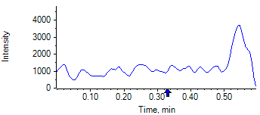

PCP 2 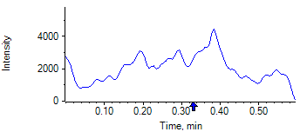

PCP D5 1 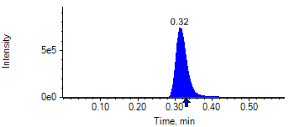

PCP D5 1 

Benzoylecgonine 1 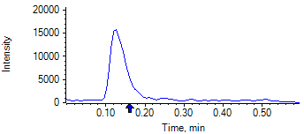

Benzoylecgonine 2 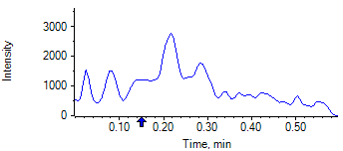

Benzoylecgonine D3 1 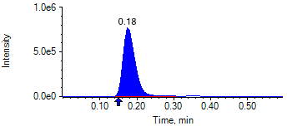

Benzoylecgonine D3 1 

|  |  |  |  |
| --- | --- | --- | --- |
| **Acquisition Method** | PCP_BE_041422Final.dam | **Data File** | SAMPLE082.wiff |
| **Sample Name** | **CPC LO NL** | **Injection Volume** | 10.00 |
| **Sample Type** | Unknown | **Injection Vial** | 77 |
| **Injection Date** | 4/30/2025 8:57:40 PM | **Dilution Factor** | 1.00 |
| **Instrument Name** | Triple Quad 5500+ | **Instrument Serial** | EX231582110 |

**Results Summary**

*CPC LO NL*

| **Peak Name** | **Integration Type** | **Transition** | **Retention Time** | **Rel RT** | **Peak Area** | **Area Ratio** | **Calculated Concentration (ng/mL)** | **Expected Ion Ratio** | **Calculated  Ion Ratio** | **Ratio Confirms ID** |
| --- | --- | --- | --- | --- | --- | --- | --- | --- | --- | --- |

|  |  |  |  |  |  |  |  |  |  |  |
| --- | --- | --- | --- | --- | --- | --- | --- | --- | --- | --- |
| PCP 1 | Baseline | 243.8 / 159.0 | 0.30 | 1.02 | 2.762e5 | 0.150 | 30.07 |  |  |  |

|  |  |  |  |  |  |  |  |  |  |  |
| --- | --- | --- | --- | --- | --- | --- | --- | --- | --- | --- |
| PCP 2 | Baseline | 243.8 / 91.0 | 0.30 | 1.01 | 1.754e5 | 0.095 |  | 59.4% | 63.5% | ✓ |

|  |  |  |  |  |  |  |  |  |  |  |
| --- | --- | --- | --- | --- | --- | --- | --- | --- | --- | --- |
| Benzoylecgonine 1 | Valley | 289.8 / 168.1 | 0.17 | 1.02 | 5.203e4 | 0.024 | 119.32 |  |  |  |

|  |  |  |  |  |  |  |  |  |  |  |
| --- | --- | --- | --- | --- | --- | --- | --- | --- | --- | --- |
| Benzoylecgonine 2 | Baseline | 289.8 / 104.9 | 0.16 | 1.02 | 3.923e4 | 0.018 |  | 71.7% | 75.4% | ✓ |

**Internal Standard Data**

|  |  |  |  |  |  |  |  |  |  |
| --- | --- | --- | --- | --- | --- | --- | --- | --- | --- |
| **Internal Standard Name** | **Integration Type** | **Transition** | **Retention Time** | **Avg IS Retention Time** | **IS Peak Area** | **IS Area Within Range** | **Expected Ion Ratio** | **Calculated  Ion Ratio** | **Ratio Confirms ID** |

|  |  |  |  |  |  |  |  |  |  |
| --- | --- | --- | --- | --- | --- | --- | --- | --- | --- |
| PCP D5 1 | Baseline | 248.8 / 164.1 | 0.29* | 0.32 | 1.846e6 | ✓ |  |  |  |

|  |  |  |  |  |  |  |  |  |  |
| --- | --- | --- | --- | --- | --- | --- | --- | --- | --- |
| PCP D5 1 | Baseline | 248.8 / 164.1 | 0.29* | 0.32 | 1.846e6 |  | 100.0% | 100.0% | ✓ |

|  |  |  |  |  |  |  |  |  |  |
| --- | --- | --- | --- | --- | --- | --- | --- | --- | --- |
| Benzoylecgonine D3 1 | Baseline | 292.8 / 171.2 | 0.16* | 0.18 | 2.199e6 | ✓ |  |  |  |

|  |  |  |  |  |  |  |  |  |  |
| --- | --- | --- | --- | --- | --- | --- | --- | --- | --- |
| Benzoylecgonine D3 1 | Baseline | 292.8 / 171.2 | 0.16* | 0.18 | 2.199e6 |  | 100.0% | 100.0% | ✓ |

**Peak Review**

PCP 1 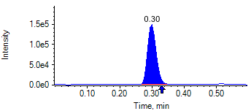

PCP 2 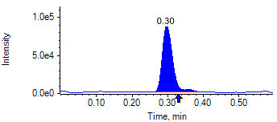

PCP D5 1 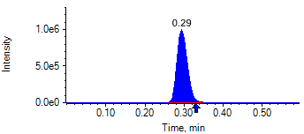

PCP D5 1 

Benzoylecgonine 1 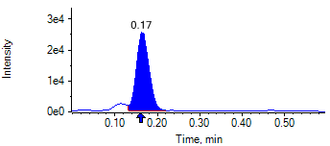

Benzoylecgonine 2 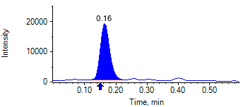

Benzoylecgonine D3 1 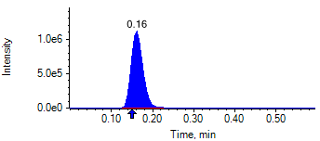

Benzoylecgonine D3 1 

|  |  |  |  |
| --- | --- | --- | --- |
| **Acquisition Method** | PCP_BE_041422Final.dam | **Data File** | SAMPLE083.wiff |
| **Sample Name** | **CPC LO NL** | **Injection Volume** | 10.00 |
| **Sample Type** | Unknown | **Injection Vial** | 78 |
| **Injection Date** | 4/30/2025 8:58:50 PM | **Dilution Factor** | 1.00 |
| **Instrument Name** | Triple Quad 5500+ | **Instrument Serial** | EX231582110 |

**Results Summary**

*CPC LO NL*

| **Peak Name** | **Integration Type** | **Transition** | **Retention Time** | **Rel RT** | **Peak Area** | **Area Ratio** | **Calculated Concentration (ng/mL)** | **Expected Ion Ratio** | **Calculated  Ion Ratio** | **Ratio Confirms ID** |
| --- | --- | --- | --- | --- | --- | --- | --- | --- | --- | --- |

|  |  |  |  |  |  |  |  |  |  |  |
| --- | --- | --- | --- | --- | --- | --- | --- | --- | --- | --- |
| PCP 1 | Baseline | 243.8 / 159.0 | 0.31 | 1.02 | 2.800e5 | 0.149 | 30.01 |  |  |  |

|  |  |  |  |  |  |  |  |  |  |  |
| --- | --- | --- | --- | --- | --- | --- | --- | --- | --- | --- |
| PCP 2 | Baseline | 243.8 / 91.0 | 0.31 | 1.01 | 1.824e5 | 0.097 |  | 59.4% | 65.1% | ✓ |

|  |  |  |  |  |  |  |  |  |  |  |
| --- | --- | --- | --- | --- | --- | --- | --- | --- | --- | --- |
| Benzoylecgonine 1 | Valley | 289.8 / 168.1 | 0.18 | 1.02 | 5.513e4 | 0.025 | 128.32 |  |  |  |

|  |  |  |  |  |  |  |  |  |  |  |
| --- | --- | --- | --- | --- | --- | --- | --- | --- | --- | --- |
| Benzoylecgonine 2 | Baseline | 289.8 / 104.9 | 0.17 | 1.02 | 3.810e4 | 0.018 |  | 71.7% | 69.1% | ✓ |

**Internal Standard Data**

|  |  |  |  |  |  |  |  |  |  |
| --- | --- | --- | --- | --- | --- | --- | --- | --- | --- |
| **Internal Standard Name** | **Integration Type** | **Transition** | **Retention Time** | **Avg IS Retention Time** | **IS Peak Area** | **IS Area Within Range** | **Expected Ion Ratio** | **Calculated  Ion Ratio** | **Ratio Confirms ID** |

|  |  |  |  |  |  |  |  |  |  |
| --- | --- | --- | --- | --- | --- | --- | --- | --- | --- |
| PCP D5 1 | Baseline | 248.8 / 164.1 | 0.31* | 0.32 | 1.875e6 | ✓ |  |  |  |

|  |  |  |  |  |  |  |  |  |  |
| --- | --- | --- | --- | --- | --- | --- | --- | --- | --- |
| PCP D5 1 | Baseline | 248.8 / 164.1 | 0.31* | 0.32 | 1.875e6 |  | 100.0% | 100.0% | ✓ |

|  |  |  |  |  |  |  |  |  |  |
| --- | --- | --- | --- | --- | --- | --- | --- | --- | --- |
| Benzoylecgonine D3 1 | Baseline | 292.8 / 171.2 | 0.17* | 0.18 | 2.169e6 | ✓ |  |  |  |

|  |  |  |  |  |  |  |  |  |  |
| --- | --- | --- | --- | --- | --- | --- | --- | --- | --- |
| Benzoylecgonine D3 1 | Baseline | 292.8 / 171.2 | 0.17* | 0.18 | 2.169e6 |  | 100.0% | 100.0% | ✓ |

**Peak Review**

PCP 1 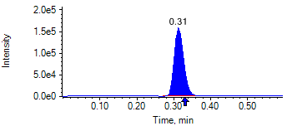

PCP 2 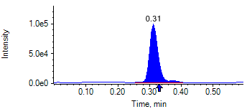

PCP D5 1 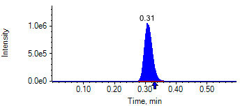

PCP D5 1 

Benzoylecgonine 1 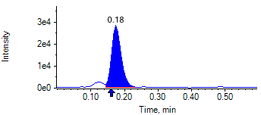

Benzoylecgonine 2 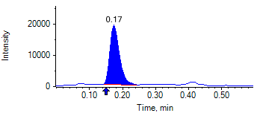

Benzoylecgonine D3 1 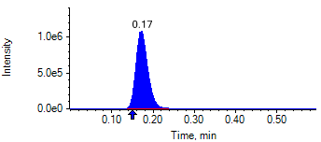

Benzoylecgonine D3 1 

|  |  |  |  |
| --- | --- | --- | --- |
| **Acquisition Method** | PCP_BE_041422Final.dam | **Data File** | SAMPLE084.wiff |
| **Sample Name** | **CPC LO NL** | **Injection Volume** | 10.00 |
| **Sample Type** | Unknown | **Injection Vial** | 79 |
| **Injection Date** | 4/30/2025 9:00:04 PM | **Dilution Factor** | 1.00 |
| **Instrument Name** | Triple Quad 5500+ | **Instrument Serial** | EX231582110 |

**Results Summary**

*CPC LO NL*

| **Peak Name** | **Integration Type** | **Transition** | **Retention Time** | **Rel RT** | **Peak Area** | **Area Ratio** | **Calculated Concentration (ng/mL)** | **Expected Ion Ratio** | **Calculated  Ion Ratio** | **Ratio Confirms ID** |
| --- | --- | --- | --- | --- | --- | --- | --- | --- | --- | --- |

|  |  |  |  |  |  |  |  |  |  |  |
| --- | --- | --- | --- | --- | --- | --- | --- | --- | --- | --- |
| PCP 1 | Valley | 243.8 / 159.0 | 0.35 | 1.01 | 2.841e5 | 0.147 | 29.45 |  |  |  |

|  |  |  |  |  |  |  |  |  |  |  |
| --- | --- | --- | --- | --- | --- | --- | --- | --- | --- | --- |
| PCP 2 | Baseline | 243.8 / 91.0 | 0.35 | 1.01 | 1.708e5 | 0.088 |  | 59.4% | 60.1% | ✓ |

|  |  |  |  |  |  |  |  |  |  |  |
| --- | --- | --- | --- | --- | --- | --- | --- | --- | --- | --- |
| Benzoylecgonine 1 | Baseline | 289.8 / 168.1 | 0.21 | 1.02 | 5.547e4 | 0.027 | 136.03 |  |  |  |

|  |  |  |  |  |  |  |  |  |  |  |
| --- | --- | --- | --- | --- | --- | --- | --- | --- | --- | --- |
| Benzoylecgonine 2 | Baseline | 289.8 / 104.9 | 0.21 | 1.02 | 3.499e4 | 0.017 |  | 71.7% | 63.1% | ✓ |

**Internal Standard Data**

|  |  |  |  |  |  |  |  |  |  |
| --- | --- | --- | --- | --- | --- | --- | --- | --- | --- |
| **Internal Standard Name** | **Integration Type** | **Transition** | **Retention Time** | **Avg IS Retention Time** | **IS Peak Area** | **IS Area Within Range** | **Expected Ion Ratio** | **Calculated  Ion Ratio** | **Ratio Confirms ID** |

|  |  |  |  |  |  |  |  |  |  |
| --- | --- | --- | --- | --- | --- | --- | --- | --- | --- |
| PCP D5 1 | Baseline | 248.8 / 164.1 | 0.35* | 0.32 | 1.937e6 | ✓ |  |  |  |

|  |  |  |  |  |  |  |  |  |  |
| --- | --- | --- | --- | --- | --- | --- | --- | --- | --- |
| PCP D5 1 | Baseline | 248.8 / 164.1 | 0.35* | 0.32 | 1.937e6 |  | 100.0% | 100.0% | ✓ |

|  |  |  |  |  |  |  |  |  |  |
| --- | --- | --- | --- | --- | --- | --- | --- | --- | --- |
| Benzoylecgonine D3 1 | Baseline | 292.8 / 171.2 | 0.20* | 0.18 | 2.060e6 | ✓ |  |  |  |

|  |  |  |  |  |  |  |  |  |  |
| --- | --- | --- | --- | --- | --- | --- | --- | --- | --- |
| Benzoylecgonine D3 1 | Baseline | 292.8 / 171.2 | 0.20* | 0.18 | 2.060e6 |  | 100.0% | 100.0% | ✓ |

**Peak Review**

PCP 1 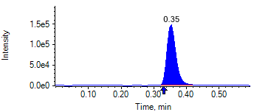

PCP 2 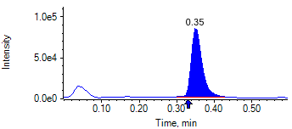

PCP D5 1 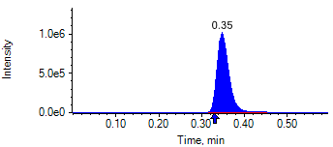

PCP D5 1 

Benzoylecgonine 1 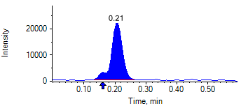

Benzoylecgonine 2 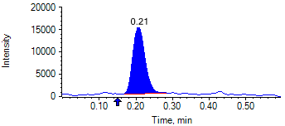

Benzoylecgonine D3 1 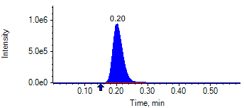

Benzoylecgonine D3 1 

|  |  |  |  |
| --- | --- | --- | --- |
| **Acquisition Method** | PCP_BE_041422Final.dam | **Data File** | SAMPLE085.wiff |
| **Sample Name** | **CPC LO NL** | **Injection Volume** | 10.00 |
| **Sample Type** | Unknown | **Injection Vial** | 80 |
| **Injection Date** | 4/30/2025 9:01:15 PM | **Dilution Factor** | 1.00 |
| **Instrument Name** | Triple Quad 5500+ | **Instrument Serial** | EX231582110 |

**Results Summary**

*CPC LO NL*

| **Peak Name** | **Integration Type** | **Transition** | **Retention Time** | **Rel RT** | **Peak Area** | **Area Ratio** | **Calculated Concentration (ng/mL)** | **Expected Ion Ratio** | **Calculated  Ion Ratio** | **Ratio Confirms ID** |
| --- | --- | --- | --- | --- | --- | --- | --- | --- | --- | --- |

|  |  |  |  |  |  |  |  |  |  |  |
| --- | --- | --- | --- | --- | --- | --- | --- | --- | --- | --- |
| PCP 1 | Baseline | 243.8 / 159.0 | 0.34 | 1.01 | 2.624e5 | 0.149 | 29.98 |  |  |  |

|  |  |  |  |  |  |  |  |  |  |  |
| --- | --- | --- | --- | --- | --- | --- | --- | --- | --- | --- |
| PCP 2 | Baseline | 243.8 / 91.0 | 0.34 | 1.01 | 1.632e5 | 0.093 |  | 59.4% | 62.2% | ✓ |

|  |  |  |  |  |  |  |  |  |  |  |
| --- | --- | --- | --- | --- | --- | --- | --- | --- | --- | --- |
| Benzoylecgonine 1 | Valley | 289.8 / 168.1 | 0.20 | 1.01 | 5.103e4 | 0.024 | 121.21 |  |  |  |

|  |  |  |  |  |  |  |  |  |  |  |
| --- | --- | --- | --- | --- | --- | --- | --- | --- | --- | --- |
| Benzoylecgonine 2 | Baseline | 289.8 / 104.9 | 0.20 | 1.01 | 3.548e4 | 0.017 |  | 71.7% | 69.5% | ✓ |

**Internal Standard Data**

|  |  |  |  |  |  |  |  |  |  |
| --- | --- | --- | --- | --- | --- | --- | --- | --- | --- |
| **Internal Standard Name** | **Integration Type** | **Transition** | **Retention Time** | **Avg IS Retention Time** | **IS Peak Area** | **IS Area Within Range** | **Expected Ion Ratio** | **Calculated  Ion Ratio** | **Ratio Confirms ID** |

|  |  |  |  |  |  |  |  |  |  |
| --- | --- | --- | --- | --- | --- | --- | --- | --- | --- |
| PCP D5 1 | Baseline | 248.8 / 164.1 | 0.33* | 0.32 | 1.759e6 | ✓ |  |  |  |

|  |  |  |  |  |  |  |  |  |  |
| --- | --- | --- | --- | --- | --- | --- | --- | --- | --- |
| PCP D5 1 | Baseline | 248.8 / 164.1 | 0.33* | 0.32 | 1.759e6 |  | 100.0% | 100.0% | ✓ |

|  |  |  |  |  |  |  |  |  |  |
| --- | --- | --- | --- | --- | --- | --- | --- | --- | --- |
| Benzoylecgonine D3 1 | Baseline | 292.8 / 171.2 | 0.19* | 0.18 | 2.123e6 | ✓ |  |  |  |

|  |  |  |  |  |  |  |  |  |  |
| --- | --- | --- | --- | --- | --- | --- | --- | --- | --- |
| Benzoylecgonine D3 1 | Baseline | 292.8 / 171.2 | 0.19* | 0.18 | 2.123e6 |  | 100.0% | 100.0% | ✓ |

**Peak Review**

PCP 1 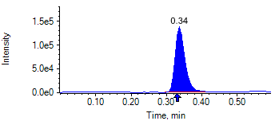

PCP 2 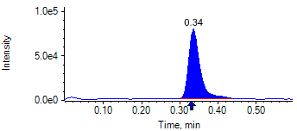

PCP D5 1 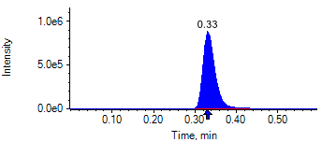

PCP D5 1 

Benzoylecgonine 1 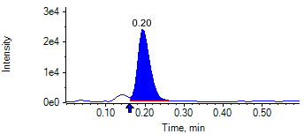

Benzoylecgonine 2 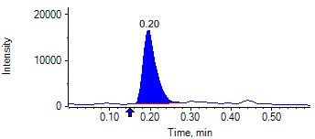

Benzoylecgonine D3 1 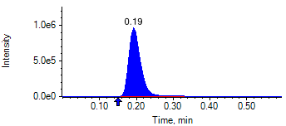

Benzoylecgonine D3 1 

|  |  |  |  |
| --- | --- | --- | --- |
| **Acquisition Method** | PCP_BE_041422Final.dam | **Data File** | SAMPLE086.wiff |
| **Sample Name** | **CPC LO NL** | **Injection Volume** | 10.00 |
| **Sample Type** | Unknown | **Injection Vial** | 81 |
| **Injection Date** | 4/30/2025 9:02:24 PM | **Dilution Factor** | 1.00 |
| **Instrument Name** | Triple Quad 5500+ | **Instrument Serial** | EX231582110 |

**Results Summary**

*CPC LO NL*

| **Peak Name** | **Integration Type** | **Transition** | **Retention Time** | **Rel RT** | **Peak Area** | **Area Ratio** | **Calculated Concentration (ng/mL)** | **Expected Ion Ratio** | **Calculated  Ion Ratio** | **Ratio Confirms ID** |
| --- | --- | --- | --- | --- | --- | --- | --- | --- | --- | --- |

|  |  |  |  |  |  |  |  |  |  |  |
| --- | --- | --- | --- | --- | --- | --- | --- | --- | --- | --- |
| PCP 1 | Baseline | 243.8 / 159.0 | 0.30 | 1.01 | 2.699e5 | 0.150 | 30.19 |  |  |  |

|  |  |  |  |  |  |  |  |  |  |  |
| --- | --- | --- | --- | --- | --- | --- | --- | --- | --- | --- |
| PCP 2 | Baseline | 243.8 / 91.0 | 0.30 | 1.01 | 1.675e5 | 0.093 |  | 59.4% | 62.1% | ✓ |

|  |  |  |  |  |  |  |  |  |  |  |
| --- | --- | --- | --- | --- | --- | --- | --- | --- | --- | --- |
| Benzoylecgonine 1 | Valley | 289.8 / 168.1 | 0.16 | 1.02 | 5.011e4 | 0.024 | 121.36 |  |  |  |

|  |  |  |  |  |  |  |  |  |  |  |
| --- | --- | --- | --- | --- | --- | --- | --- | --- | --- | --- |
| Benzoylecgonine 2 | Baseline | 289.8 / 104.9 | 0.16 | 1.02 | 3.671e4 | 0.018 |  | 71.7% | 73.3% | ✓ |

**Internal Standard Data**

|  |  |  |  |  |  |  |  |  |  |
| --- | --- | --- | --- | --- | --- | --- | --- | --- | --- |
| **Internal Standard Name** | **Integration Type** | **Transition** | **Retention Time** | **Avg IS Retention Time** | **IS Peak Area** | **IS Area Within Range** | **Expected Ion Ratio** | **Calculated  Ion Ratio** | **Ratio Confirms ID** |

|  |  |  |  |  |  |  |  |  |  |
| --- | --- | --- | --- | --- | --- | --- | --- | --- | --- |
| PCP D5 1 | Baseline | 248.8 / 164.1 | 0.29* | 0.32 | 1.797e6 | ✓ |  |  |  |

|  |  |  |  |  |  |  |  |  |  |
| --- | --- | --- | --- | --- | --- | --- | --- | --- | --- |
| PCP D5 1 | Baseline | 248.8 / 164.1 | 0.29* | 0.32 | 1.797e6 |  | 100.0% | 100.0% | ✓ |

|  |  |  |  |  |  |  |  |  |  |
| --- | --- | --- | --- | --- | --- | --- | --- | --- | --- |
| Benzoylecgonine D3 1 | Baseline | 292.8 / 171.2 | 0.16* | 0.18 | 2.083e6 | ✓ |  |  |  |

|  |  |  |  |  |  |  |  |  |  |
| --- | --- | --- | --- | --- | --- | --- | --- | --- | --- |
| Benzoylecgonine D3 1 | Baseline | 292.8 / 171.2 | 0.16* | 0.18 | 2.083e6 |  | 100.0% | 100.0% | ✓ |

**Peak Review**

PCP 1 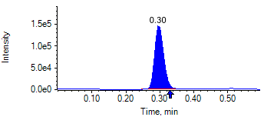

PCP 2 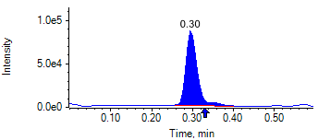

PCP D5 1 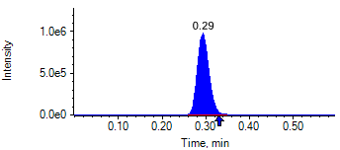

PCP D5 1 

Benzoylecgonine 1 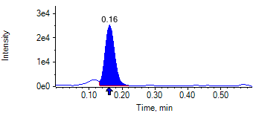

Benzoylecgonine 2 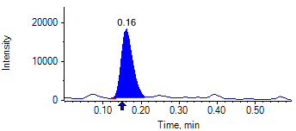

Benzoylecgonine D3 1 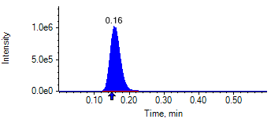

Benzoylecgonine D3 1 

|  |  |  |  |
| --- | --- | --- | --- |
| **Acquisition Method** | PCP_BE_041422Final.dam | **Data File** | SAMPLE087.wiff |
| **Sample Name** | **CPC MI NL** | **Injection Volume** | 10.00 |
| **Sample Type** | Unknown | **Injection Vial** | 82 |
| **Injection Date** | 4/30/2025 9:03:34 PM | **Dilution Factor** | 1.00 |
| **Instrument Name** | Triple Quad 5500+ | **Instrument Serial** | EX231582110 |

**Results Summary**

*CPC MI NL*

| **Peak Name** | **Integration Type** | **Transition** | **Retention Time** | **Rel RT** | **Peak Area** | **Area Ratio** | **Calculated Concentration (ng/mL)** | **Expected Ion Ratio** | **Calculated  Ion Ratio** | **Ratio Confirms ID** |
| --- | --- | --- | --- | --- | --- | --- | --- | --- | --- | --- |

|  |  |  |  |  |  |  |  |  |  |  |
| --- | --- | --- | --- | --- | --- | --- | --- | --- | --- | --- |
| PCP 1 | Baseline | 243.8 / 159.0 | 0.31 | 1.01 | 1.491e7 | 8.893 | 1917.46 |  |  |  |

|  |  |  |  |  |  |  |  |  |  |  |
| --- | --- | --- | --- | --- | --- | --- | --- | --- | --- | --- |
| PCP 2 | Baseline | 243.8 / 91.0 | 0.31 | 1.01 | 8.621e6 | 5.143 |  | 59.4% | 57.8% | ✓ |

|  |  |  |  |  |  |  |  |  |  |  |
| --- | --- | --- | --- | --- | --- | --- | --- | --- | --- | --- |
| Benzoylecgonine 1 | Baseline | 289.8 / 168.1 | 0.17 | 1.02 | 2.490e6 | 1.464 | 7725.34 |  |  |  |

|  |  |  |  |  |  |  |  |  |  |  |
| --- | --- | --- | --- | --- | --- | --- | --- | --- | --- | --- |
| Benzoylecgonine 2 | Baseline | 289.8 / 104.9 | 0.17 | 1.02 | 1.821e6 | 1.071 |  | 71.7% | 73.1% | ✓ |

**Internal Standard Data**

|  |  |  |  |  |  |  |  |  |  |
| --- | --- | --- | --- | --- | --- | --- | --- | --- | --- |
| **Internal Standard Name** | **Integration Type** | **Transition** | **Retention Time** | **Avg IS Retention Time** | **IS Peak Area** | **IS Area Within Range** | **Expected Ion Ratio** | **Calculated  Ion Ratio** | **Ratio Confirms ID** |

|  |  |  |  |  |  |  |  |  |  |
| --- | --- | --- | --- | --- | --- | --- | --- | --- | --- |
| PCP D5 1 | Baseline | 248.8 / 164.1 | 0.31* | 0.32 | 1.676e6 | ✓ |  |  |  |

|  |  |  |  |  |  |  |  |  |  |
| --- | --- | --- | --- | --- | --- | --- | --- | --- | --- |
| PCP D5 1 | Baseline | 248.8 / 164.1 | 0.31* | 0.32 | 1.676e6 |  | 100.0% | 100.0% | ✓ |

|  |  |  |  |  |  |  |  |  |  |
| --- | --- | --- | --- | --- | --- | --- | --- | --- | --- |
| Benzoylecgonine D3 1 | Baseline | 292.8 / 171.2 | 0.17* | 0.18 | 1.701e6 | ✓ |  |  |  |

|  |  |  |  |  |  |  |  |  |  |
| --- | --- | --- | --- | --- | --- | --- | --- | --- | --- |
| Benzoylecgonine D3 1 | Baseline | 292.8 / 171.2 | 0.17* | 0.18 | 1.701e6 |  | 100.0% | 100.0% | ✓ |

**Peak Review**

PCP 1 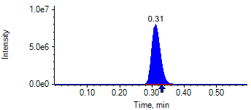

PCP 2 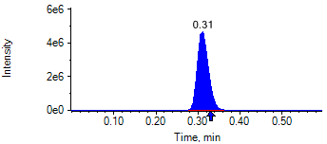

PCP D5 1 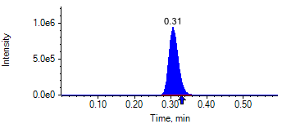

PCP D5 1 

Benzoylecgonine 1 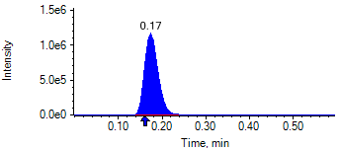

Benzoylecgonine 2 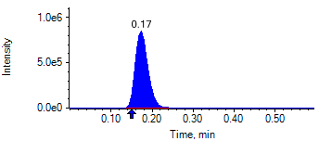

Benzoylecgonine D3 1 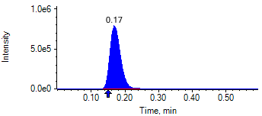

Benzoylecgonine D3 1 

|  |  |  |  |
| --- | --- | --- | --- |
| **Acquisition Method** | PCP_BE_041422Final.dam | **Data File** | SAMPLE088.wiff |
| **Sample Name** | **CPC MI NL** | **Injection Volume** | 10.00 |
| **Sample Type** | Unknown | **Injection Vial** | 83 |
| **Injection Date** | 4/30/2025 9:04:46 PM | **Dilution Factor** | 1.00 |
| **Instrument Name** | Triple Quad 5500+ | **Instrument Serial** | EX231582110 |

**Results Summary**

*CPC MI NL*

| **Peak Name** | **Integration Type** | **Transition** | **Retention Time** | **Rel RT** | **Peak Area** | **Area Ratio** | **Calculated Concentration (ng/mL)** | **Expected Ion Ratio** | **Calculated  Ion Ratio** | **Ratio Confirms ID** |
| --- | --- | --- | --- | --- | --- | --- | --- | --- | --- | --- |

|  |  |  |  |  |  |  |  |  |  |  |
| --- | --- | --- | --- | --- | --- | --- | --- | --- | --- | --- |
| PCP 1 | Baseline | 243.8 / 159.0 | 0.35 | 1.01 | 1.644e7 | 8.952 | 1930.77 |  |  |  |

|  |  |  |  |  |  |  |  |  |  |  |
| --- | --- | --- | --- | --- | --- | --- | --- | --- | --- | --- |
| PCP 2 | Baseline | 243.8 / 91.0 | 0.35 | 1.01 | 9.342e6 | 5.087 |  | 59.4% | 56.8% | ✓ |

|  |  |  |  |  |  |  |  |  |  |  |
| --- | --- | --- | --- | --- | --- | --- | --- | --- | --- | --- |
| Benzoylecgonine 1 | Baseline | 289.8 / 168.1 | 0.21 | 1.02 | 2.530e6 | 1.509 | 7972.38 |  |  |  |

|  |  |  |  |  |  |  |  |  |  |  |
| --- | --- | --- | --- | --- | --- | --- | --- | --- | --- | --- |
| Benzoylecgonine 2 | Baseline | 289.8 / 104.9 | 0.21 | 1.01 | 1.822e6 | 1.086 |  | 71.7% | 72.0% | ✓ |

**Internal Standard Data**

|  |  |  |  |  |  |  |  |  |  |
| --- | --- | --- | --- | --- | --- | --- | --- | --- | --- |
| **Internal Standard Name** | **Integration Type** | **Transition** | **Retention Time** | **Avg IS Retention Time** | **IS Peak Area** | **IS Area Within Range** | **Expected Ion Ratio** | **Calculated  Ion Ratio** | **Ratio Confirms ID** |

|  |  |  |  |  |  |  |  |  |  |
| --- | --- | --- | --- | --- | --- | --- | --- | --- | --- |
| PCP D5 1 | Baseline | 248.8 / 164.1 | 0.35* | 0.32 | 1.837e6 | ✓ |  |  |  |

|  |  |  |  |  |  |  |  |  |  |
| --- | --- | --- | --- | --- | --- | --- | --- | --- | --- |
| PCP D5 1 | Baseline | 248.8 / 164.1 | 0.35* | 0.32 | 1.837e6 |  | 100.0% | 100.0% | ✓ |

|  |  |  |  |  |  |  |  |  |  |
| --- | --- | --- | --- | --- | --- | --- | --- | --- | --- |
| Benzoylecgonine D3 1 | Baseline | 292.8 / 171.2 | 0.20* | 0.18 | 1.677e6 | ✓ |  |  |  |

|  |  |  |  |  |  |  |  |  |  |
| --- | --- | --- | --- | --- | --- | --- | --- | --- | --- |
| Benzoylecgonine D3 1 | Baseline | 292.8 / 171.2 | 0.20* | 0.18 | 1.677e6 |  | 100.0% | 100.0% | ✓ |

**Peak Review**

PCP 1 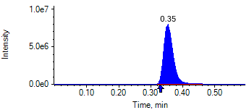

PCP 2 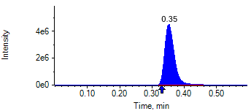

PCP D5 1 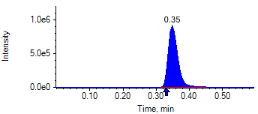

PCP D5 1 

Benzoylecgonine 1 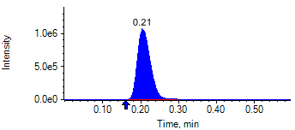

Benzoylecgonine 2 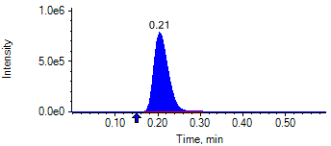

Benzoylecgonine D3 1 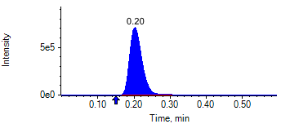

Benzoylecgonine D3 1 

|  |  |  |  |
| --- | --- | --- | --- |
| **Acquisition Method** | PCP_BE_041422Final.dam | **Data File** | SAMPLE089.wiff |
| **Sample Name** | **CPC MI NL** | **Injection Volume** | 10.00 |
| **Sample Type** | Unknown | **Injection Vial** | 84 |
| **Injection Date** | 4/30/2025 9:05:58 PM | **Dilution Factor** | 1.00 |
| **Instrument Name** | Triple Quad 5500+ | **Instrument Serial** | EX231582110 |

**Results Summary**

*CPC MI NL*

| **Peak Name** | **Integration Type** | **Transition** | **Retention Time** | **Rel RT** | **Peak Area** | **Area Ratio** | **Calculated Concentration (ng/mL)** | **Expected Ion Ratio** | **Calculated  Ion Ratio** | **Ratio Confirms ID** |
| --- | --- | --- | --- | --- | --- | --- | --- | --- | --- | --- |

|  |  |  |  |  |  |  |  |  |  |  |
| --- | --- | --- | --- | --- | --- | --- | --- | --- | --- | --- |
| PCP 1 | Baseline | 243.8 / 159.0 | 0.34 | 1.02 | 1.568e7 | 9.280 | 2004.06 |  |  |  |

|  |  |  |  |  |  |  |  |  |  |  |
| --- | --- | --- | --- | --- | --- | --- | --- | --- | --- | --- |
| PCP 2 | Baseline | 243.8 / 91.0 | 0.34 | 1.01 | 9.218e6 | 5.455 |  | 59.4% | 58.8% | ✓ |

|  |  |  |  |  |  |  |  |  |  |  |
| --- | --- | --- | --- | --- | --- | --- | --- | --- | --- | --- |
| Benzoylecgonine 1 | Baseline | 289.8 / 168.1 | 0.20 | 1.02 | 2.593e6 | 1.520 | 8031.86 |  |  |  |

|  |  |  |  |  |  |  |  |  |  |  |
| --- | --- | --- | --- | --- | --- | --- | --- | --- | --- | --- |
| Benzoylecgonine 2 | Baseline | 289.8 / 104.9 | 0.20 | 1.02 | 1.848e6 | 1.083 |  | 71.7% | 71.2% | ✓ |

**Internal Standard Data**

|  |  |  |  |  |  |  |  |  |  |
| --- | --- | --- | --- | --- | --- | --- | --- | --- | --- |
| **Internal Standard Name** | **Integration Type** | **Transition** | **Retention Time** | **Avg IS Retention Time** | **IS Peak Area** | **IS Area Within Range** | **Expected Ion Ratio** | **Calculated  Ion Ratio** | **Ratio Confirms ID** |

|  |  |  |  |  |  |  |  |  |  |
| --- | --- | --- | --- | --- | --- | --- | --- | --- | --- |
| PCP D5 1 | Baseline | 248.8 / 164.1 | 0.33* | 0.32 | 1.690e6 | ✓ |  |  |  |

|  |  |  |  |  |  |  |  |  |  |
| --- | --- | --- | --- | --- | --- | --- | --- | --- | --- |
| PCP D5 1 | Baseline | 248.8 / 164.1 | 0.33* | 0.32 | 1.690e6 |  | 100.0% | 100.0% | ✓ |

|  |  |  |  |  |  |  |  |  |  |
| --- | --- | --- | --- | --- | --- | --- | --- | --- | --- |
| Benzoylecgonine D3 1 | Baseline | 292.8 / 171.2 | 0.20* | 0.18 | 1.706e6 | ✓ |  |  |  |

|  |  |  |  |  |  |  |  |  |  |
| --- | --- | --- | --- | --- | --- | --- | --- | --- | --- |
| Benzoylecgonine D3 1 | Baseline | 292.8 / 171.2 | 0.20* | 0.18 | 1.706e6 |  | 100.0% | 100.0% | ✓ |

**Peak Review**

PCP 1 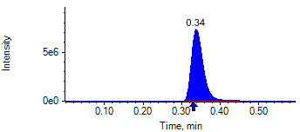

PCP 2 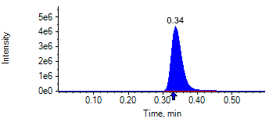

PCP D5 1 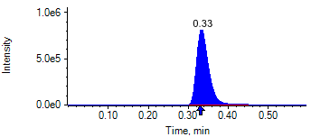

PCP D5 1 

Benzoylecgonine 1 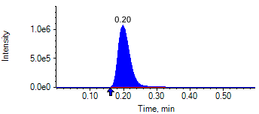

Benzoylecgonine 2 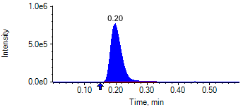

Benzoylecgonine D3 1 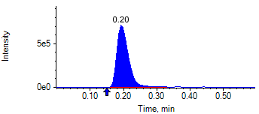

Benzoylecgonine D3 1 

|  |  |  |  |
| --- | --- | --- | --- |
| **Acquisition Method** | PCP_BE_041422Final.dam | **Data File** | SAMPLE090.wiff |
| **Sample Name** | **CPC MI NL** | **Injection Volume** | 10.00 |
| **Sample Type** | Unknown | **Injection Vial** | 85 |
| **Injection Date** | 4/30/2025 9:07:05 PM | **Dilution Factor** | 1.00 |
| **Instrument Name** | Triple Quad 5500+ | **Instrument Serial** | EX231582110 |

**Results Summary**

*CPC MI NL*

| **Peak Name** | **Integration Type** | **Transition** | **Retention Time** | **Rel RT** | **Peak Area** | **Area Ratio** | **Calculated Concentration (ng/mL)** | **Expected Ion Ratio** | **Calculated  Ion Ratio** | **Ratio Confirms ID** |
| --- | --- | --- | --- | --- | --- | --- | --- | --- | --- | --- |

|  |  |  |  |  |  |  |  |  |  |  |
| --- | --- | --- | --- | --- | --- | --- | --- | --- | --- | --- |
| PCP 1 | Baseline | 243.8 / 159.0 | 0.30 | 1.02 | 1.474e7 | 8.789 | 1894.46 |  |  |  |

|  |  |  |  |  |  |  |  |  |  |  |
| --- | --- | --- | --- | --- | --- | --- | --- | --- | --- | --- |
| PCP 2 | Baseline | 243.8 / 91.0 | 0.30 | 1.01 | 8.795e6 | 5.245 |  | 59.4% | 59.7% | ✓ |

|  |  |  |  |  |  |  |  |  |  |  |
| --- | --- | --- | --- | --- | --- | --- | --- | --- | --- | --- |
| Benzoylecgonine 1 | Baseline | 289.8 / 168.1 | 0.16 | 1.02 | 2.517e6 | 1.492 | 7878.69 |  |  |  |

|  |  |  |  |  |  |  |  |  |  |  |
| --- | --- | --- | --- | --- | --- | --- | --- | --- | --- | --- |
| Benzoylecgonine 2 | Baseline | 289.8 / 104.9 | 0.16 | 1.02 | 1.834e6 | 1.087 |  | 71.7% | 72.8% | ✓ |

**Internal Standard Data**

|  |  |  |  |  |  |  |  |  |  |
| --- | --- | --- | --- | --- | --- | --- | --- | --- | --- |
| **Internal Standard Name** | **Integration Type** | **Transition** | **Retention Time** | **Avg IS Retention Time** | **IS Peak Area** | **IS Area Within Range** | **Expected Ion Ratio** | **Calculated  Ion Ratio** | **Ratio Confirms ID** |

|  |  |  |  |  |  |  |  |  |  |
| --- | --- | --- | --- | --- | --- | --- | --- | --- | --- |
| PCP D5 1 | Baseline | 248.8 / 164.1 | 0.29* | 0.32 | 1.677e6 | ✓ |  |  |  |

|  |  |  |  |  |  |  |  |  |  |
| --- | --- | --- | --- | --- | --- | --- | --- | --- | --- |
| PCP D5 1 | Baseline | 248.8 / 164.1 | 0.29* | 0.32 | 1.677e6 |  | 100.0% | 100.0% | ✓ |

|  |  |  |  |  |  |  |  |  |  |
| --- | --- | --- | --- | --- | --- | --- | --- | --- | --- |
| Benzoylecgonine D3 1 | Baseline | 292.8 / 171.2 | 0.16* | 0.18 | 1.687e6 | ✓ |  |  |  |

|  |  |  |  |  |  |  |  |  |  |
| --- | --- | --- | --- | --- | --- | --- | --- | --- | --- |
| Benzoylecgonine D3 1 | Baseline | 292.8 / 171.2 | 0.16* | 0.18 | 1.687e6 |  | 100.0% | 100.0% | ✓ |

**Peak Review**

PCP 1 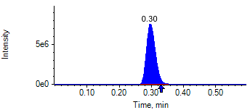

PCP 2 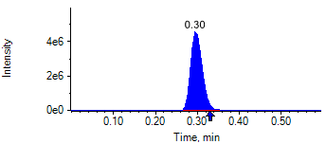

PCP D5 1 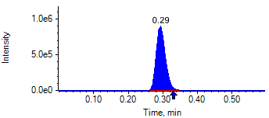

PCP D5 1 

Benzoylecgonine 1 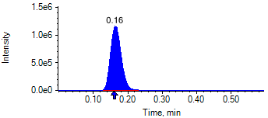

Benzoylecgonine 2 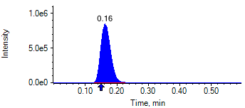

Benzoylecgonine D3 1 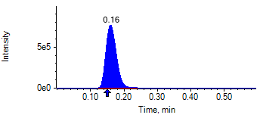

Benzoylecgonine D3 1 

|  |  |  |  |
| --- | --- | --- | --- |
| **Acquisition Method** | PCP_BE_041422Final.dam | **Data File** | SAMPLE091.wiff |
| **Sample Name** | **CPC MI NL** | **Injection Volume** | 10.00 |
| **Sample Type** | Unknown | **Injection Vial** | 86 |
| **Injection Date** | 4/30/2025 9:08:17 PM | **Dilution Factor** | 1.00 |
| **Instrument Name** | Triple Quad 5500+ | **Instrument Serial** | EX231582110 |

**Results Summary**

*CPC MI NL*

| **Peak Name** | **Integration Type** | **Transition** | **Retention Time** | **Rel RT** | **Peak Area** | **Area Ratio** | **Calculated Concentration (ng/mL)** | **Expected Ion Ratio** | **Calculated  Ion Ratio** | **Ratio Confirms ID** |
| --- | --- | --- | --- | --- | --- | --- | --- | --- | --- | --- |

|  |  |  |  |  |  |  |  |  |  |  |
| --- | --- | --- | --- | --- | --- | --- | --- | --- | --- | --- |
| PCP 1 | Baseline | 243.8 / 159.0 | 0.31 | 1.01 | 1.553e7 | 9.205 | 1987.32 |  |  |  |

|  |  |  |  |  |  |  |  |  |  |  |
| --- | --- | --- | --- | --- | --- | --- | --- | --- | --- | --- |
| PCP 2 | Baseline | 243.8 / 91.0 | 0.31 | 1.01 | 8.993e6 | 5.330 |  | 59.4% | 57.9% | ✓ |

|  |  |  |  |  |  |  |  |  |  |  |
| --- | --- | --- | --- | --- | --- | --- | --- | --- | --- | --- |
| Benzoylecgonine 1 | Baseline | 289.8 / 168.1 | 0.17 | 1.02 | 2.557e6 | 1.548 | 8185.53 |  |  |  |

|  |  |  |  |  |  |  |  |  |  |  |
| --- | --- | --- | --- | --- | --- | --- | --- | --- | --- | --- |
| Benzoylecgonine 2 | Baseline | 289.8 / 104.9 | 0.17 | 1.02 | 1.852e6 | 1.121 |  | 71.7% | 72.4% | ✓ |

**Internal Standard Data**

|  |  |  |  |  |  |  |  |  |  |
| --- | --- | --- | --- | --- | --- | --- | --- | --- | --- |
| **Internal Standard Name** | **Integration Type** | **Transition** | **Retention Time** | **Avg IS Retention Time** | **IS Peak Area** | **IS Area Within Range** | **Expected Ion Ratio** | **Calculated  Ion Ratio** | **Ratio Confirms ID** |

|  |  |  |  |  |  |  |  |  |  |
| --- | --- | --- | --- | --- | --- | --- | --- | --- | --- |
| PCP D5 1 | Baseline | 248.8 / 164.1 | 0.31* | 0.32 | 1.687e6 | ✓ |  |  |  |

|  |  |  |  |  |  |  |  |  |  |
| --- | --- | --- | --- | --- | --- | --- | --- | --- | --- |
| PCP D5 1 | Baseline | 248.8 / 164.1 | 0.31* | 0.32 | 1.687e6 |  | 100.0% | 100.0% | ✓ |

|  |  |  |  |  |  |  |  |  |  |
| --- | --- | --- | --- | --- | --- | --- | --- | --- | --- |
| Benzoylecgonine D3 1 | Baseline | 292.8 / 171.2 | 0.17* | 0.18 | 1.652e6 | ✓ |  |  |  |

|  |  |  |  |  |  |  |  |  |  |
| --- | --- | --- | --- | --- | --- | --- | --- | --- | --- |
| Benzoylecgonine D3 1 | Baseline | 292.8 / 171.2 | 0.17* | 0.18 | 1.652e6 |  | 100.0% | 100.0% | ✓ |

**Peak Review**

PCP 1 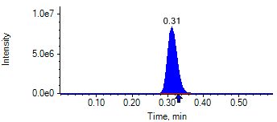

PCP 2 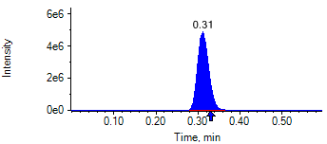

PCP D5 1 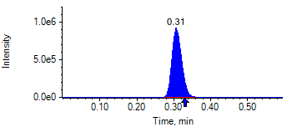

PCP D5 1 

Benzoylecgonine 1 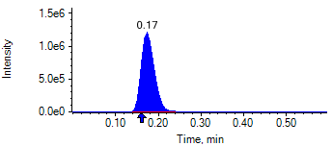

Benzoylecgonine 2 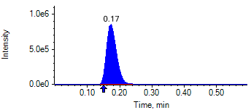

Benzoylecgonine D3 1 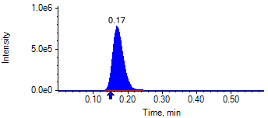

Benzoylecgonine D3 1 

|  |  |  |  |
| --- | --- | --- | --- |
| **Acquisition Method** | PCP_BE_041422Final.dam | **Data File** | SAMPLE092.wiff |
| **Sample Name** | **NEG QC** | **Injection Volume** | 10.00 |
| **Sample Type** | Quality Control | **Injection Vial** | 87 |
| **Injection Date** | 4/30/2025 9:09:30 PM | **Dilution Factor** | 1.00 |
| **Instrument Name** | Triple Quad 5500+ | **Instrument Serial** | EX231582110 |

**Results Summary**

| **Peak Name** | **Integration Type** | **Transition** | **Retention Time** | **Rel RT** | **Peak Area** | **Area Ratio** | **Calculated Concentration (ng/mL)** | **Expected Ion Ratio** | **Calculated  Ion Ratio** | **Ratio Confirms ID** |
| --- | --- | --- | --- | --- | --- | --- | --- | --- | --- | --- |

|  |  |  |  |  |  |  |  |  |  |  |
| --- | --- | --- | --- | --- | --- | --- | --- | --- | --- | --- |
| PCP 1 | N/A | 243.8 / 159.0 | N/A | N/A* | N/A | N/A | N/A |  |  |  |

|  |  |  |  |  |  |  |  |  |  |  |
| --- | --- | --- | --- | --- | --- | --- | --- | --- | --- | --- |
| PCP 2 | N/A | 243.8 / 91.0 | N/A | N/A* | N/A | N/A |  | 59.4% | 0.0% | NO |

|  |  |  |  |  |  |  |  |  |  |  |
| --- | --- | --- | --- | --- | --- | --- | --- | --- | --- | --- |
| Benzoylecgonine 1 | N/A | 289.8 / 168.1 | N/A | N/A* | N/A | N/A | N/A |  |  |  |

|  |  |  |  |  |  |  |  |  |  |  |
| --- | --- | --- | --- | --- | --- | --- | --- | --- | --- | --- |
| Benzoylecgonine 2 | N/A | 289.8 / 104.9 | N/A | N/A* | N/A | N/A |  | 71.7% | 0.0% | NO |

**Internal Standard Data**

|  |  |  |  |  |  |  |  |  |  |
| --- | --- | --- | --- | --- | --- | --- | --- | --- | --- |
| **Internal Standard Name** | **Integration Type** | **Transition** | **Retention Time** | **Avg IS Retention Time** | **IS Peak Area** | **IS Area Within Range** | **Expected Ion Ratio** | **Calculated  Ion Ratio** | **Ratio Confirms ID** |

|  |  |  |  |  |  |  |  |  |  |
| --- | --- | --- | --- | --- | --- | --- | --- | --- | --- |
| PCP D5 1 | Baseline | 248.8 / 164.1 | 0.35* | 0.32 | 1.976e6 | ✓ |  |  |  |

|  |  |  |  |  |  |  |  |  |  |
| --- | --- | --- | --- | --- | --- | --- | --- | --- | --- |
| PCP D5 1 | Baseline | 248.8 / 164.1 | 0.35* | 0.32 | 1.976e6 |  | 100.0% | 100.0% | ✓ |

|  |  |  |  |  |  |  |  |  |  |
| --- | --- | --- | --- | --- | --- | --- | --- | --- | --- |
| Benzoylecgonine D3 1 | Baseline | 292.8 / 171.2 | 0.20* | 0.18 | 2.027e6 | ✓ |  |  |  |

|  |  |  |  |  |  |  |  |  |  |
| --- | --- | --- | --- | --- | --- | --- | --- | --- | --- |
| Benzoylecgonine D3 1 | Baseline | 292.8 / 171.2 | 0.20* | 0.18 | 2.027e6 |  | 100.0% | 100.0% | ✓ |

**Peak Review**

PCP 1 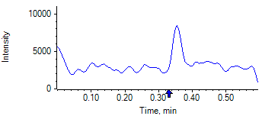

PCP 2 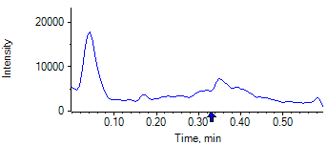

PCP D5 1 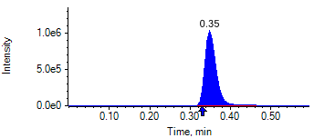

PCP D5 1 

Benzoylecgonine 1 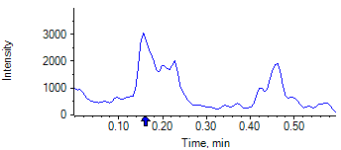

Benzoylecgonine 2 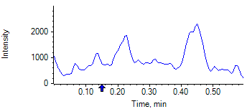

Benzoylecgonine D3 1 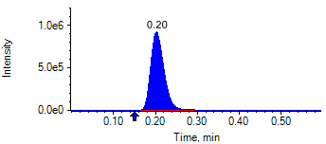

Benzoylecgonine D3 1 

|  |  |  |  |
| --- | --- | --- | --- |
| **Acquisition Method** | PCP_BE_041422Final.dam | **Data File** | SAMPLE093.wiff |
| **Sample Name** | **CPC HIGH QC** | **Injection Volume** | 10.00 |
| **Sample Type** | Quality Control | **Injection Vial** | 88 |
| **Injection Date** | 4/30/2025 9:10:42 PM | **Dilution Factor** | 1.00 |
| **Instrument Name** | Triple Quad 5500+ | **Instrument Serial** | EX231582110 |

**Results Summary**

| **Peak Name** | **Integration Type** | **Transition** | **Retention Time** | **Rel RT** | **Peak Area** | **Area Ratio** | **Calculated Concentration (ng/mL)** | **Expected Ion Ratio** | **Calculated  Ion Ratio** | **Ratio Confirms ID** |
| --- | --- | --- | --- | --- | --- | --- | --- | --- | --- | --- |

|  |  |  |  |  |  |  |  |  |  |  |
| --- | --- | --- | --- | --- | --- | --- | --- | --- | --- | --- |
| PCP 1 | Baseline | 243.8 / 159.0 | 0.32 | 1.02 | 2.733e7 | 17.550 | 3921.98 |  |  |  |

|  |  |  |  |  |  |  |  |  |  |  |
| --- | --- | --- | --- | --- | --- | --- | --- | --- | --- | --- |
| PCP 2 | Baseline | 243.8 / 91.0 | 0.32 | 1.01 | 1.595e7 | 10.240 |  | 59.4% | 58.4% | ✓ |

|  |  |  |  |  |  |  |  |  |  |  |
| --- | --- | --- | --- | --- | --- | --- | --- | --- | --- | --- |
| Benzoylecgonine 1 | Baseline | 289.8 / 168.1 | 0.18 | 1.02 | 4.347e6 | 2.881 | 15680.89 |  |  |  |

|  |  |  |  |  |  |  |  |  |  |  |
| --- | --- | --- | --- | --- | --- | --- | --- | --- | --- | --- |
| Benzoylecgonine 2 | Baseline | 289.8 / 104.9 | 0.18 | 1.02 | 3.091e6 | 2.049 |  | 71.7% | 71.1% | ✓ |

**Internal Standard Data**

|  |  |  |  |  |  |  |  |  |  |
| --- | --- | --- | --- | --- | --- | --- | --- | --- | --- |
| **Internal Standard Name** | **Integration Type** | **Transition** | **Retention Time** | **Avg IS Retention Time** | **IS Peak Area** | **IS Area Within Range** | **Expected Ion Ratio** | **Calculated  Ion Ratio** | **Ratio Confirms ID** |

|  |  |  |  |  |  |  |  |  |  |
| --- | --- | --- | --- | --- | --- | --- | --- | --- | --- |
| PCP D5 1 | Baseline | 248.8 / 164.1 | 0.32 | 0.32 | 1.557e6 | ✓ |  |  |  |

|  |  |  |  |  |  |  |  |  |  |
| --- | --- | --- | --- | --- | --- | --- | --- | --- | --- |
| PCP D5 1 | Baseline | 248.8 / 164.1 | 0.32 | 0.32 | 1.557e6 |  | 100.0% | 100.0% | ✓ |

|  |  |  |  |  |  |  |  |  |  |
| --- | --- | --- | --- | --- | --- | --- | --- | --- | --- |
| Benzoylecgonine D3 1 | Baseline | 292.8 / 171.2 | 0.18 | 0.18 | 1.509e6 | ✓ |  |  |  |

|  |  |  |  |  |  |  |  |  |  |
| --- | --- | --- | --- | --- | --- | --- | --- | --- | --- |
| Benzoylecgonine D3 1 | Baseline | 292.8 / 171.2 | 0.18 | 0.18 | 1.509e6 |  | 100.0% | 100.0% | ✓ |

**Peak Review**

PCP 1 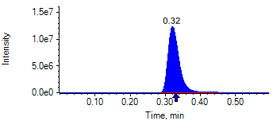

PCP 2 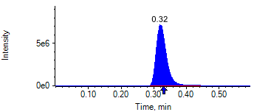

PCP D5 1 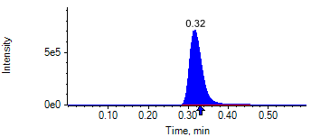

PCP D5 1 

Benzoylecgonine 1 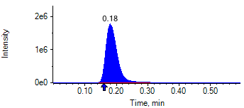

Benzoylecgonine 2 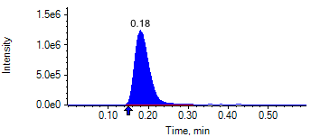

Benzoylecgonine D3 1 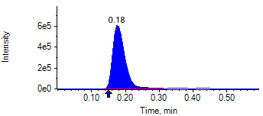

Benzoylecgonine D3 1 

|  |  |  |  |
| --- | --- | --- | --- |
| **Acquisition Method** | PCP_BE_041422Final.dam | **Data File** | SAMPLE094.wiff |
| **Sample Name** | **CPC MID QC** | **Injection Volume** | 10.00 |
| **Sample Type** | Quality Control | **Injection Vial** | 89 |
| **Injection Date** | 4/30/2025 9:11:53 PM | **Dilution Factor** | 1.00 |
| **Instrument Name** | Triple Quad 5500+ | **Instrument Serial** | EX231582110 |

**Results Summary**

| **Peak Name** | **Integration Type** | **Transition** | **Retention Time** | **Rel RT** | **Peak Area** | **Area Ratio** | **Calculated Concentration (ng/mL)** | **Expected Ion Ratio** | **Calculated  Ion Ratio** | **Ratio Confirms ID** |
| --- | --- | --- | --- | --- | --- | --- | --- | --- | --- | --- |

|  |  |  |  |  |  |  |  |  |  |  |
| --- | --- | --- | --- | --- | --- | --- | --- | --- | --- | --- |
| PCP 1 | Baseline | 243.8 / 159.0 | 0.31 | 1.02 | 1.493e7 | 8.877 | 1913.93 |  |  |  |

|  |  |  |  |  |  |  |  |  |  |  |
| --- | --- | --- | --- | --- | --- | --- | --- | --- | --- | --- |
| PCP 2 | Baseline | 243.8 / 91.0 | 0.31 | 1.01 | 8.673e6 | 5.157 |  | 59.4% | 58.1% | ✓ |

|  |  |  |  |  |  |  |  |  |  |  |
| --- | --- | --- | --- | --- | --- | --- | --- | --- | --- | --- |
| Benzoylecgonine 1 | Baseline | 289.8 / 168.1 | 0.18 | 1.03 | 2.431e6 | 1.463 | 7721.34 |  |  |  |

|  |  |  |  |  |  |  |  |  |  |  |
| --- | --- | --- | --- | --- | --- | --- | --- | --- | --- | --- |
| Benzoylecgonine 2 | Baseline | 289.8 / 104.9 | 0.18 | 1.02 | 1.704e6 | 1.025 |  | 71.7% | 70.1% | ✓ |

**Internal Standard Data**

|  |  |  |  |  |  |  |  |  |  |
| --- | --- | --- | --- | --- | --- | --- | --- | --- | --- |
| **Internal Standard Name** | **Integration Type** | **Transition** | **Retention Time** | **Avg IS Retention Time** | **IS Peak Area** | **IS Area Within Range** | **Expected Ion Ratio** | **Calculated  Ion Ratio** | **Ratio Confirms ID** |

|  |  |  |  |  |  |  |  |  |  |
| --- | --- | --- | --- | --- | --- | --- | --- | --- | --- |
| PCP D5 1 | Baseline | 248.8 / 164.1 | 0.31* | 0.32 | 1.682e6 | ✓ |  |  |  |

|  |  |  |  |  |  |  |  |  |  |
| --- | --- | --- | --- | --- | --- | --- | --- | --- | --- |
| PCP D5 1 | Baseline | 248.8 / 164.1 | 0.31* | 0.32 | 1.682e6 |  | 100.0% | 100.0% | ✓ |

|  |  |  |  |  |  |  |  |  |  |
| --- | --- | --- | --- | --- | --- | --- | --- | --- | --- |
| Benzoylecgonine D3 1 | Baseline | 292.8 / 171.2 | 0.18* | 0.18 | 1.662e6 | ✓ |  |  |  |

|  |  |  |  |  |  |  |  |  |  |
| --- | --- | --- | --- | --- | --- | --- | --- | --- | --- |
| Benzoylecgonine D3 1 | Baseline | 292.8 / 171.2 | 0.18* | 0.18 | 1.662e6 |  | 100.0% | 100.0% | ✓ |

**Peak Review**

PCP 1 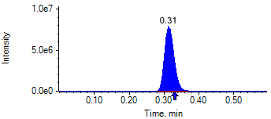

PCP 2 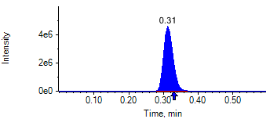

PCP D5 1 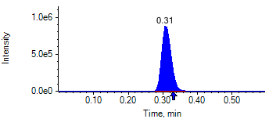

PCP D5 1 

Benzoylecgonine 1 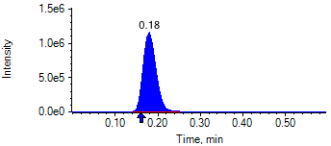

Benzoylecgonine 2 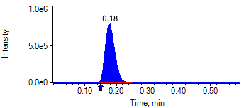

Benzoylecgonine D3 1 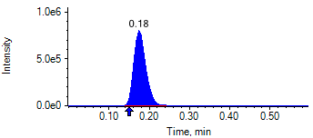

Benzoylecgonine D3 1 

|  |  |  |  |
| --- | --- | --- | --- |
| **Acquisition Method** | PCP_BE_041422Final.dam | **Data File** | SAMPLE095.wiff |
| **Sample Name** | **CPC MID QC** | **Injection Volume** | 10.00 |
| **Sample Type** | Quality Control | **Injection Vial** | 90 |
| **Injection Date** | 4/30/2025 9:13:04 PM | **Dilution Factor** | 1.00 |
| **Instrument Name** | Triple Quad 5500+ | **Instrument Serial** | EX231582110 |

**Results Summary**

| **Peak Name** | **Integration Type** | **Transition** | **Retention Time** | **Rel RT** | **Peak Area** | **Area Ratio** | **Calculated Concentration (ng/mL)** | **Expected Ion Ratio** | **Calculated  Ion Ratio** | **Ratio Confirms ID** |
| --- | --- | --- | --- | --- | --- | --- | --- | --- | --- | --- |

|  |  |  |  |  |  |  |  |  |  |  |
| --- | --- | --- | --- | --- | --- | --- | --- | --- | --- | --- |
| PCP 1 | Baseline | 243.8 / 159.0 | 0.31 | 1.01 | 1.474e7 | 8.814 | 1899.83 |  |  |  |

|  |  |  |  |  |  |  |  |  |  |  |
| --- | --- | --- | --- | --- | --- | --- | --- | --- | --- | --- |
| PCP 2 | Baseline | 243.8 / 91.0 | 0.31 | 1.01 | 8.595e6 | 5.139 |  | 59.4% | 58.3% | ✓ |

|  |  |  |  |  |  |  |  |  |  |  |
| --- | --- | --- | --- | --- | --- | --- | --- | --- | --- | --- |
| Benzoylecgonine 1 | Baseline | 289.8 / 168.1 | 0.17 | 1.02 | 2.410e6 | 1.413 | 7450.13 |  |  |  |

|  |  |  |  |  |  |  |  |  |  |  |
| --- | --- | --- | --- | --- | --- | --- | --- | --- | --- | --- |
| Benzoylecgonine 2 | Baseline | 289.8 / 104.9 | 0.17 | 1.02 | 1.736e6 | 1.018 |  | 71.7% | 72.0% | ✓ |

**Internal Standard Data**

|  |  |  |  |  |  |  |  |  |  |
| --- | --- | --- | --- | --- | --- | --- | --- | --- | --- |
| **Internal Standard Name** | **Integration Type** | **Transition** | **Retention Time** | **Avg IS Retention Time** | **IS Peak Area** | **IS Area Within Range** | **Expected Ion Ratio** | **Calculated  Ion Ratio** | **Ratio Confirms ID** |

|  |  |  |  |  |  |  |  |  |  |
| --- | --- | --- | --- | --- | --- | --- | --- | --- | --- |
| PCP D5 1 | Baseline | 248.8 / 164.1 | 0.31* | 0.32 | 1.672e6 | ✓ |  |  |  |

|  |  |  |  |  |  |  |  |  |  |
| --- | --- | --- | --- | --- | --- | --- | --- | --- | --- |
| PCP D5 1 | Baseline | 248.8 / 164.1 | 0.31* | 0.32 | 1.672e6 |  | 100.0% | 100.0% | ✓ |

|  |  |  |  |  |  |  |  |  |  |
| --- | --- | --- | --- | --- | --- | --- | --- | --- | --- |
| Benzoylecgonine D3 1 | Baseline | 292.8 / 171.2 | 0.17* | 0.18 | 1.706e6 | ✓ |  |  |  |

|  |  |  |  |  |  |  |  |  |  |
| --- | --- | --- | --- | --- | --- | --- | --- | --- | --- |
| Benzoylecgonine D3 1 | Baseline | 292.8 / 171.2 | 0.17* | 0.18 | 1.706e6 |  | 100.0% | 100.0% | ✓ |

**Peak Review**

PCP 1 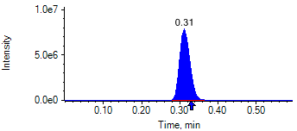

PCP 2 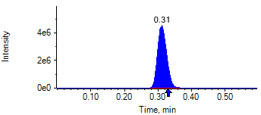

PCP D5 1 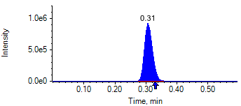

PCP D5 1 

Benzoylecgonine 1 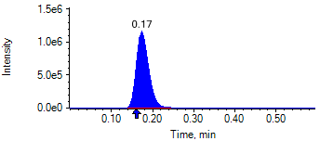

Benzoylecgonine 2 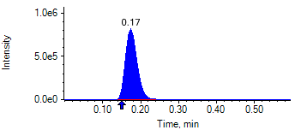

Benzoylecgonine D3 1 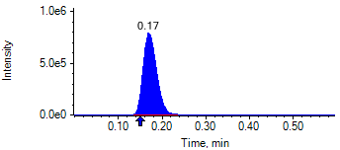

Benzoylecgonine D3 1 

|  |  |  |  |
| --- | --- | --- | --- |
| **Acquisition Method** | PCP_BE_041422Final.dam | **Data File** | SAMPLE096.wiff |
| **Sample Name** | **CPC LOW QC** | **Injection Volume** | 10.00 |
| **Sample Type** | Quality Control | **Injection Vial** | 91 |
| **Injection Date** | 4/30/2025 9:14:12 PM | **Dilution Factor** | 1.00 |
| **Instrument Name** | Triple Quad 5500+ | **Instrument Serial** | EX231582110 |

**Results Summary**

| **Peak Name** | **Integration Type** | **Transition** | **Retention Time** | **Rel RT** | **Peak Area** | **Area Ratio** | **Calculated Concentration (ng/mL)** | **Expected Ion Ratio** | **Calculated  Ion Ratio** | **Ratio Confirms ID** |
| --- | --- | --- | --- | --- | --- | --- | --- | --- | --- | --- |

|  |  |  |  |  |  |  |  |  |  |  |
| --- | --- | --- | --- | --- | --- | --- | --- | --- | --- | --- |
| PCP 1 | Baseline | 243.8 / 159.0 | 0.35 | 1.01 | 2.874e5 | 0.144 | 28.88 |  |  |  |

|  |  |  |  |  |  |  |  |  |  |  |
| --- | --- | --- | --- | --- | --- | --- | --- | --- | --- | --- |
| PCP 2 | Baseline | 243.8 / 91.0 | 0.35 | 1.01 | 1.693e5 | 0.085 |  | 59.4% | 58.9% | ✓ |

|  |  |  |  |  |  |  |  |  |  |  |
| --- | --- | --- | --- | --- | --- | --- | --- | --- | --- | --- |
| Benzoylecgonine 1 | Baseline | 289.8 / 168.1 | 0.21 | 1.02 | 5.900e4 | 0.030 | 150.80 |  |  |  |

|  |  |  |  |  |  |  |  |  |  |  |
| --- | --- | --- | --- | --- | --- | --- | --- | --- | --- | --- |
| Benzoylecgonine 2 | Baseline | 289.8 / 104.9 | 0.20 | 1.01 | 3.410e4 | 0.017 |  | 71.7% | 57.8% | ✓ |

**Internal Standard Data**

|  |  |  |  |  |  |  |  |  |  |
| --- | --- | --- | --- | --- | --- | --- | --- | --- | --- |
| **Internal Standard Name** | **Integration Type** | **Transition** | **Retention Time** | **Avg IS Retention Time** | **IS Peak Area** | **IS Area Within Range** | **Expected Ion Ratio** | **Calculated  Ion Ratio** | **Ratio Confirms ID** |

|  |  |  |  |  |  |  |  |  |  |
| --- | --- | --- | --- | --- | --- | --- | --- | --- | --- |
| PCP D5 1 | Baseline | 248.8 / 164.1 | 0.35* | 0.32 | 1.996e6 | ✓ |  |  |  |

|  |  |  |  |  |  |  |  |  |  |
| --- | --- | --- | --- | --- | --- | --- | --- | --- | --- |
| PCP D5 1 | Baseline | 248.8 / 164.1 | 0.35* | 0.32 | 1.996e6 |  | 100.0% | 100.0% | ✓ |

|  |  |  |  |  |  |  |  |  |  |
| --- | --- | --- | --- | --- | --- | --- | --- | --- | --- |
| Benzoylecgonine D3 1 | Baseline | 292.8 / 171.2 | 0.20* | 0.18 | 1.980e6 | ✓ |  |  |  |

|  |  |  |  |  |  |  |  |  |  |
| --- | --- | --- | --- | --- | --- | --- | --- | --- | --- |
| Benzoylecgonine D3 1 | Baseline | 292.8 / 171.2 | 0.20* | 0.18 | 1.980e6 |  | 100.0% | 100.0% | ✓ |

**Peak Review**

PCP 1 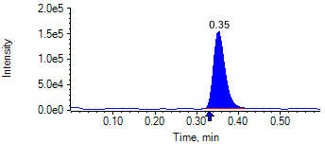

PCP 2 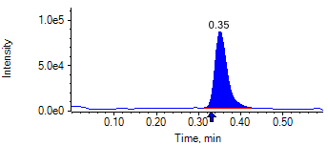

PCP D5 1 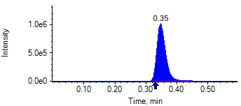

PCP D5 1 

Benzoylecgonine 1 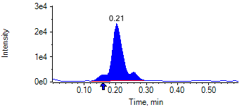

Benzoylecgonine 2 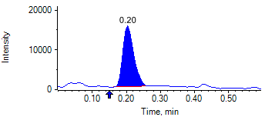

Benzoylecgonine D3 1 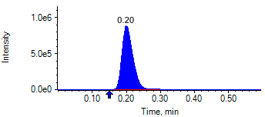

Benzoylecgonine D3 1 

|  |  |  |  |
| --- | --- | --- | --- |
| **Acquisition Method** | PCP_BE_041422Final.dam | **Data File** | SAMPLE101.wiff |
| **Sample Name** | **NEG QC CO** | **Injection Volume** | 10.00 |
| **Sample Type** | Quality Control | **Injection Vial** | 10 |
| **Injection Date** | 5/1/2025 6:43:53 PM | **Dilution Factor** | 1.00 |
| **Instrument Name** | Triple Quad 5500+ | **Instrument Serial** | EX231582110 |

**Results Summary**

| **Peak Name** | **Integration Type** | **Transition** | **Retention Time** | **Rel RT** | **Peak Area** | **Area Ratio** | **Calculated Concentration (ng/mL)** | **Expected Ion Ratio** | **Calculated  Ion Ratio** | **Ratio Confirms ID** |
| --- | --- | --- | --- | --- | --- | --- | --- | --- | --- | --- |

|  |  |  |  |  |  |  |  |  |  |  |
| --- | --- | --- | --- | --- | --- | --- | --- | --- | --- | --- |
| PCP 1 | N/A | 243.8 / 159.0 | N/A | N/A* | N/A | N/A | N/A |  |  |  |

|  |  |  |  |  |  |  |  |  |  |  |
| --- | --- | --- | --- | --- | --- | --- | --- | --- | --- | --- |
| PCP 2 | N/A | 243.8 / 91.0 | N/A | N/A* | N/A | N/A |  | 59.4% | 0.0% | NO |

|  |  |  |  |  |  |  |  |  |  |  |
| --- | --- | --- | --- | --- | --- | --- | --- | --- | --- | --- |
| Benzoylecgonine 1 | N/A | 289.8 / 168.1 | N/A | N/A* | N/A | N/A | N/A |  |  |  |

|  |  |  |  |  |  |  |  |  |  |  |
| --- | --- | --- | --- | --- | --- | --- | --- | --- | --- | --- |
| Benzoylecgonine 2 | N/A | 289.8 / 104.9 | N/A | N/A* | N/A | N/A |  | 71.7% | 0.0% | NO |

**Internal Standard Data**

|  |  |  |  |  |  |  |  |  |  |
| --- | --- | --- | --- | --- | --- | --- | --- | --- | --- |
| **Internal Standard Name** | **Integration Type** | **Transition** | **Retention Time** | **Avg IS Retention Time** | **IS Peak Area** | **IS Area Within Range** | **Expected Ion Ratio** | **Calculated  Ion Ratio** | **Ratio Confirms ID** |

|  |  |  |  |  |  |  |  |  |  |
| --- | --- | --- | --- | --- | --- | --- | --- | --- | --- |
| PCP D5 1 | Baseline | 248.8 / 164.1 | 0.36* | 0.32 | 1.783e6 | ✓ |  |  |  |

|  |  |  |  |  |  |  |  |  |  |
| --- | --- | --- | --- | --- | --- | --- | --- | --- | --- |
| PCP D5 1 | Baseline | 248.8 / 164.1 | 0.36* | 0.32 | 1.783e6 |  | 100.0% | 100.0% | ✓ |

|  |  |  |  |  |  |  |  |  |  |
| --- | --- | --- | --- | --- | --- | --- | --- | --- | --- |
| Benzoylecgonine D3 1 | Baseline | 292.8 / 171.2 | 0.18 | 0.18 | 1.693e6 | ✓ |  |  |  |

|  |  |  |  |  |  |  |  |  |  |
| --- | --- | --- | --- | --- | --- | --- | --- | --- | --- |
| Benzoylecgonine D3 1 | Baseline | 292.8 / 171.2 | 0.18 | 0.18 | 1.693e6 |  | 100.0% | 100.0% | ✓ |

**Peak Review**

PCP 1 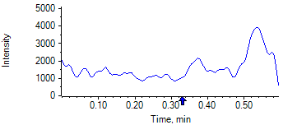

PCP 2 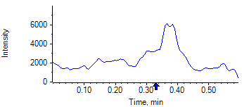

PCP D5 1 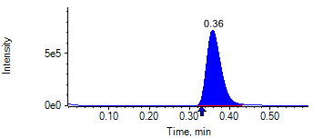

PCP D5 1 

Benzoylecgonine 1 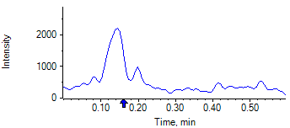

Benzoylecgonine 2 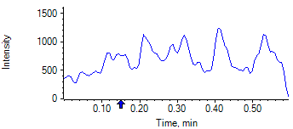

Benzoylecgonine D3 1 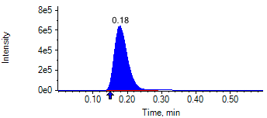

Benzoylecgonine D3 1 

|  |  |  |  |
| --- | --- | --- | --- |
| **Acquisition Method** | PCP_BE_041422Final.dam | **Data File** | SAMPLE102.wiff |
| **Sample Name** | **NEG QC CO** | **Injection Volume** | 10.00 |
| **Sample Type** | Quality Control | **Injection Vial** | 10 |
| **Injection Date** | 5/1/2025 6:45:08 PM | **Dilution Factor** | 1.00 |
| **Instrument Name** | Triple Quad 5500+ | **Instrument Serial** | EX231582110 |

**Results Summary**

| **Peak Name** | **Integration Type** | **Transition** | **Retention Time** | **Rel RT** | **Peak Area** | **Area Ratio** | **Calculated Concentration (ng/mL)** | **Expected Ion Ratio** | **Calculated  Ion Ratio** | **Ratio Confirms ID** |
| --- | --- | --- | --- | --- | --- | --- | --- | --- | --- | --- |

|  |  |  |  |  |  |  |  |  |  |  |
| --- | --- | --- | --- | --- | --- | --- | --- | --- | --- | --- |
| PCP 1 | N/A | 243.8 / 159.0 | N/A | N/A* | N/A | N/A | N/A |  |  |  |

|  |  |  |  |  |  |  |  |  |  |  |
| --- | --- | --- | --- | --- | --- | --- | --- | --- | --- | --- |
| PCP 2 | N/A | 243.8 / 91.0 | N/A | N/A* | N/A | N/A |  | 59.4% | 0.0% | NO |

|  |  |  |  |  |  |  |  |  |  |  |
| --- | --- | --- | --- | --- | --- | --- | --- | --- | --- | --- |
| Benzoylecgonine 1 | N/A | 289.8 / 168.1 | N/A | N/A* | N/A | N/A | N/A |  |  |  |

|  |  |  |  |  |  |  |  |  |  |  |
| --- | --- | --- | --- | --- | --- | --- | --- | --- | --- | --- |
| Benzoylecgonine 2 | N/A | 289.8 / 104.9 | N/A | N/A* | N/A | N/A |  | 71.7% | 0.0% | NO |

**Internal Standard Data**

|  |  |  |  |  |  |  |  |  |  |
| --- | --- | --- | --- | --- | --- | --- | --- | --- | --- |
| **Internal Standard Name** | **Integration Type** | **Transition** | **Retention Time** | **Avg IS Retention Time** | **IS Peak Area** | **IS Area Within Range** | **Expected Ion Ratio** | **Calculated  Ion Ratio** | **Ratio Confirms ID** |

|  |  |  |  |  |  |  |  |  |  |
| --- | --- | --- | --- | --- | --- | --- | --- | --- | --- |
| PCP D5 1 | Baseline | 248.8 / 164.1 | 0.33* | 0.32 | 1.846e6 | ✓ |  |  |  |

|  |  |  |  |  |  |  |  |  |  |
| --- | --- | --- | --- | --- | --- | --- | --- | --- | --- |
| PCP D5 1 | Baseline | 248.8 / 164.1 | 0.33* | 0.32 | 1.846e6 |  | 100.0% | 100.0% | ✓ |

|  |  |  |  |  |  |  |  |  |  |
| --- | --- | --- | --- | --- | --- | --- | --- | --- | --- |
| Benzoylecgonine D3 1 | Baseline | 292.8 / 171.2 | 0.17* | 0.18 | 1.659e6 | ✓ |  |  |  |

|  |  |  |  |  |  |  |  |  |  |
| --- | --- | --- | --- | --- | --- | --- | --- | --- | --- |
| Benzoylecgonine D3 1 | Baseline | 292.8 / 171.2 | 0.17* | 0.18 | 1.659e6 |  | 100.0% | 100.0% | ✓ |

**Peak Review**

PCP 1 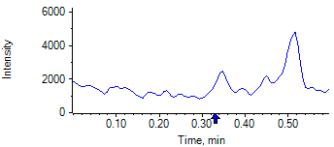

PCP 2 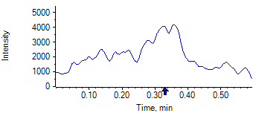

PCP D5 1 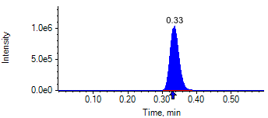

PCP D5 1 

Benzoylecgonine 1 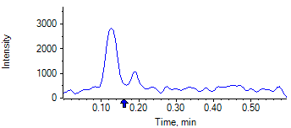

Benzoylecgonine 2 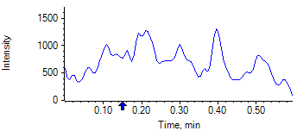

Benzoylecgonine D3 1 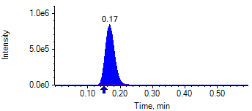

Benzoylecgonine D3 1 

|  |  |  |  |
| --- | --- | --- | --- |
| **Acquisition Method** | PCP_BE_041422Final.dam | **Data File** | SAMPLE103.wiff |
| **Sample Name** | **NEG QC CO** | **Injection Volume** | 10.00 |
| **Sample Type** | Quality Control | **Injection Vial** | 10 |
| **Injection Date** | 5/1/2025 6:46:20 PM | **Dilution Factor** | 1.00 |
| **Instrument Name** | Triple Quad 5500+ | **Instrument Serial** | EX231582110 |

**Results Summary**

| **Peak Name** | **Integration Type** | **Transition** | **Retention Time** | **Rel RT** | **Peak Area** | **Area Ratio** | **Calculated Concentration (ng/mL)** | **Expected Ion Ratio** | **Calculated  Ion Ratio** | **Ratio Confirms ID** |
| --- | --- | --- | --- | --- | --- | --- | --- | --- | --- | --- |

|  |  |  |  |  |  |  |  |  |  |  |
| --- | --- | --- | --- | --- | --- | --- | --- | --- | --- | --- |
| PCP 1 | N/A | 243.8 / 159.0 | N/A | N/A* | N/A | N/A | N/A |  |  |  |

|  |  |  |  |  |  |  |  |  |  |  |
| --- | --- | --- | --- | --- | --- | --- | --- | --- | --- | --- |
| PCP 2 | N/A | 243.8 / 91.0 | N/A | N/A* | N/A | N/A |  | 59.4% | 0.0% | NO |

|  |  |  |  |  |  |  |  |  |  |  |
| --- | --- | --- | --- | --- | --- | --- | --- | --- | --- | --- |
| Benzoylecgonine 1 | N/A | 289.8 / 168.1 | N/A | N/A* | N/A | N/A | N/A |  |  |  |

|  |  |  |  |  |  |  |  |  |  |  |
| --- | --- | --- | --- | --- | --- | --- | --- | --- | --- | --- |
| Benzoylecgonine 2 | N/A | 289.8 / 104.9 | N/A | N/A* | N/A | N/A |  | 71.7% | 0.0% | NO |

**Internal Standard Data**

|  |  |  |  |  |  |  |  |  |  |
| --- | --- | --- | --- | --- | --- | --- | --- | --- | --- |
| **Internal Standard Name** | **Integration Type** | **Transition** | **Retention Time** | **Avg IS Retention Time** | **IS Peak Area** | **IS Area Within Range** | **Expected Ion Ratio** | **Calculated  Ion Ratio** | **Ratio Confirms ID** |

|  |  |  |  |  |  |  |  |  |  |
| --- | --- | --- | --- | --- | --- | --- | --- | --- | --- |
| PCP D5 1 | Baseline | 248.8 / 164.1 | 0.32 | 0.32 | 1.849e6 | ✓ |  |  |  |

|  |  |  |  |  |  |  |  |  |  |
| --- | --- | --- | --- | --- | --- | --- | --- | --- | --- |
| PCP D5 1 | Baseline | 248.8 / 164.1 | 0.32 | 0.32 | 1.849e6 |  | 100.0% | 100.0% | ✓ |

|  |  |  |  |  |  |  |  |  |  |
| --- | --- | --- | --- | --- | --- | --- | --- | --- | --- |
| Benzoylecgonine D3 1 | Baseline | 292.8 / 171.2 | 0.15* | 0.18 | 1.568e6 | ✓ |  |  |  |

|  |  |  |  |  |  |  |  |  |  |
| --- | --- | --- | --- | --- | --- | --- | --- | --- | --- |
| Benzoylecgonine D3 1 | Baseline | 292.8 / 171.2 | 0.15* | 0.18 | 1.568e6 |  | 100.0% | 100.0% | ✓ |

**Peak Review**

PCP 1 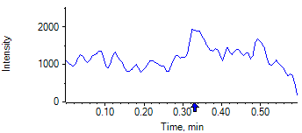

PCP 2 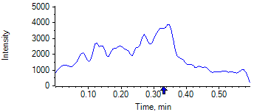

PCP D5 1 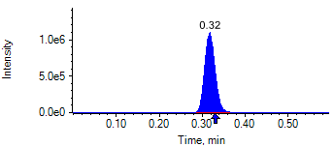

PCP D5 1 

Benzoylecgonine 1 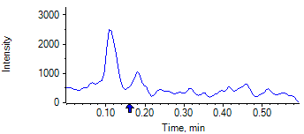

Benzoylecgonine 2 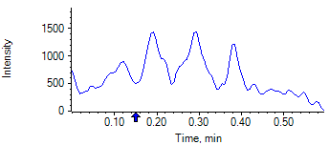

Benzoylecgonine D3 1 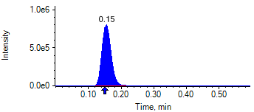

Benzoylecgonine D3 1 

|  |  |  |  |
| --- | --- | --- | --- |
| **Acquisition Method** | PCP_BE_041422Final.dam | **Data File** | SAMPLE104.wiff |
| **Sample Name** | **NEG QC CO** | **Injection Volume** | 10.00 |
| **Sample Type** | Quality Control | **Injection Vial** | 10 |
| **Injection Date** | 5/1/2025 6:47:33 PM | **Dilution Factor** | 1.00 |
| **Instrument Name** | Triple Quad 5500+ | **Instrument Serial** | EX231582110 |

**Results Summary**

| **Peak Name** | **Integration Type** | **Transition** | **Retention Time** | **Rel RT** | **Peak Area** | **Area Ratio** | **Calculated Concentration (ng/mL)** | **Expected Ion Ratio** | **Calculated  Ion Ratio** | **Ratio Confirms ID** |
| --- | --- | --- | --- | --- | --- | --- | --- | --- | --- | --- |

|  |  |  |  |  |  |  |  |  |  |  |
| --- | --- | --- | --- | --- | --- | --- | --- | --- | --- | --- |
| PCP 1 | N/A | 243.8 / 159.0 | N/A | N/A* | N/A | N/A | N/A |  |  |  |

|  |  |  |  |  |  |  |  |  |  |  |
| --- | --- | --- | --- | --- | --- | --- | --- | --- | --- | --- |
| PCP 2 | N/A | 243.8 / 91.0 | N/A | N/A* | N/A | N/A |  | 59.4% | 0.0% | NO |

|  |  |  |  |  |  |  |  |  |  |  |
| --- | --- | --- | --- | --- | --- | --- | --- | --- | --- | --- |
| Benzoylecgonine 1 | N/A | 289.8 / 168.1 | N/A | N/A* | N/A | N/A | N/A |  |  |  |

|  |  |  |  |  |  |  |  |  |  |  |
| --- | --- | --- | --- | --- | --- | --- | --- | --- | --- | --- |
| Benzoylecgonine 2 | N/A | 289.8 / 104.9 | N/A | N/A* | N/A | N/A |  | 71.7% | 0.0% | NO |

**Internal Standard Data**

|  |  |  |  |  |  |  |  |  |  |
| --- | --- | --- | --- | --- | --- | --- | --- | --- | --- |
| **Internal Standard Name** | **Integration Type** | **Transition** | **Retention Time** | **Avg IS Retention Time** | **IS Peak Area** | **IS Area Within Range** | **Expected Ion Ratio** | **Calculated  Ion Ratio** | **Ratio Confirms ID** |

|  |  |  |  |  |  |  |  |  |  |
| --- | --- | --- | --- | --- | --- | --- | --- | --- | --- |
| PCP D5 1 | Baseline | 248.8 / 164.1 | 0.34* | 0.32 | 1.866e6 | ✓ |  |  |  |

|  |  |  |  |  |  |  |  |  |  |
| --- | --- | --- | --- | --- | --- | --- | --- | --- | --- |
| PCP D5 1 | Baseline | 248.8 / 164.1 | 0.34* | 0.32 | 1.866e6 |  | 100.0% | 100.0% | ✓ |

|  |  |  |  |  |  |  |  |  |  |
| --- | --- | --- | --- | --- | --- | --- | --- | --- | --- |
| Benzoylecgonine D3 1 | Baseline | 292.8 / 171.2 | 0.19* | 0.18 | 1.890e6 | ✓ |  |  |  |

|  |  |  |  |  |  |  |  |  |  |
| --- | --- | --- | --- | --- | --- | --- | --- | --- | --- |
| Benzoylecgonine D3 1 | Baseline | 292.8 / 171.2 | 0.19* | 0.18 | 1.890e6 |  | 100.0% | 100.0% | ✓ |

**Peak Review**

PCP 1 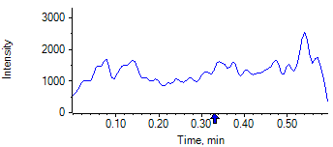

PCP 2 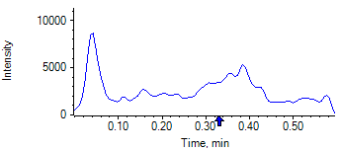

PCP D5 1 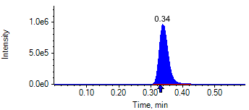

PCP D5 1 

Benzoylecgonine 1 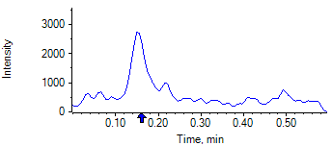

Benzoylecgonine 2 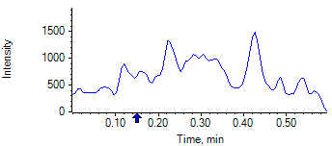

Benzoylecgonine D3 1 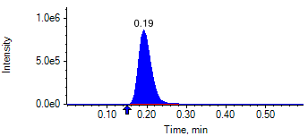

Benzoylecgonine D3 1 

|  |  |  |  |
| --- | --- | --- | --- |
| **Acquisition Method** | PCP_BE_041422Final.dam | **Data File** | SAMPLE105.wiff |
| **Sample Name** | **DL910522S01 CO** | **Injection Volume** | 10.00 |
| **Sample Type** | Unknown | **Injection Vial** | 49 |
| **Injection Date** | 5/1/2025 6:48:41 PM | **Dilution Factor** | 1.00 |
| **Instrument Name** | Triple Quad 5500+ | **Instrument Serial** | EX231582110 |

**Results Summary**

*DL910522S01 CO*

| **Peak Name** | **Integration Type** | **Transition** | **Retention Time** | **Rel RT** | **Peak Area** | **Area Ratio** | **Calculated Concentration (ng/mL)** | **Expected Ion Ratio** | **Calculated  Ion Ratio** | **Ratio Confirms ID** |
| --- | --- | --- | --- | --- | --- | --- | --- | --- | --- | --- |

|  |  |  |  |  |  |  |  |  |  |  |
| --- | --- | --- | --- | --- | --- | --- | --- | --- | --- | --- |
| PCP 1 | N/A | 243.8 / 159.0 | N/A | N/A* | N/A | N/A | N/A |  |  |  |

|  |  |  |  |  |  |  |  |  |  |  |
| --- | --- | --- | --- | --- | --- | --- | --- | --- | --- | --- |
| PCP 2 | N/A | 243.8 / 91.0 | N/A | N/A* | N/A | N/A |  | 59.4% | 0.0% | NO |

|  |  |  |  |  |  |  |  |  |  |  |
| --- | --- | --- | --- | --- | --- | --- | --- | --- | --- | --- |
| Benzoylecgonine 1 | Baseline | 289.8 / 168.1 | 0.17 | 1.02 | 2.220e5 | 0.182 | 935.57 |  |  |  |

|  |  |  |  |  |  |  |  |  |  |  |
| --- | --- | --- | --- | --- | --- | --- | --- | --- | --- | --- |
| Benzoylecgonine 2 | Baseline | 289.8 / 104.9 | 0.17 | 1.01 | 1.394e5 | 0.114 |  | 71.7% | 62.8% | ✓ |

**Internal Standard Data**

|  |  |  |  |  |  |  |  |  |  |
| --- | --- | --- | --- | --- | --- | --- | --- | --- | --- |
| **Internal Standard Name** | **Integration Type** | **Transition** | **Retention Time** | **Avg IS Retention Time** | **IS Peak Area** | **IS Area Within Range** | **Expected Ion Ratio** | **Calculated  Ion Ratio** | **Ratio Confirms ID** |

|  |  |  |  |  |  |  |  |  |  |
| --- | --- | --- | --- | --- | --- | --- | --- | --- | --- |
| PCP D5 1 | Baseline | 248.8 / 164.1 | 0.35* | 0.32 | 1.738e6 | ✓ |  |  |  |

|  |  |  |  |  |  |  |  |  |  |
| --- | --- | --- | --- | --- | --- | --- | --- | --- | --- |
| PCP D5 1 | Baseline | 248.8 / 164.1 | 0.35* | 0.32 | 1.738e6 |  | 100.0% | 100.0% | ✓ |

|  |  |  |  |  |  |  |  |  |  |
| --- | --- | --- | --- | --- | --- | --- | --- | --- | --- |
| Benzoylecgonine D3 1 | Baseline | 292.8 / 171.2 | 0.17* | 0.18 | 1.219e6 | ✓ |  |  |  |

|  |  |  |  |  |  |  |  |  |  |
| --- | --- | --- | --- | --- | --- | --- | --- | --- | --- |
| Benzoylecgonine D3 1 | Baseline | 292.8 / 171.2 | 0.17* | 0.18 | 1.219e6 |  | 100.0% | 100.0% | ✓ |

**Peak Review**

PCP 1 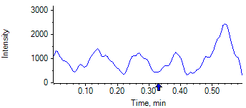

PCP 2 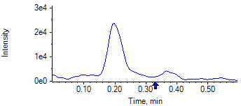

PCP D5 1 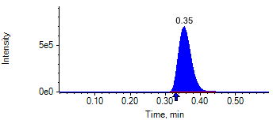

PCP D5 1 

Benzoylecgonine 1 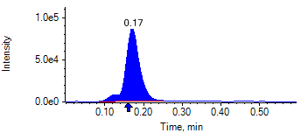

Benzoylecgonine 2 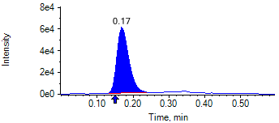

Benzoylecgonine D3 1 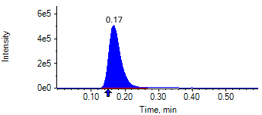

Benzoylecgonine D3 1 

|  |  |  |  |
| --- | --- | --- | --- |
| **Acquisition Method** | PCP_BE_041422Final.dam | **Data File** | SAMPLE106.wiff |
| **Sample Name** | **DL910545S01 CO** | **Injection Volume** | 10.00 |
| **Sample Type** | Unknown | **Injection Vial** | 50 |
| **Injection Date** | 5/1/2025 6:49:53 PM | **Dilution Factor** | 1.00 |
| **Instrument Name** | Triple Quad 5500+ | **Instrument Serial** | EX231582110 |

**Results Summary**

*DL910545S01 CO*

| **Peak Name** | **Integration Type** | **Transition** | **Retention Time** | **Rel RT** | **Peak Area** | **Area Ratio** | **Calculated Concentration (ng/mL)** | **Expected Ion Ratio** | **Calculated  Ion Ratio** | **Ratio Confirms ID** |
| --- | --- | --- | --- | --- | --- | --- | --- | --- | --- | --- |

|  |  |  |  |  |  |  |  |  |  |  |
| --- | --- | --- | --- | --- | --- | --- | --- | --- | --- | --- |
| PCP 1 | N/A | 243.8 / 159.0 | N/A | N/A* | N/A | N/A | N/A |  |  |  |

|  |  |  |  |  |  |  |  |  |  |  |
| --- | --- | --- | --- | --- | --- | --- | --- | --- | --- | --- |
| PCP 2 | N/A | 243.8 / 91.0 | N/A | N/A* | N/A | N/A |  | 59.4% | 0.0% | NO |

|  |  |  |  |  |  |  |  |  |  |  |
| --- | --- | --- | --- | --- | --- | --- | --- | --- | --- | --- |
| Benzoylecgonine 1 | Valley | 289.8 / 168.1 | 0.17 | 1.02 | 1.639e6 | 1.590 | 8412.54 |  |  |  |

|  |  |  |  |  |  |  |  |  |  |  |
| --- | --- | --- | --- | --- | --- | --- | --- | --- | --- | --- |
| Benzoylecgonine 2 | Baseline | 289.8 / 104.9 | 0.16 | 1.02 | 1.194e6 | 1.158 |  | 71.7% | 72.8% | ✓ |

**Internal Standard Data**

|  |  |  |  |  |  |  |  |  |  |
| --- | --- | --- | --- | --- | --- | --- | --- | --- | --- |
| **Internal Standard Name** | **Integration Type** | **Transition** | **Retention Time** | **Avg IS Retention Time** | **IS Peak Area** | **IS Area Within Range** | **Expected Ion Ratio** | **Calculated  Ion Ratio** | **Ratio Confirms ID** |

|  |  |  |  |  |  |  |  |  |  |
| --- | --- | --- | --- | --- | --- | --- | --- | --- | --- |
| PCP D5 1 | Baseline | 248.8 / 164.1 | 0.33* | 0.32 | 1.870e6 | ✓ |  |  |  |

|  |  |  |  |  |  |  |  |  |  |
| --- | --- | --- | --- | --- | --- | --- | --- | --- | --- |
| PCP D5 1 | Baseline | 248.8 / 164.1 | 0.33* | 0.32 | 1.870e6 |  | 100.0% | 100.0% | ✓ |

|  |  |  |  |  |  |  |  |  |  |
| --- | --- | --- | --- | --- | --- | --- | --- | --- | --- |
| Benzoylecgonine D3 1 | Baseline | 292.8 / 171.2 | 0.16* | 0.18 | 1.031e6 | ✓ |  |  |  |

|  |  |  |  |  |  |  |  |  |  |
| --- | --- | --- | --- | --- | --- | --- | --- | --- | --- |
| Benzoylecgonine D3 1 | Baseline | 292.8 / 171.2 | 0.16* | 0.18 | 1.031e6 |  | 100.0% | 100.0% | ✓ |

**Peak Review**

PCP 1 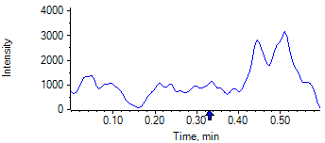

PCP 2 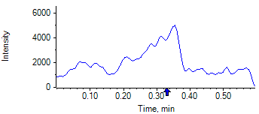

PCP D5 1 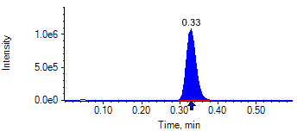

PCP D5 1 

Benzoylecgonine 1 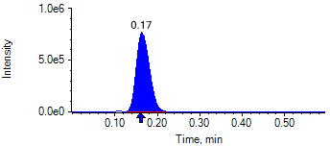

Benzoylecgonine 2 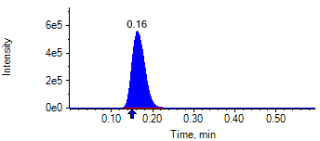

Benzoylecgonine D3 1 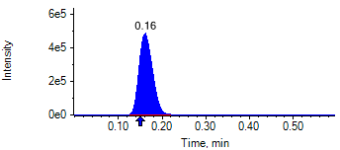

Benzoylecgonine D3 1 

|  |  |  |  |
| --- | --- | --- | --- |
| **Acquisition Method** | PCP_BE_041422Final.dam | **Data File** | SAMPLE107.wiff |
| **Sample Name** | **CPC HIGH QC CO** | **Injection Volume** | 10.00 |
| **Sample Type** | Quality Control | **Injection Vial** | 88 |
| **Injection Date** | 5/1/2025 6:51:04 PM | **Dilution Factor** | 1.00 |
| **Instrument Name** | Triple Quad 5500+ | **Instrument Serial** | EX231582110 |

**Results Summary**

| **Peak Name** | **Integration Type** | **Transition** | **Retention Time** | **Rel RT** | **Peak Area** | **Area Ratio** | **Calculated Concentration (ng/mL)** | **Expected Ion Ratio** | **Calculated  Ion Ratio** | **Ratio Confirms ID** |
| --- | --- | --- | --- | --- | --- | --- | --- | --- | --- | --- |

|  |  |  |  |  |  |  |  |  |  |  |
| --- | --- | --- | --- | --- | --- | --- | --- | --- | --- | --- |
| PCP 1 | Baseline | 243.8 / 159.0 | 0.32 | 1.02 | 2.470e7 | 17.830 | 3990.93 |  |  |  |

|  |  |  |  |  |  |  |  |  |  |  |
| --- | --- | --- | --- | --- | --- | --- | --- | --- | --- | --- |
| PCP 2 | Baseline | 243.8 / 91.0 | 0.32 | 1.01 | 1.431e7 | 10.330 |  | 59.4% | 57.9% | ✓ |

|  |  |  |  |  |  |  |  |  |  |  |
| --- | --- | --- | --- | --- | --- | --- | --- | --- | --- | --- |
| Benzoylecgonine 1 | Baseline | 289.8 / 168.1 | 0.15 | 1.02 | 3.748e6 | 3.000 | 16375.35 |  |  |  |

|  |  |  |  |  |  |  |  |  |  |  |
| --- | --- | --- | --- | --- | --- | --- | --- | --- | --- | --- |
| Benzoylecgonine 2 | Baseline | 289.8 / 104.9 | 0.15 | 1.02 | 2.657e6 | 2.127 |  | 71.7% | 70.9% | ✓ |

**Internal Standard Data**

|  |  |  |  |  |  |  |  |  |  |
| --- | --- | --- | --- | --- | --- | --- | --- | --- | --- |
| **Internal Standard Name** | **Integration Type** | **Transition** | **Retention Time** | **Avg IS Retention Time** | **IS Peak Area** | **IS Area Within Range** | **Expected Ion Ratio** | **Calculated  Ion Ratio** | **Ratio Confirms ID** |

|  |  |  |  |  |  |  |  |  |  |
| --- | --- | --- | --- | --- | --- | --- | --- | --- | --- |
| PCP D5 1 | Baseline | 248.8 / 164.1 | 0.31 | 0.32 | 1.385e6 | ✓ |  |  |  |

|  |  |  |  |  |  |  |  |  |  |
| --- | --- | --- | --- | --- | --- | --- | --- | --- | --- |
| PCP D5 1 | Baseline | 248.8 / 164.1 | 0.31 | 0.32 | 1.385e6 |  | 100.0% | 100.0% | ✓ |

|  |  |  |  |  |  |  |  |  |  |
| --- | --- | --- | --- | --- | --- | --- | --- | --- | --- |
| Benzoylecgonine D3 1 | Baseline | 292.8 / 171.2 | 0.15* | 0.18 | 1.249e6 | ✓ |  |  |  |

|  |  |  |  |  |  |  |  |  |  |
| --- | --- | --- | --- | --- | --- | --- | --- | --- | --- |
| Benzoylecgonine D3 1 | Baseline | 292.8 / 171.2 | 0.15* | 0.18 | 1.249e6 |  | 100.0% | 100.0% | ✓ |

**Peak Review**

PCP 1 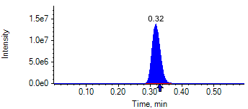

PCP 2 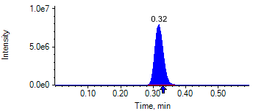

PCP D5 1 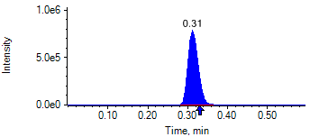

PCP D5 1 

Benzoylecgonine 1 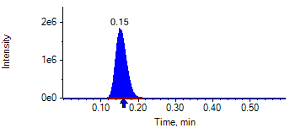

Benzoylecgonine 2 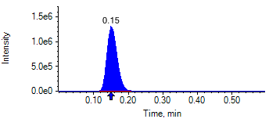

Benzoylecgonine D3 1 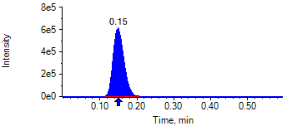

Benzoylecgonine D3 1 

|  |  |  |  |
| --- | --- | --- | --- |
| **Acquisition Method** | PCP_BE_041422Final.dam | **Data File** | SAMPLE108.wiff |
| **Sample Name** | **CPC MID QC CO** | **Injection Volume** | 10.00 |
| **Sample Type** | Quality Control | **Injection Vial** | 89 |
| **Injection Date** | 5/1/2025 6:52:15 PM | **Dilution Factor** | 1.00 |
| **Instrument Name** | Triple Quad 5500+ | **Instrument Serial** | EX231582110 |

**Results Summary**

| **Peak Name** | **Integration Type** | **Transition** | **Retention Time** | **Rel RT** | **Peak Area** | **Area Ratio** | **Calculated Concentration (ng/mL)** | **Expected Ion Ratio** | **Calculated  Ion Ratio** | **Ratio Confirms ID** |
| --- | --- | --- | --- | --- | --- | --- | --- | --- | --- | --- |

|  |  |  |  |  |  |  |  |  |  |  |
| --- | --- | --- | --- | --- | --- | --- | --- | --- | --- | --- |
| PCP 1 | Baseline | 243.8 / 159.0 | 0.34 | 1.01 | 1.502e7 | 9.106 | 1965.12 |  |  |  |

|  |  |  |  |  |  |  |  |  |  |  |
| --- | --- | --- | --- | --- | --- | --- | --- | --- | --- | --- |
| PCP 2 | Baseline | 243.8 / 91.0 | 0.34 | 1.01 | 8.741e6 | 5.300 |  | 59.4% | 58.2% | ✓ |

|  |  |  |  |  |  |  |  |  |  |  |
| --- | --- | --- | --- | --- | --- | --- | --- | --- | --- | --- |
| Benzoylecgonine 1 | Baseline | 289.8 / 168.1 | 0.20 | 1.02 | 2.297e6 | 1.526 | 8064.44 |  |  |  |

|  |  |  |  |  |  |  |  |  |  |  |
| --- | --- | --- | --- | --- | --- | --- | --- | --- | --- | --- |
| Benzoylecgonine 2 | Baseline | 289.8 / 104.9 | 0.20 | 1.02 | 1.617e6 | 1.074 |  | 71.7% | 70.4% | ✓ |

**Internal Standard Data**

|  |  |  |  |  |  |  |  |  |  |
| --- | --- | --- | --- | --- | --- | --- | --- | --- | --- |
| **Internal Standard Name** | **Integration Type** | **Transition** | **Retention Time** | **Avg IS Retention Time** | **IS Peak Area** | **IS Area Within Range** | **Expected Ion Ratio** | **Calculated  Ion Ratio** | **Ratio Confirms ID** |

|  |  |  |  |  |  |  |  |  |  |
| --- | --- | --- | --- | --- | --- | --- | --- | --- | --- |
| PCP D5 1 | Valley | 248.8 / 164.1 | 0.34* | 0.32 | 1.649e6 | ✓ |  |  |  |

|  |  |  |  |  |  |  |  |  |  |
| --- | --- | --- | --- | --- | --- | --- | --- | --- | --- |
| PCP D5 1 | Valley | 248.8 / 164.1 | 0.34* | 0.32 | 1.649e6 |  | 100.0% | 100.0% | ✓ |

|  |  |  |  |  |  |  |  |  |  |
| --- | --- | --- | --- | --- | --- | --- | --- | --- | --- |
| Benzoylecgonine D3 1 | Baseline | 292.8 / 171.2 | 0.19* | 0.18 | 1.505e6 | ✓ |  |  |  |

|  |  |  |  |  |  |  |  |  |  |
| --- | --- | --- | --- | --- | --- | --- | --- | --- | --- |
| Benzoylecgonine D3 1 | Baseline | 292.8 / 171.2 | 0.19* | 0.18 | 1.505e6 |  | 100.0% | 100.0% | ✓ |

**Peak Review**

PCP 1 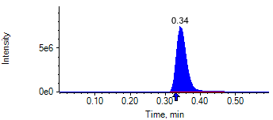

PCP 2 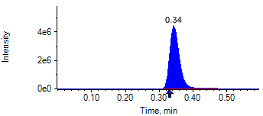

PCP D5 1 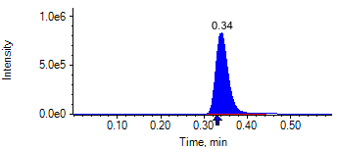

PCP D5 1 

Benzoylecgonine 1 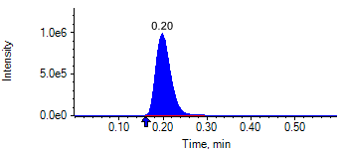

Benzoylecgonine 2 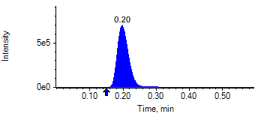

Benzoylecgonine D3 1 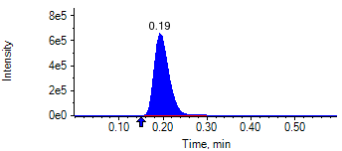

Benzoylecgonine D3 1 

|  |  |  |  |
| --- | --- | --- | --- |
| **Acquisition Method** | PCP_BE_041422Final.dam | **Data File** | SAMPLE109.wiff |
| **Sample Name** | **CPC MID QC CO** | **Injection Volume** | 10.00 |
| **Sample Type** | Quality Control | **Injection Vial** | 90 |
| **Injection Date** | 5/1/2025 6:53:27 PM | **Dilution Factor** | 1.00 |
| **Instrument Name** | Triple Quad 5500+ | **Instrument Serial** | EX231582110 |

**Results Summary**

| **Peak Name** | **Integration Type** | **Transition** | **Retention Time** | **Rel RT** | **Peak Area** | **Area Ratio** | **Calculated Concentration (ng/mL)** | **Expected Ion Ratio** | **Calculated  Ion Ratio** | **Ratio Confirms ID** |
| --- | --- | --- | --- | --- | --- | --- | --- | --- | --- | --- |

|  |  |  |  |  |  |  |  |  |  |  |
| --- | --- | --- | --- | --- | --- | --- | --- | --- | --- | --- |
| PCP 1 | Baseline | 243.8 / 159.0 | 0.37 | 1.01 | 1.691e7 | 9.013 | 1944.28 |  |  |  |

|  |  |  |  |  |  |  |  |  |  |  |
| --- | --- | --- | --- | --- | --- | --- | --- | --- | --- | --- |
| PCP 2 | Baseline | 243.8 / 91.0 | 0.37 | 1.01 | 1.007e7 | 5.366 |  | 59.4% | 59.5% | ✓ |

|  |  |  |  |  |  |  |  |  |  |  |
| --- | --- | --- | --- | --- | --- | --- | --- | --- | --- | --- |
| Benzoylecgonine 1 | Baseline | 289.8 / 168.1 | 0.19 | 1.02 | 2.573e6 | 1.547 | 8179.19 |  |  |  |

|  |  |  |  |  |  |  |  |  |  |  |
| --- | --- | --- | --- | --- | --- | --- | --- | --- | --- | --- |
| Benzoylecgonine 2 | Baseline | 289.8 / 104.9 | 0.19 | 1.02 | 1.777e6 | 1.069 |  | 71.7% | 69.1% | ✓ |

**Internal Standard Data**

|  |  |  |  |  |  |  |  |  |  |
| --- | --- | --- | --- | --- | --- | --- | --- | --- | --- |
| **Internal Standard Name** | **Integration Type** | **Transition** | **Retention Time** | **Avg IS Retention Time** | **IS Peak Area** | **IS Area Within Range** | **Expected Ion Ratio** | **Calculated  Ion Ratio** | **Ratio Confirms ID** |

|  |  |  |  |  |  |  |  |  |  |
| --- | --- | --- | --- | --- | --- | --- | --- | --- | --- |
| PCP D5 1 | Baseline | 248.8 / 164.1 | 0.37* | 0.32 | 1.876e6 | ✓ |  |  |  |

|  |  |  |  |  |  |  |  |  |  |
| --- | --- | --- | --- | --- | --- | --- | --- | --- | --- |
| PCP D5 1 | Baseline | 248.8 / 164.1 | 0.37* | 0.32 | 1.876e6 |  | 100.0% | 100.0% | ✓ |

|  |  |  |  |  |  |  |  |  |  |
| --- | --- | --- | --- | --- | --- | --- | --- | --- | --- |
| Benzoylecgonine D3 1 | Baseline | 292.8 / 171.2 | 0.18 | 0.18 | 1.663e6 | ✓ |  |  |  |

|  |  |  |  |  |  |  |  |  |  |
| --- | --- | --- | --- | --- | --- | --- | --- | --- | --- |
| Benzoylecgonine D3 1 | Baseline | 292.8 / 171.2 | 0.18 | 0.18 | 1.663e6 |  | 100.0% | 100.0% | ✓ |

**Peak Review**

PCP 1 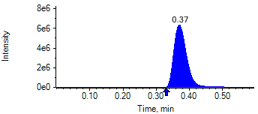

PCP 2 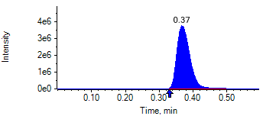

PCP D5 1 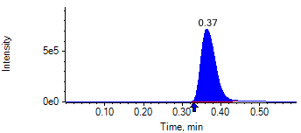

PCP D5 1 

Benzoylecgonine 1 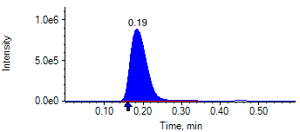

Benzoylecgonine 2 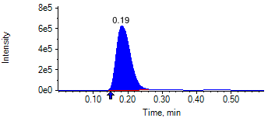

Benzoylecgonine D3 1 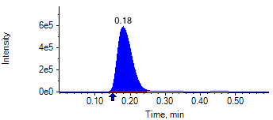

Benzoylecgonine D3 1 

|  |  |  |  |
| --- | --- | --- | --- |
| **Acquisition Method** | PCP_BE_041422Final.dam | **Data File** | SAMPLE110.wiff |
| **Sample Name** | **CPC LOW QC CO** | **Injection Volume** | 10.00 |
| **Sample Type** | Quality Control | **Injection Vial** | 91 |
| **Injection Date** | 5/1/2025 6:54:35 PM | **Dilution Factor** | 1.00 |
| **Instrument Name** | Triple Quad 5500+ | **Instrument Serial** | EX231582110 |

**Results Summary**

| **Peak Name** | **Integration Type** | **Transition** | **Retention Time** | **Rel RT** | **Peak Area** | **Area Ratio** | **Calculated Concentration (ng/mL)** | **Expected Ion Ratio** | **Calculated  Ion Ratio** | **Ratio Confirms ID** |
| --- | --- | --- | --- | --- | --- | --- | --- | --- | --- | --- |

|  |  |  |  |  |  |  |  |  |  |  |
| --- | --- | --- | --- | --- | --- | --- | --- | --- | --- | --- |
| PCP 1 | Baseline | 243.8 / 159.0 | 0.33 | 1.01 | 3.036e5 | 0.152 | 30.66 |  |  |  |

|  |  |  |  |  |  |  |  |  |  |  |
| --- | --- | --- | --- | --- | --- | --- | --- | --- | --- | --- |
| PCP 2 | Baseline | 243.8 / 91.0 | 0.33 | 1.01 | 1.846e5 | 0.093 |  | 59.4% | 60.8% | ✓ |

|  |  |  |  |  |  |  |  |  |  |  |
| --- | --- | --- | --- | --- | --- | --- | --- | --- | --- | --- |
| Benzoylecgonine 1 | Valley | 289.8 / 168.1 | 0.16 | 1.02 | 5.135e4 | 0.028 | 141.50 |  |  |  |

|  |  |  |  |  |  |  |  |  |  |  |
| --- | --- | --- | --- | --- | --- | --- | --- | --- | --- | --- |
| Benzoylecgonine 2 | Baseline | 289.8 / 104.9 | 0.16 | 1.02 | 3.452e4 | 0.019 |  | 71.7% | 67.2% | ✓ |

**Internal Standard Data**

|  |  |  |  |  |  |  |  |  |  |
| --- | --- | --- | --- | --- | --- | --- | --- | --- | --- |
| **Internal Standard Name** | **Integration Type** | **Transition** | **Retention Time** | **Avg IS Retention Time** | **IS Peak Area** | **IS Area Within Range** | **Expected Ion Ratio** | **Calculated  Ion Ratio** | **Ratio Confirms ID** |

|  |  |  |  |  |  |  |  |  |  |
| --- | --- | --- | --- | --- | --- | --- | --- | --- | --- |
| PCP D5 1 | Baseline | 248.8 / 164.1 | 0.33* | 0.32 | 1.991e6 | ✓ |  |  |  |

|  |  |  |  |  |  |  |  |  |  |
| --- | --- | --- | --- | --- | --- | --- | --- | --- | --- |
| PCP D5 1 | Baseline | 248.8 / 164.1 | 0.33* | 0.32 | 1.991e6 |  | 100.0% | 100.0% | ✓ |

|  |  |  |  |  |  |  |  |  |  |
| --- | --- | --- | --- | --- | --- | --- | --- | --- | --- |
| Benzoylecgonine D3 1 | Valley | 292.8 / 171.2 | 0.15* | 0.18 | 1.835e6 | ✓ |  |  |  |

|  |  |  |  |  |  |  |  |  |  |
| --- | --- | --- | --- | --- | --- | --- | --- | --- | --- |
| Benzoylecgonine D3 1 | Valley | 292.8 / 171.2 | 0.15* | 0.18 | 1.835e6 |  | 100.0% | 100.0% | ✓ |

**Peak Review**

PCP 1 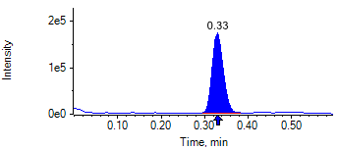

PCP 2 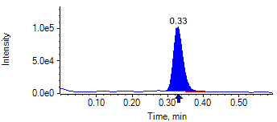

PCP D5 1 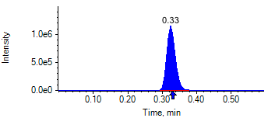

PCP D5 1 

Benzoylecgonine 1 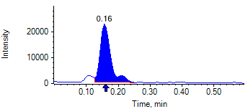

Benzoylecgonine 2 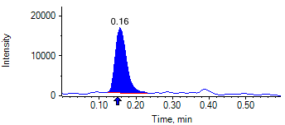

Benzoylecgonine D3 1 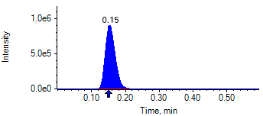

Benzoylecgonine D3 1 